Challenge Name: Add New User And Group

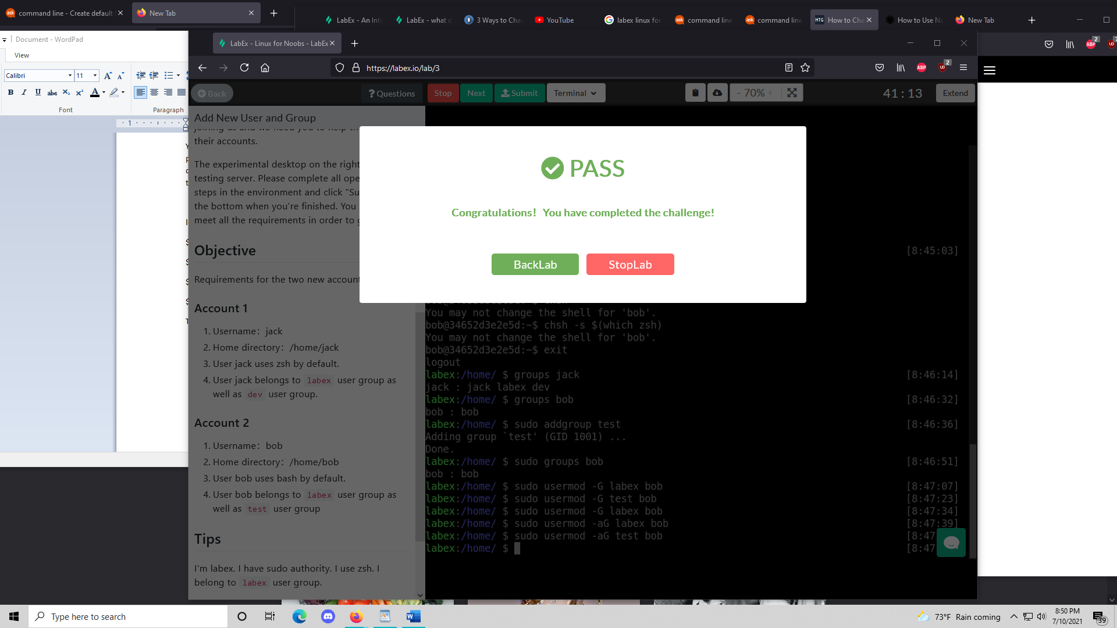

What I did to complete the challenge:

Step 1 + Step 2: Created a user and directory using the command sudo adduser

Alternative to step 1 + 2: could have done useradd to add user and created a pwd using passwd to set password plus mkhomedir_helper user to make a homedirectory for

Step 3: logged in as user using su -l (users name) and then did chsh -s $(which zsh) or (which bash) depending on which shell you need to set and then make sure to log out using the exit command

Alternative to step 3: use vi /etc/passwd and edit the usr with the file path to zsh to give him usage of zsh upon login

Step 4: did sudo addgroup (groupname) to add a user group with specified name then assigned the user to specified group ex: sudo usermod -G labex jack; sudo usermod -aG dev Jack.

Extra resources:

How to use vi: <https://staff.washington.edu/rells/R110/>

Make usr folder for existing usr in home directory: <https://linoxide.com/create-home-directory-existing-user-linux/>

Chsh command:

<https://askubuntu.com/questions/131823/how-to-make-zsh-the-default-shell>

Challenge Name: Find a File

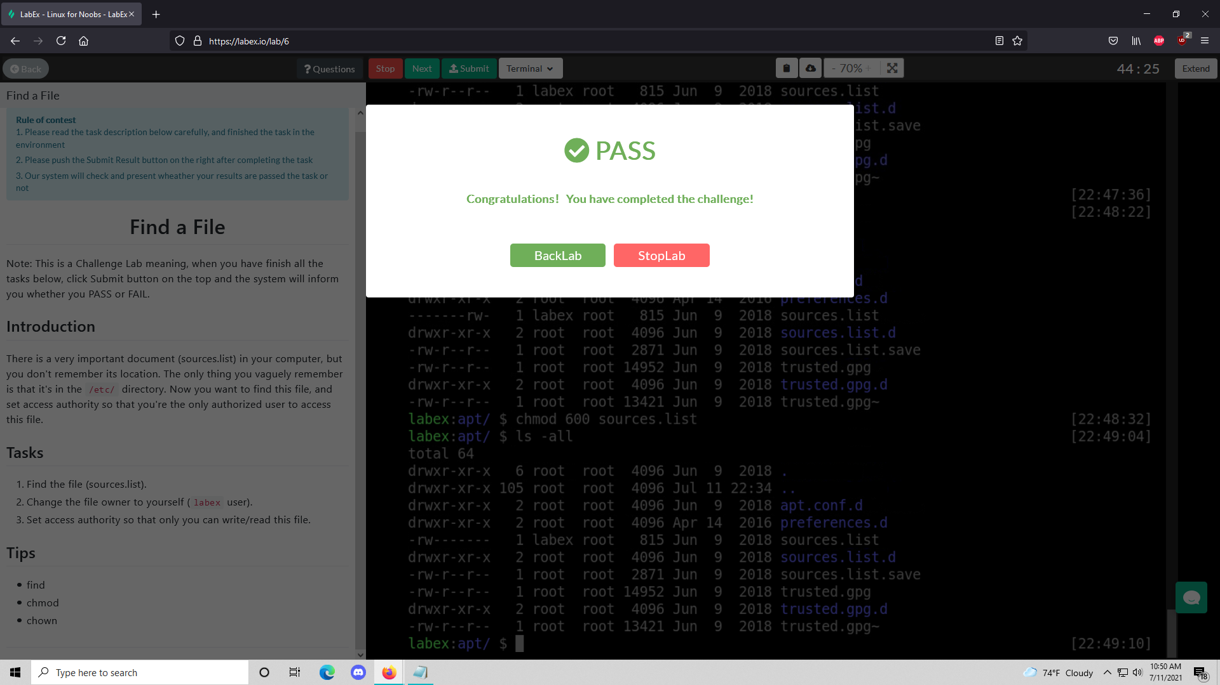

What I did to complete the challenge:

Step1: use the find command to look for the location of the file sources.list

Syntax for the find command: [where to start searching] [expression] [-options] [what to find]

Ex: sudo find /etc/ -name sources.list (/etc/ = where to start looking, -name = options sources.list = what it should look for)

Step2: used chown to change ownership of the file to labex (me)

Syntax for command: chown [options] user[:Group] File

Ex: chown labex sources.list

Step3: used chmod to change the file owner to labex (me)

Syntax for command: chmod options permissions file name

Ex: chmod 600 sources.list (give the owner read/write permission while giving everyone else none)

Tip: add the value 4(read) and 2(write) to get 6…

Extra Resources:

Chown: <https://linuxize.com/post/linux-chown-command/>

Chmod: <https://www.computerhope.com/unix/uchmod.htm>

Find: <https://www.geeksforgeeks.org/find-command-in-linux-with-examples/>

Challenge Name: Backup Systems Logs

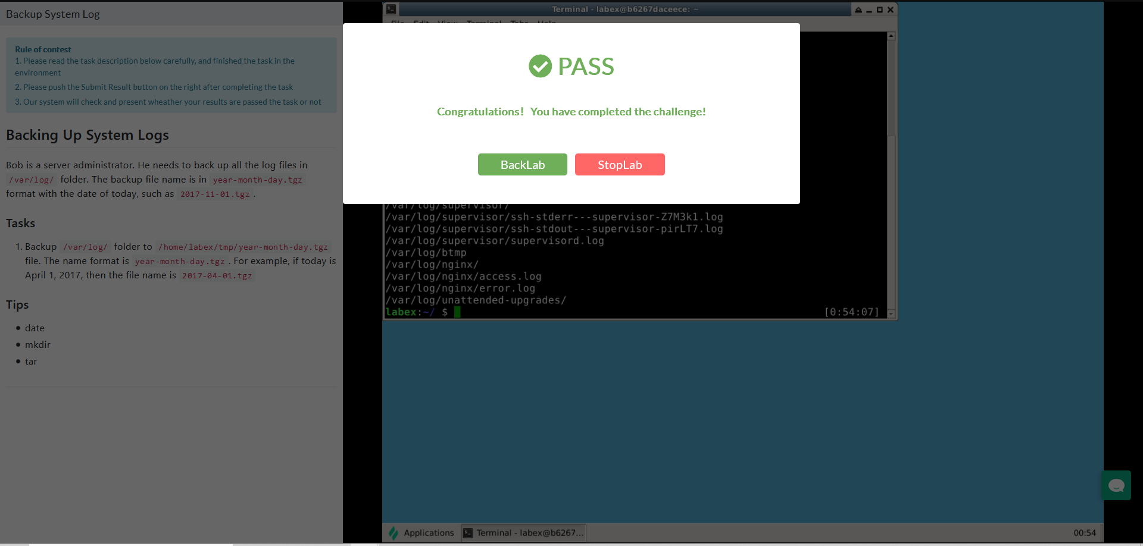

What I did to complete the challenge:

Step1: Had to create a directory using the mkdir command since it was missing a tmp folder

Ex: mkdir /home/labex/tmp

Step2: used tar command code to compress the logs in said location

Ex: tar -czvf (2021-11-07).tar.gz directory (directory containing the files you want)

Extra Resources:

Tar command for compression: [https://www.howtogeek.com/248780/how-to-compress-and-extract-files-using-the-tar-commanon-linux/](https://www.howtogeek.com/248780/how-to-compress-and-extract-files-using-the-tar-command-on-linux/)

Challenge Name: Analyze Historical Commands

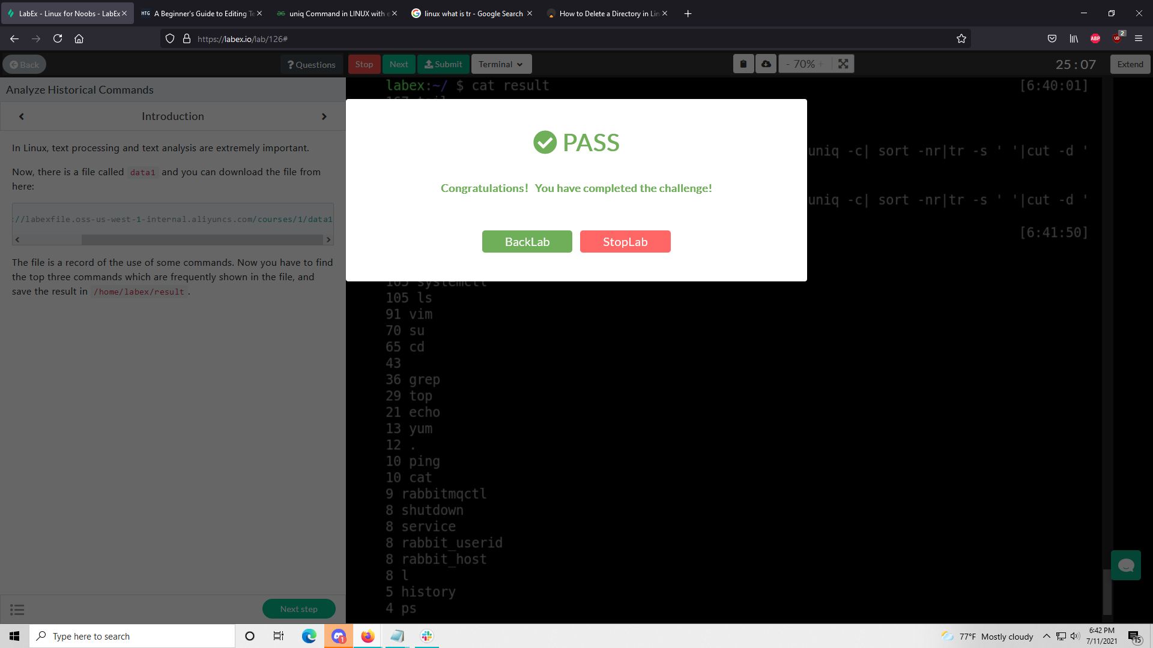

What I did to complete the challenge:

Step1: cut -c 8- data| cut -d ' ' -f 1|sort|uniq -c| sort -nr| tr -s ' '| cut -d ' ' -f 2,3| cat>/home/labex/result

Brief explanation of commands:

| = pip operator basically executes the next command if the previous is successful

cut: basically allows you to cut of parts of a line you don’t need

sort: allows you to sort contents in your file

tr: allows you to do various things with the contents in your file

Extra Resources:

Cut command: <https://www.geeksforgeeks.org/cut-command-linux-examples/>

Sort command: <https://www.geeksforgeeks.org/sort-command-linuxunix-examples/>

Tr command: <https://www.geeksforgeeks.org/tr-command-in-unix-linux-with-examples/>

Challenge Name: Data Extraction

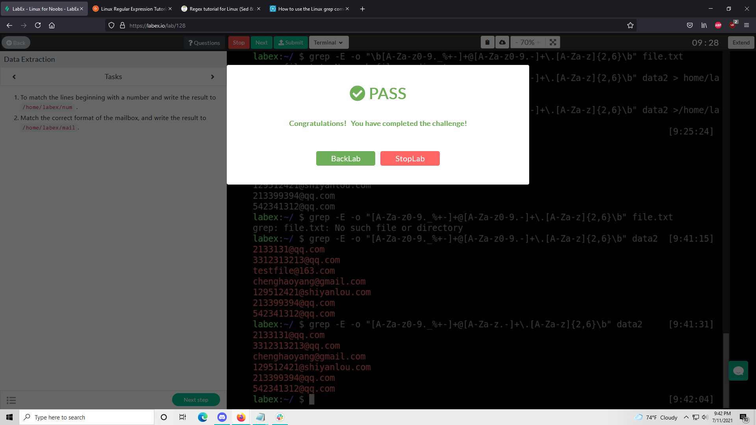

What I did to complete the challenge:

Step1: Used grep command to match the lines beginning with a number (‘^[[:digit:]]’)and then wrote the output to a file called num

Exact line: grep ‘^[[:digit:]]’ data2 > /home/labex/num (Note: > means write output to file)

Step2: Used grep command to and regexp (-E) to grab anything that matches specified pattern also based on a pattern found doing research

Exact line: grep -E -o "[A-Z a-z 0-9 ._%+-]+@[A-Za-z.-]+\.[A-Z a-z]{2,6}" file.txt

Extra Resources:

Website that has a similar pattern for email searching: <https://likegeeks.com/regex-tutorial-linux/>

Detailed explanation of regex: <https://www.guru99.com/linux-regular-expressions.html#3>