| **Name of the Student** | Anakin Skywalker |
| --- | --- |
| **Name of the Supervisor** | Obi-Wan Kenobi |
| **Project Title** | A density functional theory investigation of molecular adsorption on defective graphene |

# PROJECT SUMMARY

Graphene is a two-dimensional material that is in the form of a hexagonal network of carbon atoms. Point defects in graphene break the symmetry of this network and may alter the adsorption energies of molecules. In this project, we explore what changes occur in the adsorption energies of benzene and toluene on graphene in the presence of a single or double vacancy. The main hypothesis to be tested in this project is that the adsorption energies would increase in the presence of point defects in graphene. Our method of choice is density functional theory, which is a technique that relies on the description of the many-electron system based on the density rather than the wavefunction. We plan to calculate and compare the adsorption energies of the molecules mentioned above on pristine graphene and on defective graphene.

# **BACKGROUND**

Graphene is a two-dimensional material that has extraordinary electronic, elastic and vibrational properties [1]. Understanding the adsorption properties of different molecules on graphene is important since graphene is used as a substrate in air and water filters [2], whose working principle is the capture of toxic molecules on graphene. Point defects can be intentionally introduced in the graphene sheet intentionally or as a result of production processes [3]. The adsorption characteristics of several molecules such as CO2 [], benzene [] and … [] has been studied both experimentally and theoretically. Overall, defects appear to increase the adsorption energies of these molecules and therefore improve the performance of the graphene-based substrate as a filter.

In this study, we plan to investigate the adsorption characteristics of two molecules, benzene and toluene on pristine graphene and graphene with a single and a double vacancy (see Figure 1). The adsorption energies of benzene and toluene has been calculated previously on pristine graphene []. We plan to extend these calculations to the single and double vacancy cases.

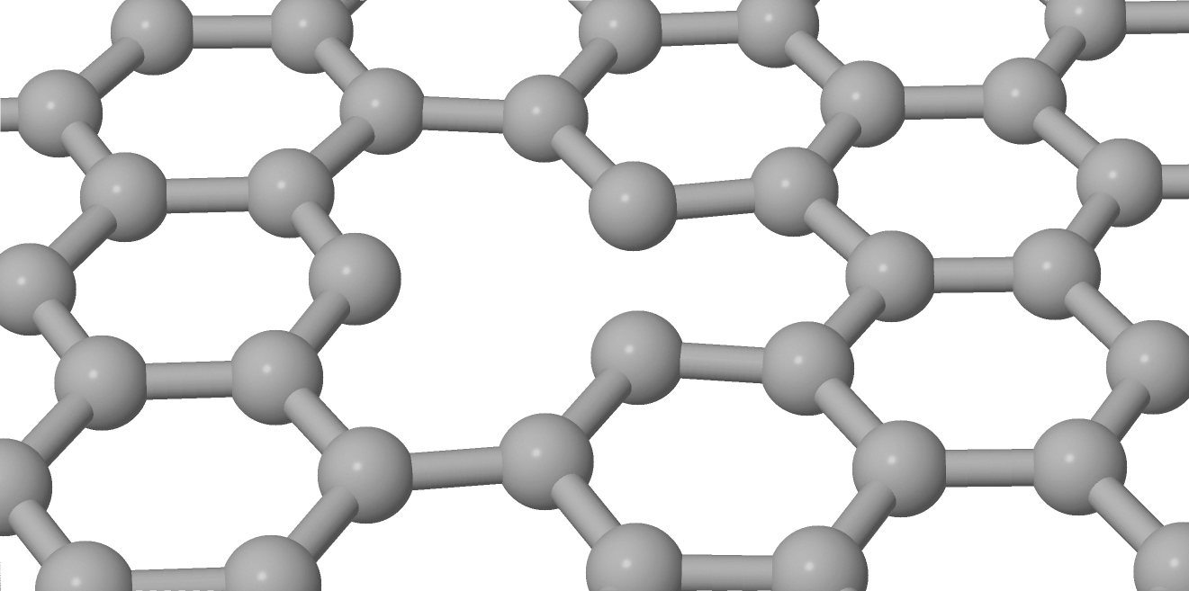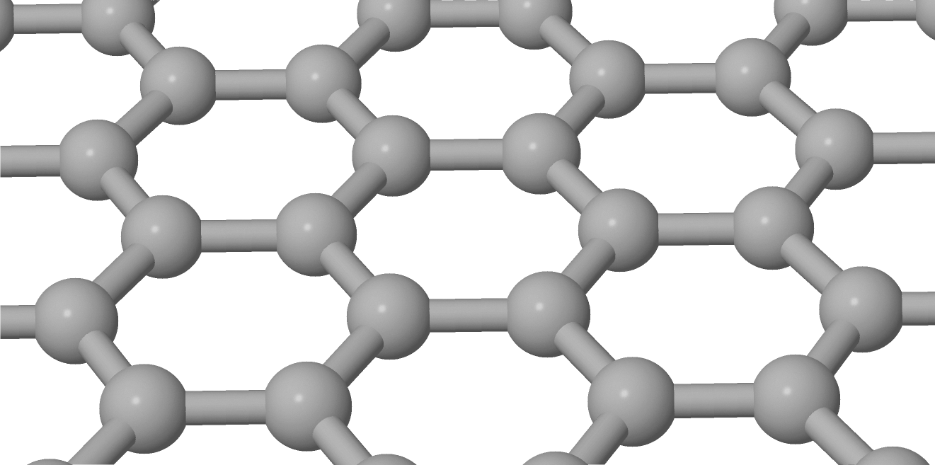

1. **(b)**

*Figure 1 : Pristine graphene (a) and defective graphene with a single vacancy (b)*

# **METHOD**

In this project, we aim to calculate the adsorption energies of molecules within the density functional theory framework [ ]. Density functional theory is a many-body method, which shifts the focus from the wavefunction to the density. The total energy for a given density is written as

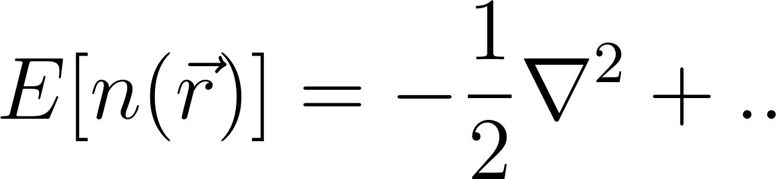

(1)

where [](https://www.codecogs.com/eqnedit.php?latex=n%0) is the density, [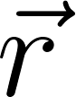](https://www.codecogs.com/eqnedit.php?latex=%5Cvec%7Br%7D%0) is the electronic position. The adsorption energies are calculated using the formula is the density,  is the electronic position. The adsorption energies are calculated using the formula

(2) 

where [](https://www.codecogs.com/eqnedit.php?latex=E_b%0), [](https://www.codecogs.com/eqnedit.php?latex=E_%7Btot%7D%0), [](https://www.codecogs.com/eqnedit.php?latex=E_%7Bsubs%7D%0) and [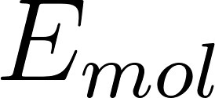](https://www.codecogs.com/eqnedit.php?latex=E_%7Bmol%7D%0) are the binding, total, substrate and molecule energies, respectively., ,  and  are the binding, total, substrate and molecule energies, respectively. Using Eq. 1 in Eq.2, we access the strength of the adsorption.

# **WORK PACKAGES AND TIMELINE**

**DELETE THIS HIGHLIGHTED TEXT IN PRODUCTION MODE**

*Describe your workflow (no word count limit).*

* *Divide your work plan into work packages (****at least four****, no upper limit).*
* *Timing a project is very important in academic life. Therefore you should discover and/or know your pace as you progress in the project. Be* ***realistic*** *about your workload and distribute project work to weeks accordingly.*
* *You should dedicate one work package to writing the final report, and one to the poster preparation. Both are due in the 14th week so you should plan accordingly. You may opt for working on parts of both throughout the semester (recommended) or at the end.*
* *Mark the timeline for each workpage on the Gannt chart below; for example with a bold face* ***X*** *character. In the table below, explain each work package in detail. 50-100 words/workpackage is enough although you can go lower and higher as long as it is clear.*
* *Work packages can overlap but do not plan to work on too many work packages at the same time.*
* *You can increase/decrease the number of work packages.*
* *OPTIONAL!!! Preferably start using a calendar software (such as Google calendar) and mark WPs with notifications. They are called milestones. Certain milestones are much more important than regular ones eg. Oral Exam, Submit Report, Prepare Poster etc. You might color/mark different than the regular ones eg. red/bold face with two notification one week before and one one day before. This is for yourself, you don’t need to turn it in.*

|  | **Weeks** | | | | | | | | | | | | |
| --- | --- | --- | --- | --- | --- | --- | --- | --- | --- | --- | --- | --- | --- |
|  | **2** | **3** | **4** | **5** | **6** | **7** | **8** | **9** | **10** | **11** | **12** | **13** | **14** |
| **WP 1** | X | X | X | X |  |  |  |  |  |  |  |  |  |
| **WP 2** |  | X | X |  |  |  |  |  |  |  |  |  |  |
| **WP 3** |  |  |  | X | X | X |  |  |  |  |  |  |  |
| **WP 4** |  |  |  | X | X | X |  |  |  |  |  |  |  |
| **WP 5** |  |  |  |  |  |  | X | X | X | X | X |  |  |
| **WP 6** |  |  |  |  |  |  |  |  |  |  | X | X |  |
| **WP 7** |  |  |  |  |  |  |  |  |  |  | X | X | X |

|  | **Description of Work Packages** |
| --- | --- |
| **WP1** | Literature search and reading up on density functional theory |
| **WP2** | Learn the software and preliminary calculations such as lattice constant of graphene |
| **WP3** | Calculation of adsorption energies of benzene and toluene on pristine graphene and comparison to literature |
| **WP4** | Write the introduction and methods part of the written report. |
| **WP5** | Calculation of adsorption energies of benzene and toluene on graphene with single and double vacancy. Comparison of these results to those on pristine graphene. |
| **WP6** | Prepare the poster |
| **WP7** | Finalize the written report (results and conclusion) |

# **REFERENCES**

[1] Volovik, G. E. *The Universe in a Helium Droplet* (Clarendon, Oxford, 2003)

[2] Novoselov, K. S. et al. Two dimensional atomic crystals. *Proc. Natl Acad. Sci. USA* **102**, 10451–10453 (2005)

[3] Zhang, Y., Small, J. P., Amori, M. E. S. & Kim, P. Electric field modulation of galvanomagnetic properties of mesoscopic graphite. *Phys. Rev. Lett.* **94**, 176803 (2005)

[4] ...