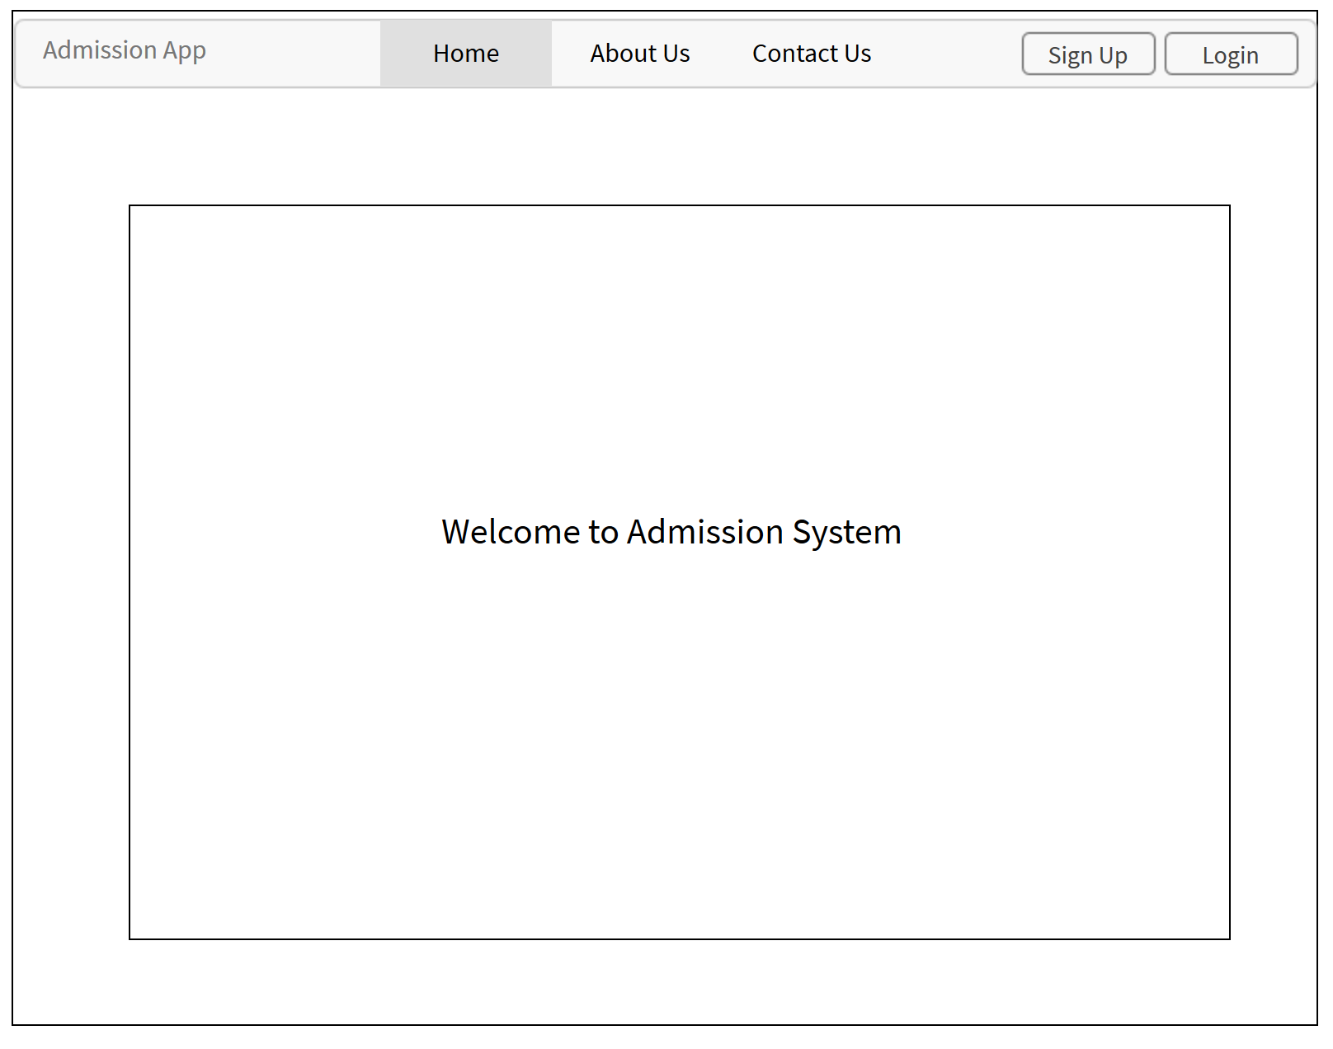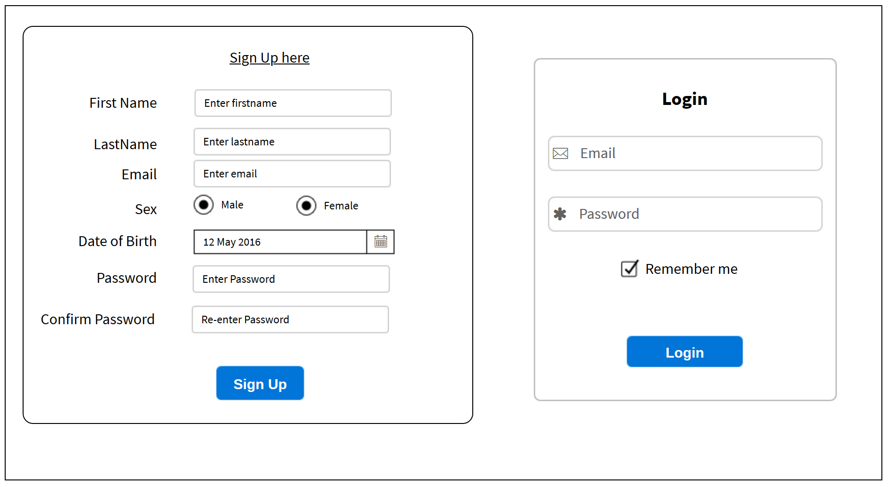

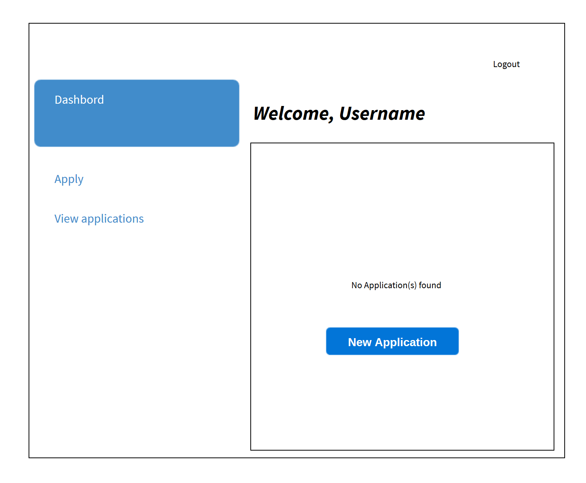

Admission System

This project is to develop an Admission System where new students have to apply for admission and keep monitoring if they have admitted or rejected.

The applicant has to first sign up and immediately be redirected to her/his dashboard where she/ he sees all applications made. If no application made he/she can start applying and waits for feedback.

Admin will also have to login to see all applications, then reviews them and provides feedbacks.