This Document explains how to create Essential JavaScript 2 Grid sample in React with bootstrap theme.

**Setting up new React project**

You can use [create-react-app](https://github.com/facebook/create-react-app) to setup the applications. To install **create-react-app** run the following command.

|  |
| --- |
| npm install -g create-react-app |

Use the below commands to create a basic react sample.

|  |
| --- |
| create-react-app quickstart --template typescript  cd quickstart  npm install |

**Adding Syncfusion Grid packages**

All the available Essential JS 2 packages are published in [npmjs.com](https://www.npmjs.com/~syncfusionorg) public registry. To install Grid component, use the following command

|  |
| --- |
| npm install @syncfusion/ej2-react-grids –save |

**Adding CSS reference**

The following CSS files are available in ../node_modules/@syncfusion package folder. This can be added as reference in src/index.css.

|  |
| --- |
| @import '../node_modules/@syncfusion/ej2-base/styles/bootstrap.css';  @import '../node_modules/@syncfusion/ej2-buttons/styles/bootstrap.css';  @import '../node_modules/@syncfusion/ej2-calendars/styles/bootstrap.css';  @import '../node_modules/@syncfusion/ej2-dropdowns/styles/bootstrap.css';  @import '../node_modules/@syncfusion/ej2-inputs/styles/bootstrap.css';  @import '../node_modules/@syncfusion/ej2-navigations/styles/bootstrap.css';  @import '../node_modules/@syncfusion/ej2-popups/styles/bootstrap.css';  @import '../node_modules/@syncfusion/ej2-splitbuttons/styles/bootstrap.css';  @import "../node_modules/@syncfusion/ej2-react-grids/styles/bootstrap.css"; |

**Adding Grid component**

Now, you can start adding the Grid component in src/App.tsxfile like as follows.

|  |
| --- |
| import { ColumnDirective, ColumnsDirective, GridComponent, Inject, Page } from '@syncfusion/ej2-react-grids';  import * as React from 'react';  import { orderdata } from './datasource';  export default class App extends React.Component<{}, {}>{      public render() {          return <GridComponent dataSource={orderdata} allowPaging={true}>              <ColumnsDirective>                  <ColumnDirective field='OrderID' width='100' textAlign="Right"/>                  <ColumnDirective field='CustomerID' width='100'/>                  <ColumnDirective field='EmployeeID' width='100' textAlign="Right"/>                  <ColumnDirective field='Freight' width='100' format="C2" textAlign="Right"/>                  <ColumnDirective field='ShipCountry' width='100'/>              </ColumnsDirective>              <Inject services={[Page]} />          </GridComponent>      }  }; |

**Running the application**

The [create-react-app](https://github.com/facebook/create-react-app) will pre-configure the project to compile and run the application in browser. Use the following command to run the application.

|  |
| --- |
| npm start |

The output will appear as follows

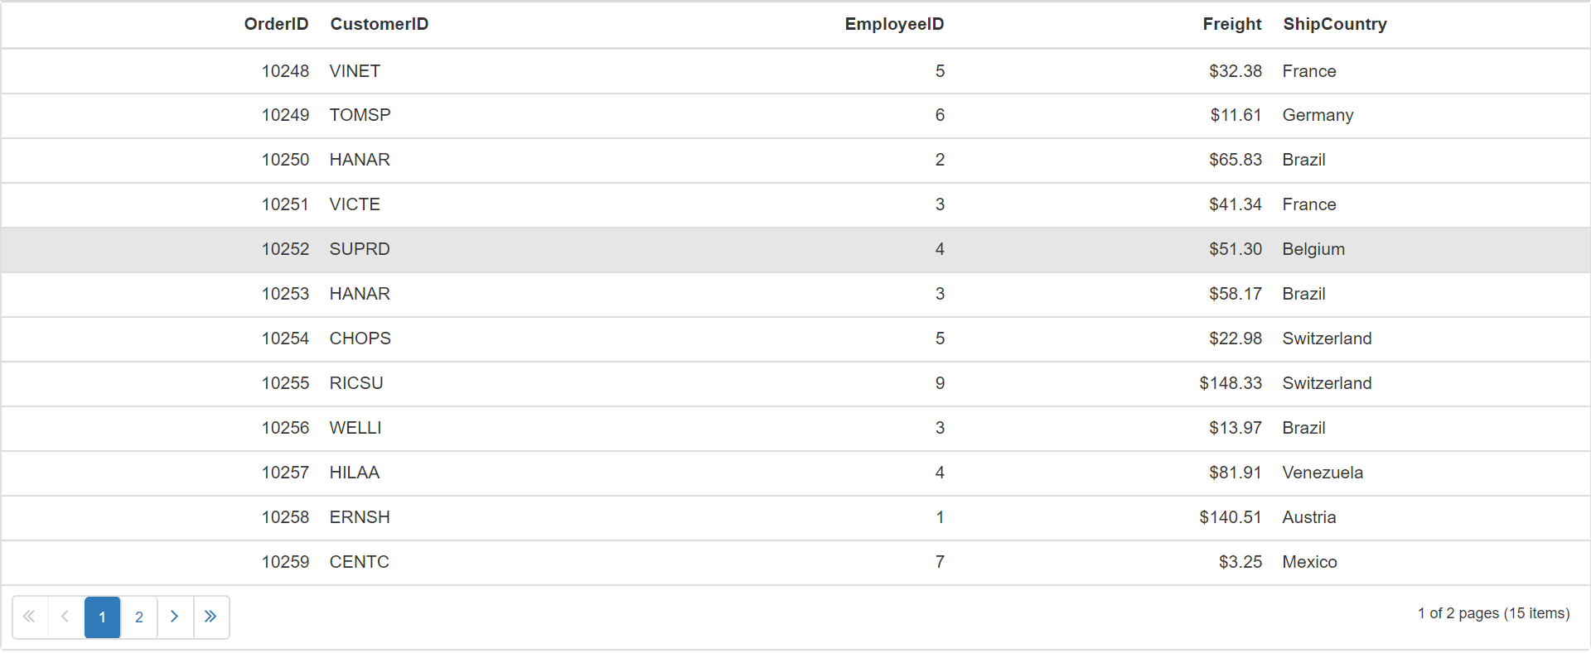

**Demo:** <https://www.syncfusion.com/downloads/support/directtrac/general/ze/quickstart836176618.zip>