Software requirement specification
for
Bike rental system

Aryan Kashyap
BCY0013

1.Introduction:

Transportation is a matter of headache for the people who don’t have their own personal transport in city of kochi. On the occasion of vacation, tour & other situations people feel the need of a vehicle which could allow them to travel long miles.The city also welcomes a latge number of tourists from different parts of the country & even outside the country, they also feel the necessity of any sort of vehicle which could make the tour trouble-free for them.
Fortunately, we have created an app which provides this service where people can rent a bike for limited time & return it back to the nearby bike hub.

1.1 Document purpose:

The purpose of this SRS is to outline both the functional and non-functional requirements of bike rental system. It also
provides a profile of the interfaces, performance considerations and design constraints imposed on the implementation.

1.2 Scope:

The bike rental system is designed to tackle the issue of the lack of transport for tourists in the city. They can now rent a bike for limited amount of time & return it back to nearby bike hub. The user interface is designed in such a way that will allow customers to use the service without any inconvenience. The platform is app-based which will allow for the service to run 24/7 execpt when their is temporary server issue.

2. Functional requirements :

These are the services which system should provide, how it should react to user inputs & in specific situations.

2.1 Registration:
- The system should allow user to create new account by collecting their information as name, mail , contact number & payment details.
- The system should allow user to log in to their account by using existing username & password.
- Also, it should allow the staffs to create an account or log in to their account by their username & password.

2.2 Bike availability:

- After logging in, user should grant access to use their location to track the nearby bikes.
- Then the system should show all the available bikes nearby the user at that moment.
- System should show a detailed description of bikes to the user as the model, gears, price range etc.
- It should allow user to limit the bike search by using a filter option.
- The user will be provided by an unique ID of the bike.
- The user should be provided with a set of plans showing the amount of hours they can rent the bike & the rent they have to pay accordingly.

2.3 Bike registration:

- After the user selects the bike, the pickup location & the plan then the system should allow user to book a bike & therefore decreasing the number of available bike from bike database by one.
- The system shoud notify other users about the bike which has been booked.
- The system should allow the staff to register customer in rental list.
- It should allow staff to update customer rental records.

2.4 Payment:

- After registering a bike, system should enable the users to pay for the rental service .
- The system should also add a security charge in the bill incase bike gets lost ot gets damaged which shall be refunded to the user upon successfully returning the bike.
- The system should allow users various payment methods as credit cards, debit cards, UPI and digital wallets.
- After the payment has been processed, system should unlock the selected bike.
- It should provide a summary for successful registration of bike.

2.5 Bike recovery
- The system should ensure that bike has been returned by the user & should return the security deposit
- In case user has not returned the bike under specific time the system should levy a penalty on the user which shall increase per hour.
3. Non-functional requirements:

3.1 Perfomance :
- The system should be able to handle a number of devices & active customer payments.
- It should update the information of the bikes without any issue.

3.2 Security:
- The system shall be able to display the availability of the bikes at all times.
- It should be able to restore itself to its previous state incase of system failure.
- It should be able to track the bike location at all times.
- It should be able to lock or unlock the bike during that travel if the user requests so.
- It should be able to confirm that the bike has been returned in the working condition.
- It should be secured with proper authentication & authorization.

3.3 User interface:
- The system should have a friendly-interface so that user can easily access the bike details & use the services without any inconvience.
- The system should provide the support for different languages for the customers.
- The system should also provide a different dashboard for staffs & a different ones for customer after they log in successfully.
- The interface should be simple & consistance using terminology commonly understood by the targeted users.

4. Data model:
The following is the proposed data flow model for the require bike rental system:

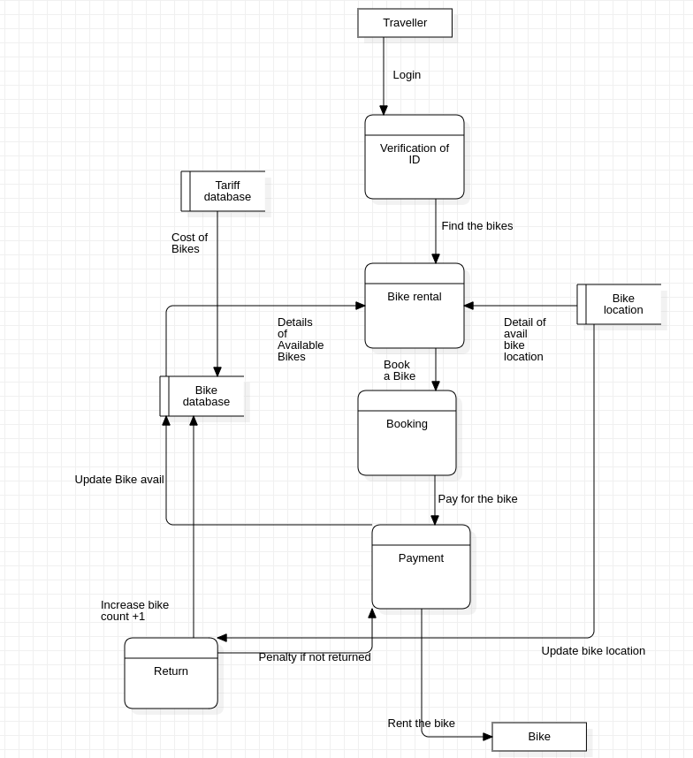

The system will collect user data including their name, mail, contact number , their location .It should have information about the bike , its model, ID, price, location & availability.
Also contatin information about the rental transaction , rental start and end times, rental duration.

5. System constraints:

5.1 Hardware constraints:
The system will user standart hardware & data communication resources, it wil require a server with sufficient processing power and memory to handle a large number of requests. It should be active 24/7. This included general network connections at the server hosting site & netowork server.

5.2 Software constraints:

The user device should have a stable internet connection to run the app smoothly. The app should be available at play store and app store. It shall able to restore to its previous state in case of system crash.

6. Assumptions & dependencies:
The system assumes that user has stable connection & a compatible device to run the app. It does depend on the availability of the bikes at a particular location.
There might be some bike hubs which don’t have a bike at particular moment of time.

7. Conclusion:
This Software Requirements Specification document outlines the functional and non-functional requirements for the Bike Rental System. The system aims to provide a convenient and hassle-free rental service for bikes . The system must be able to calculate the rental cost based on the rental duration.

