CYB613: Operating Systems Theory and Administration

Lab6: Crontab & At

## Complete Lab 14.1, 14.2 for chapter 14: Crontab & At

**Lab 14.1**

Follow steps 1 thru 17, no need to paste a screen shot for every step, except for the following:

For Step 3, Paste a screenshot of the current user **crontab** file, below

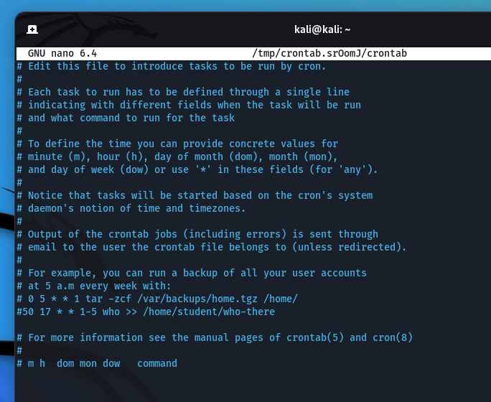

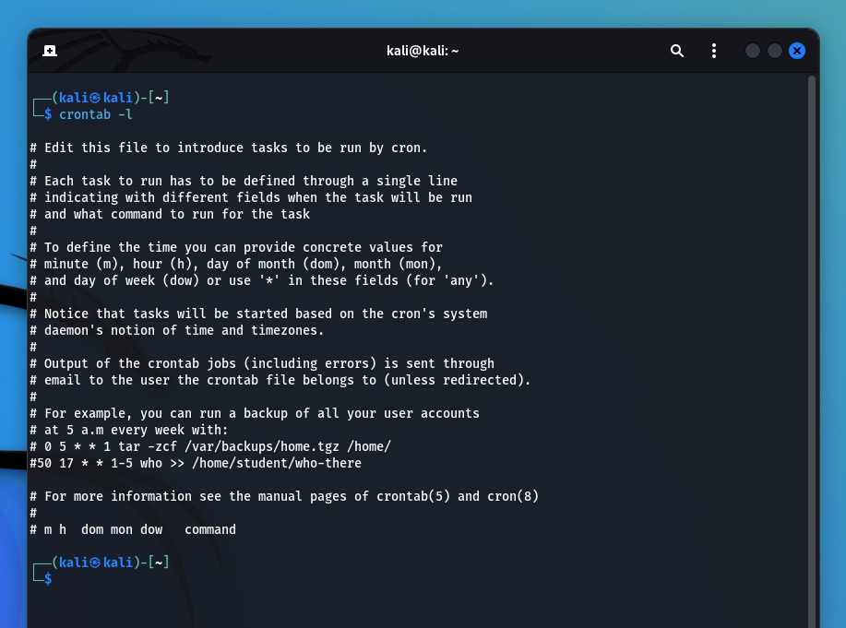

# 50 17 * * 1-5 who >> /home/student/who-there

The breakdown of the cron schedule syntax we have used:

[We have used nano editor here ]

50 is the minute when the cron job will run (at 50 minutes past the hour).

17 is the hour in 24-hour format when the cron job will run (at 5 PM).

The first * is the day of the month, where * means every day of the month.

The second * is the month, where * means every month.

1-5 represents the days of the week, where 1 is Monday and 5 is Friday.

The who command is the task to be executed, and >> /home/student/who-there appends the output of the who command to the file /home/student/who-there.

This will save the crontab and schedule the job to run at the specified time.

For Step 15 paste a screen shot for your primary system **crontab** file, below

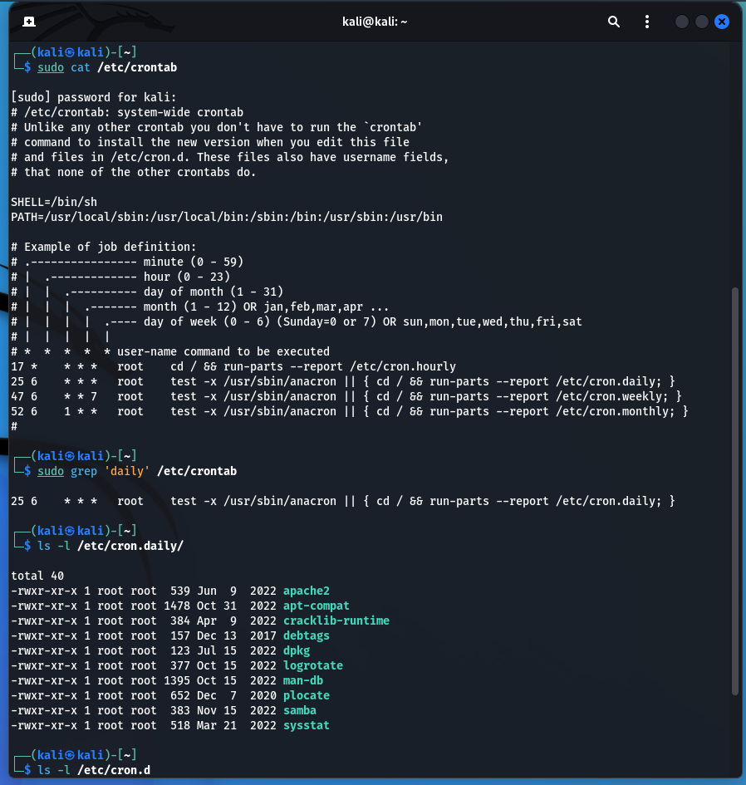

We can se that his file contains scheduled tasks that are run by the system at various intervals.

Hourly tasks: The entry 17 * * * * root cd / && run-parts --report /etc/cron.hourly indicates that every hour when the clock hits 17 minutes, the system runs scripts located in the /etc/cron.hourly directory as the root user.

Daily tasks: The entry 25 6 * * * root test -x /usr/sbin/anacron || ( cd / && run-parts --report /etc/cron.daily ) suggests that at 6:25 AM every day, the system checks if the anacron service is executable. If it isn't (which usually means that anacron isn't installed or isn't functioning), it will execute the scripts in the /etc/cron.daily directory.

Weekly tasks: Similarly, the entry 47 6 * * 7 root test -x /usr/sbin/anacron || ( cd / && run-parts --report /etc/cron.weekly ) is set for 6:47 AM on the 7th day of the week (Sunday). It checks for anacron and runs the scripts in /etc/cron.weekly if anacron is not found.

Monthly tasks: Lastly, the entry 52 6 1 * * root test -x /usr/sbin/anacron || ( cd / && run-parts --report /etc/cron.monthly ) is set to run at 6:52 AM on the first day of each month. It performs the same anacron check and executes scripts in /etc/cron.monthly if necessary.

**Lab 14.2**

Follow steps 1 thru 3, no need to pate a screen shot for every step, except for the following:

For Step 3, Paste a screenshot of the current user **at job** for the current user.

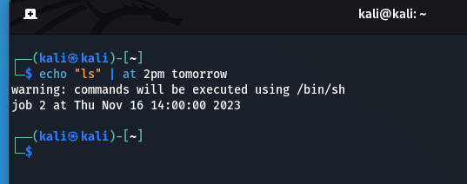

└─$ atq

1 Thu Nov 16 14:00:00 2023 a kali

2 Thu Nov 16 14:00:00 2023 a kali

We can remove these jobs by using atrm

atrm 1 & atrm 2

This will cancel the scheduled execution of the job we specify. As we can see job 1 and job 2 are removed and new jobs are created

