CYB613: Operating Systems Theory and Administration

Lab7: Shell Scripting

## Complete Lab 15.1, 15.2 for chapter 15: Scripting

**Lab 15.1**

Paste your shell script below

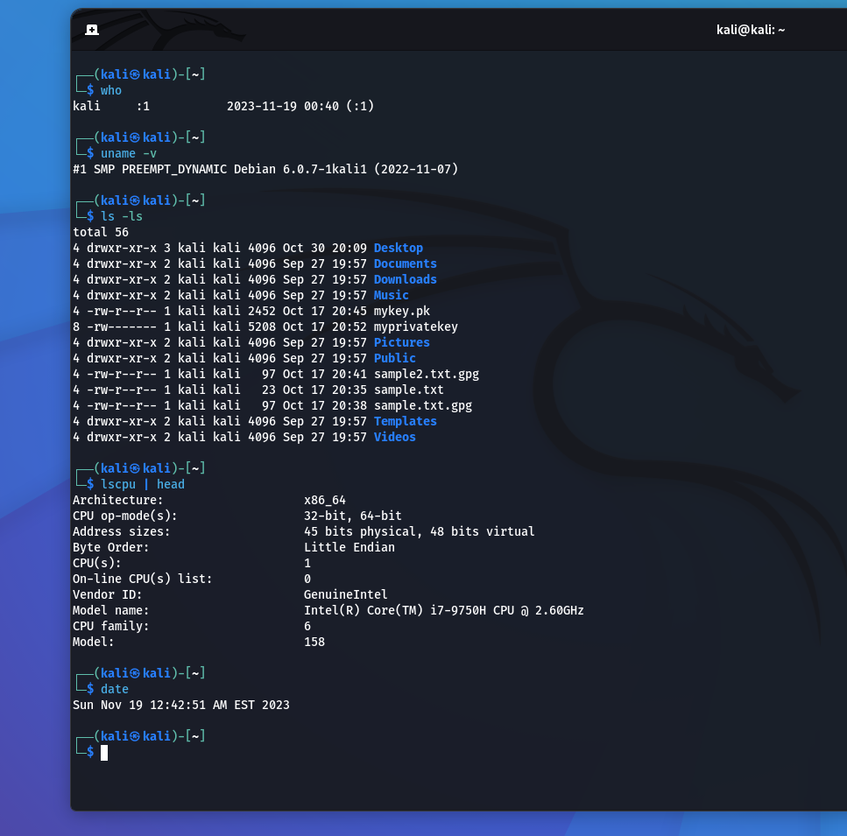

**Lab 15.2**

Paste your shell script below

