DR. YANGA'S COLLEGES, INC.
COLLEGE OF COMPUTER STUDIES
FREE ELECTIVE 4 (FRE413) — DATA ANALYTICS WITH FLUTTER
PRELIMINARY PARALLEL ACTIVITY
Design Your Data Analytics Application | Total Score: 100 Points
Student Name: | Clarence Sadiaza | Year & Section: | BSIT 4th Year
Course & Code: | FREE ELECTIVE 4 (FRE413) | Faculty: | Bryan Jay H. Mallare
Project Title: | Diagrid: Technical Blueprint Diagramming & Drafting Platform | Submission Date: | September 26, 2026
Coverage: | Weeks 2–4 (Preliminary Period) | Total Score: | 100 Points Maximum

PART 1 – PROJECT AND DATA IDENTIFICATION [15 Points]
Project Title: Diagrid: Technical Blueprint Diagramming & Drafting Platform
Purpose of the Project (Problem Solved):
Project Problem & Solution Statement
Mainstream software architecture and diagramming tools (such as Lucidchart, Draw.io, or Eraser) frequently generate chaotic, overlapping connector lines ('diagram spaghetti'), lack first-class native support for standard academic and software engineering notation (such as Crow's Foot ERD cardinality, Data Flow Diagrams, UML Use Cases, and Activity Diagrams), and impose steep learning curves or costly subscriptions.
Diagrid solves this by providing a blueprint-styled visual canvas with 20px grid snapping and automated 90° right-angled orthogonal edge routing, combined with an instant code/notes-to-diagram compilation engine. It empowers software engineering students, system architects, and developers to draft clean, standardized diagrams from scratch or compile them directly from text notes, DBML, or Mermaid code with zero connector entanglement.

Five (5) Pieces of Data Used by the Project:
No. | Data | Description
1 | Diagram Canvas Nodes & Entities | Geometric coordinates (X, Y), dimensions (width, height), shape stencil type (e.g., ERD entity table, flowchart process block, decision diamond, sequence actor), label text, and column/attribute list (e.g., Starter ERD Schema, basta).
2 | Orthogonal Connection Edges | Geometric routing paths, source node ID, target node ID, port anchor attachments (top, bottom, left, right), and relationship cardinality notation (e.g., Crow's Foot 1:N, 1:1, ||--|{).
3 | Project Workspace Metadata | High-level project attributes including project title, unique project UUID, category tag, owner user ID, public sharing status (is_public), and modification timestamps (reflected as TOTAL_PROJECTS = 8 in telemetry).
4 | User Account Profile & Telemetry | Authenticated user credentials and session telemetry, including unique user UUID, email address (e.g., sadiazaclarence@gmail.com, superadmin@diagrid.com), account role (admin/user), and auth timestamps (TOTAL_USERS = 6).
5 | Exported Diagram Assets & Telemetry | Rendered raster and vector output files and export telemetry records generated by the canvas rendering pipeline, including format (PNG, SVG, JSON, Mermaid), image dimensions, storage footprint (1.17 MB / 500 MB), and export history.

PART 2 – DATA TYPE CLASSIFICATION [15 Points]
Classify the five pieces of data identified in Part 1 into Structured Data, Semi-Structured Data, or Unstructured Data, with a clear explanation for each:
Data | Data Type | Explanation
User Account Profile & Telemetry | Structured Data | Fits strictly into a predefined relational database schema (public.profiles) with fixed columns, standardized data types (UUID, VARCHAR, TIMESTAMP, ENUM), and rigid tabular constraints.
Project Workspace Metadata | Structured Data | Organized in rows and columns within a relational database table (public.projects), where each field follows strict schemas, foreign keys, and predefined lengths.
Diagram Canvas Nodes & Entities | Semi-Structured Data | Stored as a hierarchical JSON/JSONB document structure (public.diagrams.canvas_data). Each node contains flexible, nested key-value pairs (custom styling, schema column arrays, coordinate objects) with key-value markup rather than rigid relational columns.
Orthogonal Connection Edges | Semi-Structured Data | Stored as dynamic JSON objects or structured text DSL (Mermaid syntax / DBML strings) containing nested key-value pairs (sourceId, targetId, waypoints array, cardinality rules).
Exported Diagram Assets | Unstructured Data | Composed of binary raster image pixels (PNG blobs stored in Supabase Storage or downloaded) that lack relational row-and-column formatting or internal database queryable fields.

PART 3 – DATA SOURCES [15 Points]
Identify the source of each piece of data, specifying whether it is Internal or External, and Primary or Secondary:
Data | Internal / External | Primary / Secondary | Source
User Account Profile & Telemetry | Internal | Primary | User Registration & Auth Session Gateway (Captured directly from user input during onboarding and session establishment).
Project Workspace Metadata | Internal | Primary | "Create New Project" Modal Dialog & Workspace Settings (Inputted directly by the user upon project initialization).
Diagram Canvas Nodes & Entities | Internal | Primary | Canvas Drag-and-Drop Studio & Node Inspector (Captured in real time from direct user interactions, drag gestures, and property edits on the canvas).
Orthogonal Connection Edges | Internal | Primary | Interactive Connector Port Linking Tool (Created directly by the user connecting port handles between canvas nodes).
Exported Diagram Assets | Internal | Secondary | Client-Side Canvas Rendering & Export Pipeline (Derived/processed from raw canvas nodes and edges via SVG rasterizer and HTML5 canvas).

PART 4 – DATA QUALITY [15 Points]
Identify three (3) possible data-quality problems that could occur in the project, providing a concrete example and prevention/solution for each:
Data Quality Problem | Example | Prevention / Solution
1. Dangling / Orphaned Edge References  (Consistency & Referential Integrity) | A user deletes a canvas table node (e.g., 'Users' table in Starter ERD Schema), but the connection edge ('Users -> Orders') remains saved in the database with a non-existent sourceNodeId: 'node_101', causing rendering errors or canvas crash. | Implement cascading deletion logic in state management and relational constraints (ON DELETE CASCADE in database, or state sanitization in Redux/React hook that filters out edges referencing deleted node IDs before persistence).
2. Missing Diagram Titles / Blank Sheet Classification  (Completeness) | As shown in the telemetry overview, 2 units (4%) of diagrams are classified as 'BLANK' because users initiate diagram sheets without specifying a title or notation type, making indexing and searching difficult. | Implement client-side form validation requiring a non-empty name with an auto-fallback default (e.g., 'Untitled Diagram - 2026-09-26') and prompt an onboarding stencil modal requiring the user to pick an initial notation before saving.
3. Storage Quota Exceedance / Corrupted Export Blobs  (Accuracy & Timeliness) | Users exporting multi-megabyte 3x retina diagrams or malformed base64 image data could exceed the infrastructure storage allocation (currently 1.17 MB / 500.00 MB) or fail to render. | Enforce client-side canvas payload size checks, optimize raster image compression prior to storage upload, and display a proactive storage health toast when approaching tier limits.

PART 5 – ANALYTICS DASHBOARD UI SKETCH [15 Points]
The following analytics dashboard presents real-time telemetry and usage analytics from the live Diagrid Administrative Console. It features four (4) summary metrics cards, an interactive activity trend line chart, a diagram notation distribution breakdown (48 total diagrams), and a real-time live stream records display area showing developer actions by user accounts.

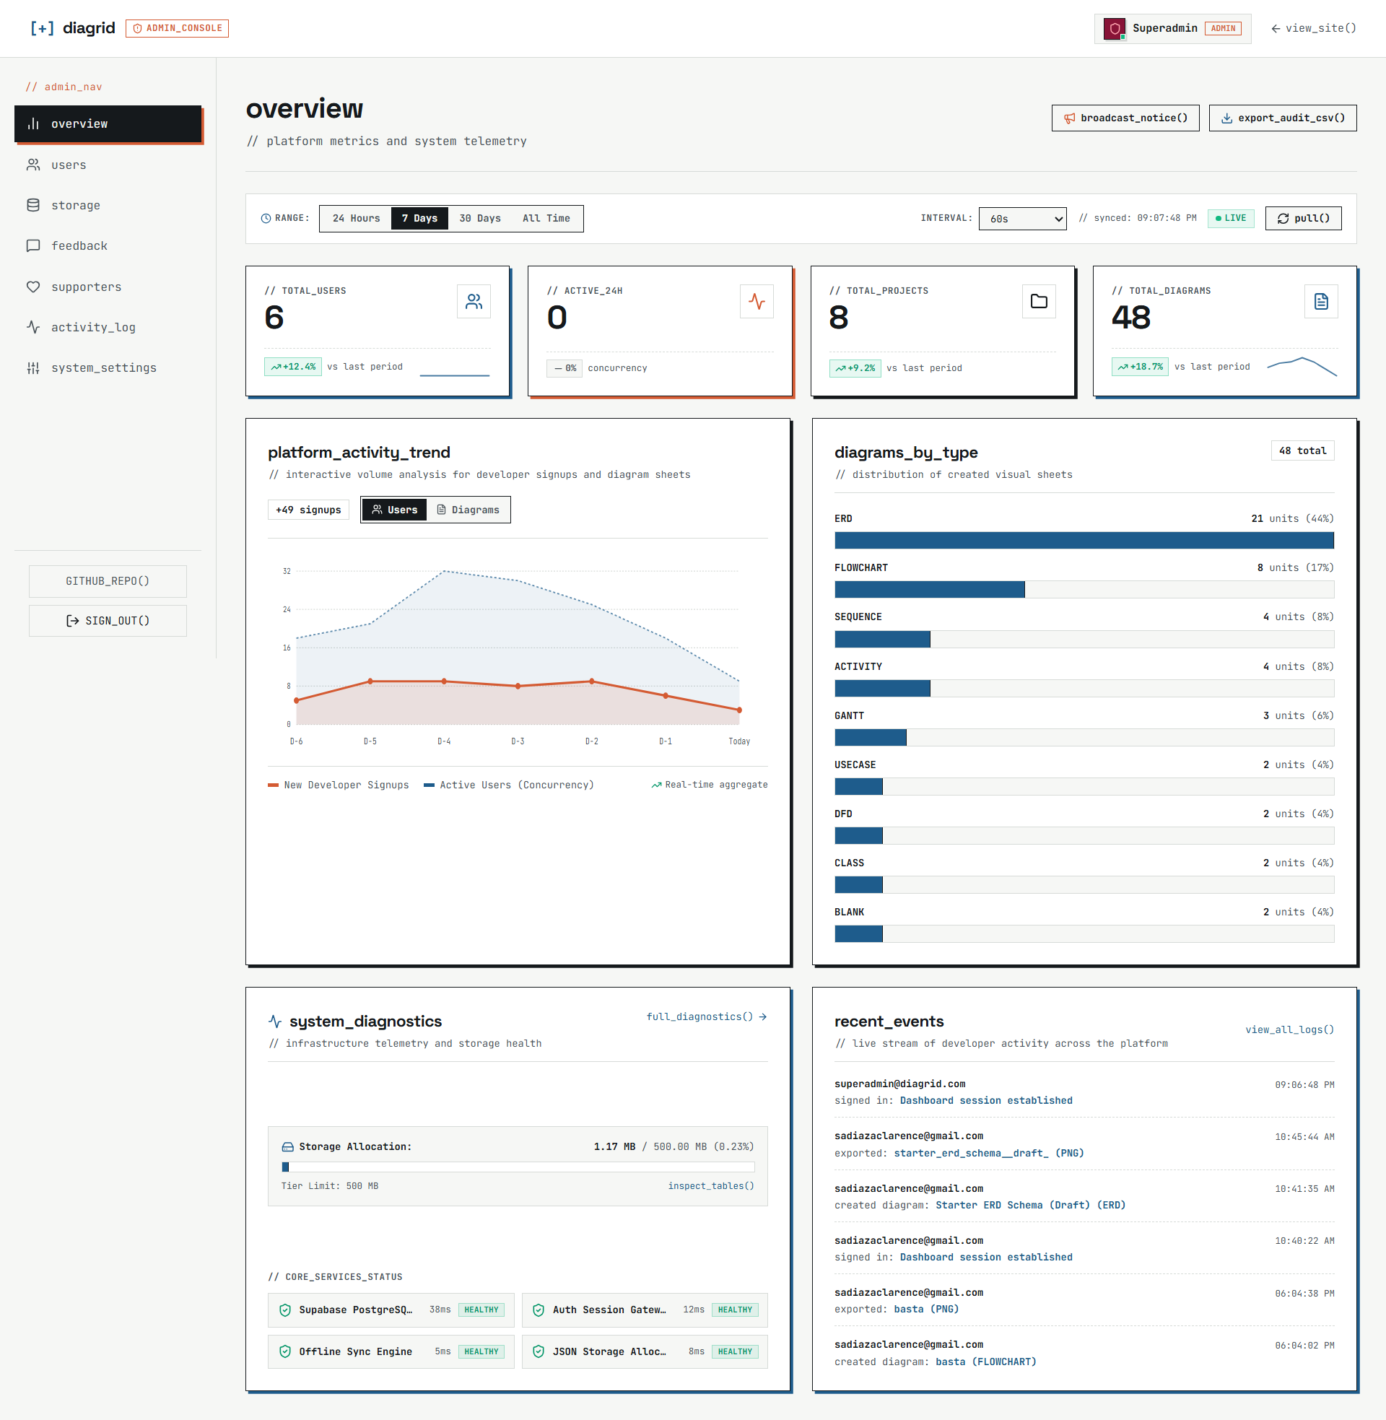
Figure 5.1: Live Diagrid Admin Overview & Analytics Dashboard (Platform Metrics & Telemetry)
Dashboard Structural Components Breakdown:
1. Application / Project Header: | Displays '[+] diagrid [ADMIN_CONSOLE]' with active user 'Superadmin (ADMIN)' and operational action buttons ('broadcast_notice()', 'export_audit_csv()', 'pull()', and live status pill).
2. Four (4) Summary Cards: | • TOTAL_USERS: 6 (+12.4% vs last period)  • ACTIVE_24H: 0 (concurrency)  • TOTAL_PROJECTS: 8 (+9.2% vs last period)  • TOTAL_DIAGRAMS: 48 (+18.7% vs last period)
3. Visual Telemetry Areas: | • platform_activity_trend: Interactive volume analysis showing developer signups and active user concurrency over the past 7 days (D-6 to Today).  • diagrams_by_type: Distribution of created visual sheets (ERD: 21 [44%], Flowchart: 8 [17%], Sequence: 4 [8%], Activity: 4 [8%], Gantt: 3 [6%], Use Case: 2 [4%], DFD: 2 [4%], Class: 2 [4%], Blank: 2 [4%]).  • system_diagnostics: Infrastructure health with storage allocation (1.17 MB / 500 MB) and service latency metrics (Supabase 38ms, Auth Gateway 12ms, Offline Sync 5ms, JSON Storage 8ms).
4. Records Display Area (recent_events): | A real-time audit stream displaying developer activity records with exact timestamps, user emails (sadiazaclarence@gmail.com, superadmin@diagrid.com), and performed operations ('exported: starter_erd_schema__draft_ (PNG)', 'created diagram: Starter ERD Schema (Draft) (ERD)', 'exported: basta (PNG)', 'created diagram: basta (FLOWCHART)').

ASCII Structural Wireframe Representation:
+------------------------------------------------------------------------------------------------------+
| [+] diagrid [ADMIN_CONSOLE] Superadmin [ADMIN] [broadcast_notice] [export_audit] |
+------------------------------------------------------------------------------------------------------+
| overview // platform metrics and system telemetry [ 7 Days ] [ LIVE ] |
| |
| +--------------------+ +--------------------+ +--------------------+ +--------------------+ |
| | // TOTAL_USERS | | // ACTIVE_24H | | // TOTAL_PROJECTS | | // TOTAL_DIAGRAMS | |
| | 6 | | 0 | | 8 | | 48 | |
| | ^+12.4% vs last | | -0% concurrency | | ^+9.2% vs last | | ^+18.7% vs last | |
| +--------------------+ +--------------------+ +--------------------+ +--------------------+ |
| |
| +---------------------------------------------+ +-----------------------------------------------+ |
| | platform_activity_trend | | diagrams_by_type (48 total) | |
| | // Signups vs Active Users (Concurrency) | | ERD: 21 (44%) | FLOWCHART: 8 (17%) | |
| | [Line Chart: D-6 to Today Volume Analysis] | | SEQUENCE: 4 (8%) | ACTIVITY: 4 (8%) | |
| +---------------------------------------------+ +-----------------------------------------------+ |
| |
| +---------------------------------------------+ +-----------------------------------------------+ |
| | system_diagnostics | | recent_events (Live stream of activity) | |
| | Storage: 1.17 MB / 500 MB (0.23%) | | • superadmin: signed in (09:06:48 PM) | |
| | • Supabase Postgres: 38ms HEALTHY | | • sadiazaclarence: exported Starter ERD (PNG) | |
| | • Auth Session Gateway: 12ms HEALTHY | | • sadiazaclarence: created Starter ERD (ERD) | |
| | • Offline Sync Engine: 5ms HEALTHY | | • sadiazaclarence: created basta (FLOWCHART) | |
| +---------------------------------------------+ +-----------------------------------------------+ |
+------------------------------------------------------------------------------------------------------+

PART 6 – DATABASE PLAN [15 Points]
Collection / Table Name: diagrams
Field | Purpose | Example Value
diagram_id | Stores the primary unique identifier for each diagram record (UUID format). | "dgm_8f7b2c1a-92d3-4f9e"
user_id | Foreign key linking the diagram to the owning user in the profiles table. | "usr_99182374-bb12-4c55"
title | Stores the descriptive display name of the diagram given by the user. | "Starter ERD Schema (Draft)"
diagram_type | Categorizes the notation and visual stencil type (erd, flowchart, sequence, activity). | "erd"
canvas_data | Serialized JSONB document containing node coordinates, labels, and orthogonal edges. | {"nodes": [...], "edges": [...]}
is_public | Boolean flag determining whether the diagram can be viewed via public read-only link. | false
updated_at | Timestamp tracking when the diagram was last saved or modified. | "2026-09-26 18:41:35+00"

Why does your application need a database?
Diagrid requires a centralized relational database (PostgreSQL via Supabase) to persistently store user accounts, project hierarchies, and complex canvas graph state across sessions and client devices. Without a database, all visual diagrams, table schemas, and custom connectors created by students and engineers would be trapped in temporary browser memory or local storage, risking catastrophic data loss upon browser cache clearance.
Furthermore, as evidenced by the live Admin Overview dashboard, the database is essential for real-time telemetry: computing platform metrics (TOTAL_USERS = 6, TOTAL_PROJECTS = 8, TOTAL_DIAGRAMS = 48), monitoring infrastructure storage health (1.17 MB / 500 MB), enforcing Row Level Security (RLS) policies between regular developers and superadmins, and maintaining a chronological audit log of all diagram creation and export events.

PART 7 – API APPLICATION [10 Points]
Identify one type of external information that could improve your existing project:
External Information Needed: | Version-controlled SQL database schema definitions (schema.sql DDL scripts), Prisma/TypeORM data model files, and commit hashes stored in remote Git repositories.
Possible API / Data Source: | GitHub REST API (GET /repos/{owner}/{repo}/contents/{path}) or GitHub GraphQL API (notably integrated into Diagrid's sidebar as the GITHUB_REPO() action).
How will this information help your application? | Currently, developers must manually draft or copy-paste schema definitions into Diagrid. By integrating the GitHub API, Diagrid can connect directly to a software project's Git repository and fetch the latest schema.sql or schema.prisma file. The application's compilation engine automatically parses these DDL statements into live visual ERD canvas tables with primary keys, foreign keys, and orthogonal relationship connectors. This eliminates tedious manual redrawing and ensures that architecture diagrams are always synchronized with the live production codebase.
How could the information be displayed in your application? | 1. GITHUB_REPO() Sidebar Modal: A clean repository browser displaying repositories, branch pickers (main, develop), and detected schema file paths.  2. Live Sync Status Header Badge: A blueprint status chip in the top canvas navbar displaying: [GitHub Connected: sadiazaclarence/diagrid | Branch: main | Commit: #a4f21e | Synced 3m ago].  3. Schema Drift Warning Toast: An indicator alerting the user when remote repository schema changes have been pushed, offering a 'Sync & Auto-Update Diagram' button.

SCORING SUMMARY & FINAL SUBMISSION CHECKLIST
Part | Component | Points
Part 1 | Project and Data Identification | 15 Points
Part 2 | Data Type Classification | 15 Points
Part 3 | Data Sources | 15 Points
Part 4 | Data Quality | 15 Points
Part 5 | Analytics Dashboard UI Sketch | 15 Points
Part 6 | Database Plan | 15 Points
Part 7 | API Application | 10 Points
TOTAL | FULL PRELIMINARY SCORE | 100 POINTS

