MATERIALS AND METHODS
The development of PANAW (Progressive Advanced Network for Automated Wayfinding) followed a developmental research design that focused on the design, creation, and testing of a mobile-based fare computation, route-finding, and transport monitoring system for tricycle transportation across the five municipalities of Guimaras: Buenavista, Jordan, Nueva Valencia, San Lorenzo, and Sibunag. PANAW expanded an earlier working prototype, TRIKEFAIR, which computed tricycle fares from a single terminal, the New Poblacion TODA Terminal in Buenavista. The materials used and the procedures conducted were planned so that the original fare computation remained unchanged while the route network, route optimization, and GPS features were added to it.
The materials used in developing the application consisted of both hardware and software components. A laptop computer running Windows 11 served as the development machine, and [Visual Studio Code] was used as the code editor for writing and debugging the program code. Node.js was used to run the PANAW server and its automated tests. Capacitor 8, an open-source tool that wraps a web application inside a native Android application, was used to package PANAW as an Android Package Kit (APK), while the Android Software Development Kit (SDK), the Gradle build system, and Java Development Kit (JDK) 21 were used to compile it. An Android Virtual Device running Android 15 (API level 35) served as the emulator for testing, and the Microsoft Edge browser was used to test the web version on desktop and phone screen sizes. Unlike many mobile applications, PANAW did not depend on a paid cloud service; all fare, route, and trip data were stored in JavaScript Object Notation (JSON) files so that the core features could run without an internet connection.
The programming languages used were HyperText Markup Language (HTML) for the structure of the screens, Cascading Style Sheets (CSS) for the visual design, and JavaScript for the application logic, the route engine, the fare engine, and the server. JSON was used for the data files, Java was used for the Android entry activity (MainActivity), and Extensible Markup Language (XML) was used for the Android manifest and resource files. No external packages were installed for the server itself; the only third-party code bundled in the application was an open-source Quick Response (QR) code encoder.
Planning and System Design
The first phase of development involved planning and design. The researchers identified the main purpose of PANAW: to let a passenger anywhere in Guimaras choose where a trip begins and ends, see the suggested route, and receive a transparent fare computed from that route. Objectives and key features were determined, including municipality and terminal selection, destination filtering, a route network, route optimization, fare transparency, GPS location, and a monitoring view for administrators. The researchers then reviewed the existing TRIKEFAIR prototype to identify the parts that had to be preserved, namely the fare engine, the fare rules, the night-time rules, fare splitting, input validation, and the trip and receipt flow. A system flow diagram was prepared to show how a passenger moves from selecting an origin to receiving a fare and a trip record. One design rule was followed throughout: the route engine only supplies the distance, and the existing fare engine remains the only part of the system that computes the fare.
Figure 1
System Flow Diagram of PANAW Application
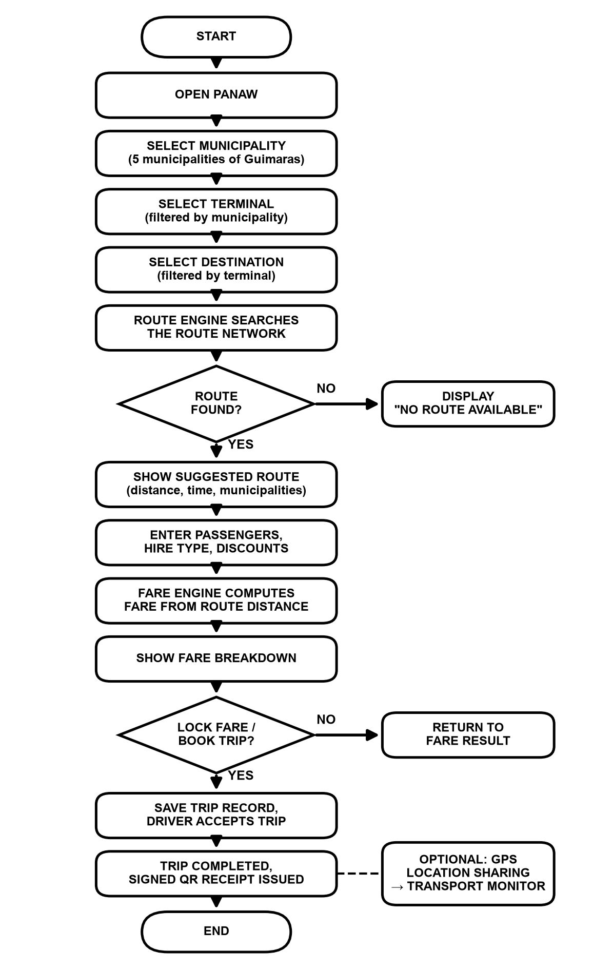
Gathering and Preparing the Route Network Data
Because no official digital map of tricycle routes in Guimaras was available, the researchers built the route network from three kinds of data, and every record was labelled with its source. First, the New Poblacion TODA Terminal and its eight original destinations were carried over from the TRIKEFAIR prototype, whose distances had been estimated as the straight-line distance between surveyed coordinates multiplied by a road factor. Second, the names and center coordinates of the five municipalities were taken from PhilAtlas. Third, the road segments connecting the municipalities were estimated using the same method, the straight-line distance between stored points multiplied by a road factor of 1.3, and travel times were estimated using an assumed average speed of 20 kilometers per hour. Segments and terminals in the third group were marked as demonstration (DEMO) data both in the data files and on screen. Places without verified coordinates were marked "Coordinates required" and given no route rather than an invented location. Fares at terminals other than New Poblacion used the same rate structure, labelled DEMO / SAMPLE RATE, because no fare ordinance for those terminals was on file.
Setting Up the Development Environment
The development environment was prepared around the existing web application. Node.js was installed to run the server and the tests, and a separate Android packaging project was created beside the web application so that the web application's own files did not need to change. The steps included installing Node.js, installing the Capacitor packages (@capacitor/core, @capacitor/cli, and @capacitor/android) through the Node Package Manager (npm), generating the Android project with Capacitor, and installing JDK 21 and the Android SDK for compiling. Build scripts were then added so that a single command, npm run apk, copies the web application into the Android project, synchronizes it, and produces the APK.
Figure 2
Dependency and Build Setup
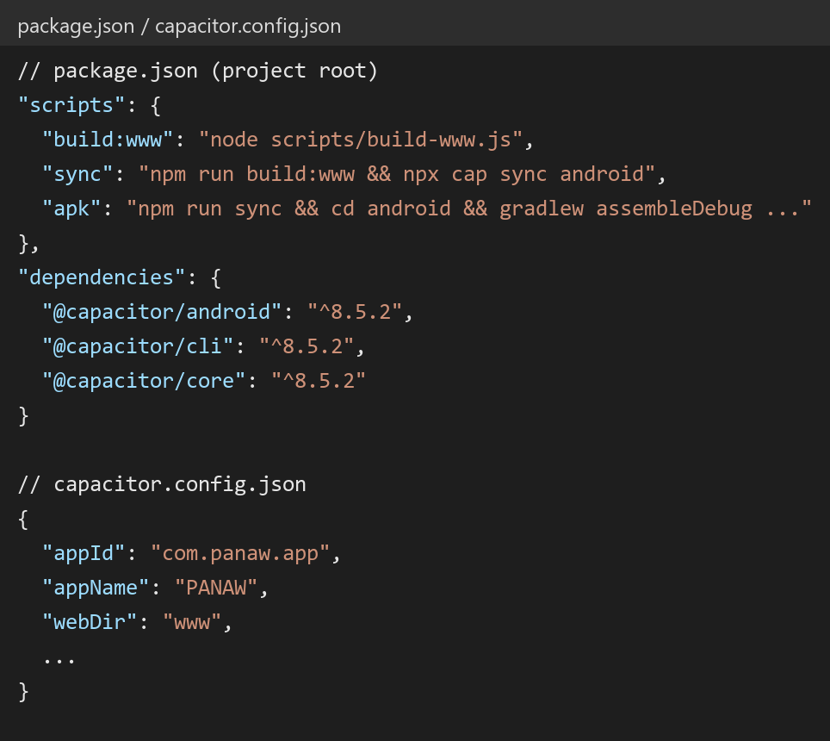
Note. This setup installs Capacitor and defines the commands that copy the web application into the Android project and build the installable APK.
Creating the Android Manifest
The AndroidManifest.xml file defines the permissions of the application and its main activity. Only three permissions were declared: internet access, and coarse and fine location for the GPS feature. Following a privacy-first approach, no permission for contacts, SMS, camera, microphone, or storage was requested, and the location permission is requested only when the user turns GPS on, never when the application opens.
Figure 3
Manifest Configuration
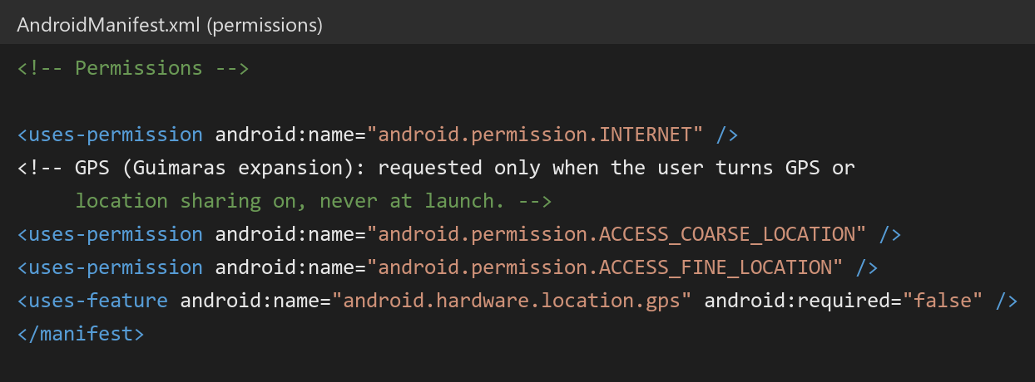
Note. This manifest declares only the permissions that the GPS and network features need. The GPS hardware is marked as optional so that the application can still be installed on devices without it.
Developing the User Interface
The user interface kept the colors, fonts, and layout of the original prototype so that PANAW would feel like an evolution of TRIKEFAIR rather than a new application. The home screen was reorganized into an Origin card with two drop-down menus, Municipality and Terminal, followed by a Destination menu. Each terminal displays labels that tell the user where its data came from, such as PROJECT DATA, DEMO TERMINAL, or DEMO / SAMPLE RATE. The layout was designed for phone screens first and also adjusts to laptop and desktop browsers.
Figure 4
Passenger Home Screen Showing Municipality and Terminal Selection
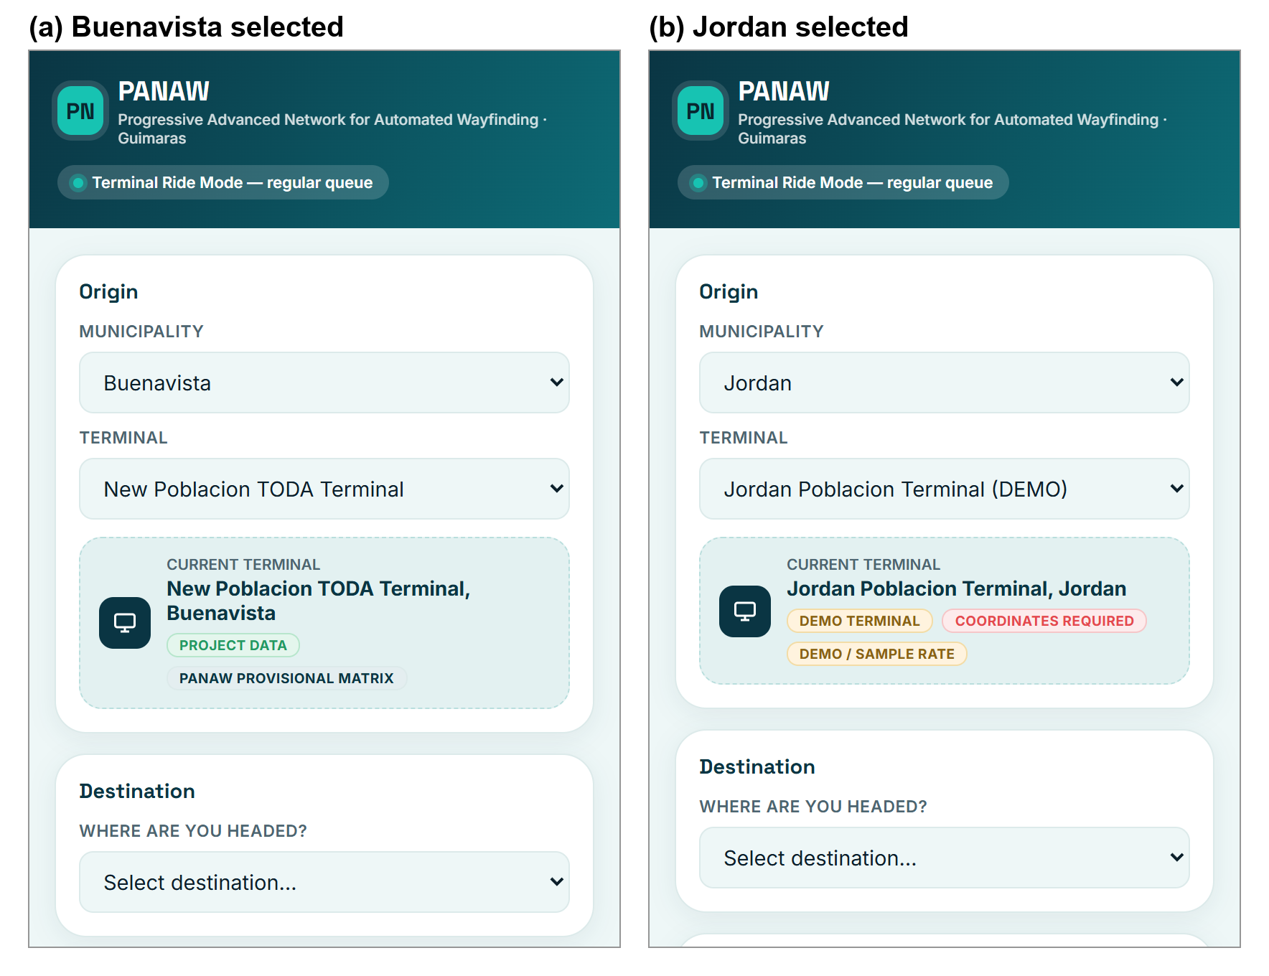
Note. When the municipality is changed from Buenavista (a) to Jordan (b), the terminal list and the destination list update immediately without reloading the page.
Developing the Municipality, Terminal, and Destination Selection
The selection controls were built as a hierarchy: municipality, then terminal, then destination. When a municipality is chosen, the application asks the route engine for the terminals in that municipality only. When a terminal is chosen, it lists only the destinations that the terminal serves. For each destination, the application checks in advance whether a route exists, so a destination without a configured route is shown as "no route available" instead of failing after it is selected.
Figure 5
Coding of Municipality, Terminal, and Destination Filtering
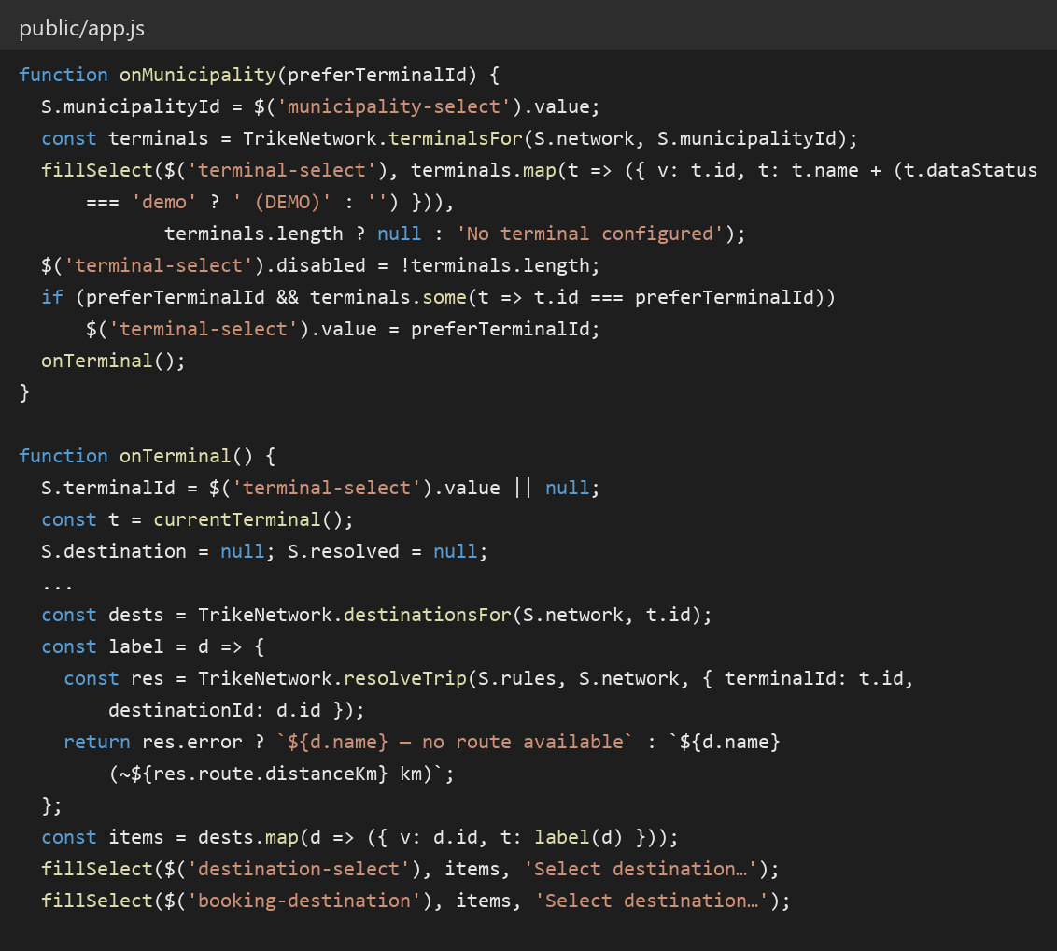
Note. This code fills the terminal and destination menus from the data files, so an administrator can add a terminal by editing data without changing the program code.
Building the Data and Model Layers
After establishing the user interface, the next stage involved developing the data layer. Instead of keeping terminals and destinations inside the program code, all transport data were placed in separate JSON files: municipalities.json, terminals.json, destinations.json, routes.json, fare_rules.json, demo_vehicles.json, and transport_modes.json. Each terminal record stores its identifier, name, municipality, coordinates, type, assigned fare rule, data status, and the destinations it serves. The final dataset covered 5 municipalities, 6 terminals, 15 destinations, and 14 road segments.
The route network in routes.json was stored as a graph made of nodes, which represent terminals, municipal centers, and destinations, and edges, which represent road segments. Each edge stores its two endpoints, distance, estimated travel time, route type, allowed transport modes, availability, and data status. The original rules.json file of TRIKEFAIR was left unchanged. A validation step checks the data each time it is loaded for duplicate identifiers, invalid municipalities, negative distances, invalid coordinates, segments that point to places that do not exist, and missing fare rules. An invalid record is skipped and reported, while the rest of the network continues to work.
Figure 6
Terminal Record (terminals.json)
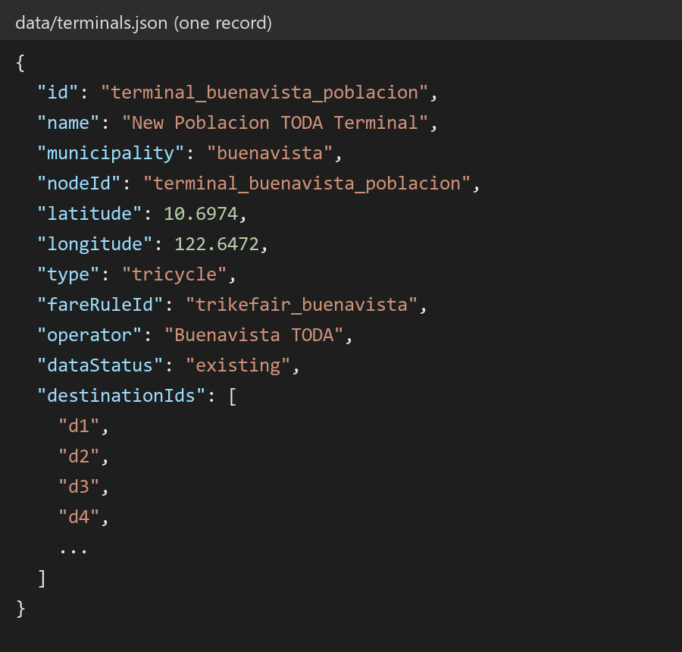
Figure 7
Route Settings and Road Segment Record (routes.json)
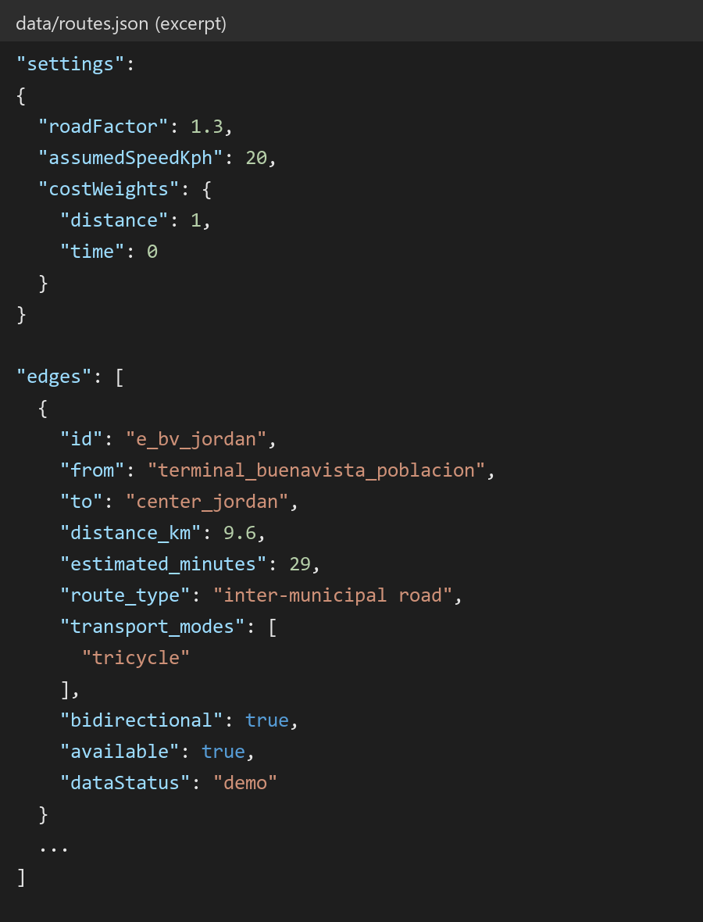
Note. The tricycle is the only active transport mode. Jeepney and multicab are listed in transport_modes.json as future modes with no route or fare data, so none were invented for them.
Integrating the Route Optimization Engine
The route engine was written as a single JavaScript module, network.js, that is shared by the server, the passenger application, and the Android application, so that all three always compute the same route. To find a route, the engine uses Dijkstra's shortest-path algorithm, a standard method for finding the lowest-cost path through a network. The engine first collects only the segments that are currently available and allowed for tricycles, then repeatedly visits the nearest unvisited place until it reaches the destination. The cost of each segment is computed as distance × distance weight + travel time × time weight. These weights are stored in routes.json and were set to distance only for this study. When a route crosses municipal boundaries, the engine also lists the municipalities passed through, for example Buenavista, Jordan, and Nueva Valencia. If no available path exists, the application displays "NO ROUTE AVAILABLE" instead of inventing one. The route is optimized against the stored route data only; no live traffic data is used, and the application states this on screen.
Figure 8
Coding of the Route Search (Dijkstra's Algorithm)
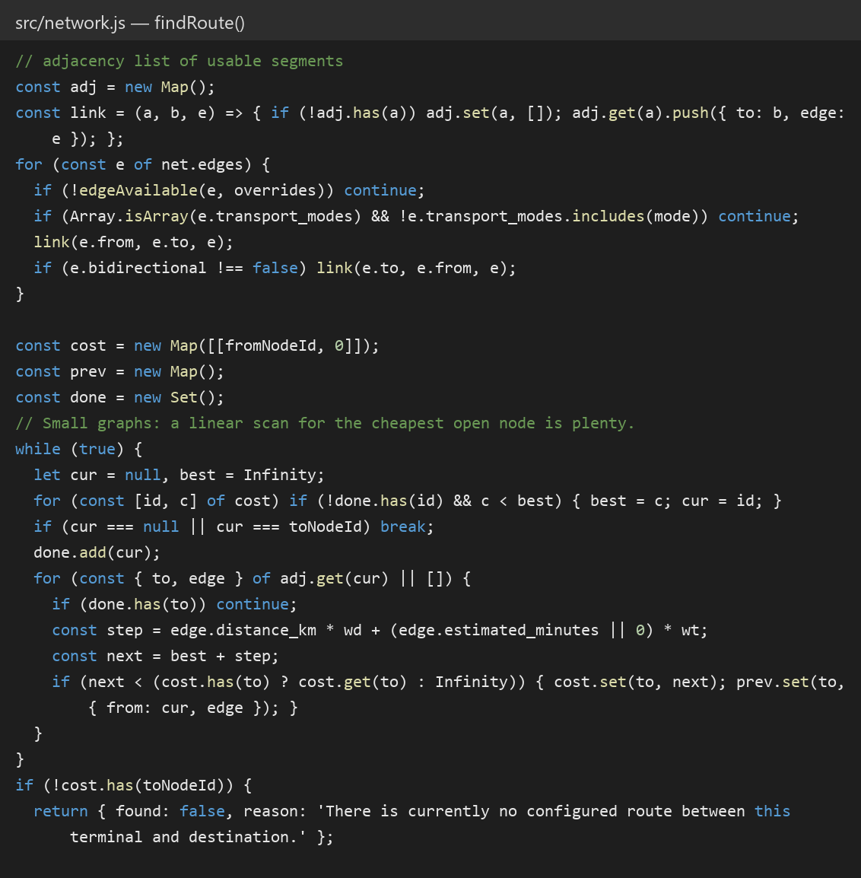
Note. Closed segments are skipped when the network is built, so closing a road segment from the monitor makes every new search take the next-best path.
Figure 9
Suggested Route for a Cross-Municipality Trip
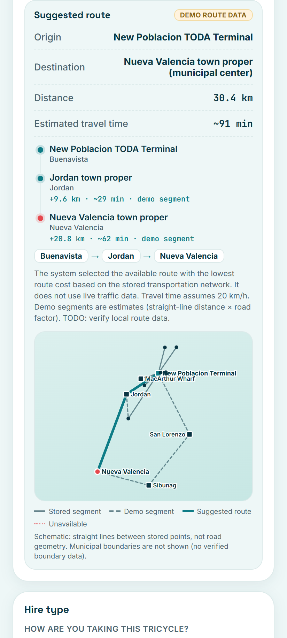
Note. The route from the New Poblacion TODA Terminal to Nueva Valencia passes through Jordan. The route is shown separately from the fare and is labelled as demonstration route data.
Connecting the Route Engine to the Fare Engine
The fare engine of the original prototype, fare.js, was not modified. The route engine passes only the computed distance to it, together with the number of passengers, the hire type, and the discount claims entered by the user. The fare engine then applies the base fare for the first kilometers, adds the per-kilometer rate for the remaining distance, applies a night surcharge only if one is authorized in the fare rules, and deducts the 20 percent discount from the share of each qualified passenger. The result screen shows the route information and the fare breakdown in separate sections so that the passenger can see exactly how the fare was produced.
Figure 10
Coding of the Fare Computation (fare.js)
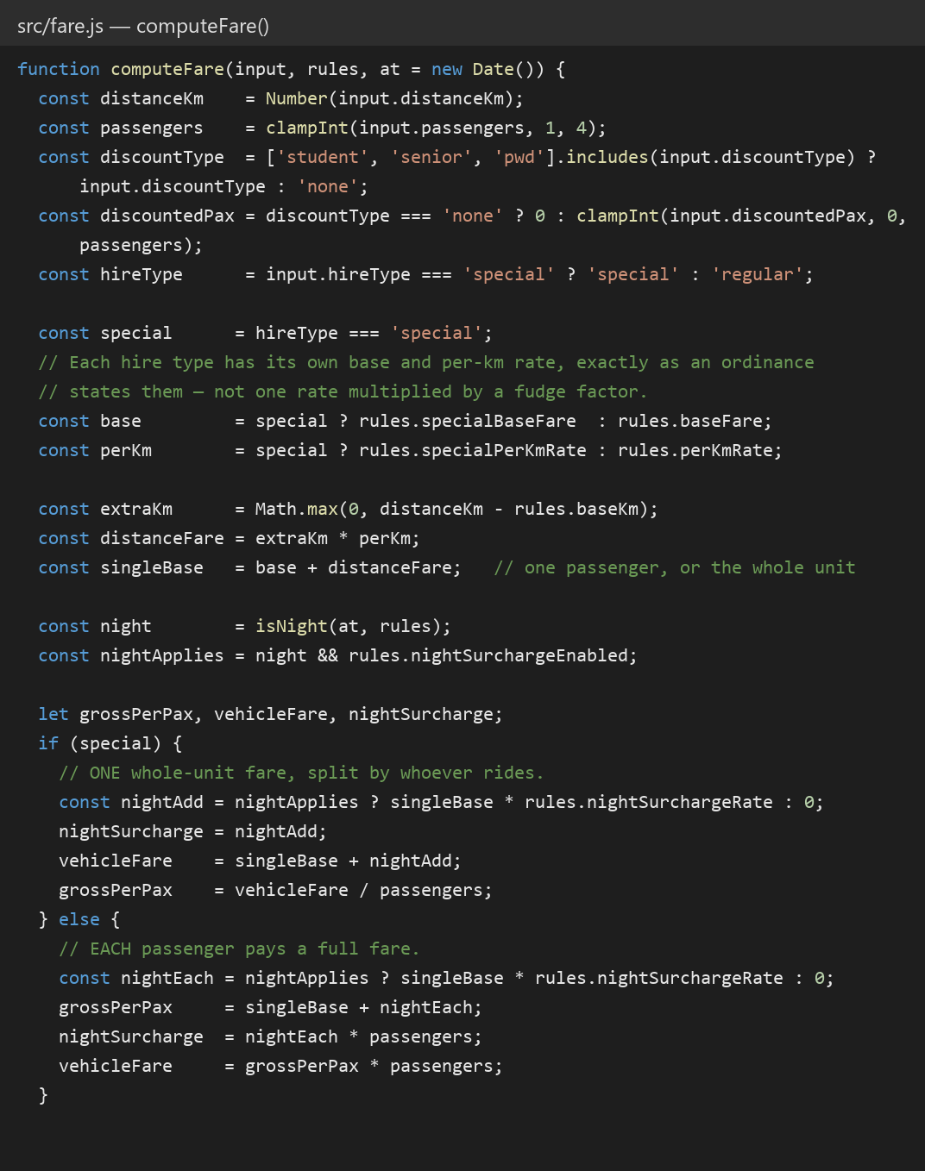
Note. The server computes the fare again when a trip is locked, so a fare amount sent from a phone is never accepted.
Figure 11
Fare Result Showing Route Information and Fare Breakdown
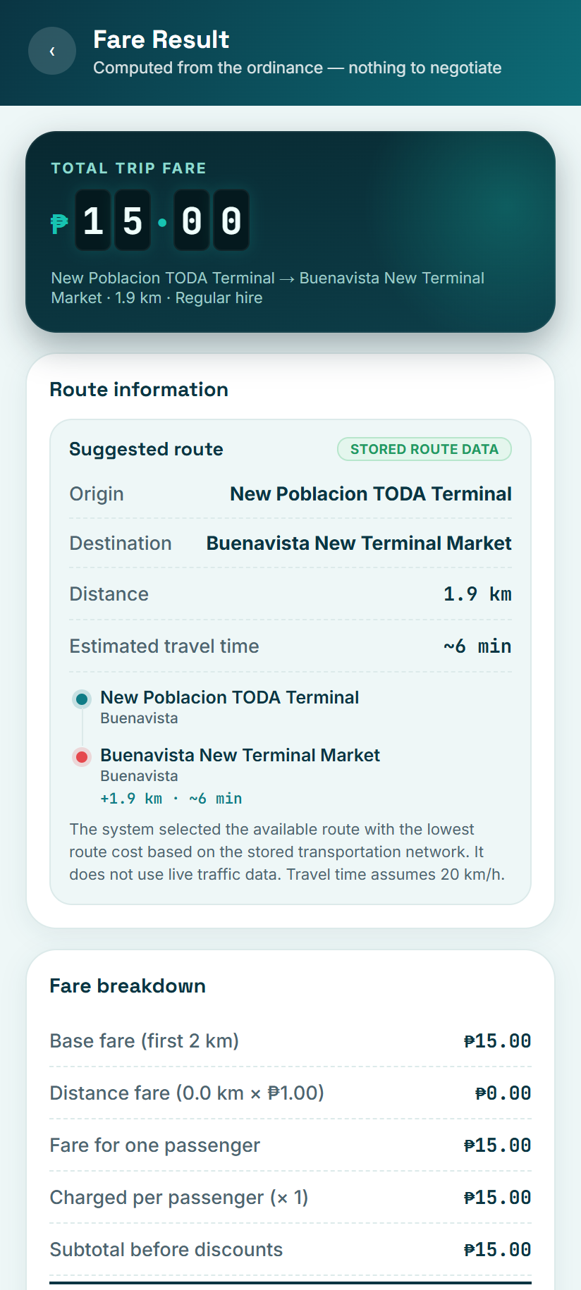
Implementing GPS and Location Tracking
GPS was added in two places. In the passenger application, the user can turn on GPS to see their current position on the route map. Before the phone asks for permission, the application explains why location access is needed, and the position stays on the device. In the driver console, a driver can share the location of the vehicle, which is sent to the server every five seconds together with the unit number and the time, or use a clearly labelled simulated position for demonstrations. If GPS is unavailable or permission is denied, the application displays "GPS UNAVAILABLE" and fare calculation and route selection continue to work.
Figure 12
Coding of Device GPS (startGps)
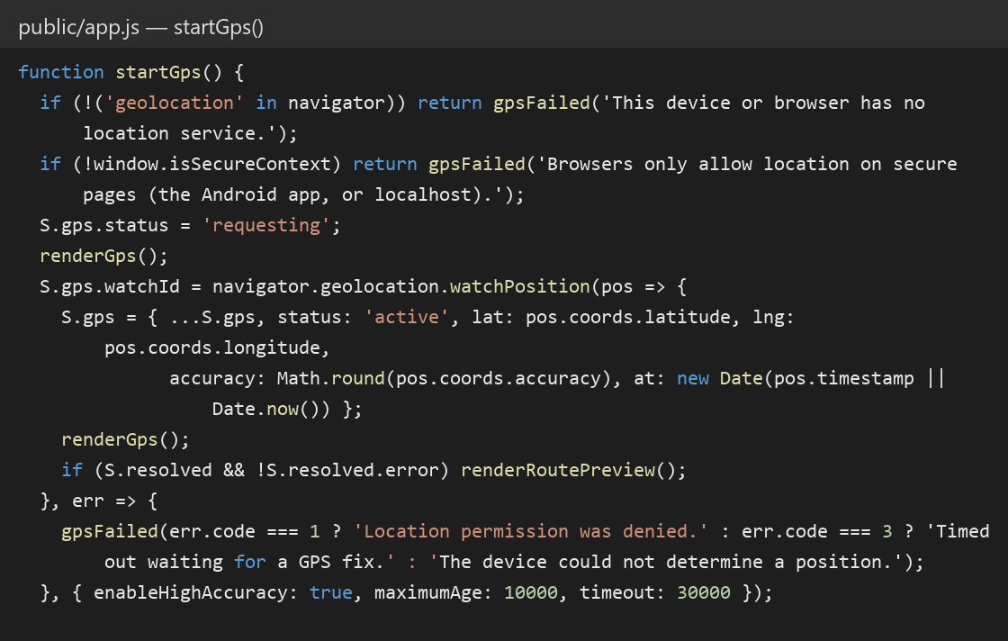
Figure 13
Driver Console with Location Sharing
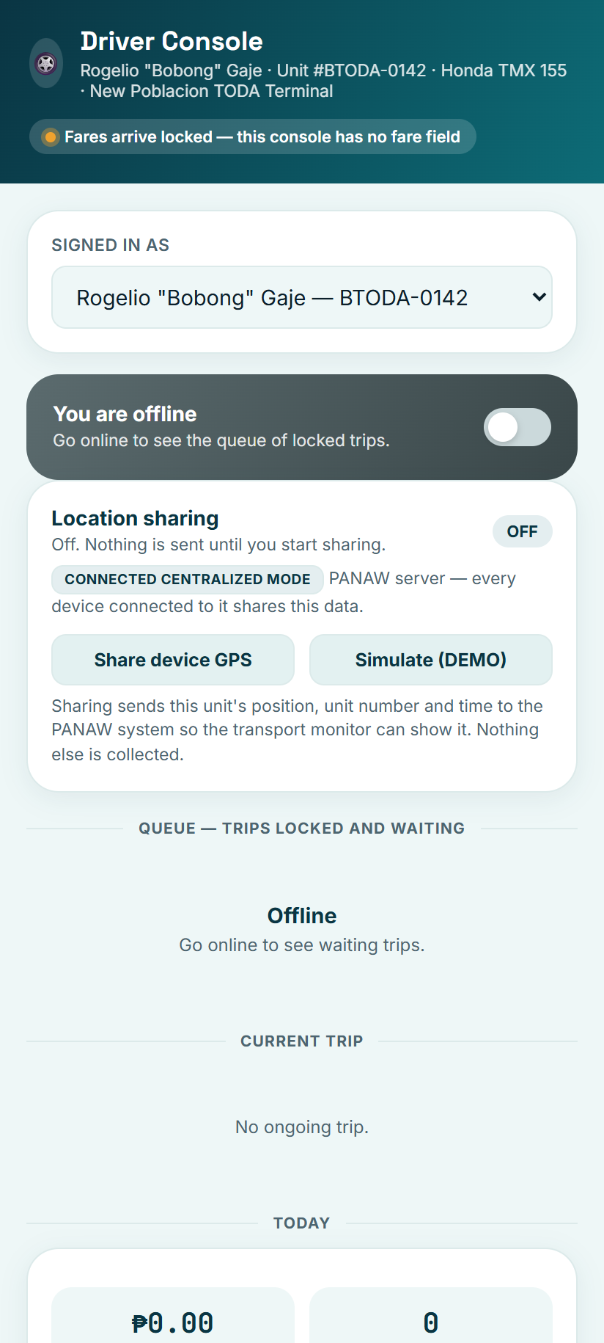
Note. Location sharing is OFF until the driver turns it on, and the screen states exactly what data is sent.
Building the Transport Monitor
A separate monitoring page was built for administrators so that the passenger never interacts with administrative controls. The monitor displays the data mode, the backend mode, the network coverage, the results of the data check, the number of vehicles per municipality, the list of vehicles with their last known positions, a schematic network map, and the trip records. Administrators can close or reopen a road segment, after which all new route searches avoid it. Demonstration vehicles are labelled DEMO VEHICLE and are never counted as real vehicles. The monitor also states which mode it is running in: CONNECTED CENTRALIZED MODE when it runs on the PANAW server and is shared by all devices on the same network, or LOCAL DEMO MODE when the APK runs alone and the data stays on the phone.
Figure 14
Guimaras Transport Monitor
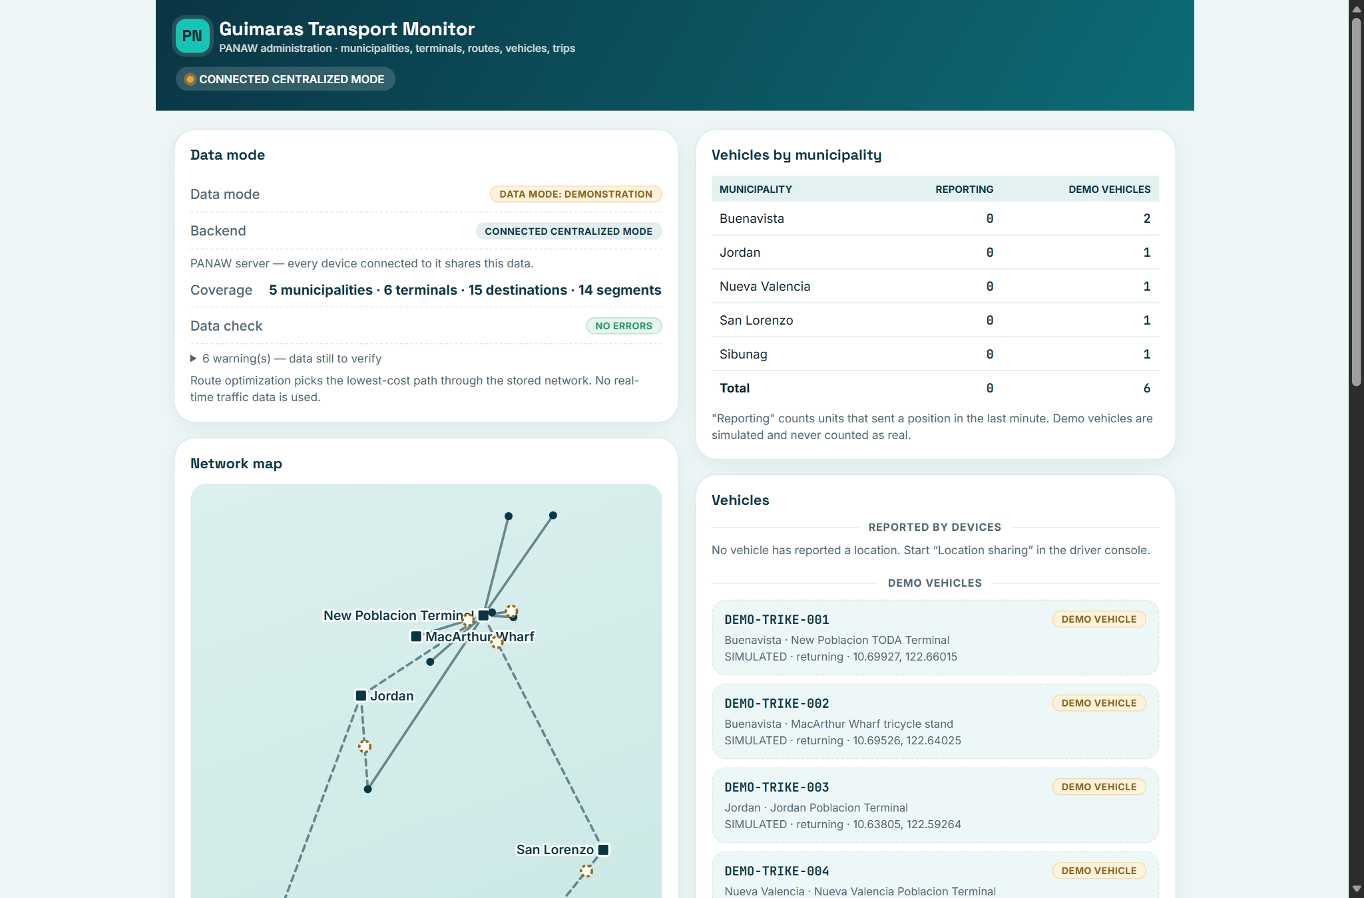
Packaging the Android Application
To run without a server, the APK includes an embedded backend. The same fare, trip, and route modules used by the server run inside the application, and a small layer answers the requests of the application on the phone itself, storing the data in the local storage of the phone. This allowed fare calculation, route selection, and trip records to work fully offline. The network map is drawn by the application itself rather than loaded from online map tiles, so it also works without an internet connection.
Figure 15
Coding of the Embedded Backend
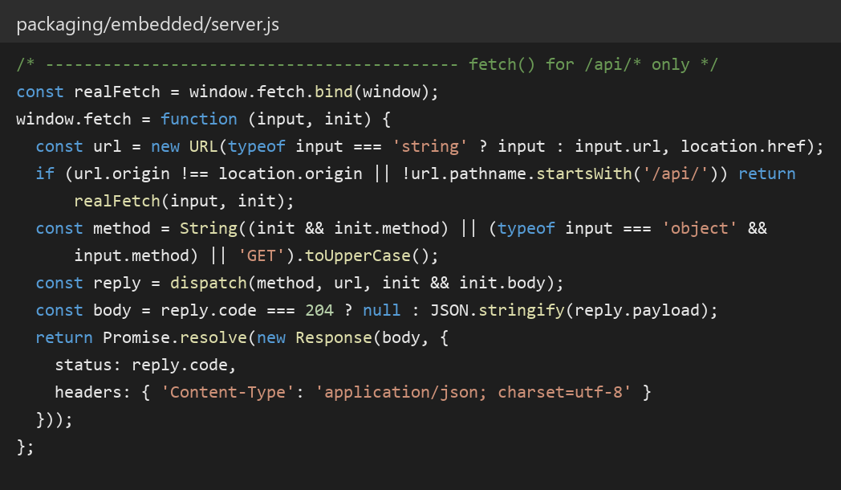
Note. Requests to the PANAW server (/api/...) are answered inside the phone, while all other requests pass through normally.
Testing and Debugging
After development, the application underwent a series of tests to ensure accuracy and reliability. An automated test suite was written and run with the command npm test. It contains 46 tests in four areas: fare regression, route engine, data validation, and the server interface. Before the expansion, 2,944 fare cases were computed with the original fare engine and saved as reference values. After the expansion, the same inputs produced identical fares, both with and without terminal selection, which confirmed that the original fare system was preserved. The route engine tests covered a direct route, a route through an intermediate place, a cross-municipality route, the choice between two paths around the island, a closed segment, no available route, an invalid destination, and a disconnected network. The Android emulator and the developer tools of the Microsoft Edge browser were used to find runtime errors and to check the layout on phone and desktop screen sizes.
Figure 16
Automated Test Results
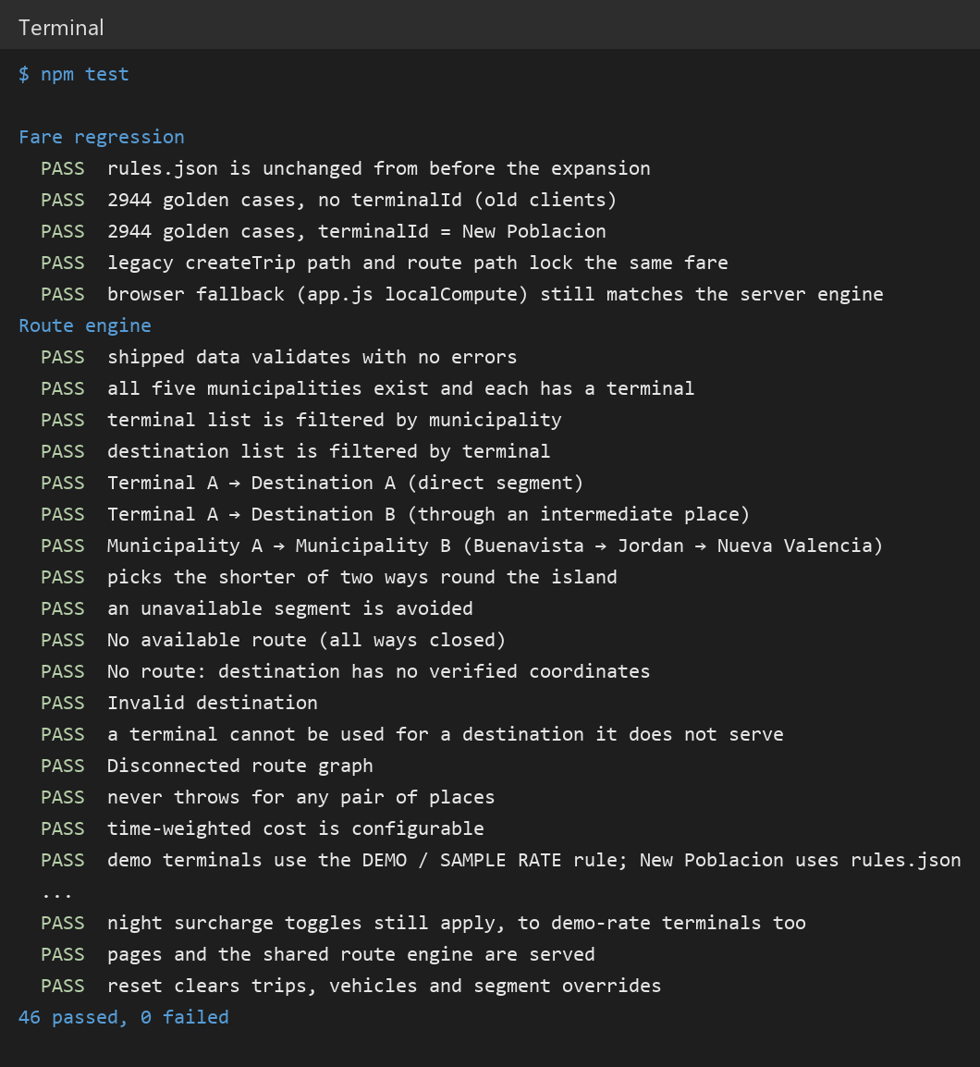
Note. All 46 tests passed, including the 2,944 fare regression cases.
Finalization and Optimization
In the final stage, the researchers refined the application before deployment. The fonts used by the interface were bundled inside the application so that it displays correctly offline, and the launcher icon was generated from the PANAW brand mark. The labels across all screens were reviewed so that no demonstration data would be presented as official data. An installable APK was generated and tested on the emulator. Backup copies of the source code and the final APK were stored in a compressed archive. After verification, PANAW was ready for pilot testing at [venue of pilot testing], marking the completion of the system development phase.
System Testing
After development, the application underwent several testing stages to ensure system stability and data protection. Functional testing was performed to verify that each module, namely municipality selection, terminal selection, destination filtering, route search, fare computation, trip locking, GPS, and the monitor, operated as intended. Integration testing was conducted to check that the route engine, the fare engine, the server, and the embedded backend worked together without error. Usability testing was carried out by allowing selected users to test the interface and give feedback on navigation and overall experience. Finally, security testing was conducted to confirm that the fare cannot be changed after it is locked, that an edited receipt link fails verification, and that location data is collected only after the user turns it on.
Pilot Testing Procedure
Before conducting the pilot testing, the researchers prepared the necessary materials, including Android phones with PANAW installed, a laptop running the PANAW server, and observation forms. Coordination was made with [name of office or organization, e.g., the New Poblacion TODA and the Municipal Government of Buenavista] to secure permission and schedule the testing. Selected participants, including passengers, tricycle drivers, and [terminal staff or other participants], were briefed about the purpose and process of the pilot test. During the testing, each passenger was instructed to use PANAW to select a municipality, terminal, and destination, view the suggested route, compute and lock a fare, while each driver accepted the trip and turned on location sharing. The researchers observed the interactions and recorded issues such as slow responses, errors, or interface difficulties using checklists. After the simulation, a short interview and survey were conducted to gather the opinions of participants on usability, accuracy of route and fare information, fare transparency, and willingness to use the system. All collected data were then analyzed to evaluate the effectiveness of the system and to identify areas that required improvement.
Figure 17
Conducting the Pilot Testing
[Insert photo of the pilot testing here]
Statistical Data Analysis Procedure
All data gathered from the pilot test participants and user surveys were organized, tabulated, and analyzed using the Statistical Package for the Social Sciences (SPSS) software. Responses were collected using a five-point Likert scale. Descriptive statistics including frequency, percentage, mean, and standard deviation were used to describe the demographic profiles of the respondents and to evaluate their perceptions of PANAW in terms of usability, accuracy of route and fare information, and fare transparency. To test for significant differences in user responses when grouped by age, sex, occupation, or frequency of tricycle travel, non-parametric tests such as the Mann–Whitney U test and the Kruskal–Wallis test were applied at a 0.05 level of significance. These analyses provided quantitative evidence of the effectiveness and user acceptance of the system.
Steps Using the PANAW Mobile Application
To use PANAW, a passenger opens the application on an Android phone and selects the municipality and the terminal where the trip begins. The passenger then selects the destination, and the application shows the suggested route with its distance, estimated travel time, and the municipalities passed through. Next, the passenger enters the number of passengers, the hire type, and any discount, and taps Calculate fare to see the full fare breakdown. The passenger may then lock the fare and request the trip, which is sent to the driver console at the same amount. When the trip is completed, a receipt with a QR code is issued that anyone can scan to verify the fare. All trip records are saved by the system for record keeping and transparency.
Figure 18
Step-by-Step Flow on How to Use the Application
