1. Teritipli list doretmek ucin haysy teg ulanylyar
2. Tertipsiz list doretmek ucin haysy teg ulanylyar
3. Link doretmek ucin haysy teg ulanylyar
4. HTML
5. CSS
6. Js
7. HTML-de Table name ucin gerek
8. Table de taze setir doretmek ucin haysy teg ulanylyar
9. HTML comment
10. CSS comment
11. Js comment
12. Tekstin renkini nadip uytgetmeli CSS – de
13. Tekstin ululygyny nadip uytgetmeli CSS – de
14. Tekstin arka renkini nadip uytgetmeli CSS – de
15. 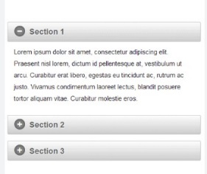Bootstrap name
16. 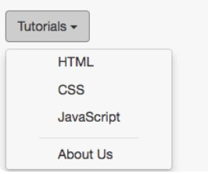Yokardaky suratyn ady name
17. Yokardaky suratyn ady name
18. Arka tarapyny sary edmek ucin haysy class ulanylyar Bootstrapda
19. Yokardaky suratyn classy name Bootstrapda
20. JavaScript-da elementi id-sy boýunça nädip almaly?
21. JavaScript-da elementi class-y boýunça nädip almaly?
22. JavaScript-da elementi teg-y boýunça nädip almaly?
23. Hemme teglerini nadip almaly?
24. Onclick ulanman “addEventListener” ulanyp nahili yazyp bolar