**Answers to questions b**

b) I visualized the count of all the markets in Agra . Following is the plot obtained .

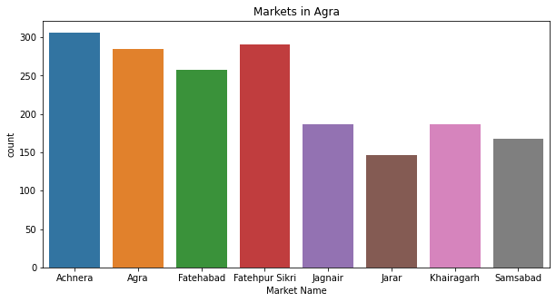

As we observe from the plot , Achnera , Agra ,Fatehabad and Fatehpur Sikri mainly dominate the markets in Agra . Now I will observe the price patterns.

**Visualization of Min Max and Modal Prices of the 4 main markets**

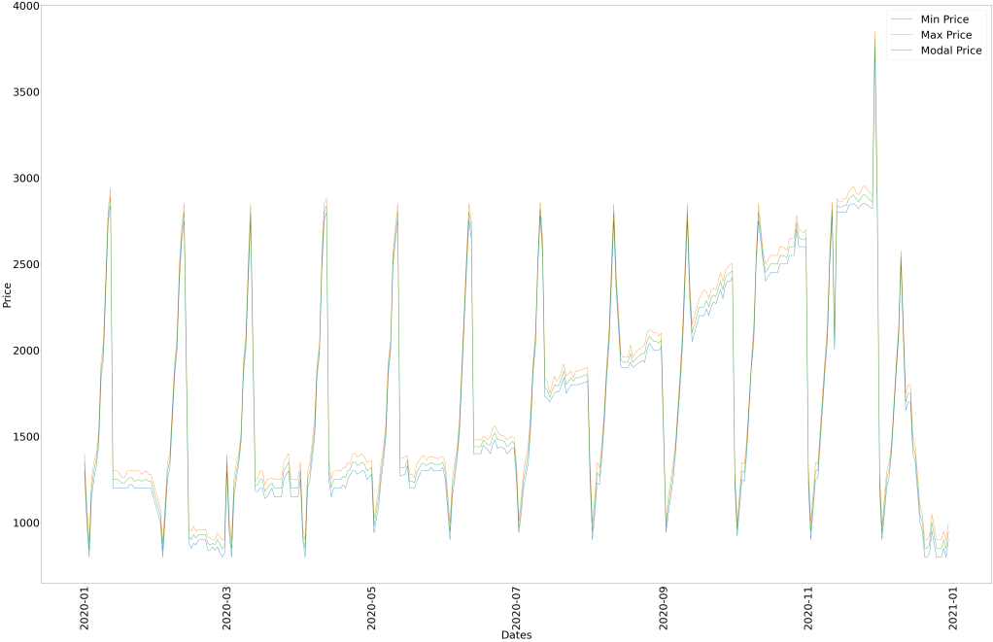

Achnera Market

* Min , max and modal prices are gradually increasing from the start of the year to the end.
* There are spikes in the prices in the beginning of each month till mid year.
* The spikes are as high as 4000
* From mid year till the end , there are sudden drops in the prices in the beginning each month.
* The drops are as low as 1000.

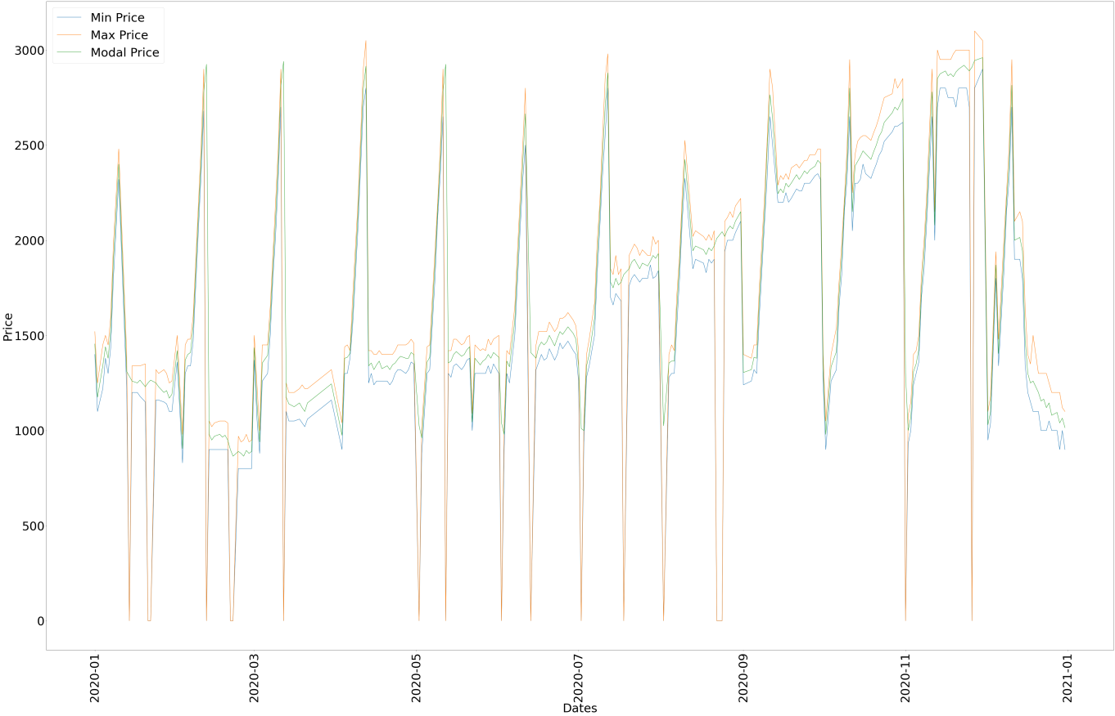

Fatehpur Sikri Market

* Here the prices ranges from 1500 to 3000 over the year.
* However during the start of the month , there is a sudden increase in the price followed by a drop .
* When there is a drop , the max price falls to as low as 0 and when there is a spike the prices reach to as high as 3000.
* Towards the end the of the year , there are no more spikes but there are drops.

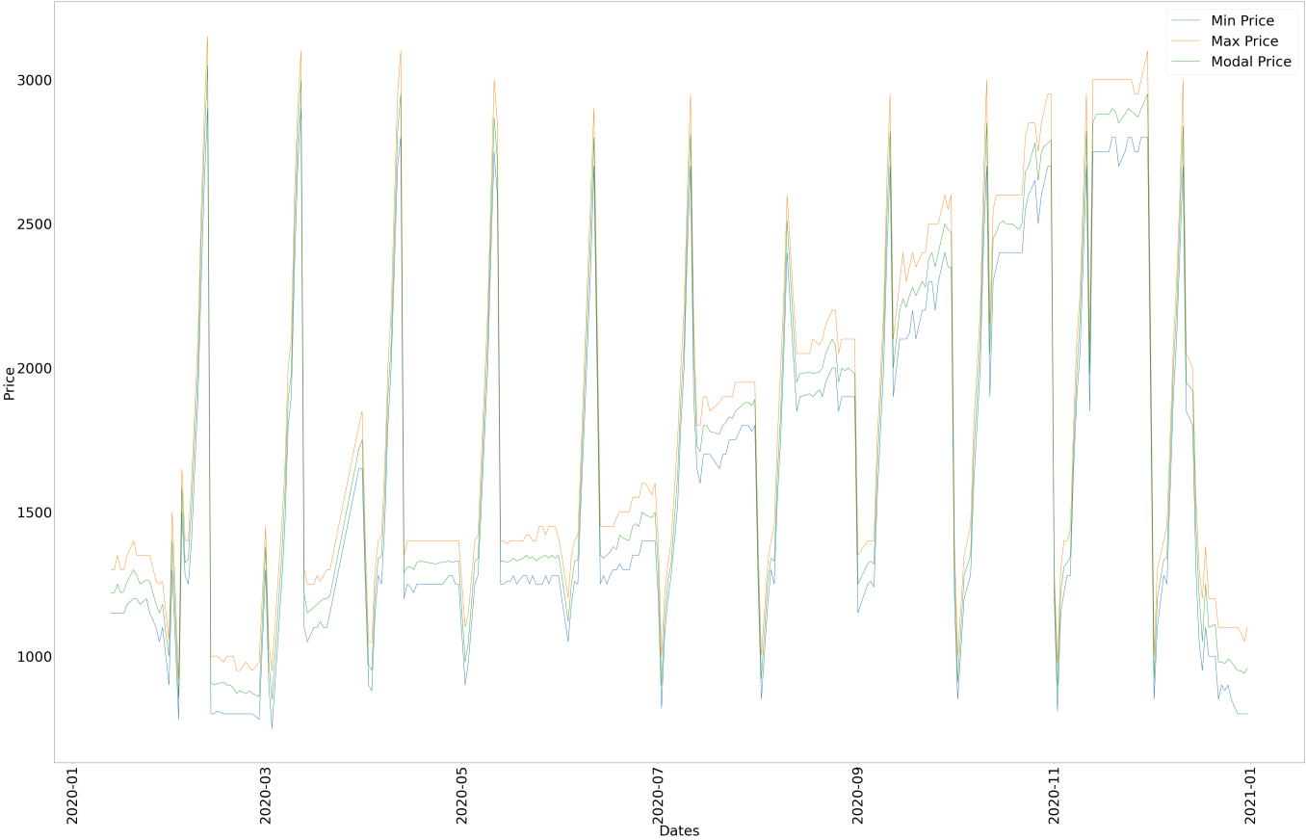

Agra Market

* Here the prices ranges from 1000 to 3000 over the year.
* During the start of each month , there is a sudden drop in the price followed by a spike .
* However here the drop is not as low as 0 but falls to 800 .The soike goes to as high as 3000
* Towards the beginning of the year , there is no drop and towards the end the of the year , there are no more spikes but there are drops.

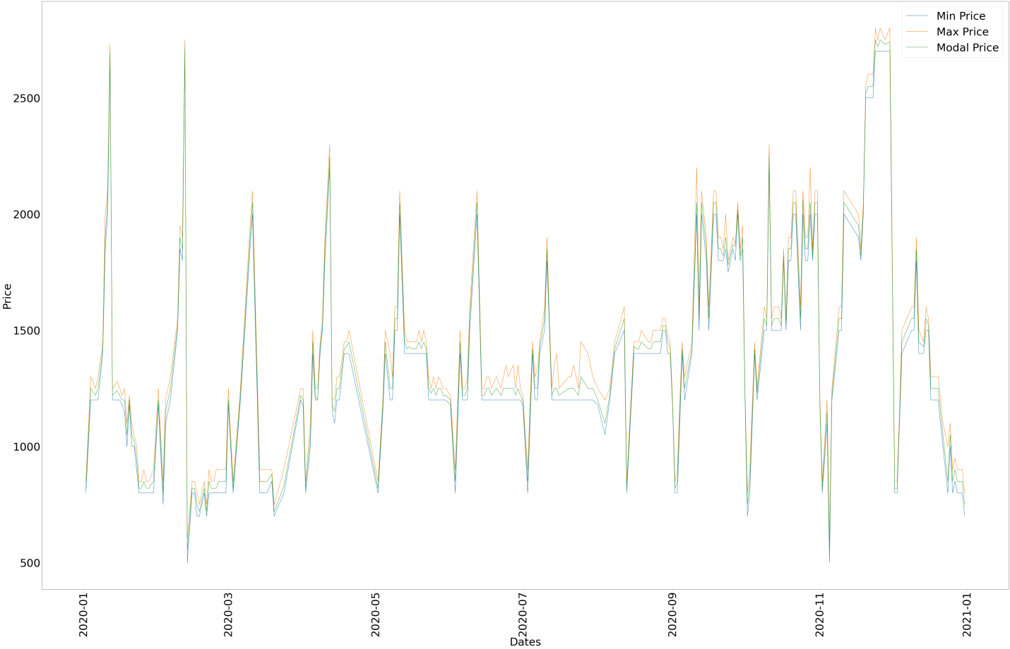

Fatehabad Market

* Mostly the price is between 1000 and 1500.
* There are some spikes at the beginning of each month .
* In some cases there is a small drop followed by a spike in the beginning of the months . However the drops are of range 400-500.
* The spikes are pretty sharp in some cases going to 2500.

So , overall I can conclude that the prices range from 1000 to 3000 . There is also a gradual increase in the prices over the year . Also there are spikes and drops in prices at the beginning of each month.

**VISUALIZATION OF MIN MAX AND MODAL PRICES OF THE 4 MAIN MARKETS BASED ON VARIETY**

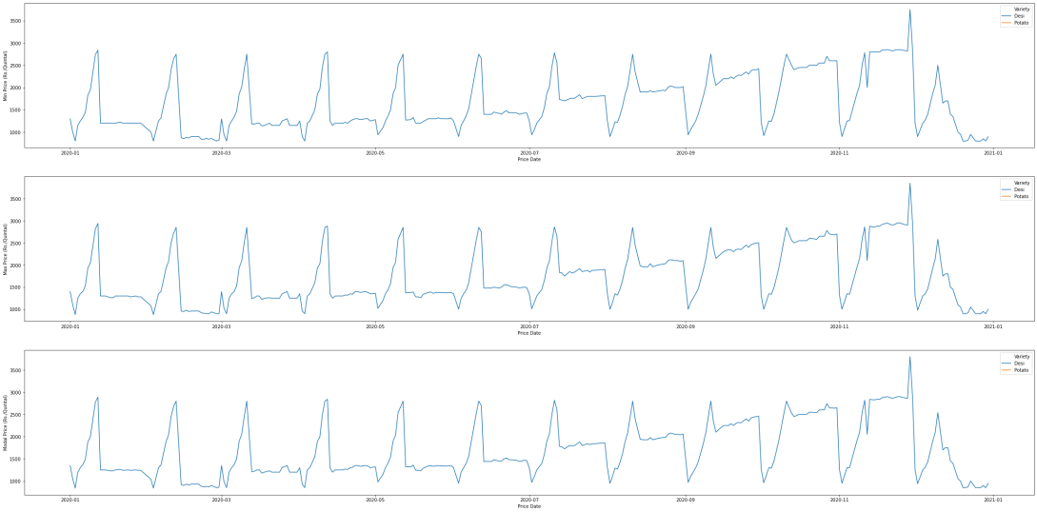

**Achnera Market**

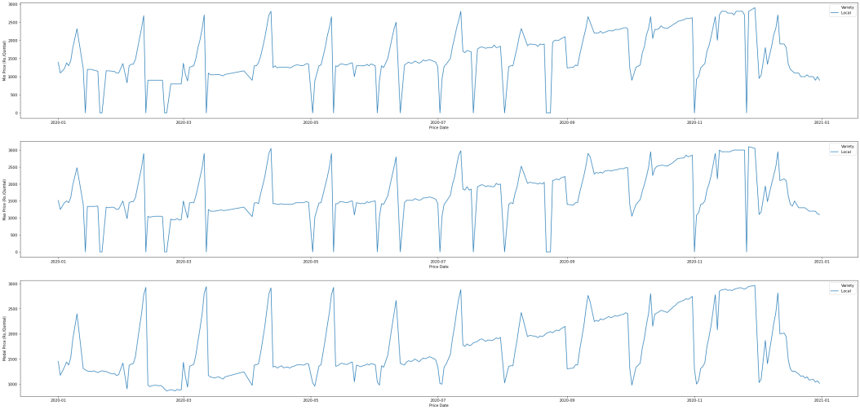

**Fatehpur Sikri Market**

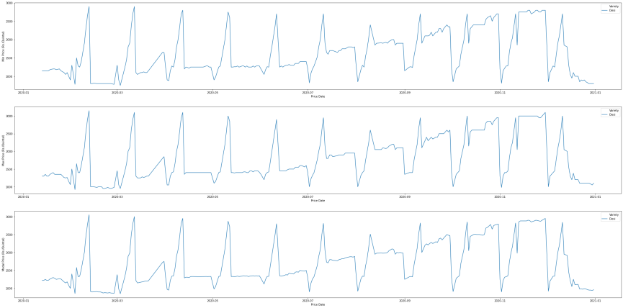

**Agra Market**

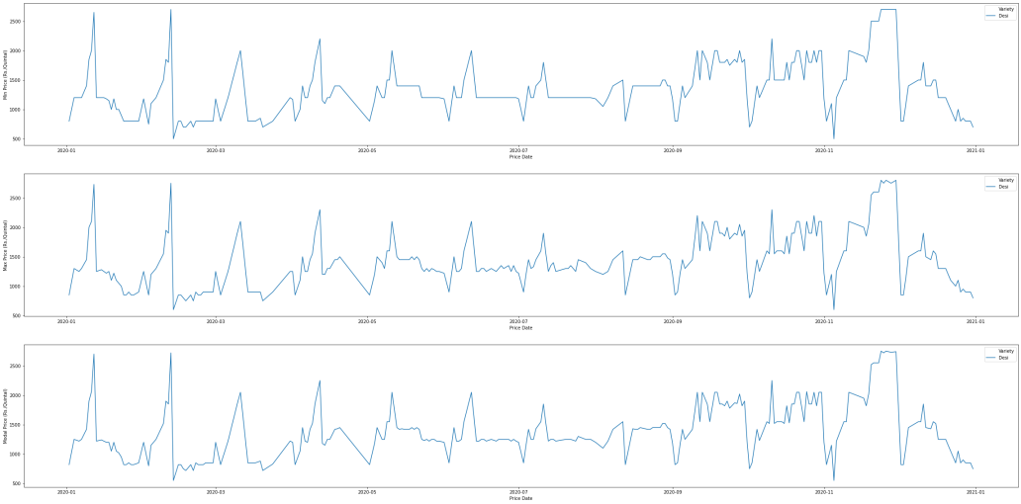

**Fatehabad Market**

In all of the plots I observe that there is no difference in pattern based on Variety as each place sell only one type of variety except Achnera although I think that's an error in the data.

**VISUALIZATION OF MONTHLY VARIATION OF PRICES**

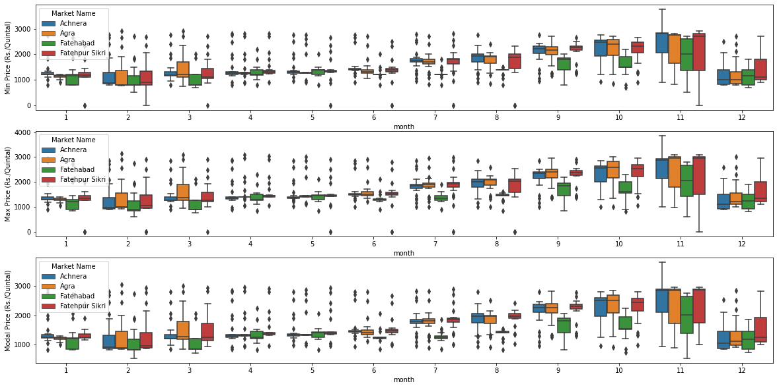

* There is a gradual increase in prices from January till November and there is a drop in December.
* Interquartile Range (IQR )also varies over the months.
* Thus I can suggest that months play an important role in determining prices of the commodity.

**VISUALIZATION OF WEEKLY VARIATION OF PRICES FOR EACH MONTH**

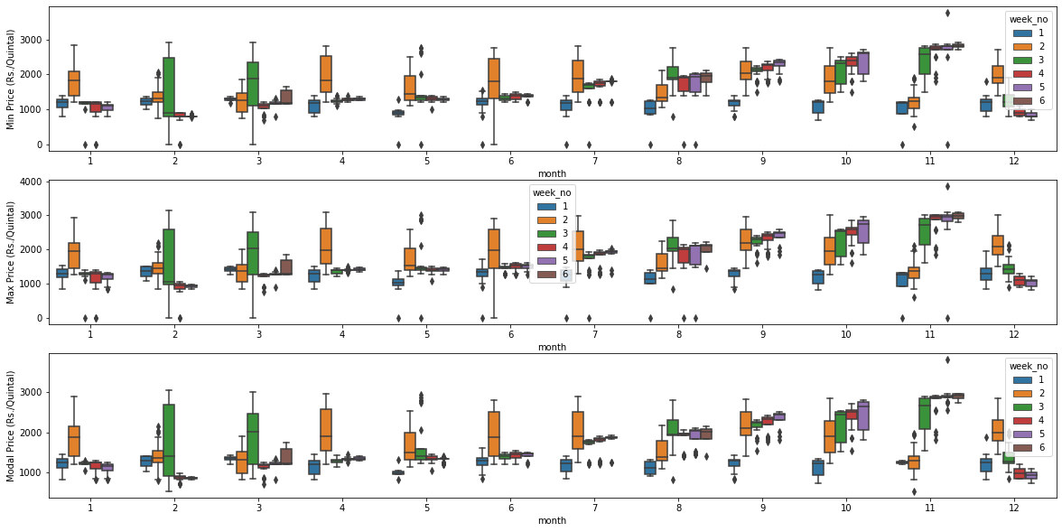

* IQR is mainly high for 2nd and 3rd week of each month which indicates the spike in prices towards the beginning of each month.
* Also IQR for 4th and 5th weeks are significantly small indicating a fall.
* The above trend exists only in the first half of the year .
* In the second half , there is just gradual increase in prices over the weeks.