

AC monitoring IOT system

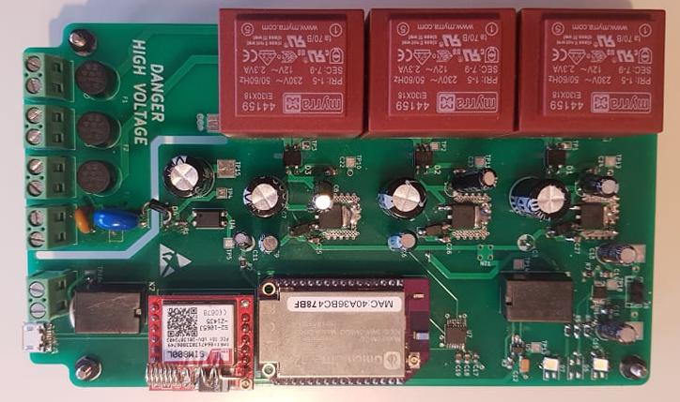

Verzion: | 1.0
Autor: | Ariyan Wasi (ariyan.wasi@sensa-group.net)
 | SENSA, 2020
Table of Contents
1 Hardware history 1
2 Project Principle 3
2.1 Workings 5
3 Visualisation Section 11
3.1 Front Part 13
4 Code and Setup 15
4.1 Setup 15
5 For next version 17

Hardware history

Ver | Rev | Date | Autor | Description
1 | 1 | 01.03.2020. | Ariyan Wasi | Initial version

Project Principle

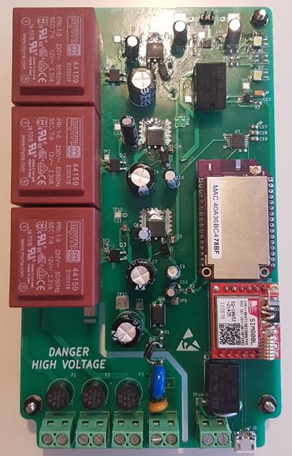

This system is made to monitor 3 phases of 220 volts and to then to report the data back via GSM or wifi.

In the event of a 1 phase faliure the system will report that back.

In the event of a 3 phase failure the system will short a connection where an alarm or some kind of signaling should be attached.

In the event of a total failure there is an input for a generator with adequte protection.

In the 3 phase failure status, the system will switch to battery power to power the IOT systems to be able to report the failure.

The system also has a micro usb connector for data transfer.

Workings

Each of the three phases has a fuse, the phase then goes into a transformer that steps the voltage down to around 12V (this most likely will be a bit higher in reality). The 12V then has semi adequate smoothing capacitors atteched. This signal then goes through a linear voltage regulator that takes the signal between 12 and 20 volts and gives a signal of 5V. This 5V signal has its own set of smoothing and decoupling capacitors. (WARN: This should be looked at, as the amount of decoupling seems enough to defirentiate the signals, when looking on the osciloskope however im not sure that the ADC can handle the difierence).

220 VAC
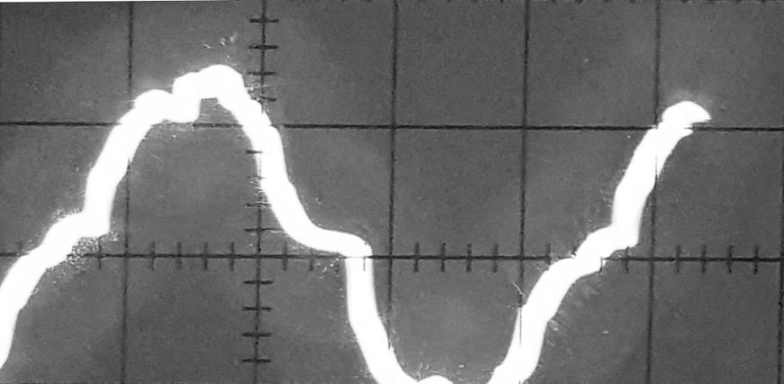

12 -> 20 VAC
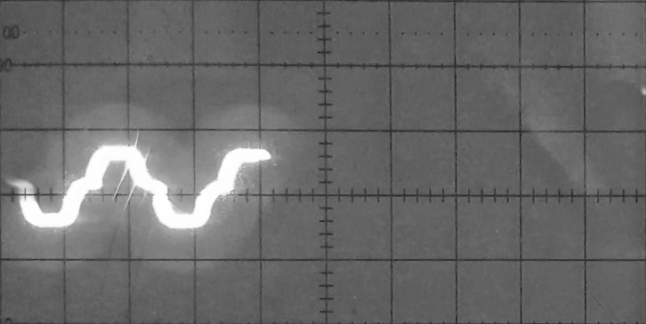

The 5V signal that went through the L7805 regulator is then used for a multitude of different things. It is firstly connected to the power managment relay. Each of the the three 5 volt signals are routed onto the ADC (MCP3004). In the event of the 3 phase not existing the voltage source will switch to the battery circuit. The signal that is chosen, battery or ac, will then be put into a 3.3 V regulator that will then power the IOT circuitry.

Base line (0V)

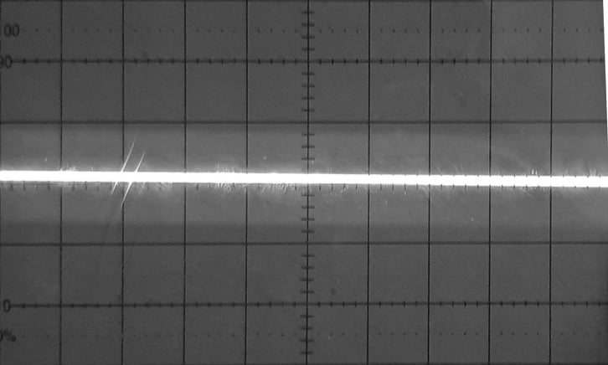

5 Volts DC

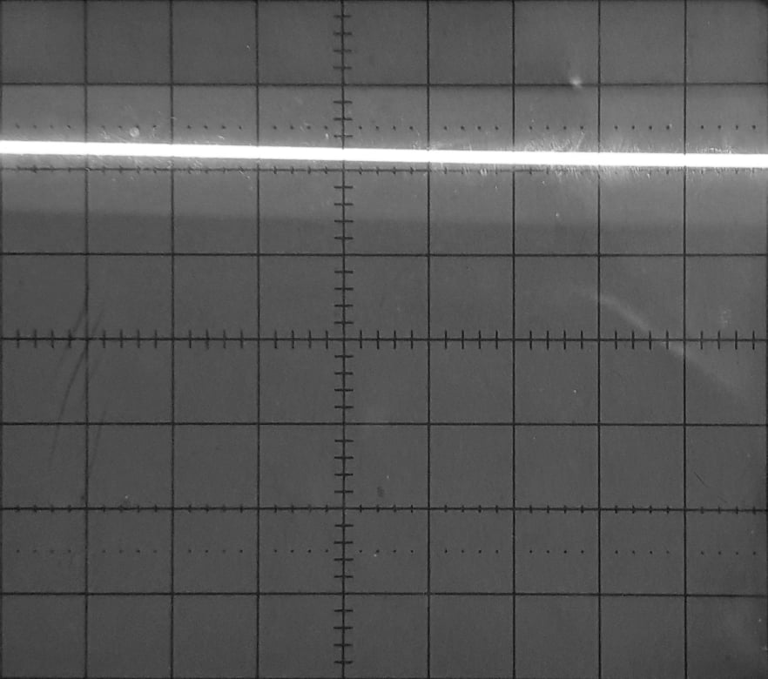

The generated 3.3 volt signal is either generated through the regulator (MIC5219-3.3YM5) with the AC sourced 5 volt signal or the battery 3.7 volt signal. In either case it generates 3.3 volts. This signal is then used to power the embedded single board computer (onion omega 2 plus) and the GSM module (SIM800L). The signal is also connected to the generator detection circuit via a passthough on the Onion Omega 2 plus.

3.3 Volts DC

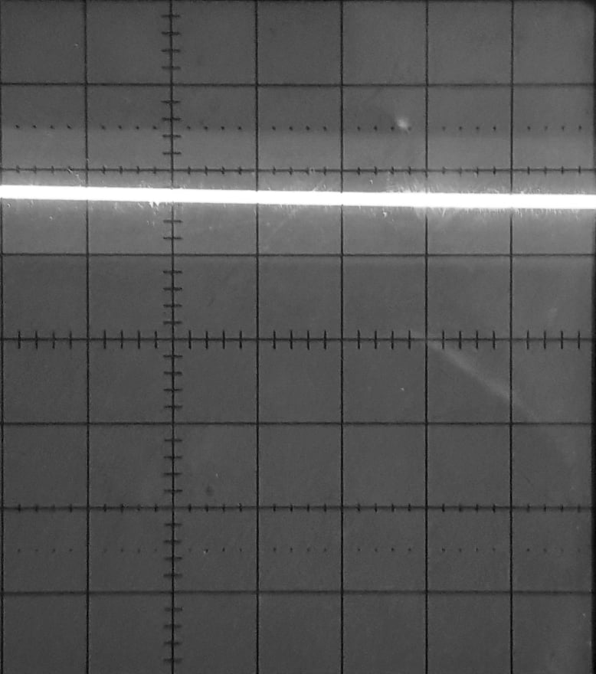

The system also enables a generator input, this input has a polyfuse and a varisitor attacted as its expected that the genrator will generate significant voltage spikes on power up. This generator voltage is then defaulted to the third AC volatge line to power everytthing and switch the main voltage from battery to AC generated. This voltage does also go through a detection voltage so that the SBC knows where or not its activated. This consists of a rectifier, resistor and optical coupler. that then turns a reference point that is routed to a digital input pin on the SBC. This input also has a smoothing capacitor.

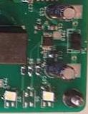
The battery is manegment is done via the MCP73833-AMI_UN ic. With adequate smoothing and decoupling capacitors, and a 3.7 volt charge indicator. Left side on the conector is ground.

The alarm signalization circuit shorts a lead via a relay in the event that there isnt a 3 phase voltage.
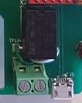

Visualisation Section

FRONT:

Front Part

On the front of the PCB we have:

- 3 Phase input
- 3 fuses
- Generator input with protection
- Alarm input with realy attached
- Three 220VAC -> 12VAC transformers
- 3 Rectifiers
- 3 diodes
- Stabilization capacitors
- 3 rectifiers
- More stabilization capacitors
- Power managment relay
- Stabilization capacitors
- Battery input
- Battery managment IC
- Stabilization caps
- Charge Indicators.
- ADC
- stabilization capacitors with tantal
- Onion Omega 2 Plus
- SIM800L
- Optocoupler
- Stabilization capacitor
- Rectifier

- The Whole BOM can be Found At:
https://github.com/kurdish-yoda/Ac-Monitoring-System/blob/master/Documentation/BOM.xls

Code and Setup
~ TO BE FINISHED BY SOME OTHER PARTY ~

Setup

Setup the omega acordingly: https://docs.onion.io/omega2-docs/first-time-setup.html

Attache the phases accordingly:

RIGHT --> Neutral (N)

LEFT (TRACE GOES INTO FUSE) --> Live (L)

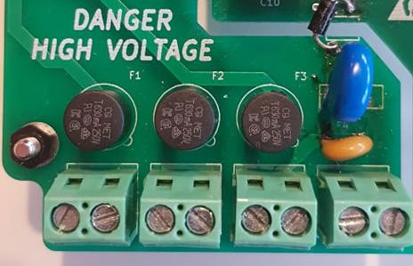

L N L N L N L(G) N(G)

After this is done the system is ready for development.

For next version


There are a few things that i say would need to be looked at for a final version or next version. (Most of these will be fixed in the comming week and updated on the github).
1. Fix the missing SIM800L VCC wire (bodge wire on the backside)

2. Relay footprint (manufacturer didnt use standart noticing of viewing angle)
3. Diode footprint (known faulty datasheet entirely)
4. Change MOV footprint
5. Add diodes where needed
6. Power and resitors on usb
7. Redesign power management
8. Add cooling, gets quite hot.

