Multi-Channel Synchronous Stepper Motor
Controller
Aka „Tons of Steppers - TOS “

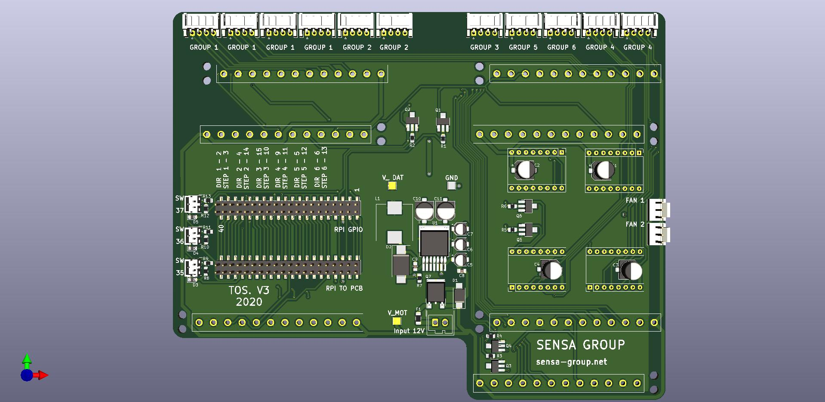

Version: | 3.0
Autor: | Ariyan Wasi (ariyan.wasi@sensa-group.net)
 | SENSA, 2020

TABLE OF CONTENTS

1 Hardware history 1
2 Project Principle 3
2.1 Workings 3
3 Visualisation Section 7
3.1 Front Part 9
3.2 Back Part 9
4 Code and Setup 11
4.1 Setup 13
5 For next version 17

Hardware history

Ver | Rev | Date | Author | Description
1 | 1 | 01.11.2019. | Ariyan Wasi | Initial version.
2 | 1 | 01.02.2020. | Ariyan Wasi | Upgraded Hardware and looks.
3 | 1 | 01.20.2021 | Ariyan Wasi | Upgraded Hardware and mechanical design.

Project Principle

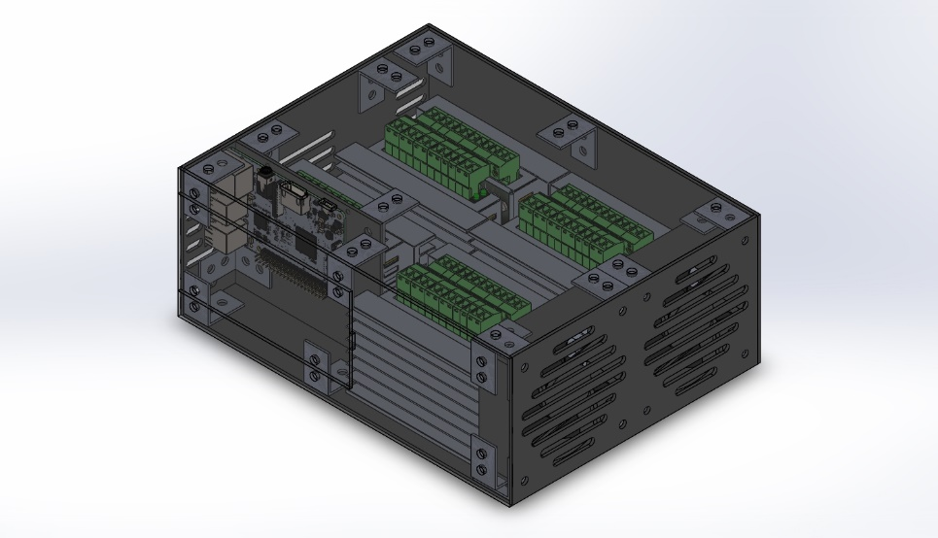

The controller is made for the simultaneous control of large groups of stepper motors that need to work at the same time synchronously. The driver board has the ability to drive one motor on its own, up to four motors, synchronously, at a time. The driver is made to be controlled via a raspberry pie with the standard forty pin header. However, it can be run easily with any other mass-market development board. The board can drive up to eleven motors at once.

Workings

The driver board is capable of supplying a wide array of bipolar stepper motors (like most „nema“ types of stepper motors) due to its large motor supply voltage range from 8 to 40 volts. At any voltage point, the stepper motor will be able to generate 5V on its on to power the logic. It does this via a high efficiency and high amperage switching regulator.
The motors are driven by a switchable TB6600 drivers (G1, G2, G3) or A4988 polulu drivers (G4, G5, G6) this driver was chosen here as there are many possibilities for upgrading in the future as it is a pretty standard footprint and pinout. (https://www.pololu.com/product/1182)

Group 1,2,4 achieves synchronous motor movement due to a pair of high-power transistors. One transistor is to carry the direction signal of the rotation of the stepper motors, the other is to carry the signal that defines the number of „steps“ that the stepper motors should take.
The whole backing is installed in a case that hides the sensitive electronics on the bottom while being exposed on the top part for ease of access to connectors and for the ability to read the silkscreen.

Visualisation Section

FRONT:

BACK:
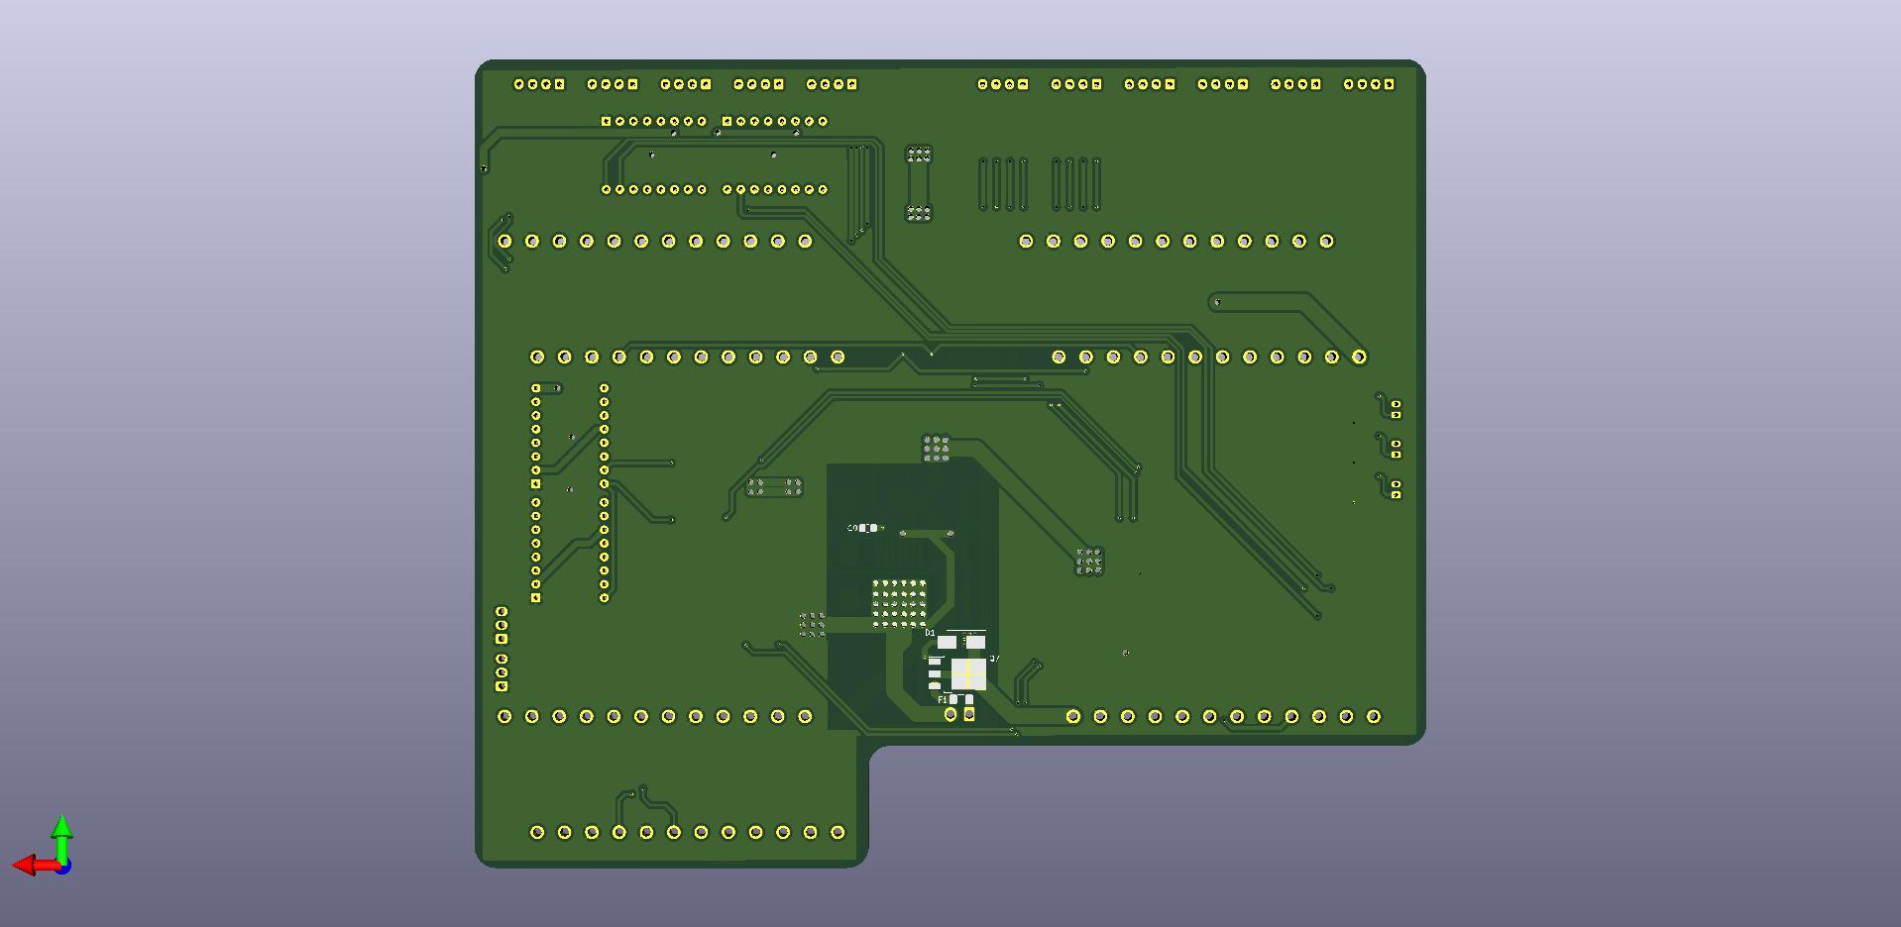

Front Part

On the front of the PCB we have:

- The motor supply input.
- Raspberry pi in and pass through.
- Each of the group outputs and corresponding labels.
- Buck converter.
- Three pairs of high-power transistors.
- Low power polulu drivers.
- Three connections for limit switches.

Back Part

On the back of the PCB we have:

- P-Mosfet for reverse polarity protection.
- Connectors for the TB6600 drivers.

Code and Setup

A sample program can be found in the repository:
https://github.com/kurdish-yoda/TOS/blob/main/Code_and_Documents/TOS_SCRPT.py

Using this script, one could move any of the eight stepper group either a predefined amount or a custom angle. The predefined amount are: 45, 90, 180 and 360 degrees.

Command Syntax:
- move360(group, dir):
- move+angle(stepperGroup & direction)
- move(group, dir, degree): <-- to move a custom amount
- move(stepperGroup & direction & amount of degrees)

Direction
The direction is defined by an 1 or a 0.

1 being a clockwise rotation, and 0 being a counter clock wise direction.

Steps Per Revolution
Before using the script one should go in and adjust the SPR (steps per revolution) perameter. This will depend on what motor is used.
Each singular driver on the board is setup for 1/16 microstepping. That means that the chips will take each step of the motor normally and devide it up by 16. This means that what ever number of steps the motor has in its datasheets needs to be increased 16 fold.

An example would be if you would use a normal nema 17 motor that has about 200 steps per revolution, 200 * 16 = 3200. So 3200 would be the SPR value. As thats how many steps the motor can do hokked up to this driver.

Setup

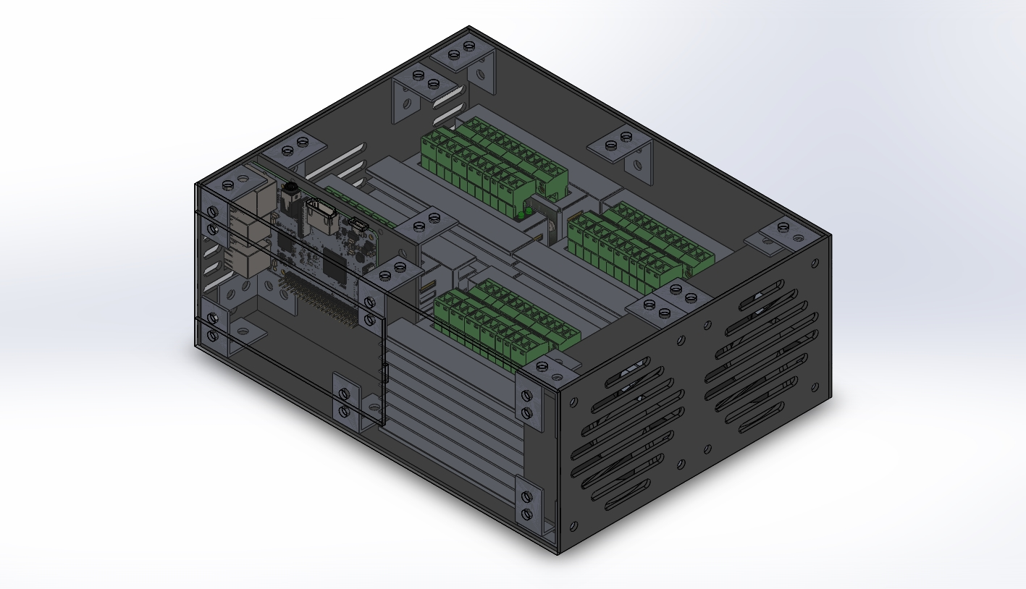

One should attach the raspberry pi in its hatch, in addition to the raspberry pi 3 it is also possible to attach the zero variant also, and then connect the cable as shown:
After that, mains voltage should be given to power up the system.

For next version
1. Silkscreen fix for the group pin out.

