CS 1632 – DELIVERABLE 4: Performance TESTING Using VISUAL VM

WILLIAM KUREK

**Summary:**

After running VisualVM on the program, it was clear right away that the three methods getOpCode, toString, and modulo had a significant effect on the performance. So, I started to the examine the code for each and quickly discovered performance and presentation issues with each. Each contained an unnecessary for loop which had a significant negative impact on the performance of the program. It was obvious that the removal of each of these for loops would significantly increase the overall performance of the program and the program would work exactly the same as before. After each refactor and retesting the program it was clear that my observations were correct; the program was faster and took up significantly less CPU time.

**VisualVM Screenshots:** 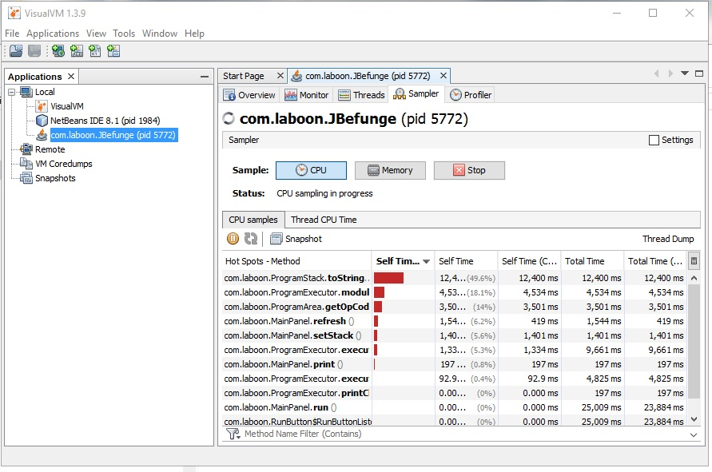

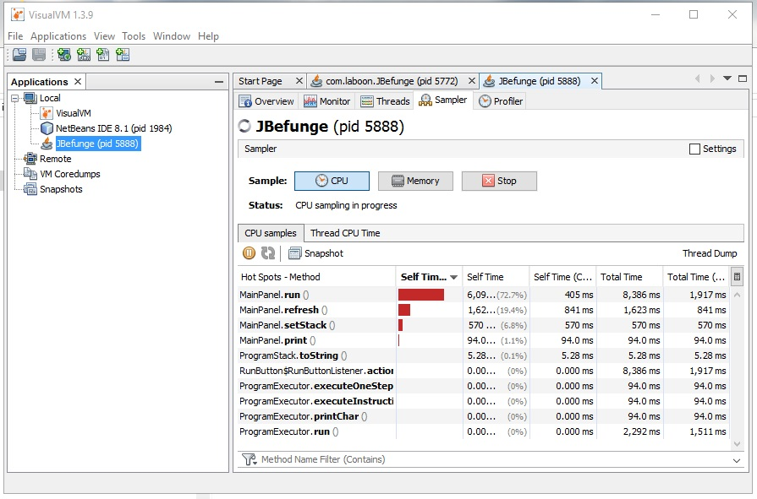

**Initial and Final Times:**

**BEFORE:**

**RUN 1:** 26535 milliseconds

**RUN 2:** 22651 milliseconds

**RUN 3:** 22160 milliseconds

**MEAN:** 23782 milliseconds

**AFTER:**

**RUN 1:** 2300 milliseconds

**RUN 2:** 2118 milliseconds

**RUN 3:** 1941 milliseconds

**MEAN:** 2119.6667 milliseconds