# CS 1632 – DELIVERABLE 5: STATIC Analysis

WILLIAM KUREK

Github.com/kurek192

**SUMMARY:**

After running the static analysis tools, it was obvious how to go about fixing the code issues. The tools were straightforward and clear on what exactly the issue was. Using my knowledge of style and performance in java, such as using StringBuilder for string concatenation, I experienced no issues fixing the code. Also, some of the issues were created in deliverable 4 by mistake, so It was nice to have these tools to me realize my careless mistakes.

**BEFORE CHECKSTYLE:**

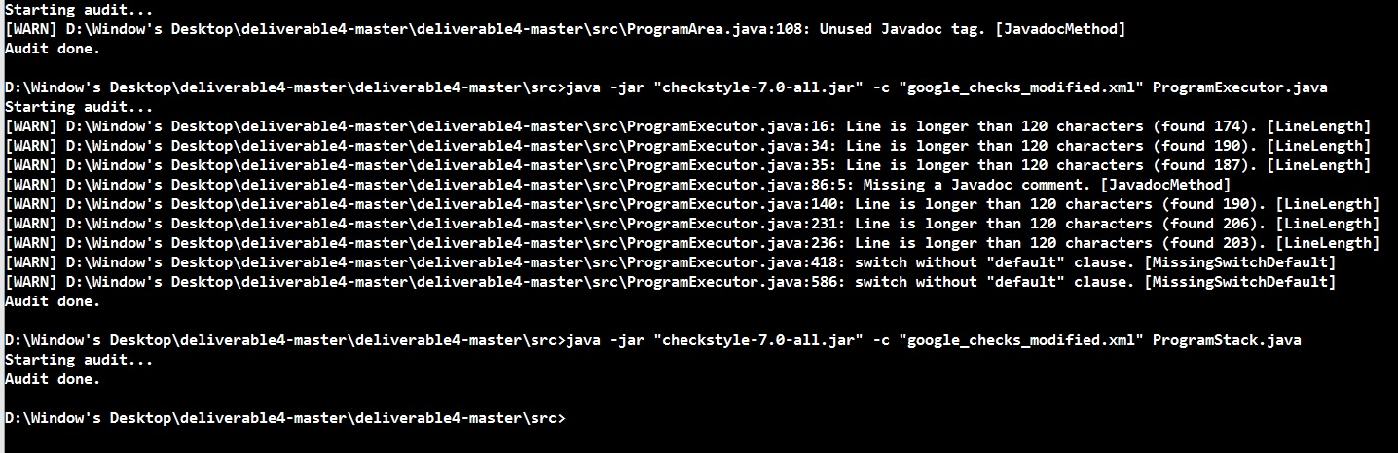

**AFTER CHECKSTYLE:**

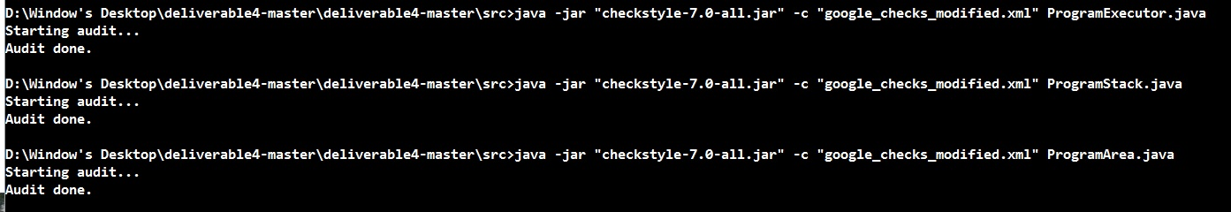

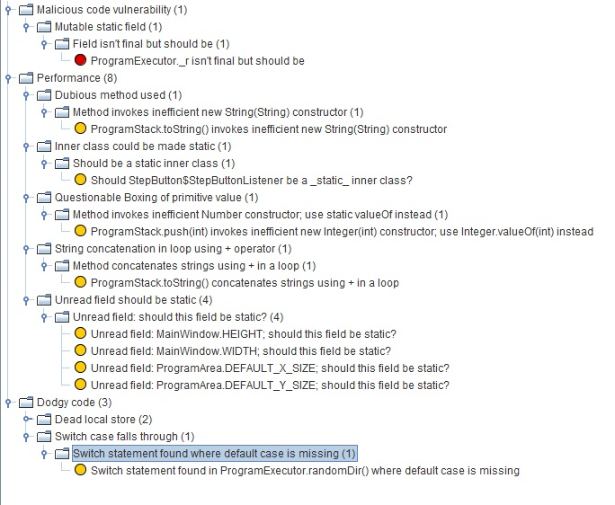**BEFORE FINDBUGS:**

**AFTER FINDBUGS:**