GIT
- SCM-Source Code Management: So in SCM we are having tools like git,git lab,git bash
- GIT- Local repository-Linux/windows commands will work on all irrespective of os machines
Definition-Git is a distributed version control system (VCS) used to track changes in source code during software development. It helps developers collaborate, manage different versions of code, and roll back to previous states if needed.
- GITHUB-Remote Repository-Graphical
Definition-GitHub is a web-based platform built around Git that enables version control, collaboration, and project management for software development teams.
- Git performs version control by tracking and managing code changes.
- GitHub hosts Git repositories and provides collaboration tools.
- Supports team collaboration, code reviews, and remote contributions.
- Offers free and paid plans for individuals and organizations.
- Version Control System:-A Version Control System (VCS) is a tool used in software development and collaborative projects to track and manage changes to source code.
- Tracks and records changes to the codebase, maintaining a structured project history.
- Allows multiple developers to collaborate on the same project without overwriting each other's work.
- Developers access and update a central repository, where project files are stored.
- Enables teams to share updates and revert to earlier versions of the project when needed.
2 types of vcs:
------------------
1.Central VCS:
In a Centralized Version Control System, all the files and their version history are stored in a single central server. Developers connect to this server to access or modify files.
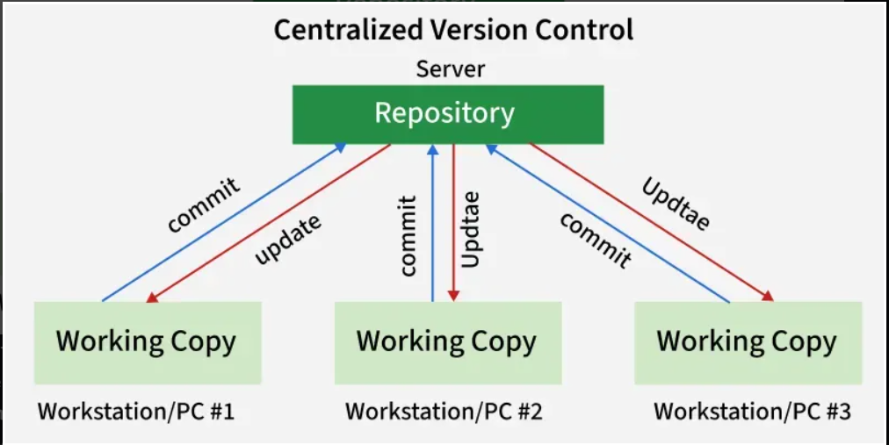
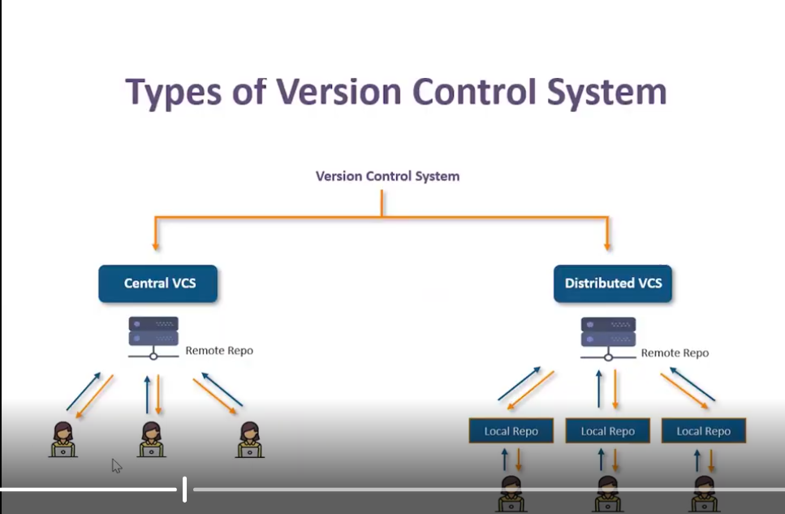
Centralized Version Control (CVCS) is a system where there is a central repository that stores all the code, and developers access this repository to make changes. Popular examples of CVCS include Subversion (SVN) and CVS.
2.Distributed VCS: Distributed (DVCS) is a system where every developer has a complete local copy of the entire project, including its history, and they can work offline. Changes can be made locally, and later synchronized with other developers’ versions. Popular DVCS systems include GIT, Mercurial, and Bazaar.
