**Bike Sharing Demand Prediction**

**(Supervised Machine Learning Regression)**

**By- N. SANTOSH KUMAR CHOUDHURY,**

**KURESH CHANDRA TRIPATHY**

**Data science trainees,**

**Alma Better, Bangalore**

# **Bike Sharing Demand Prediction (Supervised Machine Learning Regression)**

## **Objective:-**

We are provided with a Rental bike’s dataset name “**SeoulBikeData.csv**”. Our main objective is performing Supervised Machine Learning Regression on the given dataset and draw useful conclusions about the prediction of bike count required at each hour for the stable supply of rental bikes.

**Data Summary: -**

We are given a Rental bike’s dataset. This dataset contains.

It contains the following features.

1. Date - year-month-day

2. Rented Bike count - Count of bikes rented at each hour

3. Hour - Hour of the day

4. Temperature-Temperature in Celsius

5. Humidity - %

6. Wind Speed - m/s

7. Visibility - 10m

8. Dew point temperature - Celsius

9. Solar radiation - MJ/m2

10. Rainfall – mm

11. Seasons

12. Holiday

13. Functioning Day

* Total number of rows in data: 8760
* Total number of columns: 14

## **Data Cleaning and Feature Engineering**

### As we know clearing data will remove the conflict between any duplicate data/row.

1. Missing values finding and replacing with proper values.
2. Change required column data types from Object to appropriate datatypes.
3. Checking duplicate rows in dataset.
4. Adding some required new columns.

* Date column is converted from object to date type data.
* Date into Year, Month, Day column.
* Checking the Null value
* Checking Duplicate rows in Bike Data.

## **Exploratory Data Analysis**

* An EDA is a thorough examination meant to uncover the underlying structure of a data set and is important for a company because it exposes trends, patterns, and relationships that are not readily apparent.

Mainly performed using Matplotlib and Seaborn library and the following graph and plots had been used:

* Bar Plot.
* Histogram.
* Scatter Plot.
* Line Plot.
* Heatmap.
* Box Plot

**Analysis of Independent variable w.r.t Dependent variable**

* 1.Categorical variables
* 2.Numerical variables

**Categorical variables**

**What is a categorical variables in data analysis?**

* A categorical variable (sometimes called a nominal variable) is one that has two or more categories, but there is no intrinsic ordering to the categories.
* Our dependent variable is "Rented Bike Count" so we need to analysis this column with the other columns by using some visualization plot. First, we analyze the category data type then we proceed with the numerical data type.

## **1. Rented bike vs Month**

* From the above bar plot is clearly showing that from Jan to Jun demand for the rented bike is growing high and then slowly the demand start dropping till Sep and then again, a small demand increase for some a month and then it decreases.

# **Rented bikes demand w.r.t hour on weekdays and weekends**

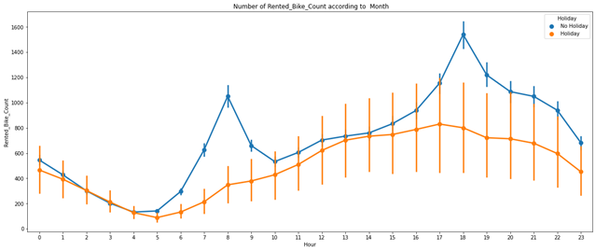

# From this point plot graph, we can see that on holiday ranted bike demand is less as compared to No-holiday. Between 7am-9am and 5pm-7pm demand of rented bike is high. Which Country have Most Babies During their Visit.

# **Rented** bikes demand w.r.t Season

* Form the bar chart and point plot we can clearly say that in summer demand is high as compared to other season and in winter the demand is lowest.
* Point chart also tell that in morning from 7-9am and 5-7pm demand is high in every season.

# **Rented** bikes demand w.r.t hour on weekdays and weekends

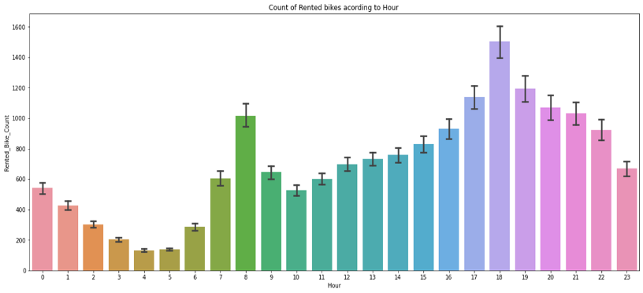

# From this point plot graph, we can see that on holiday ranted bike demand is less as compared to No-holiday. Between 7am-9am and 5pm-7pm demand of rented bike is high and in between 3-6 am it is low.

**Numerical variables**

**What is a categorical variables in data analysis?**

* A numeric variable (also called quantitative variable) is a quantifiable characteristic whose values are numbers.
* A numeric variable (also called quantitative variable) is a quantifiable characteristic whose values are numbers.

# **Relationship between “Rented_Bike_Count” and “Temperature”**

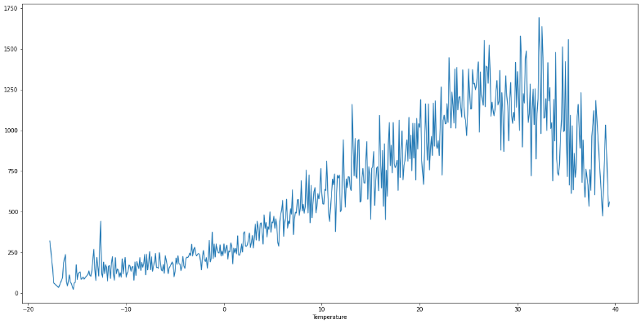

* In above plot the demand of rented bike is highest when temperature is around 20°C-30°C.

# Relationship between “Rented_Bike_Count” and “Dew_point_temperature”

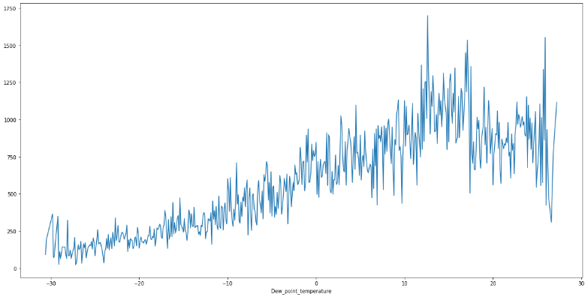

# This plot the demand of rented bike is highest when dew point temperature is around 20°C-30°C.

# This graph also follows same trend as temperature.

# Relationship between “Rented_Bike_Count” and “Wind_speed”

* In this plot the demand of rented bike is Same throughout the wind speed/ uniformly distributed but when the wind speed is (5-6) m/s demand rises
* When the wind speed is more than 7 m/s then demand for bike is also increase.
* Here we can say that the patten is very random.

# Relationship between “Rented_Bike_Count” and “Solar_Radiation”

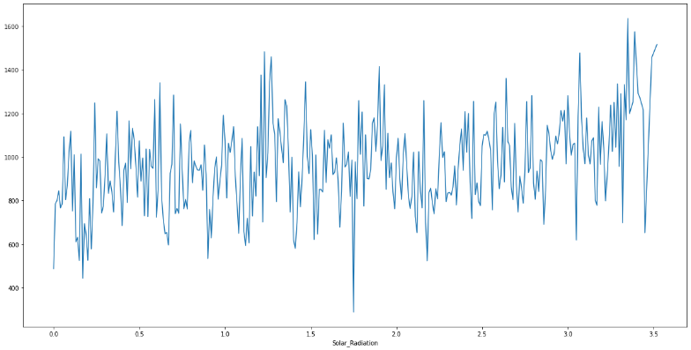

* In this plot the demand of rented bike is high if there is solar radiation. Mostly the number is around 1000(+/-200).

**Regression plot**

1. It is a plot give a visual guide that helps to emphasize patterns in a dataset between two parameters.

2. Regression lines can be used as a way of visually the liner relationship between,

the Independent (x)----->Numerical variables and Dependent variables(y)----->Rented_Bike_Count variables here in the graphs.

* **Checking of Correlation between variables**

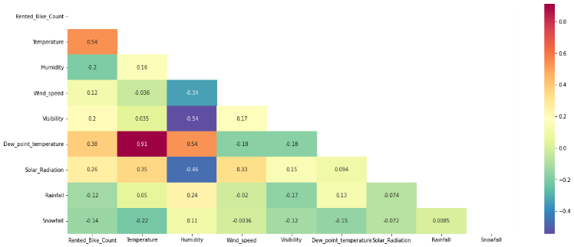

* We can observe on the heatmap that on the target variable line the most positively correlated variables to the rent are:
  1. Temperature
  2. Dew Point temperature
  3. Solar radiation
* Most negatively correlated variables are:

1. Humidity
2. Rainfall

## From the above graph we can see that relation between columns 'Temperature' and 'Dew point temperature' i.e 0.91 so we if we drop this column than it will not affect the outcome of our analysis.

## We can drop the column 'Dew point temperature'.

**Model Training & Testing**

* Assigning the dependent and independent variables.
* Splitting the model into train and test sets.
* Transforming data using min-maxscaler.
* Fitting linear regression on train set.
* Getting the predicted dependent variable values from the model.

The train-test split is used to estimate the performance of machine learning algorithms that are applicable for prediction-based Algorithms/Applications. Before fitting any model, it a general rule that we have to split the dataset into a training and testing set. This dataset split in proportions of the data go into the training model and some proportion will go for evaluation how our model performs on any unseen data.

Generally, the proportion may vary from 70:30,80:20,75:25 depending on the person. Mostly we prefer 80:20 ratio for the training and testing respectively.

**Code used to Analysis Booking**

* #Assign the value in X for independent variable and Y dependent variable.
* X = bike_df_copy.drop(columns=['Rented_Bike_ Count'], axis=1)

X.head()

* #Assign the value in Y fop dependent variable/target value

y = np.sqrt(bike_df_copy['Rented_Bike_Count'])

y.head()

bike_df_copy.describe().columns

# **LINEAR REGRESSION**

* Linear regression analysis is used to predict the value of a variable based on the value of another variable. The variable you want to predict is called the dependent variable. The variable you are using to predict the other variable's value is called the independent variable.
* #import the packages and do LinearRegression from sklearn.linear_model import LinearRegression

reg= LinearRegression().fit(X_train, y_train)

**Conclusion: -**

* Customer visiting from Country Portugal has most number of Babies.
* Most of Booking done in year 2016 i.e. 56,707 number of booking.
* Meal is mostly preferred by the guests during their visit is BB type which is 77.8% of all type of meal.
* Most number of booking coming from Country Portugal.
* Most number of booking for stays_in_week_nights.
* High number of booking happens in Western Europe country.
* Most number of booking done in month of AUGUST.
* City Hotel has highest number of booking i.e. 79330 numbers.
* TA type of market-segment has most number of cancellations.
* ‘A ‘Type room has highest number of booking i.e. 72%.
* Agent no-9 is most valuable agent.
* Most demanded room type is A, but better adr rooms are of type H, G and C also.
* Hotels should increase the no. of room types A and H to maximize revenue
* Bookings made via complementary market segment andadults have on average high no. of special request.
* For customers, generally the longer stays (more than 15 days) can result in better deals in terms of low adr.

**Challenges: -**

1. There was a lot of duplicate data.
2. Data was present in wrong datatype format.
3. Choosing appropriate visualization techniques to use was difficult.
4. A lot of null values were there in the dataset.

.