Contents

JAVA CONTENTS 2

History of JAVA: - 2

Version hierarchy of JAVA: 2

What is JAVA:- 3

Features of JAVA:- 3

Type of Application :- 4

Platform of JAVA:- 4

# History of JAVA: -

* In **1990 Sun micro system** try to build set up box. They assign to Green Team. **James Gosling** is the team leader of that team is also known as the **father of the Java.**
* Earlier name of Java is known as OAK(OAK Tree represent to strength)

Facts of OAK-

* It is the National Tree of USA, Italy and Numbers of country etc.
* 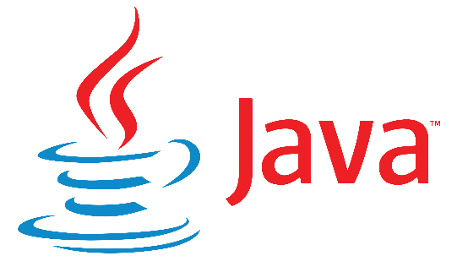A company named OAK technology is already present in USA. So the founder of OAK language change its name to JAVA( which represent the location java island in Indonesia where, coffee 1st discovered)

# Version hierarchy of JAVA:

1. JDK 1.0------->1995
2. JDK 1.2------->1997
3. JDK 1.5------->2004

All are the Stable Version of Java

1. JDK 1.8------->2014
2. JDK ……………

Here we are going to use JDK 1.8

1. JDK 15-------->2020
2. JDK 17-------->2021

# What is JAVA: -

* Java is a general-purpose programming language.
* General purpose means it is used in both hardware and software Industries.
* But JAVA is very much famous in software industry to develop the application.

# Features of JAVA: -

1. It is simple.
2. Secure
3. Platform Independent
4. Portable
5. Robust
6. Object oriented programming language
7. 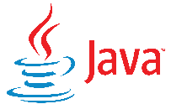Class structure programming language
8. Type safe programming language
9. Interpreted programming language
10. WORA language (Write once run anywhere)

# Type of Application: -

1. The application which can run without internet called 🡪 Web Application.
2. The application which can run without internet called 🡪 Standalone Application.

# Platform of JAVA: -

There are 3 types of platforms in Java. -