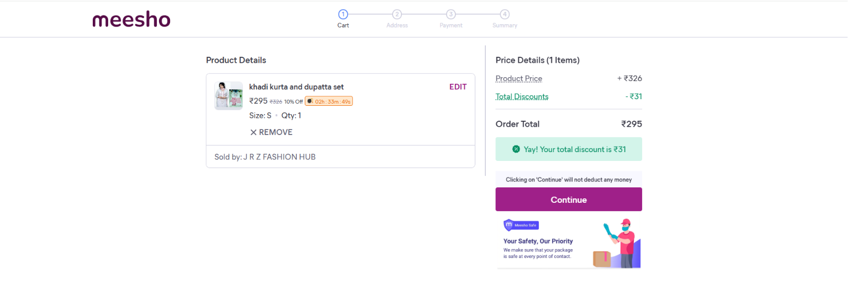
In this only the curd output will be printed and need to use some Java Script for discount, in every condition the discount is fix as “25%” and this make every order total simple.
For order total create id so the continue button will carry and proceed.

we will not add number to it.
instead, we will only and green bar


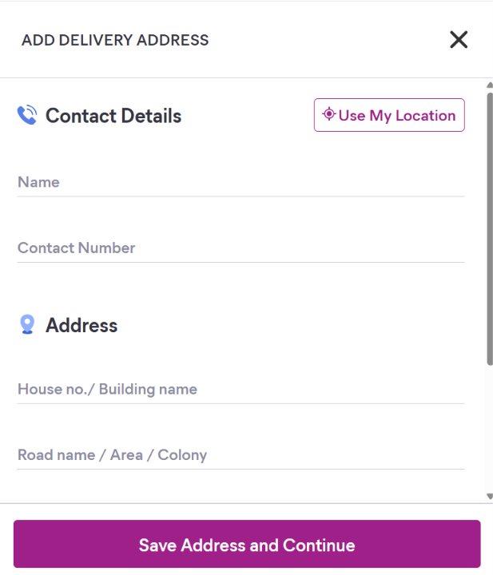
Build this form same
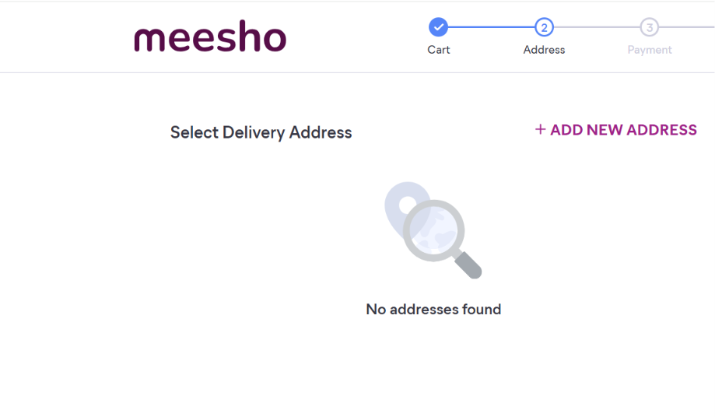
Add form result here in Select Delivery Address
there will be one selected option.
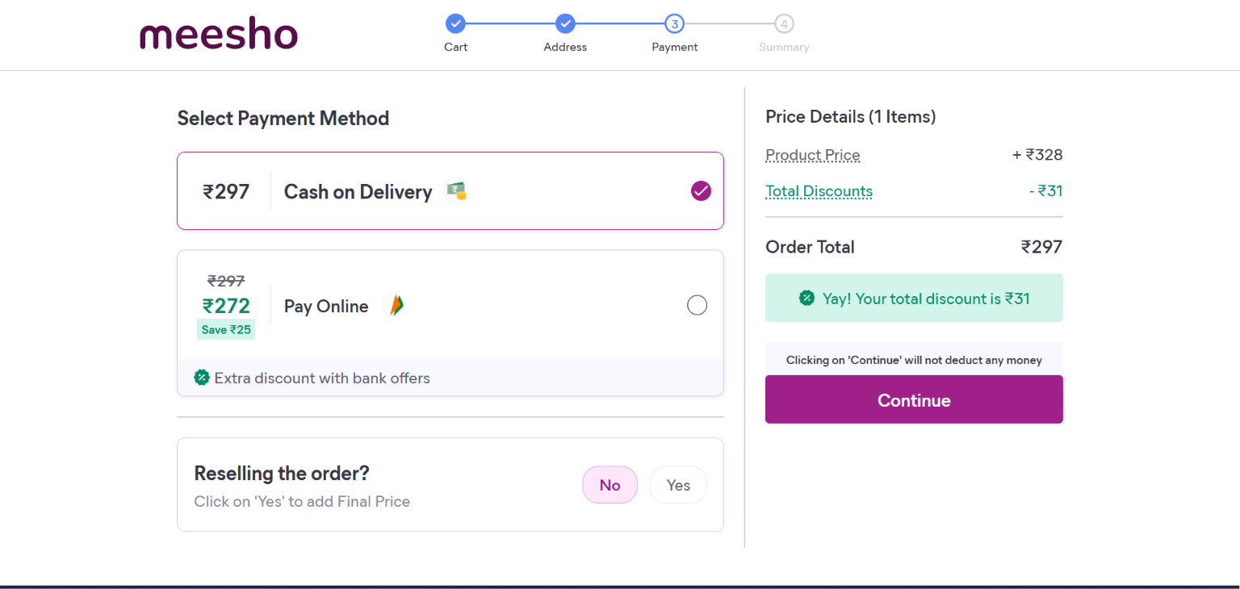
2 radio button and amount and payment method only.
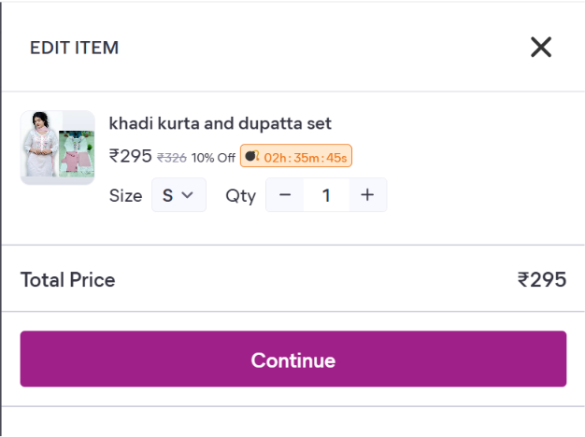
This is an option item to create ether it is created by AI
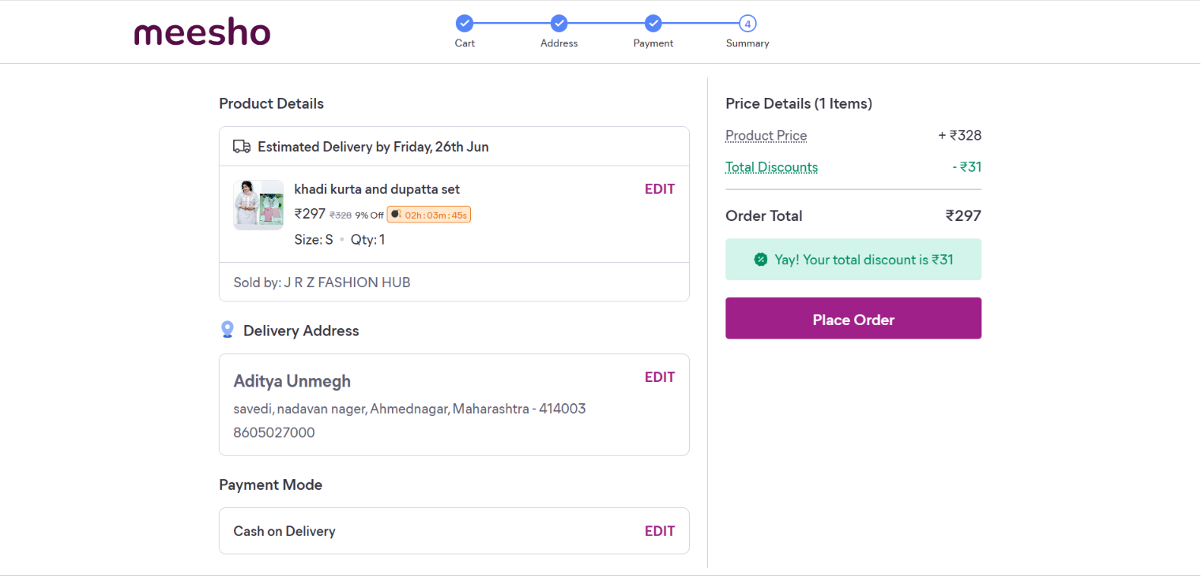
No edit option/add edit option if time remained.

