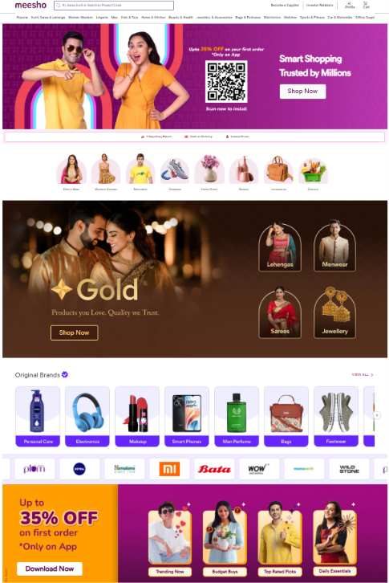

Nav items
1) Fashion
2) Mobile
3) Electricity
4) Home appliances
5) Toys & Gift
6) Book
7) Furniture
8) Sport
9) Grocery.

- Use HTML & CSS
- Do not Create section for “Become a Supplier” and “Investor Relations”
- Every Image can be brought from site
- Every Shop Now button should be working .Do not try to make any other button .
- No need to write media-qurry

I have this infinity slider code , you just need to adjust with height.

