Transcriptome expression analysis of the gene regulation mechanism and biochemical change of Exophiala mesophila tolerance to high concentrations of As(V) and Cr(VI)
Combined Transcriptome and Biochemical Analysis of Exophiala mesophila tolerance mechanisms to High As(V) and Cr(VI) Concentrations

Cristy Medina-Armijo¹, Ibraheem Youlself², Francesc Prenafeta-Boldú¹.
¹Program of Sustainability in Biosystems, Institute of Agrifood Research and Technology (IRTA), Caldes de Montbui, Catalonia, Spain.
² ALBA Synchrotron Light Source, Cerdanyola del Vallés, Catalonia, Spain.

Abstract
Exophiala mesophila, a filamentous black fungus in the Chaetothyriales order, exhibits remarkable adaptability in toxic environments and degrade aromatic compounds and xenobiotics. Notably, they display exceptional tolerance to high concentrations of heavy metals and metalloids (HMMs) like arsenic As(V) and chromium Cr(VI). This study investigated the overall biochemical and transcriptomic response of E. mesophila to HMM stress. A combined approach using SR-FTIR spectroscopy (analyzing functional group intensity) and RNA-sequencing (RNA-seq) was employed. RNA-seq was performed on E. mesophila cultures grown under As/Cr)-free and (As/Cr)-stressed conditions. The analysis identified 575 differentially expressed genes (DEGs) upon HMM exposure. Approximately 40% (228 unigenes) were associated with 10 established HMM tolerance pathways. These pathways included metal ion handling, organic acid metabolism, ROS scavenging, and DNA repair, all crucial for E. mesophila's extreme As/Cr tolerance. Biochemical analyses revealed changes in protein, lipid, and DNA in HMM-exposed cells, supporting the RNA-seq data. These findings suggest a coordinated strategy involving both extracellular and intracellular mechanisms for enhanced HMM tolerance. Furthermore, using tricyclazole, a DHN-melanin inhibitor, alongside HMM exposure resulted in significant changes in phosphodiester and protein molecules. This indicates an oxidative stress response with ROS generation and potential membrane disruptions, ultimately leading to cell lysis in melanin-deficient cells exposed to HMMs. This study is the first to explore the E. mesophila transcriptome under As/Cr stress. The findings provide valuable insights for future molecular studies on HMM tolerance mechanisms in fungi.
Keywords: Exophiala mesophila, fungal melanin, tricyclazole, supramolecular structure, transcriptomics, metallotolerance, genomics, proteomics, SR-FTIR

Introduction
Exophiala mesophila, a black fungus belonging to the Ascomycota phylum (family Herpotrichiellaceae, order Chaetothyriales), exhibits a remarkable ecological adaptability. Most Exophiala species are dimorphic, transitioning between yeast-like budding cells and filamentous hyphae. This morphological flexibility allows them to thrive in diverse environments, as evidenced by their isolation from clinical specimens (Woo et al., 2013; Usuda et al., 2021), animal tissues (de Hoog et al., 2011), plants (Zhan et al., 2011), and even extreme habitats like arsenic-rich mine soils (Seyedmousavi et al., 2011) and deep-sea sediments (Feng et al., 2021). Notably, Exophiala species can also act as an opportunistic pathogen for immunocompetent individuals, causing cutaneous and subcutaneous skin infections (Ng et al., 2017; Kirchhoff et al., 2019). Previously, Exophiala mesophila was isolated from toxic adhesives and characterized for its remarkable tolerance to pentavalent arsenic As(V) exceeding 12 g L⁻¹ with an IC50 of (6.03 g As⁵⁺ L⁻¹) and chromium Cr(VI) at 2.5 g L⁻¹ with an IC50 of (0.05 g Cr⁶⁺ L⁻¹) (Medina-Armijo et al., 2024). Moreover, its significant capacity to remove Cr(VI) was demonstrated in kinetic studies, exhibiting a bioabsorption capacity of 95.26 mg g⁻¹. Additionally, its conspicuous synthesis of DHN-melanin and an efficient melanin extraction method with high Cr(VI) sorption levels have been reported, achieving a sorption capacity of 544.84 mg g⁻¹ (Medina-Armijo et al., 2024). The mechanisms of melanin in black fungi have been extensively investigated and involve a complex interplay of functional groups (OH, COOH, C=O, NH) cross-linked into a rigid, cross-like structure within the fungal cell wall (Prota, 1992). These extended aromatic chains, acting as chromophores, exhibit a high capacity for electromagnetic interactions due to the formation of π-bonds (Díaz et al., 2005). These attributes have garnered significant interest in black fungi due to their remarkable resilience under toxic stress conditions and potential applications in bioremediation processes (Tran-Ly et al., 2020)(Medina-Armijo et al., 2024b). Despite the well-established protective role of melanin in black fungi, the underlying mechanisms of their remarkable tolerance to high levels of heavy metal and metalloid contamination remain an intriguing area of scientific inquiry. These mechanisms likely encompass the protective function of melanin, the ability to induce novel proteins, and a coordinated metabolic response that can trigger host-regulating processes, transport mechanisms, DNA repair, and other stress-response pathways. In this study, we employ an combined analysis approach to comprehensively investigate the biochemical and gene expression changes in E. mesophila upon exposure to high concentrations of As(V) and Cr(VI). To elucidate the specific role of DHN-melanin in tolerance mechanisms, this study incorporates the inhibition of DHN-melanin synthesis using tricyclazole alongside exposure to toxic metalloids. This approach allows for a biochemical analysis of E. mesophila with suppressed melanin production.

Material and methods
Fungi strain and cultivation
The fungus Exophiala mesophila IRTA M2-F10, is classified as a BSL1 and isolated previously from glue (Medina-Armijo et al., 2024), was used for the metal exposure experiments and the inhibiton DHN-melanin using tricyclazole.
E. mesophila colony on (PDA agar; Condalab, Spain) at 25ºC were used as inocula for the production of fungal biomass in 100ml os sterilized liquid médium (Yeast extract 4 g L⁻¹ was supplied as the carbon and energy source and macronutrients were added as 4.5 g KH₂PO₄, 0.5 g K₂HPO₄, 2.0 g NH₄Cl, and 0.1 mg MgSO₄ · 7H₂O per-litre. Mineral micronutrients were added as 2 mL of a stock solution that contained 120 mg FeCl₃, 50 mg H₃BO₃, 10 mg CuSO₄·5H₂O, 10 mg KI, 45 mg MnSO₄ · H₂O, 20 mg Na₂MoO₄ · H₂O, 75 mg ZnSO₄ · H₂O, 50 mg CoCl₂ · 6H₂O, 20 mg AlK(SO₄)₂ · 12H₂O, 13.25 g CaCl₂ · H₂O, and 10 g NaCl, per litre. Cultivation were performed in the dark at 25 °C under shaking at 120 rpm for two weeks. After incubation, 1.5 mL of the cultures in exponential phase (0.5 mL, > 10⁶ CFU mL⁻¹) were centrifuged at 9391 g for 5 min to harvest the fungal cells. The pellet was washed with ultrapure sterilized water and were used for the metal/melanin inhibitor exposure assays.
Investigating Biochemical Effects with SR-FTIR Sample Preparation
Tricyclazole, a well-known inhibitor of 1,8-dihydroxy naphthalene (DHN) melanin synthesis in fungi, was used to inhibit the production of DHN-melanin by E. mesophila. Tricyclazole was supplied as an ethanol solution (50 µg L⁻¹ final concentration) to liquid culture, as previously described by (Medina-armijo, n.d.). The incubation with metal and trizyclazole were perfomed in serum flasks filled (10 mL final volume) with a buffered (35 mM K₂HPO₄/NaH₂PO₄+2H₂O, pH 7) mineral medium amended with glucose (0.3 %) and yeast extract (0.01 %), similar to what has previously been described (Medina-Armijo et al., 2024). All fungal cultures were incubated at 25°C at 120 rpm for six days. The treatment with arsenic was supplemented with 5 g L⁻¹ with HAsNa₂O₄+7H₂O (purity 98 %, Thermo Fisher Scientific, Kandel, Germany) and the treatment with chromium was supplemented with 1 g L⁻¹ with K₂Cr₂O (purity 98%, Scharlab ExpertQ®, Spain).
To investigate the role of E. mesophila in HHM, fungal cells were pretreated with tricyclazole to inhibit melanin biosynthesis. Four groups were analyzed for biochemical characterization: 1) unexposed control cells (C1), 2) tricyclazole-treated control cells (C2) (to assess the impact of tricyclazole alone), 3) cells exposed to As(V)/Cr(VI) without tricyclazole (T1, T2), and 4) cells exposed to both tricyclazole and As(V)/Cr(VI) (T3, T4) at concentrations corresponding to the previously established IC50 values for E. mesophila tolerance (Medina-Armijo et al., 2024).
For SR-FTIRM sample preparation, the treatments were immediately fixed for interrupting the growth of fungal cells and stopping the induce-effects of metals. The fixed medium was removed, the cell in suspension was then centrifuged at 9391 g for 5 min at 4°C. The pellet was rinsed with millipore water and resuspended with 1% formalin (Sigma Aldrich, Saint Louis, USA), cells were kept at 4°C. After that, samples were centrifuged at 9391 g for 5 min at 4°C and the pellet was washed 3 times in millipore water. The final cell suspension was deposited on infrared transparent calcium fluoride (CaF2) cover glasses. SR-FTIRM analyzes were performed with dried cells and all treatments were carried out by triplicate.
SR-FTIRM measurements
SR-FTIRM measurements were performed at the infrared beamline MIRAS of the ALBA-CELLS synchrotron light source using the Hyperion 3000 microscope coupled to a Vertex 70 spectrometer (Bruker, Germany). The microscopy opening was equipped with a 36x Schwarzschild magnification objective (NA=0.65) and a cadmium telluride 50 µm MCT detector. All spectra were obtained using a single masking aperture size 15 x 15 µm, covering the full cell size. Single point maps of individual cells were collected in the 4000-900 cm⁻¹ mid-infrared range at 4 cm⁻¹ spectral resolution with 256 co-added scans per spectrum. A background measurement was performed on the CaF₂ slides without cell, with 10 repeated measurements. The absorbance spectrum was obtained by subtracting the reference spectrum from the raw cell. The subtraction data and was done directly (automatically) using OPUS 7.5 software (Bruker, Germany), according to (Medina-armijo, n.d.; Martínez-Rovira et al., 2019).
SR-FTIRM data analysis
The spectral features were evaluated by principal Component Analysis (PCA) using Unscrambler X (CAMO Software AS, Norway). PCA was performed on vector normalized second derivative spectra (Savitzky–Golay algorithm; 3rd polynomial order). The normalization (standard normal variate SNV) and PCA were separately applied in the 3100–2800 and 1800–1000 cm⁻¹ spectral regions. Raw spectra were corrected following the rubber band method (32 baseline points) using OPUS 7.5 (Bruker, Germany). The following bans/regions were evaluated: methyl asymmetric stretching: 2980–2945 cm⁻¹ (CH₃); methylene asymmetric stretching: 2945–2900 cm⁻¹ (CH₂); amide I: 1710–1598 cm⁻¹ (AI); amide II: 1590–1483 cm⁻¹ (AII); phosphate I: 1270–1186 cm⁻¹ (PhI); phosphate II: 1146–1004 cm⁻¹ (PhII). The total area under the spectra (except the 2800–1800 cm⁻¹ region) was associated with the total cell biomass (Cell) following previous studies (Yousef et al., 2016; H. Valido et al., 2020).
Total RNA extraction, library preparation, and Illumina sequencing
For transcriptomic studies, Exophiala mesophila exposed to As(v) and Cr(VI) was performed como se indica en la sección anterior. The culture medium of each sample were centrifuged at 4 °C and 9391 g /min for 10 min, and the supernatant was then removed. The cells pellet were stored at -80 °C. Three biological replicates were established for each tretaments. Total RNA was extracted from 2 streseed cell As(V)/Cr(VI) and 1 control (without stress) mycelial simples using Trizol reagent (Invitrogen, USA), followed by the treatment of total RNA with RNase-free DNase I (Merck KGaA, Darmstadt, Germany) with prior homogenization (30seg 30Hzgx2). The RNA quality was verified by using 2100 Bioanalyzer (Agilent, CA, USA) (OD260/OD280 ≥ 1.8; OD260/OD230 ≥ 1.6. At least, 1 mg of RNA from each sample was used for RNA-Seq. The construction of sequencing libraries from their respective total mRNA were sequenced using Illumina NextSeq (150x2 bp). Quality control of raw demultiplexed forward and reverse reads was performed using multiple tools. Briefly, descriptive stats of read-quality were calculated using FastQC v0.11.8 (Babraham Bioinformatics: FastQC Una herramienta de control de calidad para datos de secuencia de alto rendimiento, n.d.) and summarised with MultiQC v1.0 (Ewels et al., 2016) (Ewels et al. 2016), then, adapters in 5’ ends were removed using Trimmomatic v0.39 (Bolger et al., 2014). Paired reads were mapped against Exophiala mesophila strain:CBS 40295 RefSeq Genome reference genome from RefSeq Genome using STAR v2.7.10.a (Dobin et al., 2013). Qualimap v.2.2.2 (García-Alcalde et al., 2012) was used to perform the quality control of the mapping Transcript quantification was estimated using featureCounts v1.6.4 (Liao et al., 2014). The subsequent libraries analyses were conducted by Microomics Systems S.L. (Barcelona, Spain).
Andrews, S. 2012. “FastQC: a quality control tool for high throughput sequence data.” http://www.bioinformatics.babraham.ac.uk/projects/fastqc.
Enrichment analysis of diferentially expressed genes
The clean reads of each sample library were aligned back to the constructed transcriptome assembly using Ensembl Fungi browser 111. The script align_and_estimate_abundance.pl in DESeq2 v1.36.0 (in R) program was used to identify the diferentially expressed genes (DEGs) given adjusted p-value <0.05 and log2fold change >1 as a threshold for signifcant diferential expresión (Love et al., 2014). All assembled transcripts and unigenes were searched against the Gene Ontology (GO) which covers molecular functions, cellular components and biological processes and Kyoto Encyclopedia of Genes and Genomes (KEGG) which covers metabolic pathways. In the case of GO enrichment analysis, it was obtained using AnnotationForge v.1.38.1 (Carlson and Pagès 2022) and clusterProfiler v.4.7.1.0003 (Yu et al., 2012), while KEGG enrichment analysis was calculated using KofamScan (Aramaki 2020) and custom script.
Results
Biochemical effect on the cellular response induce by tricyclazole and heavy metal tolerance in Exophiala mesophila
Arsenic (V) exposure
The influence of pre-existing melanin on the response of Exophiala mesophila to arsenate exposure was assessed using Fourier-transform infrared (SR-FTIR) spectroscopy (Figures 1 and 2). These figures depict the results of Averaged absorbance and principal component analysis (PCA) including scores, loading plots, and average spectra for in three regions: 1) the fingerprint region (1,800-1,000 cm−1), 2) the amide I and II regions (1,700-1,500 cm−1), associated with protein structure modifications, and 3) the DNA region (1,350-1,000 cm−1), corresponding to the phosphodiester group primarily found in nucleic acids. PCA score analysis revealed distinct spectral variations in several regions, particularly concerning melanin content, when comparing arsenate-exposed cells to control groups. Within the fingerprint region, PCA loadings displayed a clear distinction between intact cells (C1-T1 treated groups) and those where melanin synthesis was inhibited with tricyclazole (C2-T3 treated groups). This distinction was primarily driven by PC1, explaining 70% of the total variance observed. In the lipid region, PC1 loadings, accounting for 68% of the variance, showed greater variation for the C2 and T3 groups (tricyclazole/metal). This suggests a stronger influence of both melanin inhibition and arsenate exposure on the lipid profile.

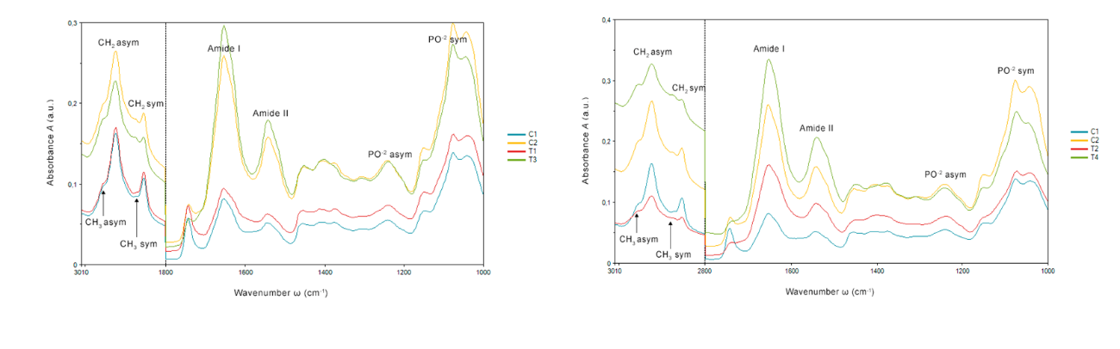
Figure 1. Averaged absorbance spectra from controls and treatments (unit vector normalized). The different averaged absorbance spectra have been shifted along the absorbance axis. Non-exposed cells: intact cells (C1) and cells treated with the melanin inhibitor tryciclazole (C2). (rigth) Cells exposed to arsenate (5 g L⁻¹): Intact cells exposed to As(V) (T1); and tricyclazole-induced cells exposed to As(V) (T3). (left) Chromium exposure treatment (1 g L⁻¹) of intact cells (T2) and albino-induced cells by means of tryciclazole (T4). For the sake of clarity, the different averaged absorbance spectra have been shifted along the absorbance axis.

Figure 2. PCA score at the fingerprint region (1,800-1,000 cm⁻¹ left) and the lipid region (3,100-2,800 cm⁻¹, right). C1: intact cells and, C2: tricyclazole -induced cells; T1: intact cells exposed to Arsenic; T3: tricyclazole-induced cells exposed to Arsenic.

Further analysis using second-derivative spectra derived from averaged absorbance data (Figure 3) strengthens these observations. The spectra reveal alterations in the position and intensity of peaks corresponding to amide I and II bands, particularly in cells lacking melanin (T3 treatment). Amide I (1,700⁻¹,1,600 cm⁻¹), associated with C=O stretching in proteins, and amide II (1,600-1,480 cm⁻¹), assigned to N-H bending and C-N stretching vibrations in proteins, are indicators of protein secondary structure. The observed spectral shifts in T3 cells suggest a more pronounced β-type structure compared to melanin-containing cells. Additionally, the fingerprint region spectra (Figure 3) show significant variance in the amide I and II bands for the T3 treatment (arsenic exposure with inhibited melanin synthesis). The region between 1,350 and 1,000 cm⁻¹ corresponds to asymmetric stretching of PO₂ groups in nucleic acids and phospholipids, while sugars exhibit strong bands due to C-O-C and P-O-C vibrations. Compared to the control C1 (native cells), Figure x displays several changes in intensity and position of peaks in the C2 (tricyclazole) and T1/T3 treatments. Peaks in the region between 1,120 and 1,050 cm⁻¹ are assigned to symmetric C-C stretching in α-glucans and asymmetric stretching in C-O-C, P-O-C β-glucan complexes, respectively. These spectral shifts suggest changes in cell wall polysaccharides. In the lipid region (3,100-2,800 cm⁻¹), changes in the intensity of CH₂ and CH₃ symmetric and asymmetric modes are observed. These alterations could be related to the state of hydrocarbons and lipids specific to cell walls and membranes. Notably, a significant perturbation was observed in tricyclazole treatments (inhibition of DHN-melanin) compared to C1 and T2 (no tricyclazole).
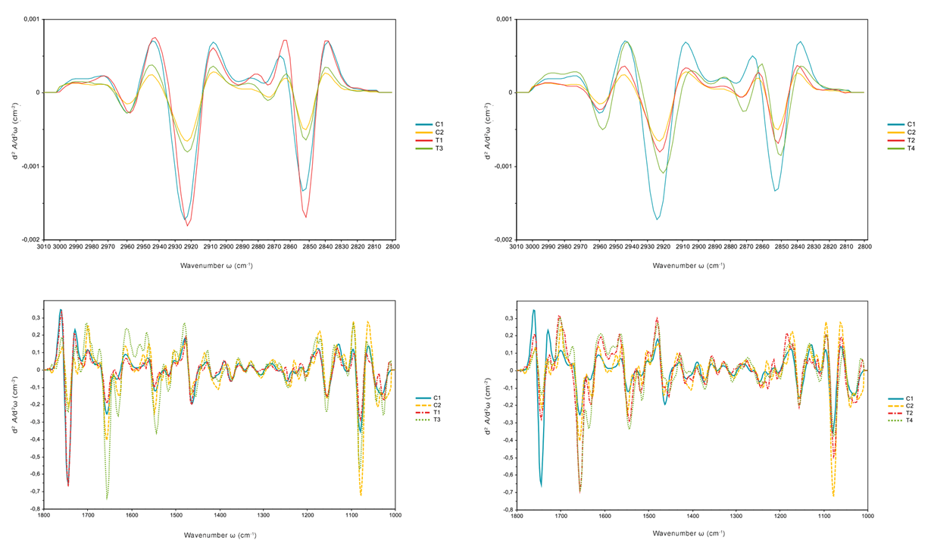
Figure 3. The Savitzky-Golay second derivative spectra is shown for the two controls and the treatment exposed to arsenic (rigth) and chromium (left). Fingerprint region (1,800-1,000 cm⁻¹left) and the lipid region (3,100-2,800 cm⁻¹, right).

Chromium exposure
Exposure to hexavalent chromium Cr(VI) revealed a stronger influence on spectral changes compared to arsenate exposure, likely due to both metal toxicity and melanin suppression. Principal component analysis (PCA) scores were generated for the following treatment and control samples: C1: control native cells; C2: control non-exposed metal and tricyclazole-treated cells; T2: cells exposed to chromium; and T4: tricyclazole-treated cells exposed to chromium. Melanin inhibition was achieved by incubating fungal cells with tricyclazole. Figures 2 and 4 depict the average spectra and PCA plots of the FTIR análisis.
The results demonstrate clear discrimination between treatment and control samples, primarily along PC1, which explains 46% of the variance in the fingerprint region (1,800 – 1,000 cm⁻¹). Notably, the separation of PCA scores for treated cells increased as a function of chromium exposure. In the fingerprint region, non-exposed intact cells (C1) clearly separated from all other treatments (exposure to chromium and/or tricyclazole). This observation is distinct from the response to arsenic, where exposure to the melanin inhibitor tricyclazole was the main factor driving the separation of samples into two main clusters (Figure 12).
PCA loading plots highlight a high contribution from the lipid region (PC1), explaining 83% of the variance in the fingerprint region (3,000-2,800 cm⁻¹). Figure 4, shows a slight increase in the total lipid content for the T4 treatment (tricyclazole and chromium exposure). This observation is supported by a slight increase in the absorbance of CH₂ and CH₃ stretching modes in the spectra, particularly for T4. These changes might be indicative of either lipid peroxidation or altered lipid metabolism associated with early stages of cell death processes.
Figure 4. PCA score at the fingerprint region (1,800-1,000 cm⁻¹ left) and the lipid region (3,100-2,800 cm⁻¹, right) are represented: non-exposed intact cells (C1) and tricyclazole-induced cells (C2); and exposed intact cells (T2) and tricyclazole-induced cells (T4).

Figure 3 depicts the second derivative spectra of several key bands, including phosphate (Ph I, II), amide I, and amide II, revealing their relative intensity distribution. The spectra show an increase in amide I and II band vibrations in chromium-exposed cells and those lacking melanin (C2, T2, T4). Chromium exposure correlated with peaks at 1,660 cm⁻¹ and 1,638 cm⁻¹, corresponding to the β-sheet and α-helix conformations of the amide I band, respectively. These observations suggest potential alterations in protein secondary structure. Additionally, changes in DNA organization were observed upon metal exposure and melanin deficiency. Shifts in wavenumbers between 1,350-1,000 cm⁻¹ and 1,242-1,082 cm⁻¹ were attributed to asymmetric and symmetric stretching of PO²⁻ groups, particularly significant in the T2 and T4 treatments. These shifts suggest alterations in DNA organization.
Finally, the lipid spectral region (3,100-2,800 cm⁻¹) revealed changes in the intensity of symmetric and asymmetric CH₂ and CH₃ stretching modes. Notably, treatments C2, T2, and T3 (tricyclazole and/or chromium exposure) displayed more prominent changes compared to arsenic exposure. This observation for the T2 (chromium) treatment suggests that chromium, due to its toxic nature, might significantly affect fungal membrane permeability, similar to the effects observed in treatments where melanin synthesis was suppressed.
De novo assembly of a Exophiala mesophila reference transcriptome
A total of 22,033,333 (control); 35,700,000 (As_treatment) and 31,666,667 (Cr_treatment) raw reads were generated from the control and treated samples, respectively. After cleaning and quality checks, 21,300,330 and 34,666,667 and 31,100,000 clean reads were obtained, and GC figures between 50 to 53%. More than 96.88% of bases in raw reads had a Q value ≥ 20 (and error probability of 0.95%) and more than 98.80% of bases in clean reads had a Q value ≥ 20 (and error probability of 0.94%). Transcriptome sequencing revealed a total of 9,056 expressed genes in both control and treatment groups. Principal component analysis (PCA) was employed to evaluate the transcriptome sequencing data and assess the similarity between biological replicates and significant diference between the contro and treatment were observed in special with cromo treatments, arsenic treatment is more similary to control withou exposed to heavy metal and metalloid (Figure 5, showed of PCA and heapmap).

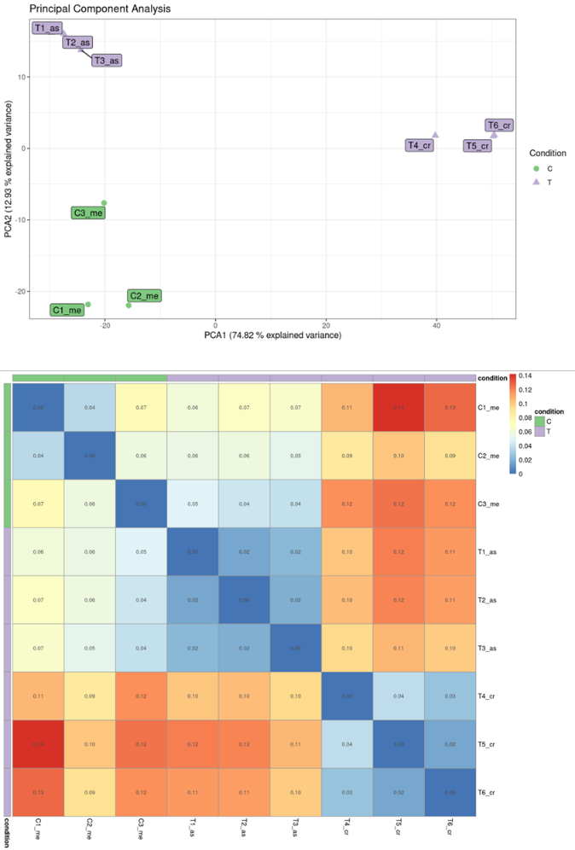
Figure 5.

As expected, samples from distinct developmental stages exhibited clear separation along the first two principal components (Figure 5). Differential gene expression (DEG) analysis between conditions identified distinct patterns: Co vs. As: 1,134 genes were positively expressed (increased expression), while 7,922 were negatively expressed (decreased expression). Further analysis revealed 572 underexpressed (decreased) and 562 overexpressed (increased) genes within the positively expressed group. Co vs. Cr: Here, 3,773 genes were positively expressed, and 5,283 were negatively expressed. Among the positively expressed genes, 1,652 were underexpressed, and 2,121 were overexpressed. Cr vs. As: Comparing the two metal/metalloid exposures, 4,168 genes were positively expressed, and 4,888 were negatively expressed. Within the positively expressed group, 1,968 were underexpressed, and 2,200 were overexpressed (Figure 6).

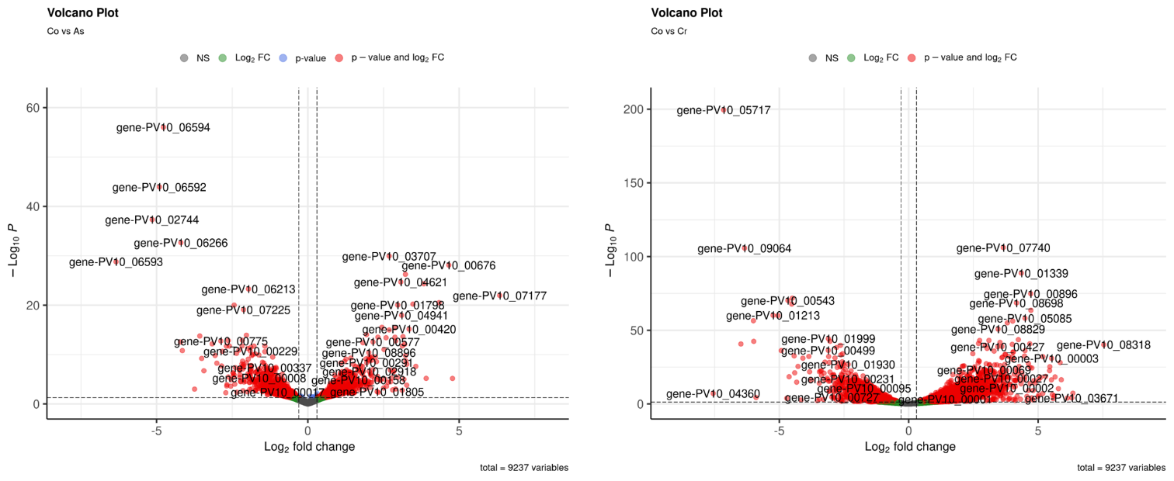
Figure 6. Volcano plot demonstrating the E. mesophila genes displaying high expression profile (large fold change values) and high statistical significance (as evidenced by the p-values) in (As/Cr)-free vs. (As/Cr)-stressed conditions. The data for all detected transcripts were plotted as log₂ fold change (x-axis), versus the −log₁₀ of the adjusted p-value (y-axis). Genes significantly upregulated or downregulated (at least 4-fold at p < 0.05)

GO and KEGG Pathway Enrichment Analysis of Differentially Expressed Genes
During GO classification, each of the unigenes were classified which was based on three functional categories: molecular functions, biological processes and cellular components (p-value ≤ 0.01 and FDR ≤ 0.1), which were clustered into 15, 10 and 0 classifications, respectively in arsenic treatments (Figure 7). To chroumium clustered into 22, 21 and 16, respectively. KEGG pathway analysis was performed to identify pathways associated with the DEGs. The DEGs, were mapped to 126 and 356 enriched pathways in arsenic and chromium. Eight significant enrichment pathways were identified (p-value < 0.05 and FDR ≤ 0.1) and listed in Table 1. During the analysis, pathways associated with human diseases were deliberately excluded.

Arsenic Metallotolerance Mechanisms in E. mesophila
Gene Ontology (GO) analysis revealed significant enrichment of terms related to small molecule metabolism (biological process). Specifically, enriched terms included carboxylic acid metabolic process, organic acid metabolic process, and oxoacid metabolic process (Figure 7 a-b). Furthermore, enriched terms within the molecular function category highlighted processes associated with energy metabolism and transport. These included ATP hydrolysis activity, organicion transmembrane transporter activity, and active transmembrane transporter activity. Importantly, GO terms associated with cellular process were not significantly enriched. Among the differentially expressed genes (DEGs), a cluster of 90 genes was identified that were associated with functions relevant to heavy metal tolerance. These functions included ATP-binding cassette (ABC) transporter activity, cation (Na+, K+, Ca2+) binding, vacuolar localization, and hemerythrin HHE cation binding.

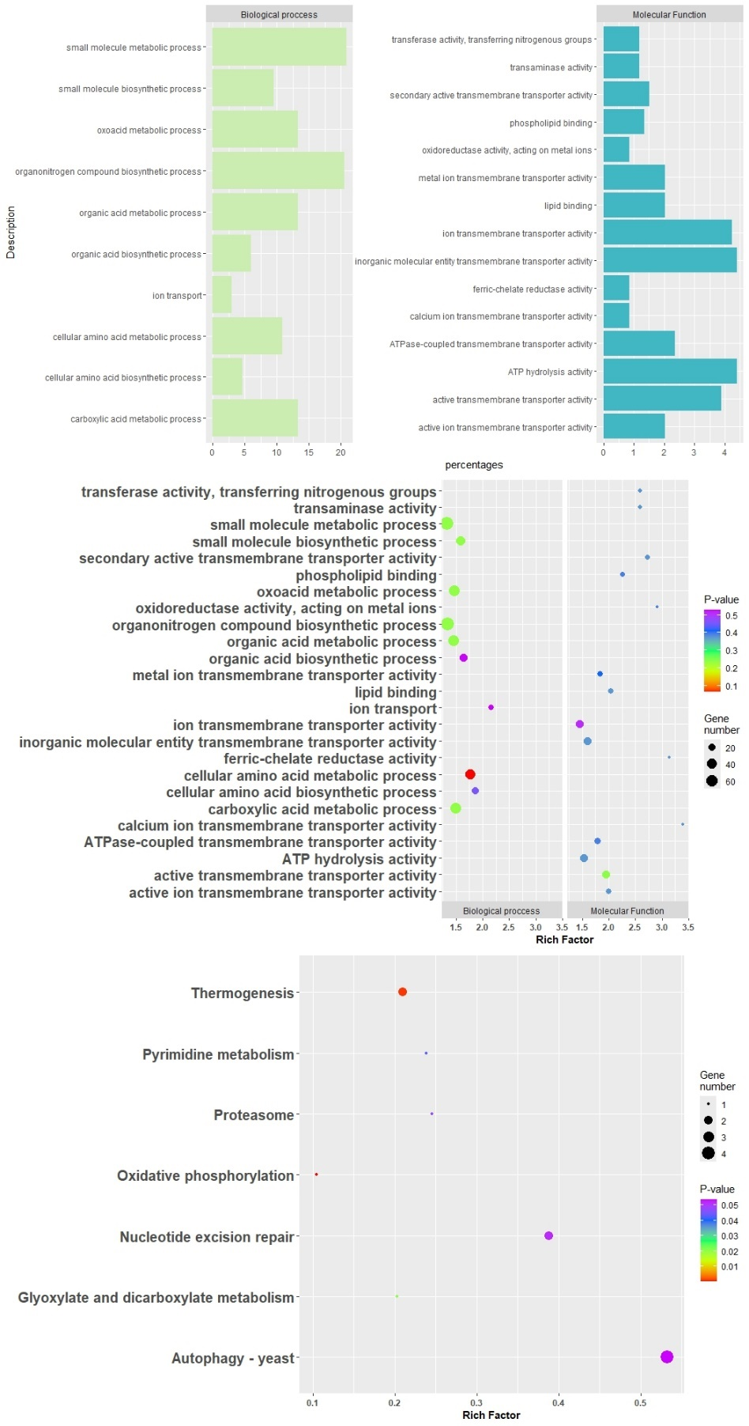
Figure 7. GO enrichment analysis of all DEGs. The enriched biological process, cellular component and molecular function GO terms of DEGs in Exophiala mesophila under As-free and As-stressed exposure. (Rigth) indicates the percentage of DEGs (lefth) gene numbers vs. P-values gene numbers in each GO term. KEGG metabolic pathways analysis of E. mesophila transcripts (numerous unigenes were classified into more than one metabolic class). Gene transcripts of a specific class in number of total 1231 annotated unigenes.

KEGG pathway análisis (Figure 7c), identified several significantly enriched pathways, including thermogenesis, pyrimidine metabolism, proteasome, oxidative phosphorylation, nucleotide excision repair, glyoxylate metabolism, dicarboxylate metabolism, and autophagy (yeast) (Figure X). However, these enriched pathways were associated with a relatively low number of expressed genes. To further investigate the As(V) resistance mechanism, a detailed analysis of genes related to heavy metal tolerance was conducted. These genes included those involved in metal binding and transport, transferase activity (nitrogenous group transfer), ferric-chelate reductase activity, methylation, DNA repair, superperoxide dismutate, and cell wall metabolic processes (listed in Table).

Chromuim metallotolence mechanims in E. mesophila
Gene Ontology (GO) enrichment analysis of differentially expressed genes (DEGs) in Cr(VI)-treated E. mesophila revealed associations with diverse genetic functions categorized under cellular component, molecular function, and biological processes (Figure 8 a-b). Positively regulated DEGs across all treatments were significantly enriched in biological processes primarily involving localization, transport, catabolic process, response to stress, and cellular response to DNA damage stimulus. Enriched molecular functions included ion transmembrane transporter activity, peptidase activity, structural molecule activity, and ATP hydrolysis activity. At the cellular component level, enriched terms encompassed cell periphery, cytoskeleton, peptidase complex, proteasome complex, and supramolecular polymer.
Unigenes associated with the induction of tolerance and detoxification of inorganic compounds were identified in the expression of genes encoding proteins involved in transport (NAPH2:quinone reductase, ferric quinone reductase, peroxisomal catalase (CAT), Mitochondrial distribution and morphology protein), DNA repair oxidoreductase complex (DNA repair protein rda, and structural maintenance of chromosomes protein).
KEGG análisis (Figure 8c) of fungal DEGs identified pathways involved in metal stress response, categorized primarily into eleven physiological categories, including carbohydrate metabolism, energy metabolism, and cofactor and vitamin metabolism (Table 1). Positively regulated DEGs were significantly enriched in valine, leucine, and isoleucine degradation, tyrosine and tryptophan metabolism, the thermogenesis pathway, oxidative phosphorylation, and alanine, aspartate, and glutamate metabolism, suggesting their essential role in metal stress response. Pentose and glucuronate interconversions, RNA polymerase, the pentose phosphate pathway, and pyrimidine and purine metabolism were primarily enriched in downregulated DEGs.

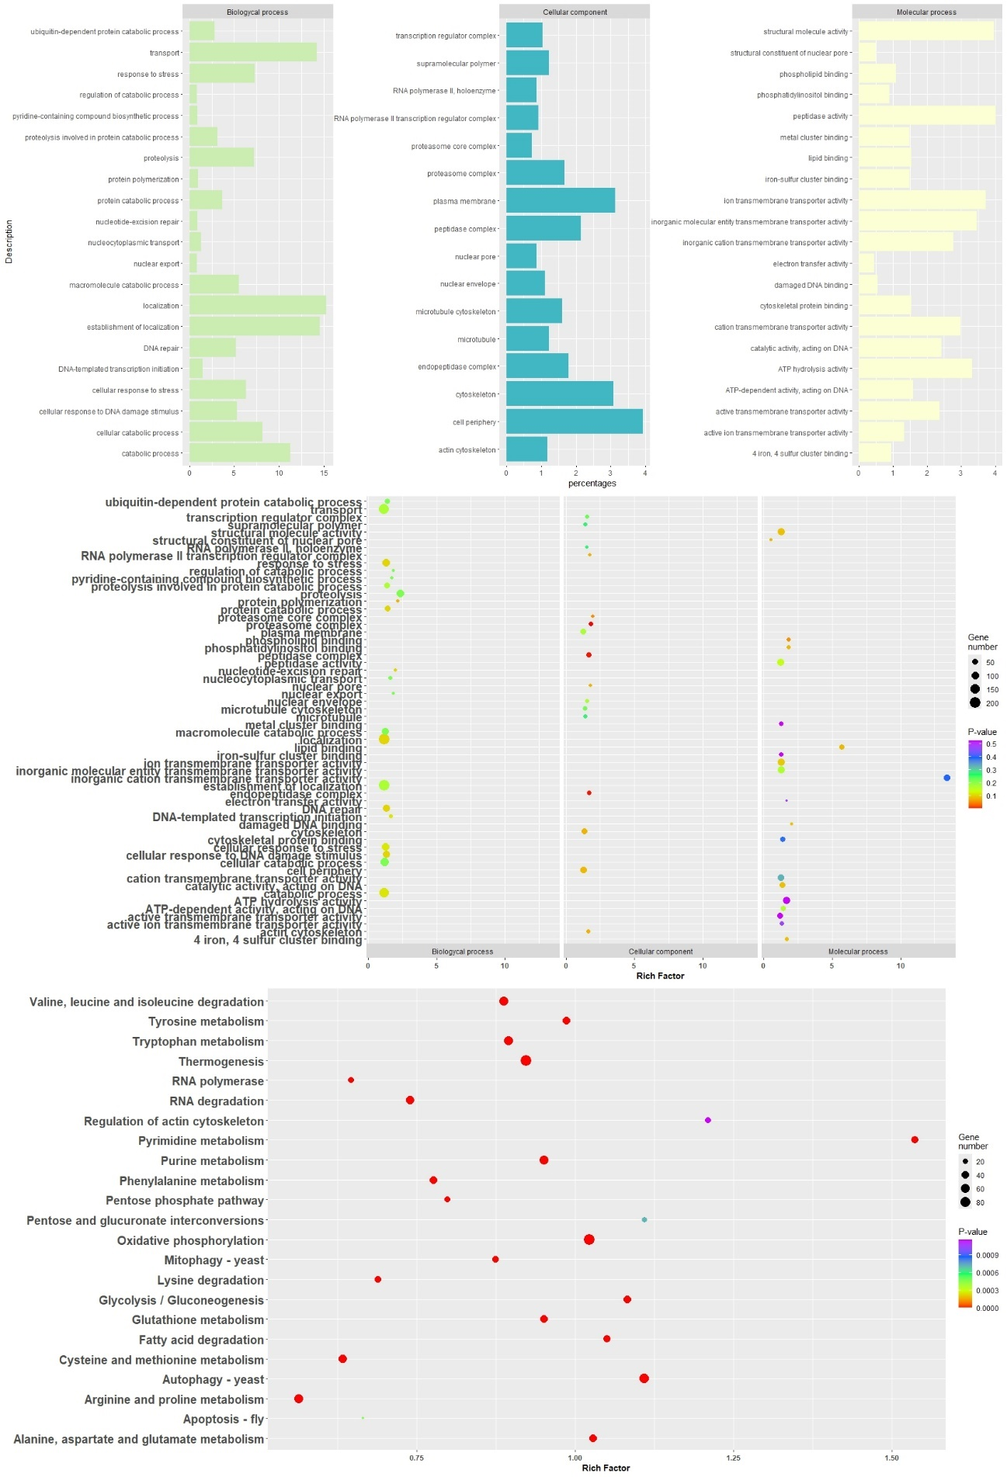
Figure 8. GO enrichment analysis of all DEGs. The enriched biological process, cellular component and molecular function GO terms of DEGs in Exophiala mesophila under Cr-free and Cr-stressed exposure. (Rigth) indicates the percentage of DEGs (lefth) gene numbers vs. P-values gene numbers in each GO term. KEGG metabolic pathways analysis of E. mesophila transcripts (numerous unigenes were classified into more than one metabolic class). Gene transcripts of a specific class in number of total 1231 annotated unigenes .

Discussion
Melanin rol in metalotolerance HHM
Our analysis of SR-FTIR revealed alterations in the DNA fingerprint region, particularly within the phosphodiester group bands, upon exposure to As(V) and Cr(VI). These changes suggest potential modifications in DNA structure, such as pyrimidine dimers or DNA-DNA/protein-DNA cross-links. Notably, these alterations were predominantly observed in the vibrations of the phosphodiester group (asymmetric PO₂ and symmetric PO₂), primarily in melanin-deficient cells exposed As(V)/Cr(VI). This suggests a heightened susceptibility to DNA organization or conformation changes under these conditions.
Overall, the investigation highlights a more pronounced biochemical response in the absence of melanin during As(V)/Cr(VI) exposure. The significan variance in the asymmetric and symmetric PO₂ bands, along with the initial changes in protein secondary structure, could be attributed to ROS generation through contact with toxic ions. This ROS generation can induce oxidative damage a wide range of molecules, including nucleic acids, proteins and lipids, potentially leading to the observed conformational changes, consistent with previous studies (Perrone et al., 2008; Zhan et al., 2016). Additionally, the changes in the phosphodiester group of proteins point towards a cascade of events involving extensive metabolic reorganization, encompassing transport, cellular homeostasis, DNA repair, and DNA/RNA synthesis.
The dramatic changes observed in As(V)/Cr(VI)-exposed, melanin-inhibited cells could be attributed to the initial apoptotic response triggered by ROS generation. In Saccharomyces cerevisiae, a direct link between endoplasmic reticulum (ER) stress induction, elevated mitochondrial matrix Ca(II) levels, ROS accumulation, and apoptosis promotion has yet to be established (Perrone et al., 2008). These findings suggest that melanin inhibition potentiates ROS generation within the cells, surpassing the levels observed in non-inhibited cells upon exposure to As(V)/Cr(VI). This elevated oxidative stress likely exerts a direct impact on mitochondria, cytochrome c, and the ER, prompting the cell to self-destruct through apoptosis.
Futhermore, chromium exposure exhibited the most pronounced effects across all investigated biochemical groups. In addition to the significant changes observed in DNA and proteins, we also identified a slight increase in the absorbance of the CH₂ and CH₃ stretching modes in the SR-FTIR spectra of lipids from exposed cells. This observation suggests potential alterations in lipid metabolism or increased lipid peroxidation, which is a hallmark of oxidative stress (Kumar et al., n.d.). Chromium-mediated lipid damage could disrupt the cell membrane of E. mesophila, ultimately leading to cell lysis. Furthermore, these peroxidation reactions could contribute to the generation of additional ROS, exacerbating the oxidative stress response.
Arsenic Metallotolerance Mechanisms in Exophiala mesophila
SR-FTIR analysis revealed potential alterations in protein secondary structure in Exophiala mesophila following arsenic exposure. These changes are likely attributed to the generation of reactive oxygen species (ROS) and subsequent oxidative damage. This finding aligns with the observed upregulation of superoxide dismutase (SOD) genes in E. mesophila through gene expression analysis. This is a well-documented phenomenon, suggesting a cellular defense mechanism against the increased ROS generated by arsenic stress.
Previous studies have established the metal-chelating properties of melanin due to its abundant carboxyl, phenolic, hydroxyl, and amine groups (Fogarty and Tobin, 1996). These functional groups act as potential binding sites for metal ions. Interestingly, our SR-FTIR analysis of arsenic-exposed E. mesophila cells with melanin revealed significant changes in wavenumbers associated with cell wall and membrane hydrocarbons and lipids. However, no alterations were observed in the aromatic structures corresponding to melanin or chitin. This observation suggests that direct binding of arsenic to cell wall melanin via electrostatic attraction is less likely. The negatively charged cell wall and arsenate could lead to repulsion. Consequently, complexation with other cations like Fe(III) or Ca(II) might mediate arsenic association with melanin. Supporting this notion, we observed the overexpression of ferri-chelate reductase (FRO2) genes. This suggests the formation of a complex between As(V) and Fe(III), potentially facilitating arsenic binding to melanin. Additionally, iron reduction can generate ROS, further contributing to oxidative stress in the cell wall. Melanin's ability to quench and detoxify superoxide ions might be crucial for maintaining cellular stability, potentially creating a functional overlap with metal binding. Melanin and the antioxidant enzyme SOD could act synergistically during arsenic stress. Extracellular melanin could initially buffer oxidative bursts, while intracellular SOD provides further protection. SR-FTIR analysis with melanin inhibition revealed alterations in functional groups associated with potential metal binding, including prominent protein modifications. This suggests excess ROS production, potentially due to reduced cell wall melanin. However, further research is necessary to fully elucidate the intricate interaction between melanin, ROS, and their combined protective roles
In the cytosol, potential protective mechanism involves Hemerythrin/HHE (Hr) proteins. Traditionally known for their iron Fe(III) and oxygen binding capabilities, Hr proteins in E. mesophila might be upregulated to sequester arsenic or other displaced cations, shielding cellular components from their toxic effects. In Cryptococcus neoformans, Hr cation-binding domains have been implicated in the response to nitric oxide (Chow et al., 2007), suggesting potential alternative ligand interactions. However, research on the role of fungal Hr proteins in metal detoxification, including intracellular sequestration, metal compartmentalization in vacuoles, and ROS management in conjunction with antioxidant enzymes like superoxide dismutase (SOD) and catalase (CAT), is scarce (Bellini et al., 1583).
Transcriptomic analysis revealed a significant upregulation of genes encoding transporter proteins in Exophiala mesophila following arsenic exposure. These upregulated transporters included ATP-binding cassette (ABC) transporters, Na⁺/K⁺ transporters, Fe²⁺ transporters, and Ca²⁺ transporters (Yor1). This robust transcriptional response suggests a potential mechanism for E. mesophila to adapt to arsenic stress. Interestingly, biochemical analyses did not detect dramatic changes in metabolite profiles between control and arsenic-treated samples. This suggests that the upregulated transporter genes likely contribute to maintaining cellular integrity by facilitating the controlled influx and efflux of various ions (Na⁺, K⁺, Ca²⁺, Fe²⁺) across the cell membrane. This regulated transport system could act to counteract the disruptive effects of arsenic on cellular ion homeostasis. Similar observations of upregulated transporter gene expression in response to arsenic stress have been reported in other fungi, such as Aspergillus oryzae (Liang et al., 2021). Additionally, Cladophialophora exuberans exhibits upregulated transporter regulation in response to copper stress (Silva et al., 2023). These findings support the hypothesis that transporter regulation plays a crucial role in fungal adaptation to various metal exposures. The observed downregulation of some putative arsenic transporters may represent another facet of E. mesophila's resistance strategy. By downregulating these transporters, the fungus might limit arsenic influx. However, the upregulation of transporters like the vacuolar calcium ion transporter (VCX) suggests a more complex regulatory network. This specific transporter might facilitate the movement of arsenic ions into the vacuole, potentially sequestering them away from sensitive cellular components. Similar roles for vacuoles in heavy metal detoxification have been described in other organisms (Lenassi et al., 2013; Zhao et al., 2015; Silva et al., 2023).
A remarkable alignment between biochemical and gene expression analyses highlights the complex mechanisms underlying arsenic tolerance in Exophiala mesophila. SR-FTIR analysis revealed alterations in protein secondary structure and downregulation of molecular functions in Gene Ontology (GO) analysis. These findings are consistent with the functional genomics data, suggesting a prominent role for transport mechanisms in arsenic resistance. This notion is further supported by the lack of dramatic changes in biochemical parameters between control and arsenic-treated samples. This suggests that the regulated transport system effectively buffers cells against arsenic-induced perturbations.
Beyond transport regulation, KEGG pathway analysis unveils additional adaptation strategies employed by E. mesophila. Alterations in pyrimidine metabolism suggest a prioritization of RNA synthesis, potentially for the production of new proteins or enzymes essential for stress response and adaptation. Additionally, the upregulation of genes associated with oxidative phosphorylation implies an effort to maintain energy production despite the stress induced by arsenic. Notably, the overexpression of proteins potentially acting as arsenic transporters to mitochondria (COX1) was observed. This finding aligns with the observed upregulation of the proteasome, specifically the protein Putative Proteasome Subunit Beta 7 (PSMB7). Proteasome metabolims in Golgi complex play a crucial role in eliminating misfolded or damaged proteins resulting from arsenic exposure (Sigler et al., 1999; Poljsak et al., 2010).
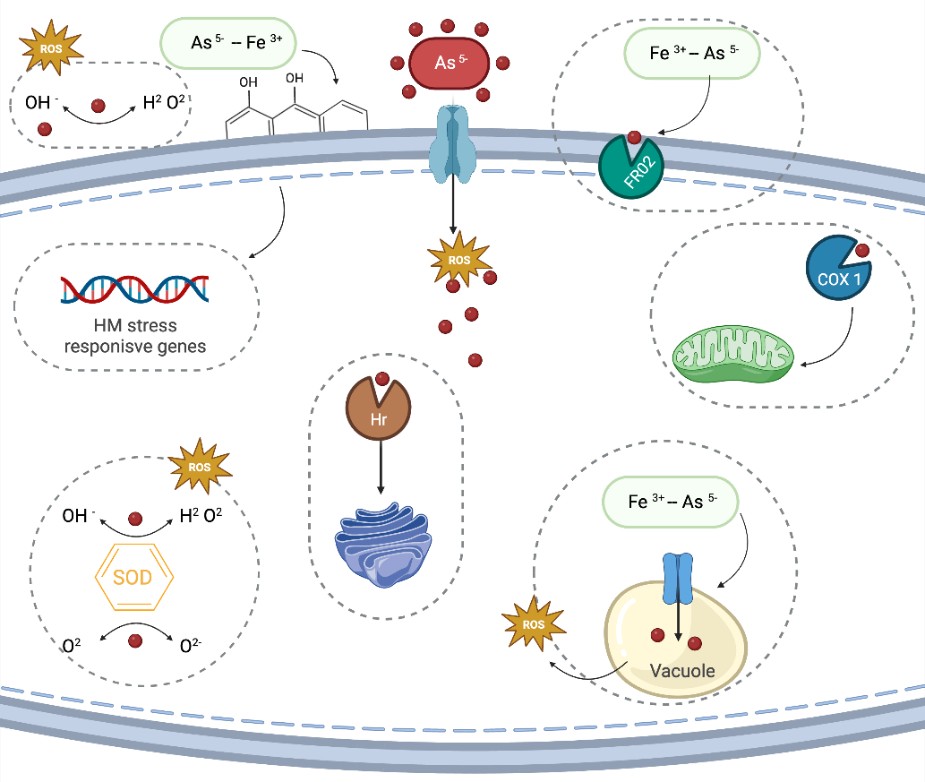

Figure 10. Schematic representation of possible genetic pathways associated to influx and efflux of As(V) in Exophiala mesophila (As(V)- is the Red spheric). YOR1 - Putative ABC transporter permease protein; FRO2 - Ferric/chelate reductase; HR - Hemerithrin; SOD - Superoxide dismutase; PMC1 - Calcium Transport Protein in vacuole; COX - Cytochrome c oxidase; PIC2 - Mitochondrial phosphate carrier protein 2; CRM1 - Chromosome region maintenance protein 1; PSMB7 - Putative Proteasome Subunit Beta 7.

Chromium Metallotolerance Mechanisms in E. mesophila
Chromium exposure exerts its toxic effects on E. mesophila at the cellular level, causing significant damage to the cell wall, proteins, DNA, polysaccharides, and overall cellular integrity. This is in contrast to arsenic exposure, where the primary response involves altered transport mechanisms. SR-FTIR analysis revealed that chromium exposure affects the biochemistry of E. mesophila aregardless of melanin inhibition, this suggests a high likelihood of cell lysis.
Metal exposure has been linked to the increased biosynthesis of glutathione (GSH), a low-molecular-weight chelator molecule that protects essential metabolic proteins from binding to heavy metals (Perrone et al., 2008). Furthermore, chromium exposure can induce apoptosis through oxidative stress, due increased formation of reactive oxygen species (ROS) and mitochondrial damage. This process involves cytochrome c release, DNA fragmentation, phosphatidylserine exposure, and metacaspase activation (Majumder et al., 2017). Mitochondria play a crucial role in cell cycle regulation and differentiation, and their membrane permeability is critical during apoptosis.
Exposure to chromium triggers rapid changes in gene expression in E. mesophila, contrasting with the significant supramolecular changes observed through SR-FTIR analysis. Notably, there is upregulation of genes associated with cellular detoxification, including those encoding NDH-quinone: NADPH dehydrogenase quinone (YCP4) and peroxisomal catalase (CAT). This finding suggests the activation of defense mechanisms against chromium-induced stress. Intriguingly, overexpression of NDH-quinone is observed. This is consistent with the reduction of chromium Cr(VI) to Cr(III) under aerobic conditions, a process typically associated with soluble chromate reductases that utilize NADH or NADPH as cofactors (Viti et al., 2014). However, it is important to note that this NADPH-dependent reduction of Cr(VI) to Cr(III) generates reactive oxygen species (ROS) intermediates. The upregulation of catalase (CAT) suggests a potential mechanism for controlling these ROS intermediates. Additionally, quinols produced by the quinone reductase activity of NDH-quinone confer tolerance to ROS (Gonzalez et al., 2005). Therefore, it is possible that the ROS generated by NDH-quinone during Cr(VI) reduction are neutralized by the quinols formed by the same enzyme. This creates a potential self-regulating system for managing ROS production during chromium detoxification.
Exposure to chromium triggers diverse responses in E. mesophila, including the upregulation of genes associated with various transport mechanisms. Gene Ontology (GO) analysis revealed significant changes in biological processes and molecular functions related to transport. Among the highly expressed genes, those encoding transporter proteins stand out, including K/Na efflux P-type ATPase (fungal type) (ENA1), copper-translocating P-type ATPase (ctpA), electron carrier (ETC), and F-actin-capping protein alpha subunit (CAP1). This suggests a multifaceted adaptation for chromium transport into the cytosol. These transport mechanisms may also facilitate the reduction of Cr(VI) and the release of reduced chromium compounds, such as CrO4²⁻ and SO4²⁻. GO analysis indicates involvement in iron-sulfur cluster binding, potentially implicating the electron transport chain (ETC) of complex I. This ETC could utilize S(0) or Fe(0) as inorganic electron donors for biological Cr(VI) reduction.
The oxygen-containing functional groups of melanin (C–O, CO–OH, C–OH, and C–O–R) could also serve as electron donors (π electrons) for Cr(VI) reduction. SR-FTIR analysis revealed a decrease in the C=O stretch ratio in chromium- and melanin-exposed samples compared to the control. This observation suggests that during the interaction between Cr(VI) and fungal biomass, some C–O groups may be oxidized to C=O, leading to the reduction of Cr(VI) to Cr(III). Similar observations have been reported by other researchers, suggesting that fungi can bind Cr(VI) to available carboxyl groups on their mycelia, converting Cr(IV) to non-toxic Cr(III) (Vieira et al., 2010; Majumder et al., 2017). Furthermore, SR-FTIR analysis detected changes in frequencies between C-O streching in the chromium-exposure treatments. These changes may represent the formation of Cr(III)-phosphate complex moieties. Majumder et al. (2017) reported the oxidation of C–O groups to C=O under Cr(VI) exposure and also found the involvement of phosphate and sulfonyl groups in chromate ion coordination. Additionally, they observed shifts in peaks from 1,029 cm⁻¹ to 1,033 cm⁻¹ and 531 cm⁻¹ to 576 cm⁻¹, potentially indicating the formation of Cr(III)-phosphate compounds (Majumder et al., 2017). Overall, the findings highlight the complex interplay between reduction mechanisms of Cr(VI), and melanin-mediated redox reactions in the chromium of E. mesophila.
Exposure to chromium has a profound impact on various metabolic pathways in E. mesophila, as revealed by KEGG pathway analysis. Notably, purine and pyrimidine metabolism, which provide building blocks for DNA and RNA synthesis, are significantly affected. These combined effects highlight the widespread cellular disruption caused by chromium exposure (Poljsak et al., 2010). To counteract chromium-induced DNA damage, two types of proteins involved in DNA repair processes were overexpressed, as indicated by Gene Ontology (GO) analysis: DNA protein rad2 (RAD2) and ATP-dependent DNA helicase II (ku70).
The disruption of DNA integrity and the subsequent repair mechanisms are accompanied by alterations in energy regulation through oxidative phosphorylation. This suggests that cells attempt to maintain energy production despite the stress induced by chromium exposure. In addition to autophagy-related metabolic pathways, the upregulation of autophagy genes reveals another adaptive mechanism employed by E. mesophila to cope with chromium-induced stress. Autophagy is an essential cellular process that involves the recycling of damaged or unnecessary cytoplasmic components through lysosomal degradation (Chiarelli and Roccheri, 2012). Fatty acid degradation may also highlight a crucial role for melanin as an electron acceptor in lipid degradation reactions. This electron-accepting capacity of melanin could potentially reduce the generation of reactive oxygen species (ROS) during lipid metabolism. Consequently, melanin might act as a protective mechanism against chromium-induced oxidative stress.
Intriguingly, chromium exposure appears to induce the metabolic activity of tyrosine, tryptophan, and phenylalanine, potentially leading to melanin production via the dopa-melanin pathway. This finding contrasts with the previously observed tricyclazole-induced inhibition of DHN-melanin synthesis in E. mesophila. This suggests a remarkable ability for E. mesophila to produce melanin through distinct pathways depending on the specific environmental stress encountered. However, increased tyrosine metabolism does not solely confirm melanin synthesis. It could contribute to protein synthesis for fungal growth, or alternatively, tyrosine degradation could serve as an energy source during limited nutrients. Notably, previous studies reported similar observations: overexpression of tyrosine metabolism in Exophiala pisciphila (Zhao et al., 2015), but without a connection to dopa-melanin production. Additionally, another study documented enhanced melatonin synthesis enzymes in E. pisciphila driven by tryptophan hydroxylase activity (Yu et al., 2021). These findings highlight the diverse metabolic pathways Exophiala species can utilize for melanin production depending on the specific environmental stressor.

Conclusión
In conclusion, the combined analysis of the E. mesophila genome assembly and annotation with SR-FTIR testing under HMM (heavy metal and metalloid) conditions provides valuable insights into the mechanisms employed by this fungus to tolerate extreme environments and potentially adapt to them. This comprehensive approach goes beyond establishing E. mesophila's potential for hydrocarbon bioremediation by identifying it as a promising candidate for heavy metal bioremediation. Transcriptome analysis revealed genes associated with transport mechanisms potentially responsible for arsenic uptake and homeostasis within the fungal cell. While chromium exhibits greater cellular toxicity, the combined action of Cr(VI) reduction mechanisms, repair processes, and catalase activity likely allows this fungus to tolerate high chromium concentrations. However, due to the limited genomic information available for black fungi, further studies are needed to validate the function and expression of identified genes in the presence of the tested heavy metals. This validation will solidify E. mesophila's potential as a bioremediation agent.

Author Contributions: CM-A: conceptualization, data curation, formal analysis, investigation, writing—original draft. IY: analytical work, interpretation (FTIR characterization). CM-A: laboratory experiments and bioinformatics work. FP-B: project administration, supervision, writing—review and editing. All the authors made critical contributions to the whole manuscript.
Funding: This research was funded by the Spanish Agencia Estatal de Investigación for funding (PID2019-111572RB-I00/AEI/10.13039/501100011033, MIC-RICE project), and the Consolidated Research Group SOSBIO (ref. 2021 SGR 01568) Generalitat de Catalunya). Cristy Medina-Armijo was a recipient of the fellowship Agencia Nacional de investigación y Desarrollo (ANID) from Chile.
Acknowledgments: This research was supported by the CERCA Programme/Generalitat de Catalunya. The FTIR experiments were performed at MIRAS beamline at ALBA Synchrotron with the collaboration of ALBA staff. The support of the CERCA Programme/Generalitat de Catalunya is also acknowledged.
Conflicts of Interest: The authors declare no conflict of interest.

References

Aramaki, Takuya. 2020. “KofamScan.” GitHub Repository. https://github.com/takaram/kofam_scan.
Babraham Bioinformatics: FastQC Una herramienta de control de calidad para datos de secuencia de alto rendimiento (n.d.). Available at: https://www.bioinformatics.babraham.ac.uk/projects/fastqc/ [Accessed April 17, 2024].
Bellini, E., Maresca, V., Betti, C., Castiglione, M. R., Fontanini, D., Capocchi, A., et al. (2020). The Moss Leptodictyum riparium Counteracts Severe Cadmium Stress by Activation of Glutathione Transferase and Phytochelatin Synthase, but Slightly by Phytochelatins. Int. J. Mol. Sci. Artic. Int. J. Mol. Sci 2020, 1583. doi: 10.3390/ijms21051583.
Bolger, A. M., Lohse, M., and Usadel, B. (2014). Trimmomatic: a flexible trimmer for Illumina sequence data. Bioinformatics 30, 2114–2120. doi: 10.1093/bioinformatics/btu170.
Chiarelli, R., and Roccheri, M. C. (2012). Heavy Metals and Metalloids as Autophagy Inducing Agents: Focus on Cadmium and Arsenic. Cells 1, 597. doi: 10.3390/cells1030597.
Chow, E. D., Liu, O. W., O’Brien, S., and Madhani, H. D. (2007). Exploration of whole-genome responses of the human AIDS-associated yeast pathogen Cryptococcus neoformans var grubii: Nitric oxide stress and body temperature. Curr. Genet. 52, 137–148. doi: 10.1007/S00294-007-0147-9/FIGURES/6.
de Hoog, G. S., Vicente, V. A., Najafzadeh, M. J., Harrak, M. J., Badali, H., and Seyedmousavi, S. (2011). Waterborne Exophiala species causing disease in cold-blooded animals. Persoonia Mol. Phylogeny Evol. Fungi 27, 46–72. doi: 10.3767/003158511x614258.
Díaz, P., Gimeno, Y., Carro, P., González, S., Schilardi, P. L., Benítez, G., et al. (2005). Electrochemical self-assembly of melanin films on gold. Langmuir 21, 5924–5930. doi: 10.1021/la0469755.
Dobin, A., Davis, C. A., Schlesinger, F., Drenkow, J., Zaleski, C., Jha, S., et al. (2013). STAR: ultrafast universal RNA-seq aligner. Bioinformatics 29, 15–21. doi: 10.1093/bioinformatics/bts635.
Ewels, P., Magnusson, M., Lundin, S., and Käller, M. (2016). MultiQC: summarize analysis results for multiple tools and samples in a single report. Bioinformatics 32, 3047–3048. doi: 10.1093/bioinformatics/btw354.
Feng, L., Song, Q., Jiang, Q., and Li, Z. (2021). The horizontal and vertical distribution of deep-sea sediments fungal community in the south China sea. Front. Mar. Sci. 8, 592784. doi: 10.3389/fmars.2021.592784/bibtex.
Fogarty, R. V., and Tobin, J. M. (1996). Fungal melanins and their interactions with metals. Enzyme Microb. Technol. 19, 311–317. doi: 10.1016/0141-0229(96)00002-6.
García-Alcalde, F., Okonechnikov, K., Carbonell, J., Cruz, L. M., Götz, S., Tarazona, S., et al. (2012). Qualimap: evaluating next-generation sequencing alignment data. Bioinformatics 28, 2678–2679. doi: 10.1093/bioinformatics/bts503.
Gonzalez, C. F., Aekerley, D. F., Lynch, S. V., and Matin, A. (2005). ChrR, a soluble quinone reductase of Pseudomonas putida that defends against H2O2. J. Biol. Chem. 280, 22590–22595. doi: 10.1074/jbc.M501654200.
Valido, H. I., Resina-Gallego, M., Yousef, I., Luque-Gálvez, M. P., Valiente, M., and López-Mesas, M. (2020). Calcium oxalate kidney stones, where is the organic matter?: A synchrotron based infrared microspectroscopy study. J. Biophotonics 13, 1–8. doi: 10.1002/jbio.202000303.
Kirchhoff, L., Olsowski, M., Rath, P. M., and Steinmann, J. (2019). Exophiala dermatitidis: Key issues of an opportunistic fungal pathogen. Virulence 10, 984–998. doi: 10.1080/21505594.2019.1596504.
Lenassi, M., Gostinčar, C., Jackman, S., Turk, M., Sadowski, I., Nislow, C., et al. (2013). Whole genome duplication and enrichment of metal cation transporters revealed by de novo genome sequencing of extremely halotolerant black yeast Hortaea werneckii. PLoS One 8, e71328. doi: 10.1371/journal.pone.0071328.
Liang, J., Liu, J., Cheng, T. Q., and Song, W. (2021). Comparative transcriptome analysis providing resistance mechanism of Aspergillus oryzae under arsenate stress. Geomicrobiol. J. 38, 426–435. doi: 10.1080/01490451.2021.1877854.
Liao, Y., Smyth, G. K., and Shi, W. (2014). Feature Counts: an efficient general purpose program for assigning sequence reads to genomic features. Bioinformatics 30, 923–930. doi: 10.1093/bioinformatics/btt656.
Love, M. I., Huber, W., and Anders, S. (2014). Moderated estimation of fold change and dispersion for RNA-seq data with DESeq2. Genome Biol. 15, 1–21. doi: 10.1186/S13059-014-0550-8/figures/9.
Majumder, R., Sheikh, L., Naskar, A., Vineeta, Mukherjee, M., and Tripathy, S. (2017). Depletion of Cr(VI) from aqueous solution by heat dried biomass of a newly isolated fungus Arthrinium malaysianum: A mechanistic approach. Sci. Rep. 7. doi: 10.1038/s41598-017-10160-0.
Martínez-Rovira, I., Seksek, O., Puxeu, J., Gómez, J., Kreuzer, M., Dučić, T., et al. (2019). Synchrotron-based infrared microspectroscopy study on the radiosensitization effects of Gd nanoparticles at megavoltage radiation energies. Analyst 144, 5511–5520. doi: 10.1039/c9an00792j.
Medina-armijo, C. (2024.). Characterization of melanin from Exophiala mesophila with the prospect of potential biotechnological applications.
Medina-Armijo, C., Isola, D., Illa, J., Puerta, A., Viñas, M., and Prenafeta-Boldú, F. X. (2024). The metallotolerance and biosorption of As(V) and Cr(VI) by Black Fungi. J. Fungi 2024, Vol. 10, Page 47 10, 47. doi: 10.3390/jof10010047.
Ng, C. Y., de Hoog, S., Li, H. E., Lee, Y. Y., Chen, C. B., and Sun, P. L. (2017). Cutaneous Exophiala oligosperma infection in a patient with bullous pemphigoid with a review of the Literature. Mycopathologia 182, 539–547. doi: 10.1007/s11046-016-0104-6/tables/3.
Perrone, G. G., Tan, S. X., and Dawes, I. W. (2008). Reactive oxygen species and yeast apoptosis. Biochim. Biophys. Acta - Mol. Cell Res. 1783, 1354–1368. doi: 10.1016/j.bbamcr.2008.01.023.
Prota, G. (1992). Melanins and melanogenesis. Academic Press. San Diego, CA, USA, 1992.
Seyedmousavi, S., Badali, H., Chlebicki, A., Zhao, J., Prenafeta-boldú, F. X., and De Hoog, G. S. (2011). Exophiala sideris, a novel black yeast isolated from environments polluted with toxic alkyl benzenes and arsenic. Fungal Biol. 115, 1030–1037. doi: 10.1016/j.funbio.2011.06.004.
Silva, N. M. da, Reis, G. F., Costa, F. de F., Grisolia, M. E., Geraldo, M. R., Lustosa, B. P. R., et al. (2023). Genome sequencing of Cladophialophora exuberans, a novel candidate for bioremediation of hydrocarbon and heavy metal polluted habitats. Fungal Biol. 127, 1032–1042. doi: 10.1016/j.funbio.2023.03.003.
Tran-Ly, A. N., Reyes, C., Francis, ·, Schwarze, W. M. R., and Ribera, · Javier (2020). Microbial production of melanin and its various applications. World J. Microbiol. Biotechnol. 36, 170. doi: 10.1007/s11274-020-02941-z.
Usuda, D., Higashikawa, T., Hotchi, Y., Usami, K., Shimozawa, S., Tokunaga, S., et al. (2021). Exophiala dermatitidis. World J. Clin. Cases 9, 7963. doi: 10.12998/wjcc.v9.i27.7963.
Vieira, R. S., Lisa Oliveira, M. M., Guibal, E., Rodríguez-Castellón, E., and Beppu, M. M. (2010). Copper, mercury and chromium adsorption on natural and crosslinked chitosan films: An XPS investigation of mechanism. Physicochem. Eng. Asp. 374, 108–114. doi: 10.1016/j.colsurfa.2010.11.022.
Viti, C., Marchi, E., Decorosi, F., and Giovannetti, L. (2014). Molecular mechanisms of Cr ( VI ) resistance in bacteria and fungi. 38, 633–659. doi: 10.1111/1574-6976.12051.
Woo, P. C. Y., Ngan, A. H. Y., Tsang, C. C. C., Ling, I. W. H., Chan, J. F. W., Leung, S. Y., et al. (2013). Clinical spectrum of Exophiala infections and a novel Exophiala species, Exophiala hongkongensis. J. Clin. Microbiol. 51, 260–267. doi: 10.1128/jcm.02336 12/asset/997c9c86-0076-4ca5 b31e7b656183b83b/assets/graphic/zjm9990922290003.jpeg.
Yousef, I., Seksek, O., Sulé-Suso, J., Gil, S., Prezado, Y., and Martinez-Rovira, I. (2016). FTIR Study of the biochemical effects induced by X-Ray irradiations combined with GD nanoparticles in F98 glioma cells. Biophys. J. 110, 475a. doi: 10.1016/j.bpj.2015.11.2543.
Yu, G., Wang, L. G., Han, Y., and He, Q. Y. (2012). ClusterProfiler: An R package for comparing biological themes among gene clusters. Omi. A J. Integr. Biol. 16, 284–287. doi: 10.1089/omi.2011.0118/asset/images/large/figure1.jpeg.
Yu Y, Teng Z, Mou Z, et al. (2021). Melatonin confers heavy metal-induced tolerance by alleviating oxidative stress and reducing the heavy metal accumulation in Exophiala pisciphila, a dark septate endophyte (DSE). BMC Microbiol. 21(1):40. doi:10.1186/s12866-021-02098-1
Zhan, F., He, Y., Yang, Y., Li, Y., Li, T., and Zhao, Z. (2016). Effects of tricyclazole on cadmium tolerance and accumulation characteristics of a dark septate endophyte (DSE), Exophiala pisciphila. Bull. Environ. Contam. Toxicol. 96, 235–241. doi: 10.1007/s00128-015-1676-4.
Zhan, F., He, Y., Zu, Y., Li, T., and Zhao, Z. (2011). Characterization of melanin isolated from a dark septate endophyte (DSE), Exophiala pisciphila. World J. Microbiol. Biotechnol. 27, 2483–2489. doi: 10.1007/s11274-011-0712-8.
Zhao, D., Li, T., Shen, M., Wang, J., and Zhao, Z. (2015). Diverse strategies conferring extreme cadmium (Cd) tolerance in the dark septate endophyte (DSE), Exophiala pisciphila: Evidence from RNA-seq data. Microbiol. Res. 170, 27–35. doi: 10.1016/j.micres.2014.09.005.

