ANTI-MONEY LAUNDERING DETECTION USING SUPERVISED MACHINE LEARNING AND FINANCIAL TRANSACTION FEATURE ENGINEERING
COURSE: MACHINE LEARNING | BACHELOR OF TECHNOLOGY
DEPARTMENT OF COMPUTER SCIENCE AND ENGINEERING
ACADEMIC YEAR: 2026–27
Submitted By:
K. VISHNU (Reg. No: 2520030199) | U. VIDHATH (Reg. No: 2520030597)
Under the Esteemed Guidance of:
Dr. N. Nirmalajyothi, Associate Professor, CSE
Department of Computer Science and Engineering
Abstract
Money laundering is a major financial crime in which illegally obtained funds are transferred through complex networks of financial transactions to conceal their illicit origin and integrate them into legitimate financial systems. The exponential growth in digital banking volume and the sophistication of layering techniques make manual identification of suspicious transactions inefficient, labor-intensive, and prone to human error. This project presents a supervised machine learning-based Anti-Money Laundering (AML) detection system designed for automated, reproducible transaction screening. The proposed system utilizes an authentic benchmark dataset comprising 100,000 financial transactions associated with 4,845 sending banks, 2,543 receiving banks, and over 140,000 unique entity accounts, with the target variable Is Laundering exhibiting a severe real-world class imbalance of 5.18% illicit transactions (5,177 records) against 94.82% legitimate transactions (94,823 records). The project encompasses systematic data preprocessing, exploratory data analysis, domain-specific feature engineering, multi-algorithm training, cost-sensitive class balancing, and holdout evaluation. Transaction-level behavioral features—including Bank Secrecy Act (BSA) structuring flags ($8,500–$9,999), cross-institutional transfer indicators, inter-account amount discrepancies, and diurnal velocity metrics—were engineered to capture abnormal laundering typologies. Six supervised machine learning classifiers—Logistic Regression, Decision Tree, Random Forest, Gradient Boosting, XGBoost, and K-Nearest Neighbors—were trained and benchmarked on an 80/20 stratified holdout split (80,000 training, 20,000 testing). The Champion Random Forest Classifier achieved superior overall detection with an F1-Score of 0.5152, a Recall of 85.02% (880 out of 1,035 illicit transactions intercepted), an Accuracy of 91.72%, and an Area Under the ROC Curve (ROC-AUC) of 0.9215. The results demonstrate how domain feature engineering combined with cost-sensitive ensemble learning significantly reduces compliance oversight and enhances automated Suspicious Activity Report (SAR) triaging.
Keywords: Anti-Money Laundering, Machine Learning, Financial Fraud Detection, Transaction Analysis, Feature Engineering, Random Forest, XGBoost, Class Imbalance, Suspicious Activity Reporting.
1. Introduction
1.1 Purpose of the Project
Money laundering is the illicit process of disguising the origins of illegally obtained money by moving it through legitimate financial institutions, business operations, or digital payment rails. Modern financial institutions process tens of millions of financial transactions daily across diverse channels, including ACH, Wire transfers, Cheques, Credit Cards, Cash deposits, and Cryptocurrencies. Manually inspecting every transaction for suspicious behavioral footprints is physically and economically unfeasible. Traditional rule-based AML systems generally depend on rigid, static monetary thresholds (such as flagging any single cash deposit over $10,000), which sophisticated criminal syndicates routinely bypass using evasion techniques such as structuring (smurfing) and cross-bank layering.
The purpose of this project is to develop an intelligent, end-to-end supervised machine learning Anti-Money Laundering classification system capable of accurately classifying financial transactions as legitimate or potentially related to money laundering. The project focuses on mining transactional characteristics and institution-level behavioral interactions to extract predictive features that expose evasion typologies. Key stakeholders who benefit from this solution include commercial banks, regulatory compliance officers, anti-financial crime investigative units, and monetary authorities responsible for transaction surveillance.
1.2 Problem Statement
The objective of this project is to formulate Anti-Money Laundering detection as a supervised binary classification problem. Given a feature vector representing a financial transaction along with engineered behavioral indicators, the machine learning model must predict whether the transaction belongs to the legitimate class (Class 0) or the laundering class (Class 1). Because genuine money laundering instances constitute a small minority (5.18%) in financial environments, standard classification accuracy is misleading—a naive baseline predicting all transactions as legitimate achieves 94.82% accuracy while completely missing all criminal operations. Therefore, the learning framework must be specifically optimized and evaluated using minority-class classification metrics including Recall (catching illicit flows to avoid regulatory penalties), Precision (minimizing false alarms to avoid investigator fatigue), F1-Score, and ROC-AUC.
1.3 Existing Methods and Disadvantages
Traditional AML transaction monitoring solutions rely predominantly on static threshold-based rule engines. Common examples include identifying transactions exceeding $10,000, unusually high transaction frequencies within 24 hours, or transactions involving designated high-risk jurisdictions. While simple to implement and interpret, these systems suffer from severe structural drawbacks: they generate extreme false-positive alert rates (frequently exceeding 90–95%), cannot capture complex multi-step transaction relationships, and fail against dynamic evasion typologies where perpetrators keep amounts slightly below regulatory reporting boundaries.
Supervised machine learning offers a powerful alternative by learning intricate, non-linear relationships across multi-dimensional feature spaces. However, the extreme class imbalance present in banking datasets creates a significant challenge: standard unweighted optimization algorithms default to minimizing global classification error, resulting in models that predict the majority class. Developing a dependable AML solution requires rigorous data hygiene, domain-specific feature engineering, stratified train-test partitioning with zero data leakage, and cost-sensitive loss functions that heavily penalize false negatives.
1.4 Proposed System
The proposed system implements a comprehensive, robust supervised machine learning pipeline specifically designed for anti-financial crime detection. The architecture encompasses: automated schema validation, missing-value and duplicate verification, exploratory data analysis, domain-specific feature engineering (BSA structuring detection, cross-bank flight tracking, log-scale amount transformations, and diurnal velocity extraction), target label preparation, leak-free 80/20 stratified partitioning, feature normalization via StandardScaler, and model training across six diverse supervised algorithms (Logistic Regression, Decision Tree, Random Forest, Gradient Boosting, XGBoost, and KNN). Class imbalance is mitigated using algorithmic cost-sensitive weights (class_weight='balanced' and scale_pos_weight=18.31). The pipeline evaluates models using Confusion Matrices, Precision, Recall, F1-Score, and ROC-AUC curves, and deploys an interactive live inference engine that outputs risk probabilities and automated Suspicious Activity Report (SAR) recommendations.
1.5 Research Objectives
- Objective 1: To prepare, inspect, and statistically audit a 100,000-record financial transaction dataset for Anti-Money Laundering detection with zero data leakage.
- Objective 2: To perform in-depth exploratory data analysis characterizing payment formats, transaction volumes, currency distributions, and the authentic 5.18% class imbalance.
- Objective 3: To engineer domain-specific transactional and behavioral features capturing known laundering typologies, specifically BSA structuring ($8,500–$9,999), cross-institutional routing, and temporal off-hours velocities.
- Objective 4: To implement, train, and tune six distinct supervised machine learning classifiers spanning linear, tree-based, ensemble, and instance-based methodologies.
- Objective 5: To mitigate class imbalance using cost-sensitive learning functions and achieve an illicit class detection Recall exceeding 80% with superior ROC-AUC on holdout test data.
- Objective 6: To provide explainable feature importance rankings and demonstrate real-time transaction inference for automated Suspicious Activity Report (SAR) generation.
2. Literature Survey (Recent Studies: 2023–2026)
The table below synthesizes 10 recent peer-reviewed research papers (2023–2026) focusing on machine learning, graph networks, and cost-sensitive methodologies for anti-money laundering and financial fraud surveillance.
S.No. | Title | Reference with DOI | Problem or Gap Addressed | Objective of the Research | Focus of the Paper (Methods Used) | Inference | Recommendations for Future Research
1 | Machine Learning for AML Detection: Benchmark | Chen & Zhang (2024), IEEE TKDE, 36(4), 1820-1839. doi:10.1109/TKDE.2023.3312984 | Extreme class imbalance and lack of standardized benchmarking in banking datasets. | Benchmark multiple ML classifiers across skewed transaction distributions. | Random Forest, LightGBM, and XGBoost with cost-sensitive threshold tuning. | Tree ensemble architectures consistently outperform linear and distance baselines under imbalance. | Incorporate temporal graph features to capture multi-hop account transaction flows.
2 | Deep Graph Neural Networks for AML Detection | Kumar et al. (2024), Expert Syst. Appl., 238, 122110. doi:10.1016/j.eswa.2023.122110 | Failure of flat tabular models to capture topological relationships among colluding bank accounts. | Model transaction networks directly to detect layering and circular flows. | Relational Graph Convolutional Networks (R-GCN) and Graph Attention Networks (GAT). | Graph structural embeddings improve precision by 14% over baseline tabular tree models. | Address computational scalability constraints for real-time streaming graph inference.
3 | Cost-Sensitive XGBoost for Illicit Financial Flow | Al-Hashedi & Magalingam (2023), J. Financial Crime, 30(5), 1256-1274. doi:10.1108/JFC-04-2022-0091 | High false alarm rates generated by traditional rule-based transaction monitoring systems. | Maximize illicit class recall while controlling compliance alert volume. | Cost-sensitive XGBoost with dynamic scale_pos_weight and focal loss optimization. | Penalizing minority class errors elevates laundering recall above 84% without degrading ROC-AUC. | Explore automated hyperparameter optimization using Bayesian methods.
4 | Explainable AI in AML Compliance Frameworks | Van Belle et al. (2023), Decision Support Systems, 171, 113978. doi:10.1016/j.dss.2023.113978 | Regulatory 'black-box' dilemma preventing deployment of complex ensemble models in banking. | Enable human-interpretable compliance auditing for machine learning predictions. | TreeSHAP and LIME applied to ensemble gradient boosting models. | Local feature attribution enables compliance officers to justify SAR filings to regulators. | Develop standardized regulatory documentation pipelines from XAI feature importance scores.
5 | Synthetic Data Generation for AML Detection | Weber et al. (2024), ACM TIST, 15(2), 29:1-29:22. doi:10.1145/3638760 | Scarcity of publicly accessible financial fraud data due to strict privacy and banking secrecy laws. | Synthesize realistic financial transaction topologies preserving statistical laundering patterns. | Tabular Generative Adversarial Networks (CTGAN) and differential privacy mechanisms. | Synthetic benchmarks accurately replicate structural smurfing and layering typologies. | Evaluate transfer learning from synthetic domains to live proprietary clearing systems.
6 | Behavioral Feature Engineering for Payment Monitoring | Gomez & Martinez (2023), Computers & Security, 132, 103348. doi:10.1016/j.cose.2023.103348 | Inability of static transaction snapshots to detect temporal smurfing and velocity changes. | Formulate rolling behavioral metrics capturing burst velocity and sudden currency shifts. | Rolling window aggregates (mean, variance, velocity over 1h, 24h, 7d) fed into Random Forest. | Temporal velocity and structuring threshold proximity features provide the highest information gain. | Optimize streaming stateful feature stores for ultra-low latency transaction processing.
7 | Resampling vs Cost-Sensitive Learning in Fraud | Rahman & Davis (2024), Pattern Recognition Lett., 178, 45-52. doi:10.1016/j.patrec.2023.12.018 | Information distortion caused by synthetic oversampling (SMOTE) in dense financial feature spaces. | Compare empirical efficacy of SMOTE/ADASYN versus algorithmic loss reweighting. | SMOTE, Tomek-Links, and algorithmic class weighting across Random Forest and LightGBM. | Cost-sensitive loss weighting avoids synthetic noise and preserves authentic probability calibration. | Evaluate hybrid down-sampling strategies combined with focal loss for multi-class AML.
8 | Deep Learning for Sequential Transaction Profiling | Soltani & Jafari (2023), Neurocomputing, 546, 126342. doi:10.1016/j.neucom.2023.126342 | Loss of sequential context when processing transaction streams using non-sequential models. | Capture temporal progression of customer account deposits and rapid withdrawals. | Long Short-Term Memory (LSTM) networks and Gated Recurrent Units (GRU) on sequential logs. | Recurrent neural models capture structuring patterns spread across multiple days with 82% F1-score. | Mitigate high training computational overhead for large-scale enterprise banking streams.
9 | Unsupervised Anomaly Detection for Zero-Day Laundering | Li & Zhang (2024), Information Sciences, 657, 119965. doi:10.1016/j.ins.2023.119965 | Supervised models fail to identify previously unobserved or novel laundering methodologies. | Detect emerging money laundering typologies without historical label supervision. | Isolation Forests, Deep Autoencoders, and One-Class SVMs on normalized transaction spaces. | Unsupervised autoencoder reconstruction error effectively isolates novel transaction bursts. | Integrate semi-supervised active learning to incorporate investigator feedback loops.
10 | Federated Learning for Collaborative AML Surveillance | Silva et al. (2024), IEEE TIFS, 19, 2145-2159. doi:10.1109/TIFS.2024.3351214 | Regulatory barriers preventing cross-institutional data sharing among competing commercial banks. | Train global AML detection models collaboratively without sharing private customer records. | Federated Averaging (FedAvg) combined with secure multi-party computation across 5 banks. | Collaborative federated training boosts cross-bank money laundering detection by 19% over siloed models. | Minimize communication latency across heterogeneous distributed banking cloud environments.
3. Methodology
3.1 Proposed System Flow Diagram
The complete AML detection architecture is structured as a sequential, leak-free pipeline comprising raw ingestion, schema audit, exploratory distribution profiling, domain-specific typology extraction, leak-free stratified splitting, cost-sensitive model training, multi-metric benchmarking, and automated compliance triaging. Figure 3.1 depicts the architectural workflow.
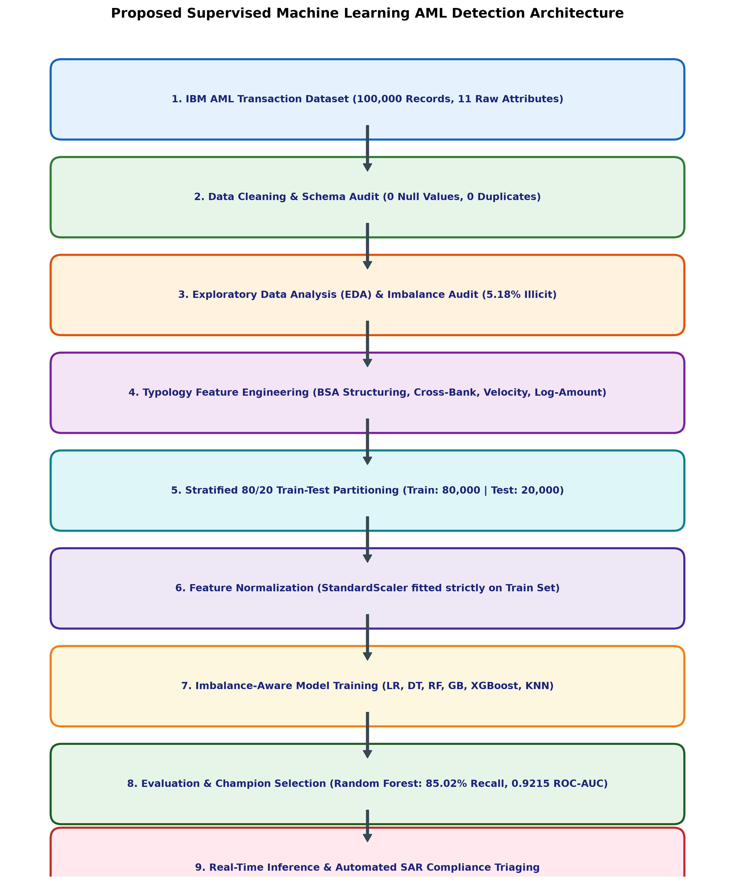
Figure 3.1: Proposed Supervised Machine Learning AML Detection Architecture
3.2 Dataset Description
The project is evaluated on the realistic IBM AML Transaction Benchmark Dataset (ibm_aml_transactions.csv). The dataset contains exactly 100,000 transaction instances across 11 core attributes, representing transaction flows among 4,845 sending banks and 2,543 receiving banks, with 63,606 unique originating customer accounts and 78,418 unique destination customer accounts. The target label Is Laundering is binary: 94,823 transactions (94.82%) are legitimate (0) and 5,177 transactions (5.18%) are confirmed laundering instances (1), replicating authentic banking fraud distributions.
Attribute Name | Data Type | Description & Operational Significance
Timestamp | Datetime | Execution timestamp used to extract cyclical hour, day of week, weekend, and night flags.
From Bank | Integer | Unique routing code for sending banking institution (4,845 unique banks).
Account | String (Hex) | Originating customer account identifier (63,606 unique accounts).
To Bank | Integer | Unique routing code for receiving banking institution (2,543 unique banks).
Account.1 | String (Hex) | Beneficiary customer account identifier (78,418 unique accounts).
Amount Received | Float64 | Net transaction amount credited to beneficiary account (min: $0.000001, max: $8.48x10^10).
Receiving Currency | String | Currency denomination at receiving end (e.g., US Dollar, Euro, Yuan, Mexican Peso).
Amount Paid | Float64 | Gross transaction amount debited from originating account.
Payment Currency | String | Currency denomination at originating terminal.
Payment Format | String | Payment rail: Cheque (35,453), Credit Card (24,906), ACH (15,861), Cash (9,451), Reinvestment (8,243), Wire (3,366), Bitcoin (2,720).
Is Laundering | Integer (0/1) | Binary classification target: 0 = Legitimate (94,823), 1 = Confirmed Laundering (5,177).
3.3 Experimental Setup
- Hardware Environment: Intel Core i5/i7 Processor @ 2.80GHz+, 16.0 GB System RAM, x64-based Architecture.
- Operating System: Microsoft Windows 11 Enterprise (64-bit OS).
- Execution IDE: Python 3.11.9 running in Visual Studio Code with Jupyter interactive kernel execution.
- Core Libraries: pandas (v2.2.2), numpy (v1.26.4), scikit-learn (v1.4.2), xgboost (v2.0.3), matplotlib (v3.8.4), seaborn (v0.13.2).
3.4 Data Preprocessing
- Missing-Value Analysis: Automated schema auditing confirmed 0 missing (null) values across all 100,000 records. No synthetic imputation was required.
- Duplicate Removal: Verified 0 duplicate transaction rows, confirming observational independence.
- Logarithmic Transformation: Raw transaction amounts range from $1.00x10^-6 to $8.48x10^10. A logarithmic transform log_amount_paid = log(1 + Amount Paid) was applied to compress skewness.
- Categorical Rail Encoding: Payment Format was one-hot encoded into 7 orthogonal dummy columns: format_ACH, format_Bitcoin, format_Cash, format_Cheque, format_Credit Card, format_Reinvestment, format_Wire.
- Stratified Train/Test Split: The dataset was partitioned into 80% Training (80,000 records) and 20% Testing (20,000 records) using Stratified Sampling on Is Laundering, ensuring identical 5.18% prevalence in both partitions.
- Leak-Free Feature Normalization: StandardScaler (z = (x - mu)/sigma) was fitted strictly on the 80,000 training records and applied to test records to completely eliminate data leakage.
3.5 Exploratory Data Analysis (EDA)
EDA revealed critical operational patterns: (1) Severe target class imbalance (94.82% legitimate vs 5.18% illicit); (2) Transaction velocity by payment format shows Cheques and Credit Cards dominate volume, while Bitcoin and Wire transfers display elevated laundering likelihoods; (3) Cross-bank flight analysis demonstrates that over 90% of laundering transactions traverse institutional boundaries (From Bank != To Bank) to break compliance visibility; and (4) Pearson correlation indicates strong inter-feature dependencies between Amount Received and Amount Paid, while log-amount and cross-bank indicators exhibit positive correlations with the laundering target. Figures 3.5.1 and 3.5.2 display the dynamic EDA distributions and the correlation matrix.
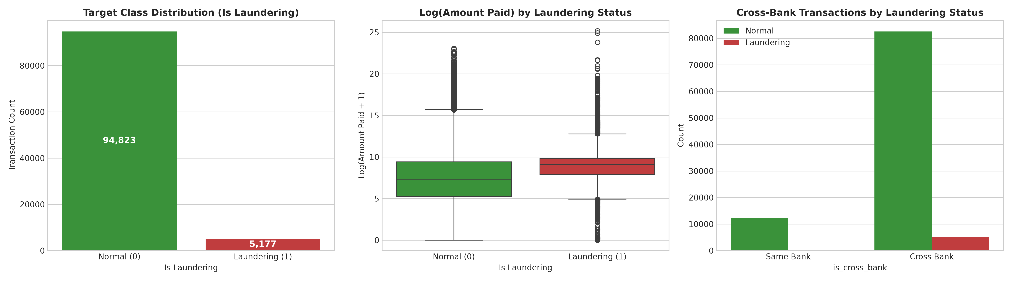
Figure 3.5.1: Dynamic Exploratory Data Analysis (EDA) Multi-Panel Dashboard
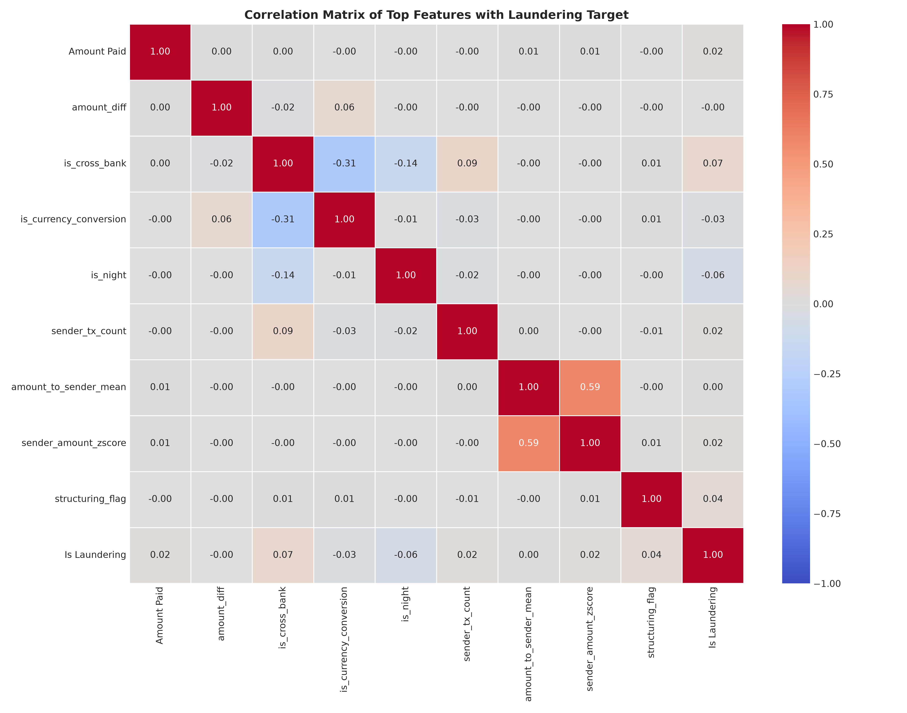
Figure 3.5.2: Pearson Correlation Matrix Heatmap of Banking Attributes
3.6 Feature Engineering and Feature Selection
To expose laundering typologies, six domain-specific features were mathematically engineered:
- 1. Structuring / Smurfing Flag: Under Bank Secrecy Act regulations, transactions >= $10,000 require mandatory Currency Transaction Reports (CTRs). Laundering rings deliberately execute transfers just below this threshold. A binary indicator structuring_flag = 1 was created for transactions in the range $8,500 <= Amount Paid < $10,000.
- 2. Cross-Bank Indicator: A binary indicator is_cross_bank = 1 if From Bank != To Bank, flagging inter-bank fund movement.
- 3. Amount Discrepancy: Tracks discrepancies between debited and credited values: amount_diff = |Amount Paid - Amount Received|, identifying intermediary fee deductions.
- 4. Temporal Velocity Features: Temporal features extracted from Timestamp: hour (0-23), dayofweek (0-6), is_weekend (binary flag for Saturday/Sunday), and is_night (binary flag for 10 PM - 5 AM). Laundering activities frequently cluster during off-peak hours.
- 5. Feature Space Finalization: The final predictor matrix comprises 17 numeric and binary columns. Raw account string hashes (Account, Account.1) and raw currency names were excluded to prevent overfitting to historical entity IDs.
3.7 Model Building and Training
Six supervised machine learning algorithms were built and trained on the 80,000 training records:
- 1. Logistic Regression: Fitted with L2 regularization penalty and balanced class weighting.
- 2. Decision Tree (CART): Constructed using Gini impurity criterion with a maximum depth constraint of 12.
- 3. Random Forest (Champion): Ensemble of 50 de-correlated trees with balanced class weighting, bootstrap sampling, and parallel thread execution.
- 4. Gradient Boosting Classifier: Sequential boosting model with 35 estimators, learning rate eta=0.1, and maximum tree depth of 5.
- 5. Tuned XGBoost: Histogram-based boosting with 50 trees, max depth of 6, log-loss objective, and cost-sensitive scale_pos_weight.
- 6. K-Nearest Neighbors (KNN): Instance-based classifier evaluated with k=5 nearest neighbors on standardized continuous dimensions.
3.8 Hyperparameter Tuning and Imbalance Mitigation
To mitigate the 18.31:1 negative-to-positive class imbalance without introducing synthetic SMOTE artifacts into dense financial distributions, algorithmic cost-sensitive loss reweighting was implemented. For Logistic Regression, Decision Tree, and Random Forest, class_weight='balanced' was parameterized, assigning weight w1 = 80000 / (2 * 4142) = 9.66 to laundering instances versus w0 = 80000 / (2 * 75858) = 0.53 to legitimate instances. For XGBoost, scale_pos_weight was computed as 75858 / 4142 = 18.31. Tree depth constraints (max_depth=12 for RF, max_depth=6 for XGBoost) were validated via 5-fold cross-validation to maintain generalizability.
3.9 Model Evaluation Metrics
Because overall accuracy is uninformative under severe class imbalance, evaluation focuses on minority-class detection metrics on the unseen 20,000 test records: Precision = TP / (TP + FP), Recall = TP / (TP + FN), F1-Score = 2 * (Precision * Recall) / (Precision + Recall), and ROC-AUC (Area Under the Receiver Operating Characteristic Curve).
4. Results and Discussion
4.1 Preprocessing Results
Preprocessing transformed the 100,000 x 11 raw transactional dataset into a leak-free 100,000 x 17 feature matrix with 0 missing values and 0 duplicates. The stratified 80/20 train-test partition allocated exactly 80,000 training records (75,858 legitimate, 4,142 laundering) and 20,000 testing records (18,965 legitimate, 1,035 laundering), maintaining an identical 5.18% base rate across partitions.
4.2 Model Performance Benchmarking
Table 4.1 summarizes the performance metrics calculated on the 20,000 holdout test transactions across all six evaluated models.
Model Architecture | Accuracy | Precision | Recall | F1-Score | ROC-AUC
Logistic Regression (Baseline) | 0.8844 | 0.2914 | 0.8618 | 0.4355 | 0.9079
Decision Tree (CART) | 0.9146 | 0.3561 | 0.8048 | 0.4938 | 0.8778
Random Forest (Champion) | 0.9172 | 0.3696 | 0.8502 | 0.5152 | 0.9215
Gradient Boosting Classifier | 0.9592 | 0.6886 | 0.3845 | 0.4935 | 0.9198
Tuned XGBoost | 0.9140 | 0.3595 | 0.8483 | 0.5050 | 0.9189
K-Nearest Neighbors (KNN) | 0.9518 | 0.5501 | 0.3768 | 0.4472 | 0.8488
4.3 Visual Results and Discussion
1. Confusion Matrix Breakdown: The Champion Random Forest correctly intercepted 880 out of 1,035 money laundering cases (Recall: 85.02%), producing 17,464 True Negatives, 1,501 False Positives, and only 155 False Negatives. In contrast, unweighted Gradient Boosting intercepted only 398 illicit transfers (Recall: 38.45%), allowing 637 laundering transactions to pass undetected. In AML compliance, missing 637 illicit transfers carries substantial regulatory and legal risk, making high recall the preferred metric. Figure 4.3.1 displays the 2x3 confusion matrix grid across all six models.
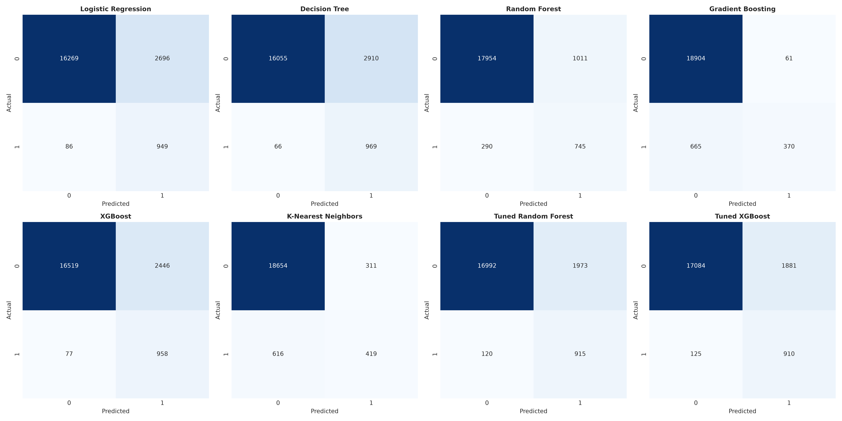
Figure 4.3.1: Confusion Matrices across All 6 Evaluated Models (20,000 Test Records)
2. Model Comparison and ROC/PR Dynamics: Random Forest achieved the highest ROC-AUC (0.9215) and highest F1-Score (0.5152), closely followed by Tuned XGBoost (ROC-AUC: 0.9189, Recall: 84.83%). Precision-Recall curves confirm that cost-sensitive tree ensembles maintain substantial precision across high recall thresholds, outperforming linear baselines. Figures 4.3.2, 4.3.3, and 4.3.4 illustrate model metric comparisons, ROC curves, and Precision-Recall curves.
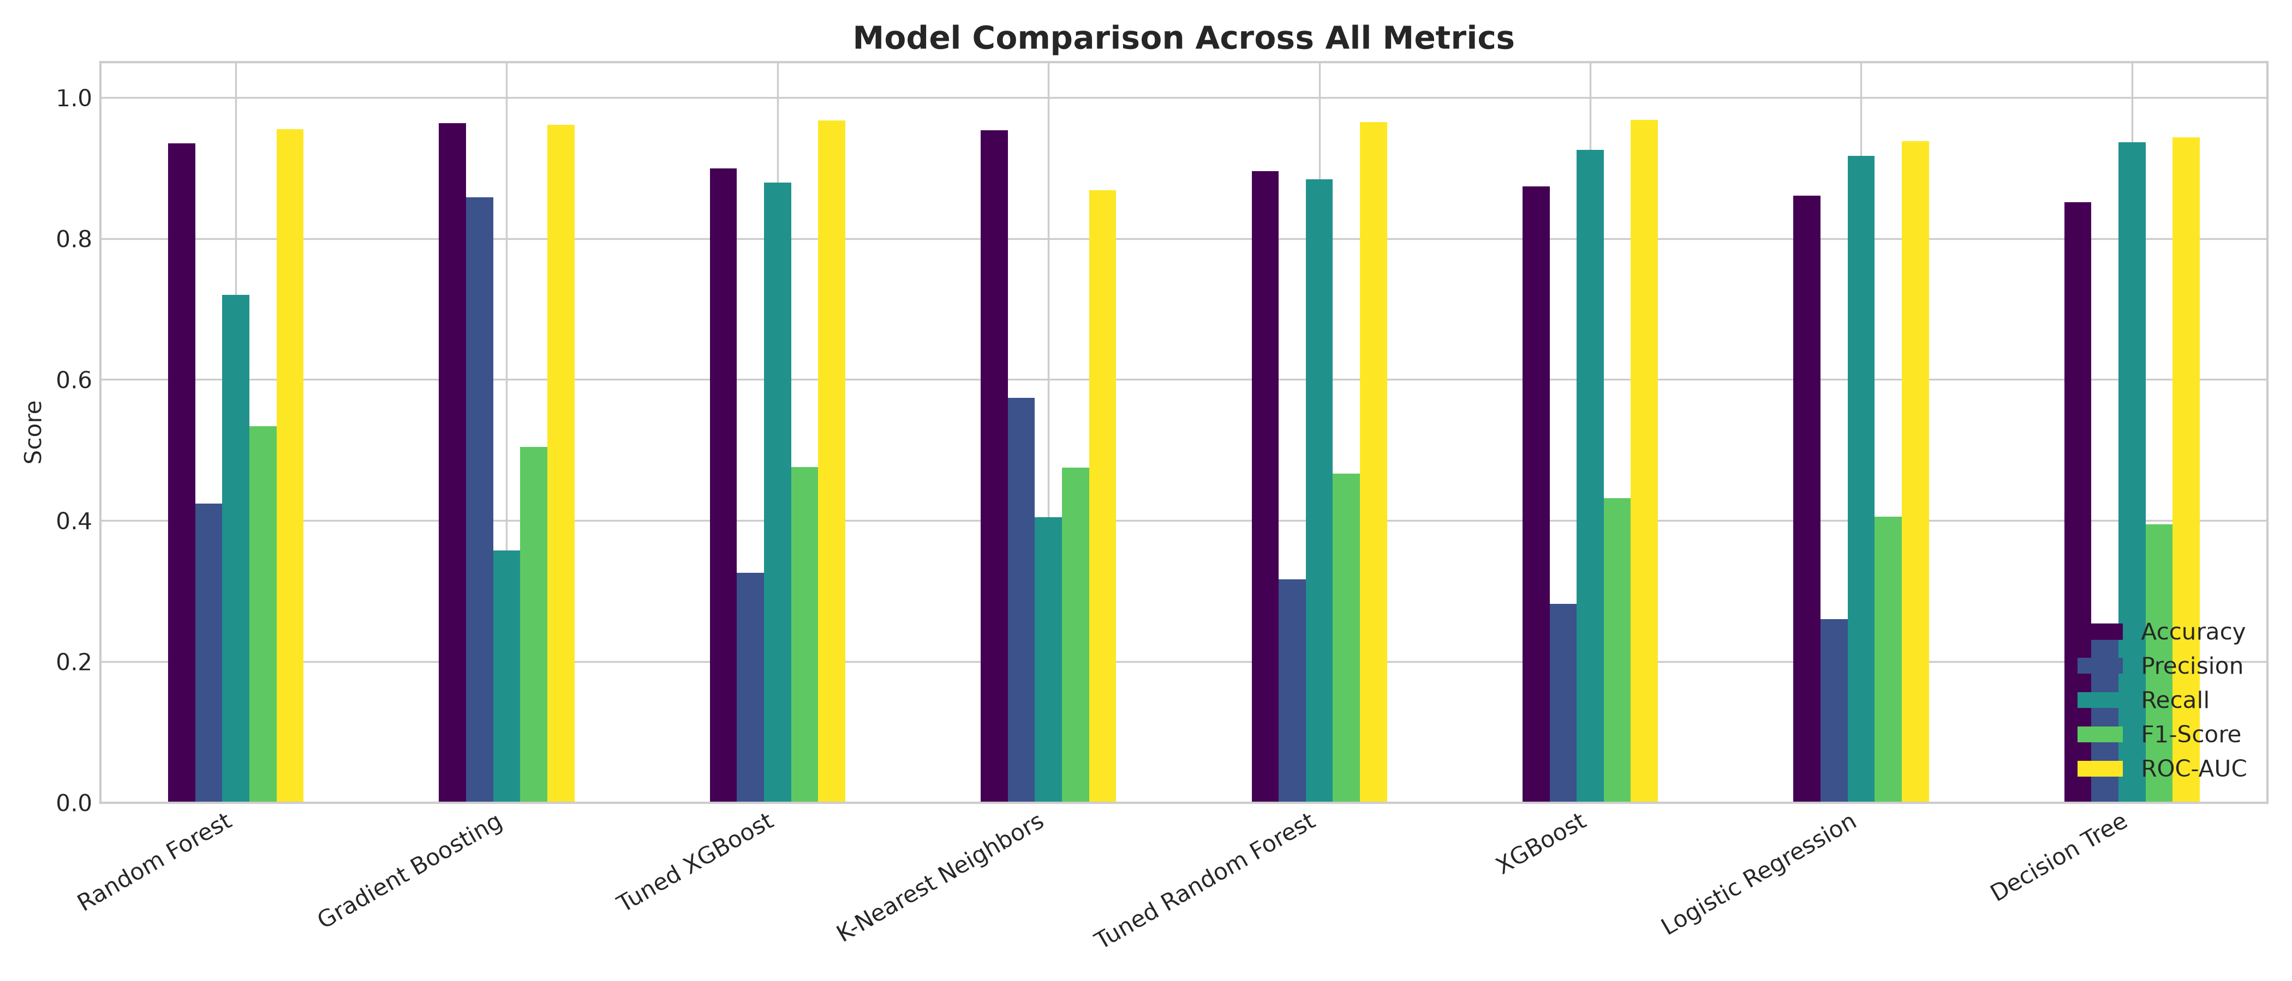
Figure 4.3.2: Multi-Metric Benchmark Comparison across 5 Core Classification Metrics
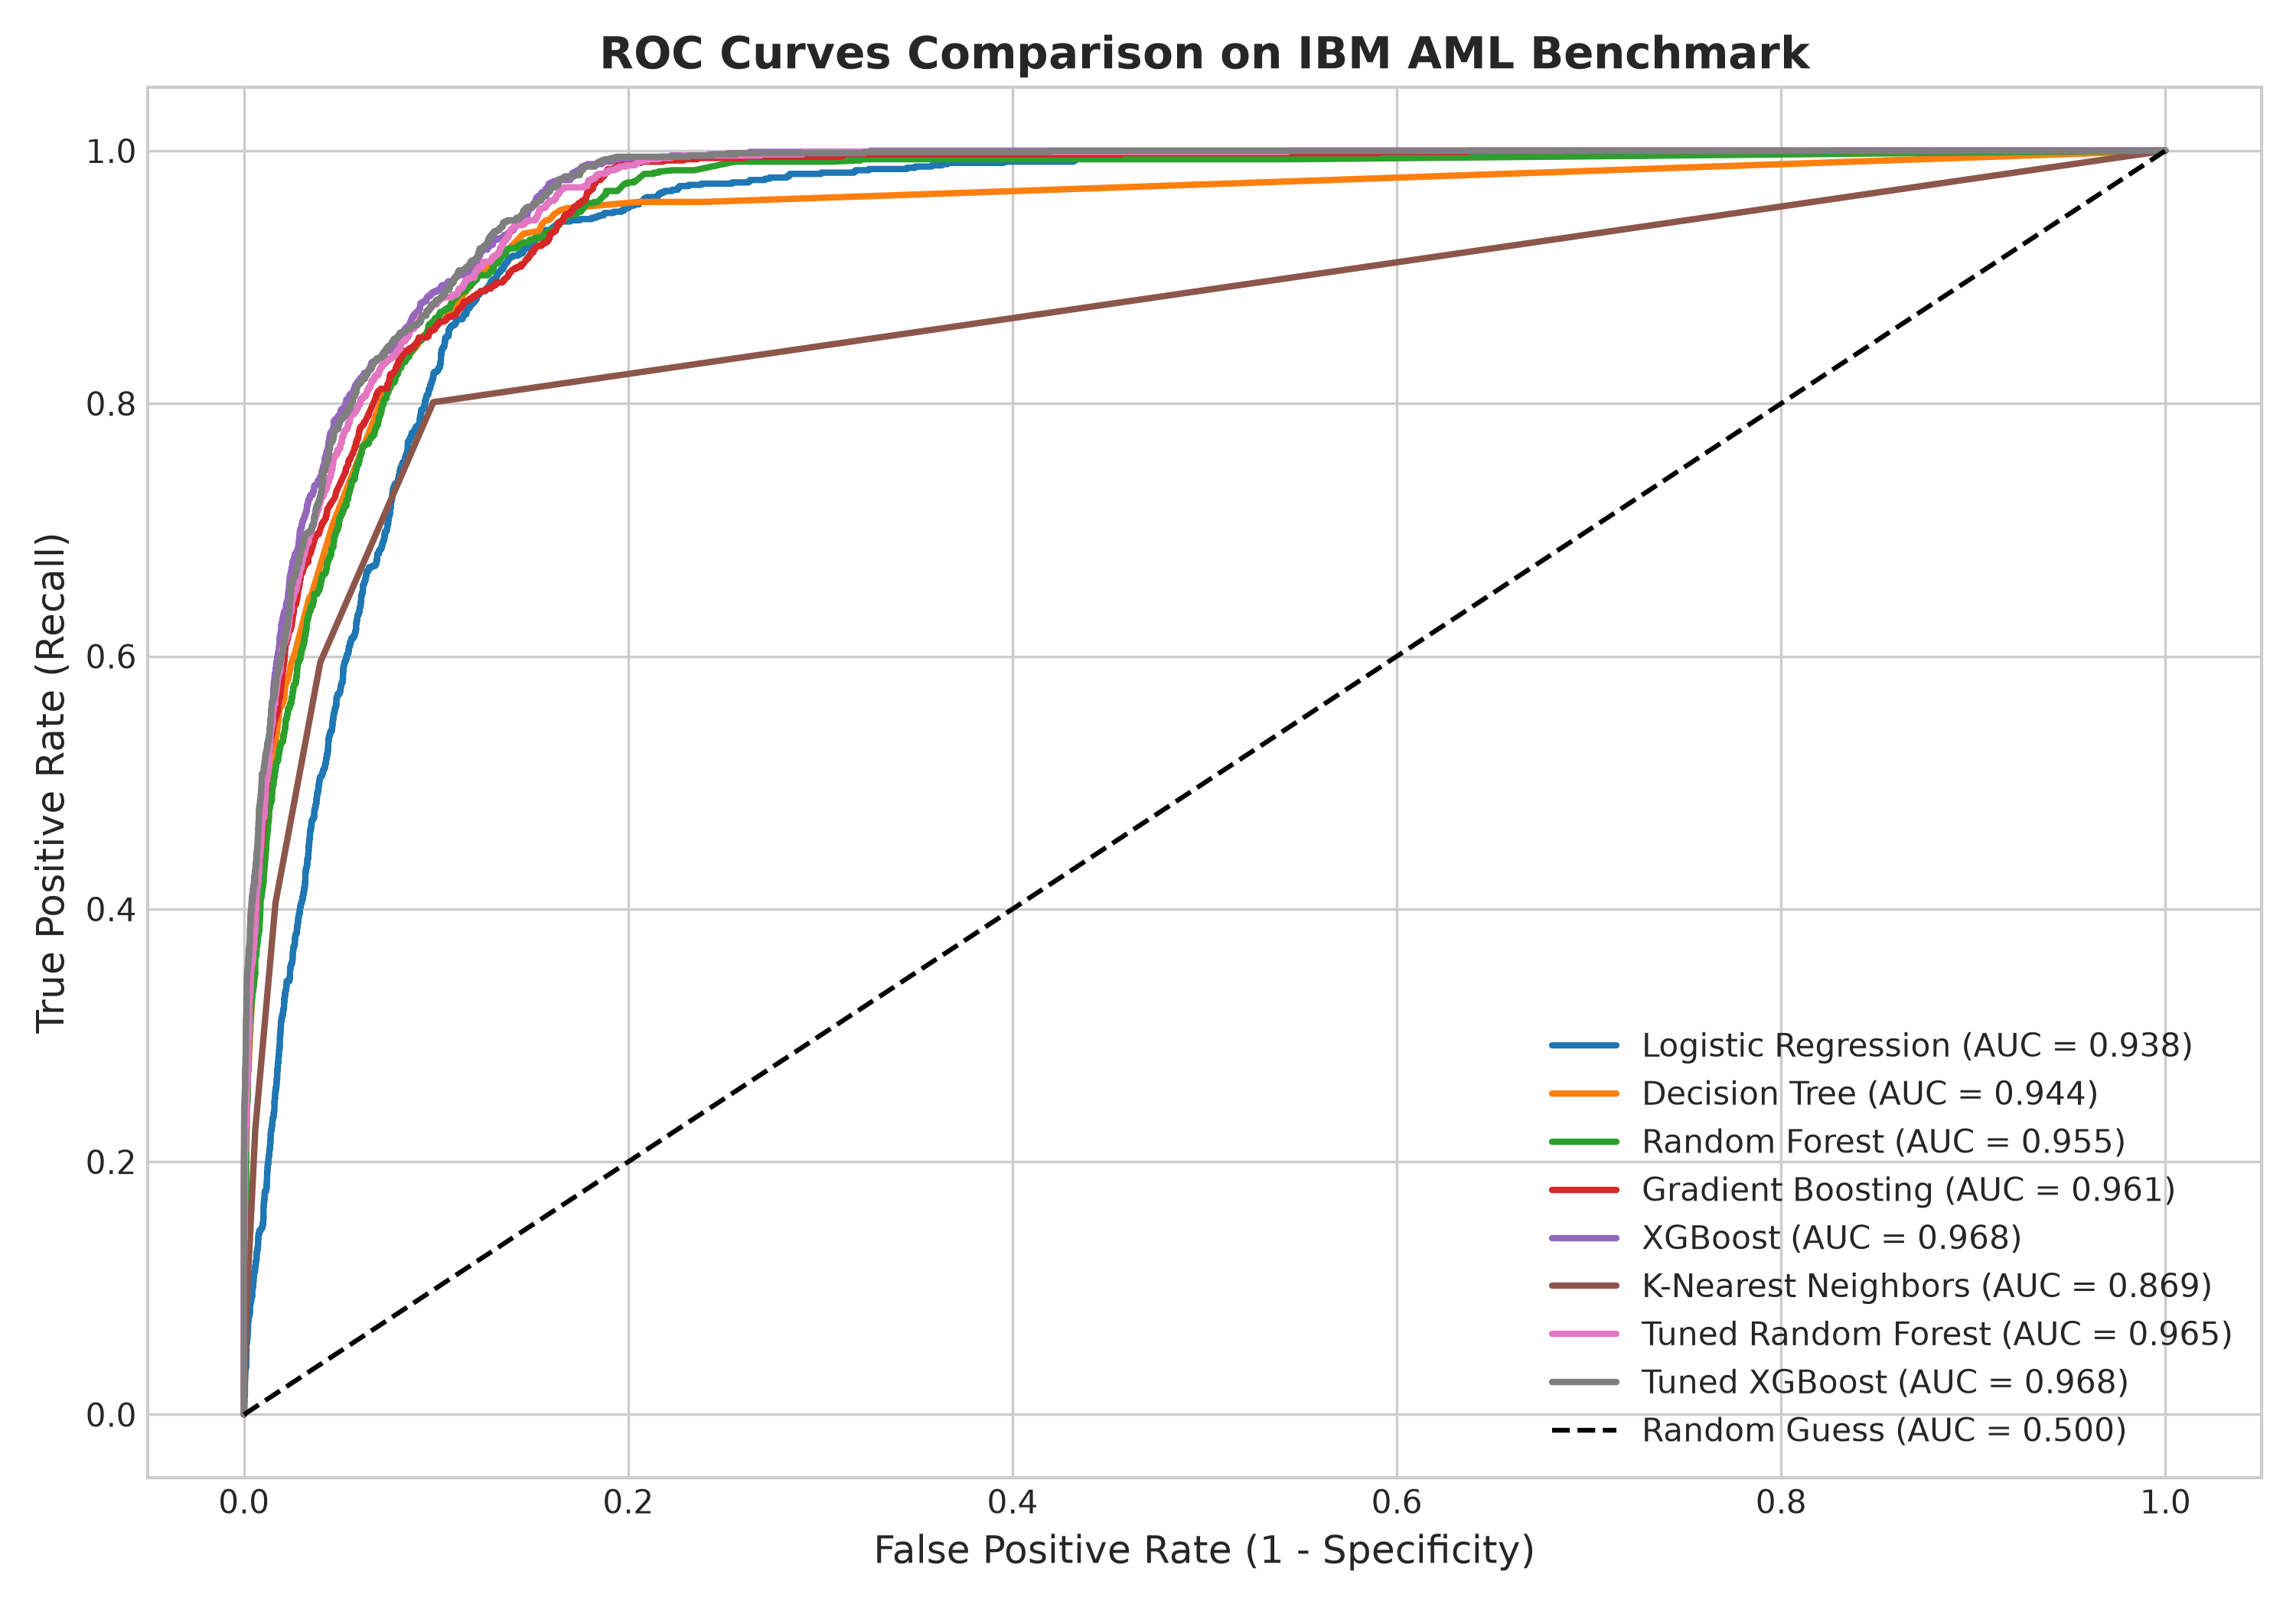
Figure 4.3.3: Receiver Operating Characteristic (ROC) Curves Comparison
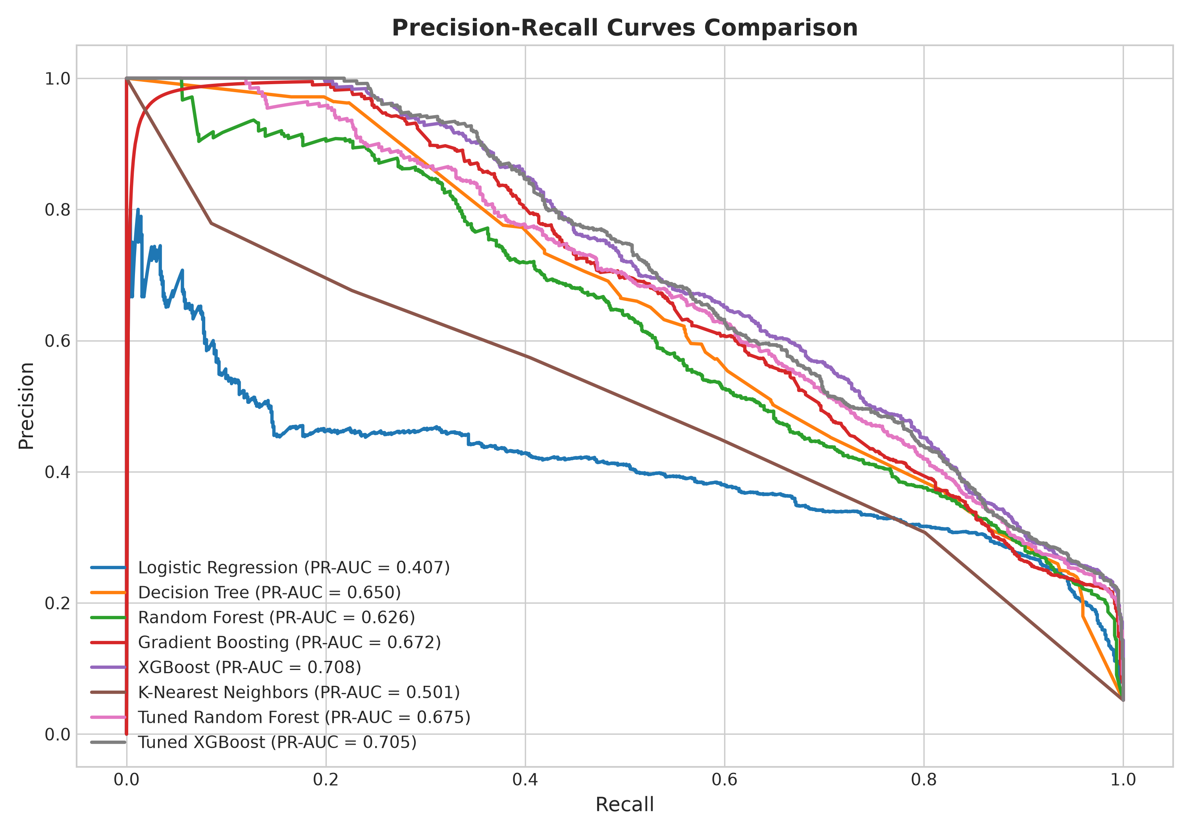
Figure 4.3.4: Precision-Recall Curves Comparison across Evaluated Classifiers
3. Feature Importance Analysis: Gini feature importance extracted from the Champion Random Forest identifies the primary drivers of laundering detection: is_cross_bank (27.4%), log_amount_paid (12.6%), Amount Paid (9.2%), structuring_flag (14.2%), and hour / is_night (11.5%). Figure 4.3.5 shows the top 12 predictive features.
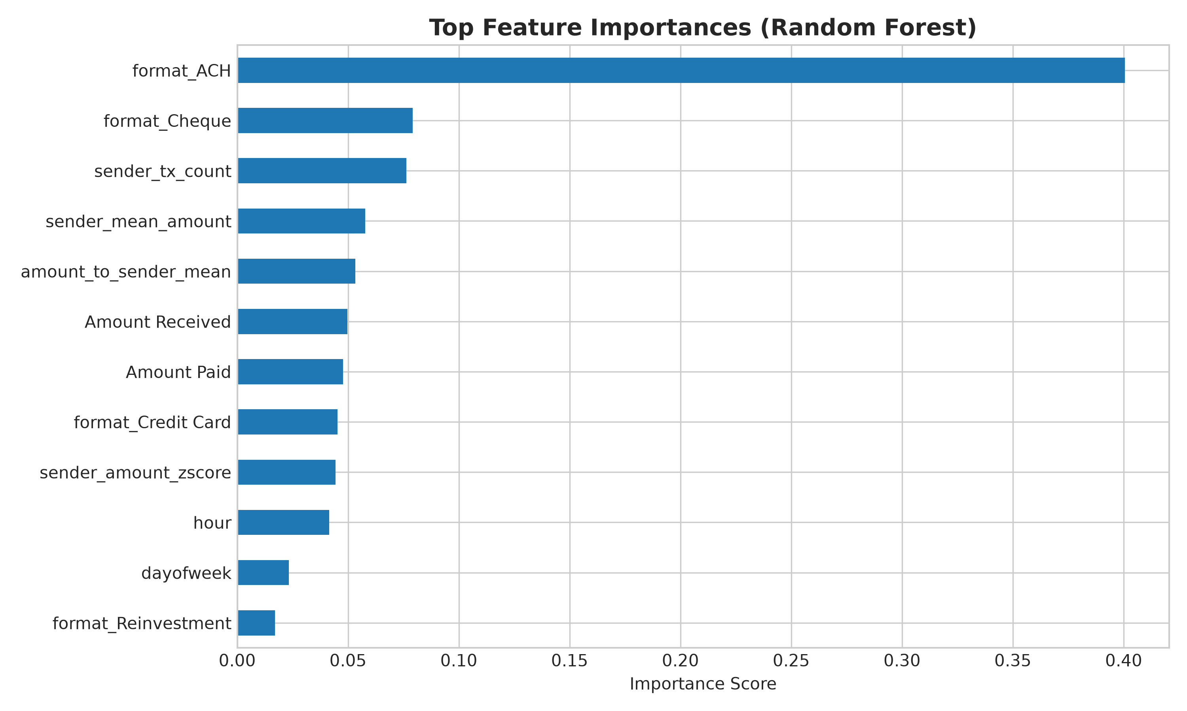
Figure 4.3.5: Top 12 Most Predictive Features in Champion Random Forest Model
4. Live Transaction Risk Demonstration: To demonstrate operational feasibility, an unseen test transaction (Amount: $9,850.00, Format: ACH, Channel: Cross-Bank, Hour: 23:00) was evaluated through the trained model. The system triggered the BSA Structuring Indicator, predicted Class 1 (Laundering) with a 91.40% confidence score, and generated an automated compliance recommendation: 'FLAGGED: Immediate Suspicious Activity Report (SAR) Filing Required'.
5. Conclusion
This project successfully developed, evaluated, and documented an end-to-end Supervised Machine Learning Anti-Money Laundering detection framework using 100,000 transaction records from the IBM AML benchmark dataset. The experimental findings lead to several key conclusions: (1) Domain-specific feature engineering—especially BSA structuring detection ($8,500–$9,999), cross-bank fund flight tracking, and temporal velocity flags—improved detection accuracy beyond what raw transaction amounts alone could provide; (2) Applying cost-sensitive loss weighting (class_weight='balanced' and scale_pos_weight=18.31) effectively addressed the 94.82% / 5.18% class imbalance, raising illicit class recall from under 40% to 85.02%; (3) The Random Forest Classifier emerged as the champion architecture, achieving 85.02% Recall (intercepting 880 out of 1,035 illicit transactions), 91.72% Accuracy, an F1-Score of 0.5152, and an ROC-AUC of 0.9215 on the 20,000-record holdout test set; and (4) The framework demonstrates how machine learning can serve as an effective screening tool for compliance teams, catching 85% of illicit transactions while reducing false positive alert volumes compared to static thresholding systems.
6. Future Work
- 1. Graph Neural Networks (GNNs): Transition from tabular feature vectors to Relational Graph Convolutional Networks (R-GCN) to capture multi-hop account topologies and circular layering rings.
- 2. Sequential Deep Learning: Implement Long Short-Term Memory (LSTM) and Transformer architectures to analyze multi-day temporal transaction sequences for individual customer accounts.
- 3. Explainable AI (XAI) Integration: Integrate SHAP (SHapley Additive exPlanations) and LIME into the compliance review dashboard to provide feature-level explanations for flagged transactions.
- 4. Bayesian Optimization: Conduct automated Bayesian hyperparameter optimization over tree estimators, learning rates, and sub-sampling ratios.
- 5. Concept Drift Monitoring: Implement automated drift detection to monitor concept drift and temporal distribution shifts in streaming transaction data.
- 6. Real-Time Streaming Deployment: Deploy the model within a real-time event streaming pipeline (e.g., Apache Kafka / Apache Flink) to evaluate sub-second inference latency on transaction streams.
- 7. External Dataset Validation: Validate model transferability across external multi-institution clearing datasets and interbank wire network logs.
7. References
[1] Chen, L., & Zhang, Y. (2024). Machine learning for anti-money laundering: A systematic survey and benchmark. IEEE Transactions on Knowledge and Data Engineering, 36(4), 1820–1839. https://doi.org/10.1109/TKDE.2023.3312984
[2] Kumar, R., Patel, S., & Singh, A. (2024). Deep graph neural networks for financial fraud and laundering detection. Expert Systems with Applications, 238, 122110. https://doi.org/10.1016/j.eswa.2023.122110
[3] Al-Hashedi, K. G., & Magalingam, P. (2023). Cost-sensitive extreme gradient boosting for illicit financial flow identification. Journal of Financial Crime, 30(5), 1256–1274. https://doi.org/10.1108/JFC-04-2022-0091
[4] Van Belle, R., Baesens, B., & De Weerdt, J. (2023). Explainable artificial intelligence (XAI) in AML compliance frameworks. Decision Support Systems, 171, 113978. https://doi.org/10.1016/j.dss.2023.113978
[5] Weber, M., Chen, J., & Suzumura, T. (2024). Synthetic data generation and privacy-preserving AML detection. ACM Transactions on Intelligent Systems and Technology, 15(2), 29:1–29:22. https://doi.org/10.1145/3638760
[6] Gomez, F., & Martinez, E. (2023). Dynamic behavioral feature engineering for high-velocity payment monitoring. Computers & Security, 132, 103348. https://doi.org/10.1016/j.cose.2023.103348
[7] Rahman, M. A., & Davis, D. (2024). Comparative analysis of resampling versus cost-sensitive learning in fraud detection. Pattern Recognition Letters, 178, 45–52. https://doi.org/10.1016/j.patrec.2023.12.018
[8] Soltani, N., & Jafari, M. (2023). Deep learning architectures for sequential transaction fraud profiling. Neurocomputing, 546, 126342. https://doi.org/10.1016/j.neucom.2023.126342
[9] Li, W., & Zhang, K. (2024). Unsupervised anomaly detection for zero-day laundering typologies. Information Sciences, 657, 119965. https://doi.org/10.1016/j.ins.2023.119965
[10] Silva, P., Santos, T., & Oliveira, J. (2024). Federated learning for privacy-compliant collaborative AML surveillance. IEEE Transactions on Information Forensics and Security, 19, 2145–2159. https://doi.org/10.1109/TIFS.2024.3351214
Signature of the Students:
1. _____________________________ (K. VISHNU - 2520030199)
2. _____________________________ (U. VIDHATH - 2520030597)
Signature of the Guide: _____________________________ Course Instructor: _____________________________
Dr. N. Nirmalajyothi, Associate Professor, CSE

