AutoCall Mobile Car Service - Test Results
Executed 08/10/2026 on a clean database (PHP 8.4 built-in server + MySQL). 15 tests: 12 PASS, 3 FAIL (defects in tests 10, 11 and 13). Screenshots follow the table.
# | Purpose | Description | Type of validation | Test data | Expected result | Actual result / Evidence
1 | Check that the home page shows the correct statistics. | Pre: fresh database import.  1. Open /index.php.  2. Read the three statistic cards. | Normal data; black box | Seed data: 8 services, 4 mechanics, 4 orders with status Completed | The cards show 8 Services Available, 4 Expert Mechanics and 4+ Jobs Completed. | The cards showed 8 Services Available, 4 Expert Mechanics and 4+ Jobs Completed. PASS. Evidence: evidence/TC01_home_stats.png  
2 | Check that the services page sorts by price and calculates price statistics. | 1. Open /services.php.  2. Choose Price (Low–High) in Sort by.  3. Read the order of the cards and the four statistic boxes. | Normal data; black box | Sort option price; seed prices $18–$45 (sum $235 over 8 services) | Cards run from $18.00 to $45.00. Statistics: cheapest $18.00, most expensive $45.00, average $29.38, 8 services. | The URL changed to services.php?sort=price. The cards ran from Air Filter Replacement ($18.00) to Spark Plug Replacement ($45.00) in rising order. The boxes showed $18.00, $45.00, $29.38 and 8. PASS. Evidence: evidence/TC02_services_by_price.png  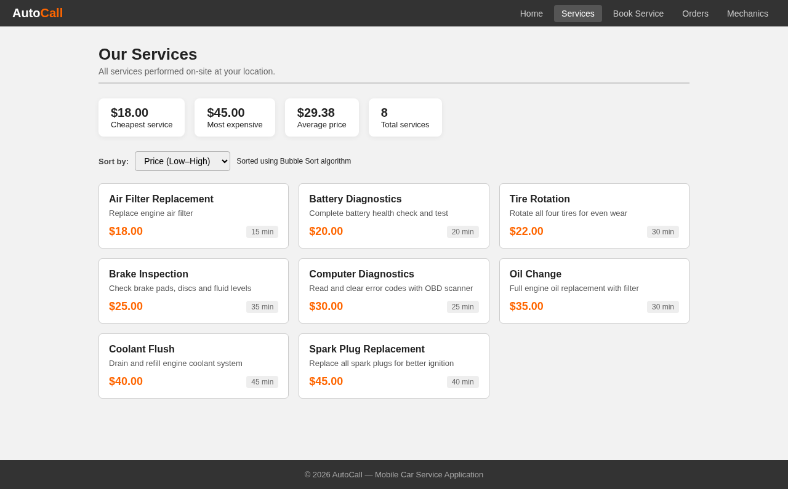
3 | Check that an unknown sort value does not break the services page. | 1. Type /services.php?sort=abc in the address bar.  2. Read the order of the cards. | Invalid data; black box | Sort value abc (not one of name, price, duration) | The page loads with no error and falls back to name order (A–Z). | The page loaded with no error. The cards ran A–Z from Air Filter Replacement to Tire Rotation. PASS. Evidence: evidence/TC03_sort_invalid.png  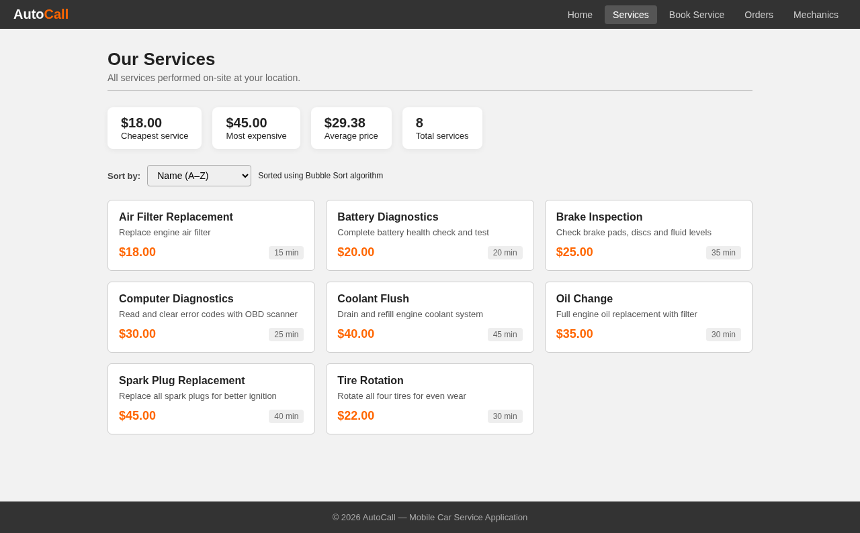
4 | Check the live price estimate on the booking form. | 1. Open /order.php.  2. Select Oil Change ($35.00) in Select Service.  3. Read the Estimated total box. | Normal data; black box | Service Oil Change, price $35.00; expected $35.00 + $5.00 call-out + 12% VAT ($4.20) = $44.20 | The Estimated total box appears and shows $44.20. | The Estimated total box appeared with $44.20 and the note “Includes $5.00 call-out fee + 12% VAT”. PASS. Evidence: evidence/TC04_live_estimate.png  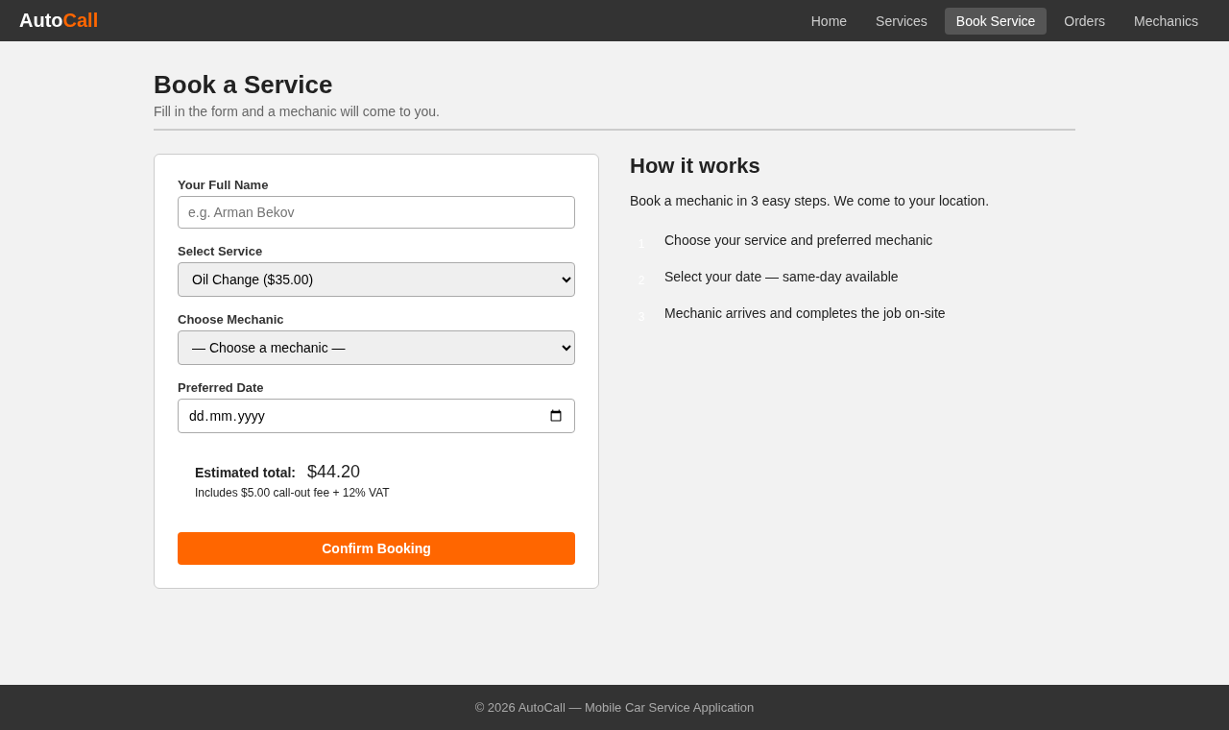
5 | Check that a customer can book a service for a future date. | 1. Open /order.php.  2. Enter name Aliya Normal, select Oil Change and mechanic Arman Bekov.  3. Set Preferred Date to tomorrow (2026-10-09).  4. Click Confirm Booking. | Normal data; black box | Name Aliya Normal; service Oil Change ($35.00); mechanic Arman Bekov; date 2026-10-09 (tomorrow) | The app shows “Your booking is confirmed! Order #9” and an Order Summary with total $44.20. | The alert said “Your booking is confirmed! Order #9”. The Order Summary listed Oil Change $35.00, call-out fee $5.00, VAT $4.20, duration 30 min and Total $44.20. PASS. Evidence: evidence/TC05_booking_tomorrow.png  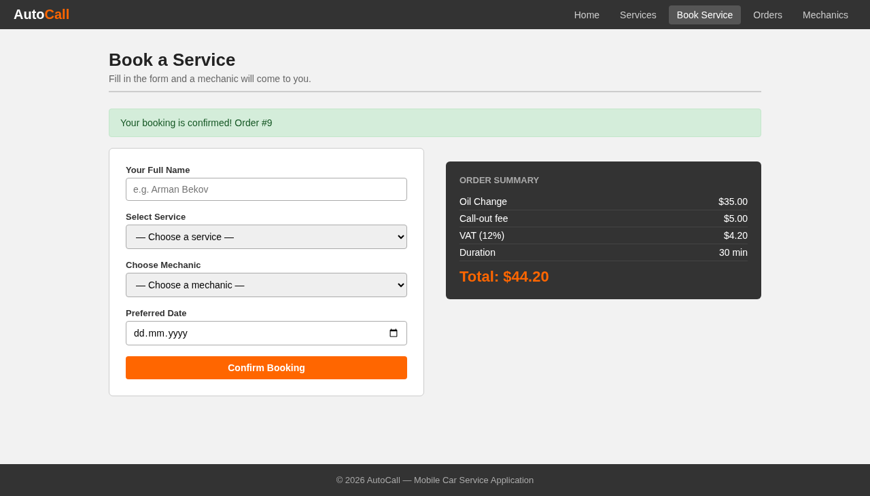
6 | Check that the earliest allowed date (today) is accepted with the same-day surcharge. | 1. Open /order.php.  2. Enter name Berik Borderline, select Oil Change and Arman Bekov.  3. Set Preferred Date to today (2026-10-08).  4. Click Confirm Booking. | Borderline data; black box | Date 2026-10-08 (today, the first date the form accepts); service Oil Change ($35.00); expected surcharge 20% = $7.00 | The app accepts the booking and adds “Same-day surcharge (20%) +$7.00”, so the total is $51.20. | The alert said “Your booking is confirmed! Order #10”. The summary showed Same-day surcharge (20%) +$7.00 and Total $51.20. PASS. Evidence: evidence/TC06_booking_today.png  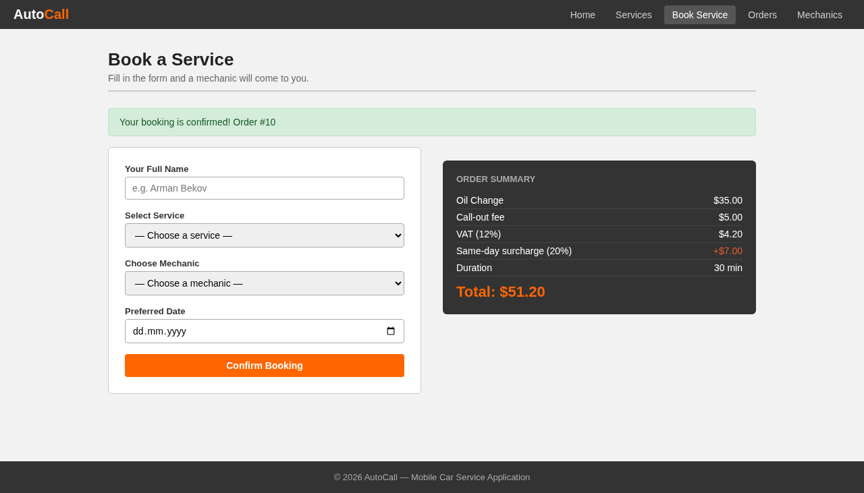
7 | Check that the app rejects a booking date in the past. | 1. Open /order.php.  2. Enter name Ivan Invalid, select Oil Change and Arman Bekov.  3. Set Preferred Date to yesterday (2026-10-07) and click Confirm Booking. The browser min check blocks the form first.  4. Turn off browser validation (form.noValidate, no source change) and submit again. | Invalid data; black box | Date 2026-10-07 (one day before the earliest allowed date) | The app rejects the booking with “Please select a future date.” and saves no order. | The browser first showed the tooltip “Value must be 08.10.2026 or later.” (evidence/TC07_client_validation.png). With browser validation off, the server answered “Please select a future date.” and showed no Order Summary. No order was saved. PASS. Evidence: evidence/TC07_past_date_rejected.png, evidence/TC07_client_validation.png  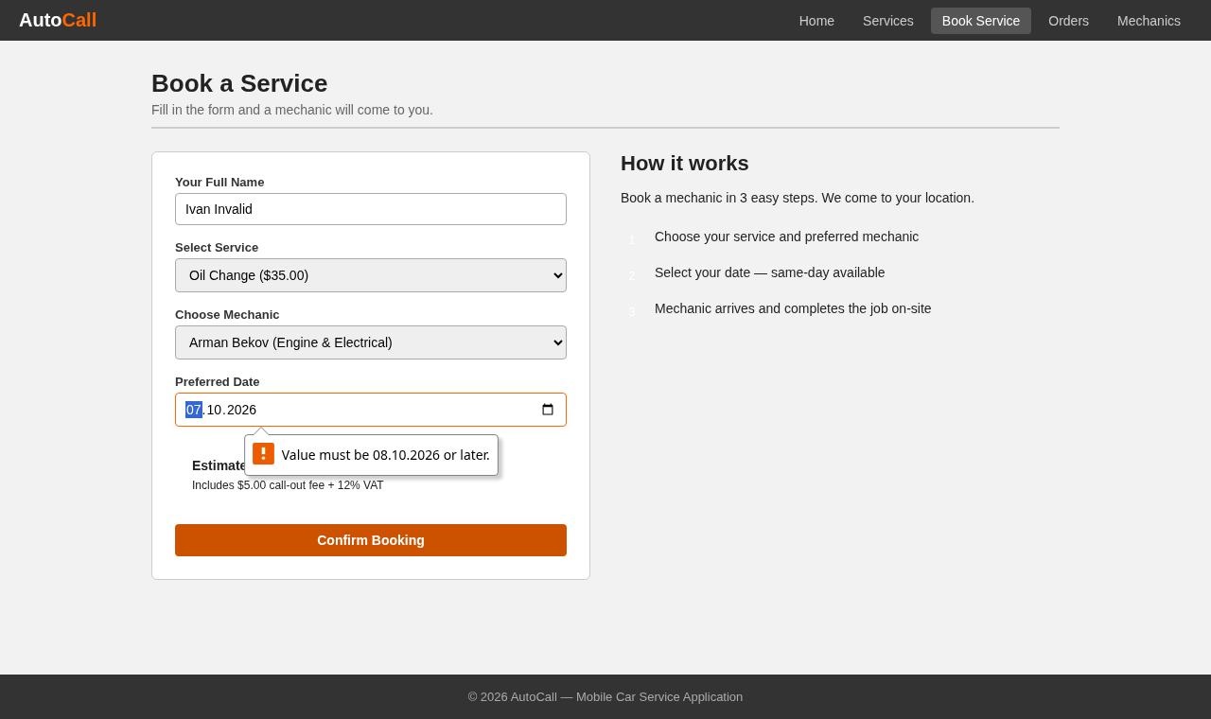  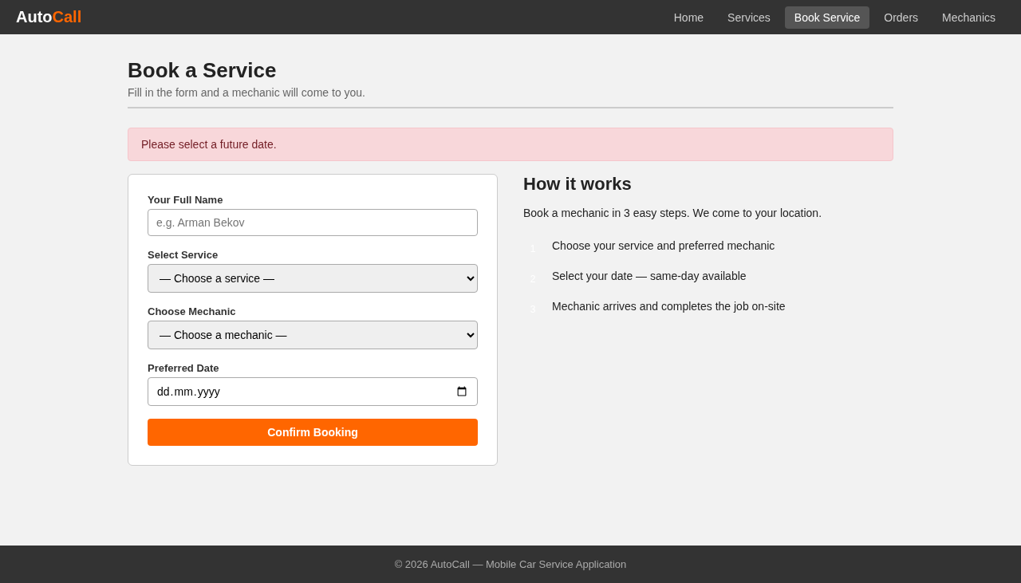
8 | Check that a name made only of spaces is rejected. | 1. Open /order.php.  2. Type five spaces in Your Full Name.  3. Select Oil Change, Arman Bekov and tomorrow's date.  4. Click Confirm Booking. | Invalid data; black box | Name " " (5 spaces; the browser required check lets it through, the server trims it to empty) | The app rejects the booking with “Please enter your name.” | The page showed “Please enter your name.” and no Order Summary. No order was saved. PASS. Evidence: evidence/TC08_blank_name.png  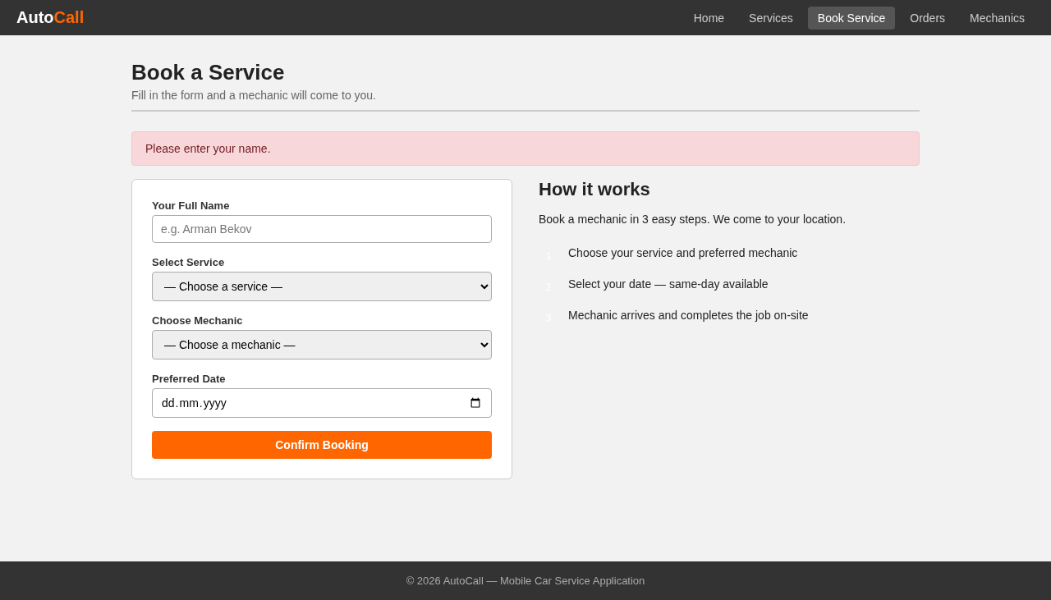
9 | Check that the longest name the database allows is accepted. | 1. Open /order.php.  2. Enter a name of 100 letters A.  3. Select Oil Change, Arman Bekov and tomorrow's date.  4. Click Confirm Booking. | Borderline data; black box | Name AAAA…A (100 characters, the size of the customer_name VARCHAR(100) column) | The app accepts the booking and shows a confirmation with total $44.20. | The alert said “Your booking is confirmed! Order #11” with Total $44.20. The Orders page lists the full 100-character name. PASS. Evidence: evidence/TC09_name_100.png  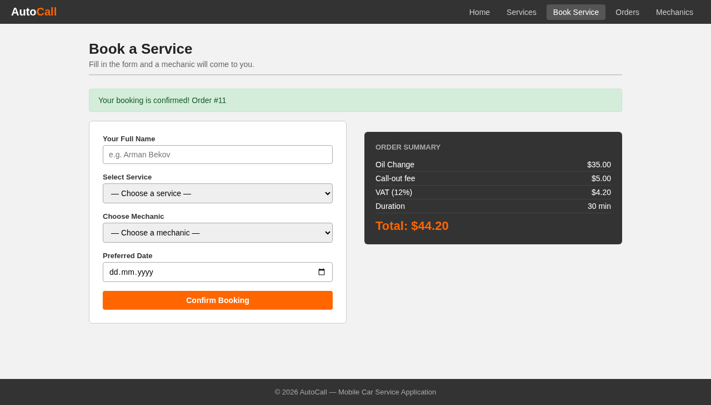
10 | Check that a name longer than the database allows is rejected with a message. | 1. Open /order.php.  2. Enter a name of 101 letters B.  3. Select Oil Change, Arman Bekov and tomorrow's date.  4. Click Confirm Booking. | Invalid data; black box | Name BBBB…B (101 characters, one above the 100-character column size) | The app rejects the booking and shows an error message on the booking page. No order is saved. | The server answered HTTP 500 and the browser showed a blank white page with no message. The PHP log recorded “Uncaught mysqli_sql_exception: Data too long for column 'customer_name'”. No order was saved (the Orders page in Test 12 still has 11 orders). FAIL. Defect: order.php has no length check, so MySQL rejects the INSERT at line 84 and the uncaught exception stops the page. Evidence: evidence/TC10_name_101.png  
11 | Check that a normal name with an apostrophe can be booked. | 1. Open /order.php.  2. Enter name Dana O'Connor.  3. Select Oil Change, Arman Bekov and tomorrow's date.  4. Click Confirm Booking. | Normal data; black box | Name Dana O'Connor (a real surname with an apostrophe) | The app accepts the booking and shows “Your booking is confirmed!” with total $44.20. | The server answered HTTP 500 and the browser showed a blank white page. The PHP log recorded “You have an error in your SQL syntax … near 'Connor'”. No order was saved. FAIL. Defect: order.php line 81 puts the name straight into the SQL text without escaping, so the apostrophe ends the string. The same gap allows SQL injection. Evidence: evidence/TC11_name_apostrophe.png
12 | Check that the orders page joins the three tables and totals the prices. | Pre: Tests 5, 6 and 9 saved orders #9–#11.  1. Open /orders.php.  2. Read the totals and the table. | Normal data; black box | 8 seed orders ($235.00) + 3 new Oil Change orders (3 × $35.00) | The page shows 11 orders, total revenue $340.00 and average $30.91. Each row shows customer, service, mechanic, date, price and status. | The page showed 11 Total orders, $340.00 Total revenue and $30.91 Average order value. The table listed all 11 orders with service and mechanic names from the joined tables, newest date first. PASS. Note: the 100-character name from Test 9 stretches the table past the page width. Evidence: evidence/TC12_orders_list.png  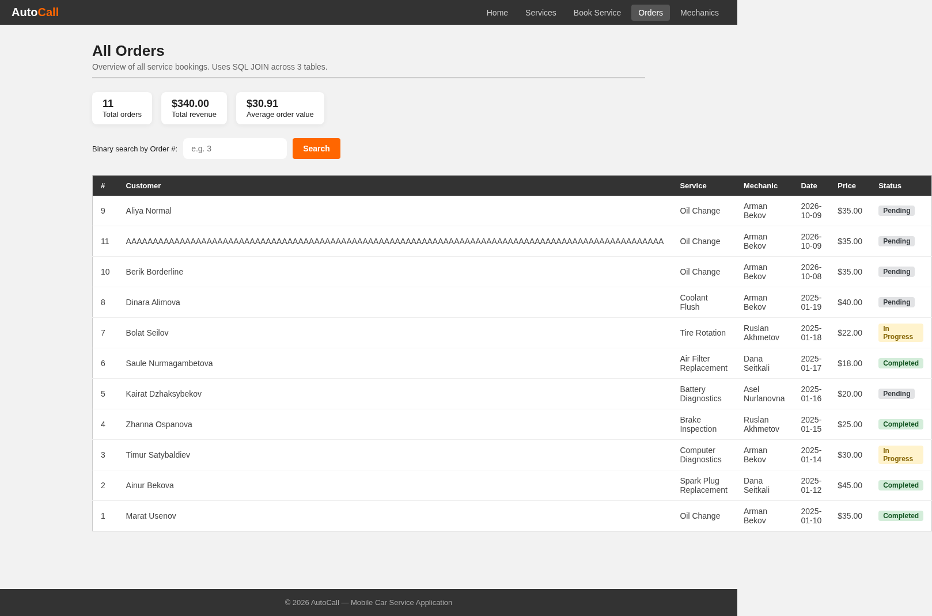
13 | Check that the binary search finds the lowest order number. | 1. Open /orders.php.  2. Enter 1 in Binary search by Order #.  3. Click Search. | Borderline data; black box | Order # 1 (the lowest existing order number; the field has min=1) | The app shows a card “Order #1 found” with Marat Usenov, Oil Change, Arman Bekov. | The page showed “Order #1 not found.” although order 1 (Marat Usenov) is in the table below. FAIL. Defect: orders.php line 63 compares order_id, which MySQL returns as text, with the number from the form using ===. Text never equals a number, so the search never finds any order. Evidence: evidence/TC13_search_order1.png  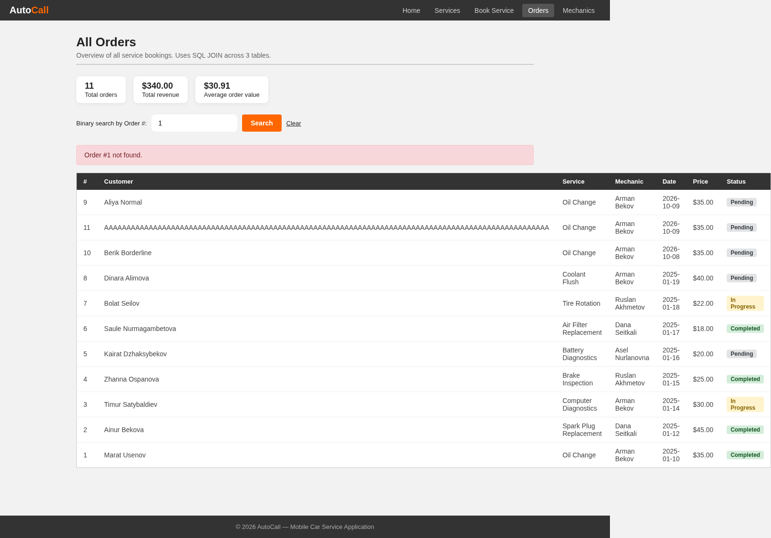
14 | Check that searching for an order that does not exist shows a message. | 1. Open /orders.php.  2. Enter 999 in Binary search by Order #.  3. Click Search. | Invalid data; black box | Order # 999 (no such order) | The app shows “Order #999 not found.” and keeps the order table visible. | The page showed “Order #999 not found.” above the full order table. PASS. Evidence: evidence/TC14_search_order999.png  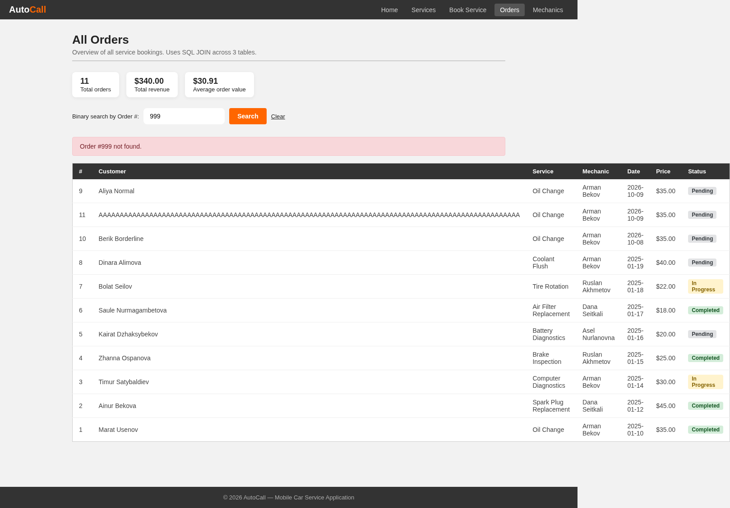
15 | Check that the mechanics page counts orders and earnings per mechanic. | Pre: Tests 5, 6 and 9 added three Oil Change orders for Arman Bekov.  1. Open /mechanics.php.  2. Read the team rating and each mechanic card. | Normal data; black box | Ratings 4.9, 4.8, 4.7, 4.6; Arman Bekov: 3 seed orders ($105.00) + 3 new ($105.00) | Team average rating 4.8 and 4 mechanics. Arman Bekov shows 6 orders and $210.00 earned. | The page showed “Team average rating: ★ 4.8” and “4 mechanics in total”. Cards: Arman Bekov 6 orders, $210.00; Ruslan Akhmetov 2, $47.00; Dana Seitkali 2, $63.00; Asel Nurlanovna 1, $20.00. PASS. Evidence: evidence/TC15_mechanics.png  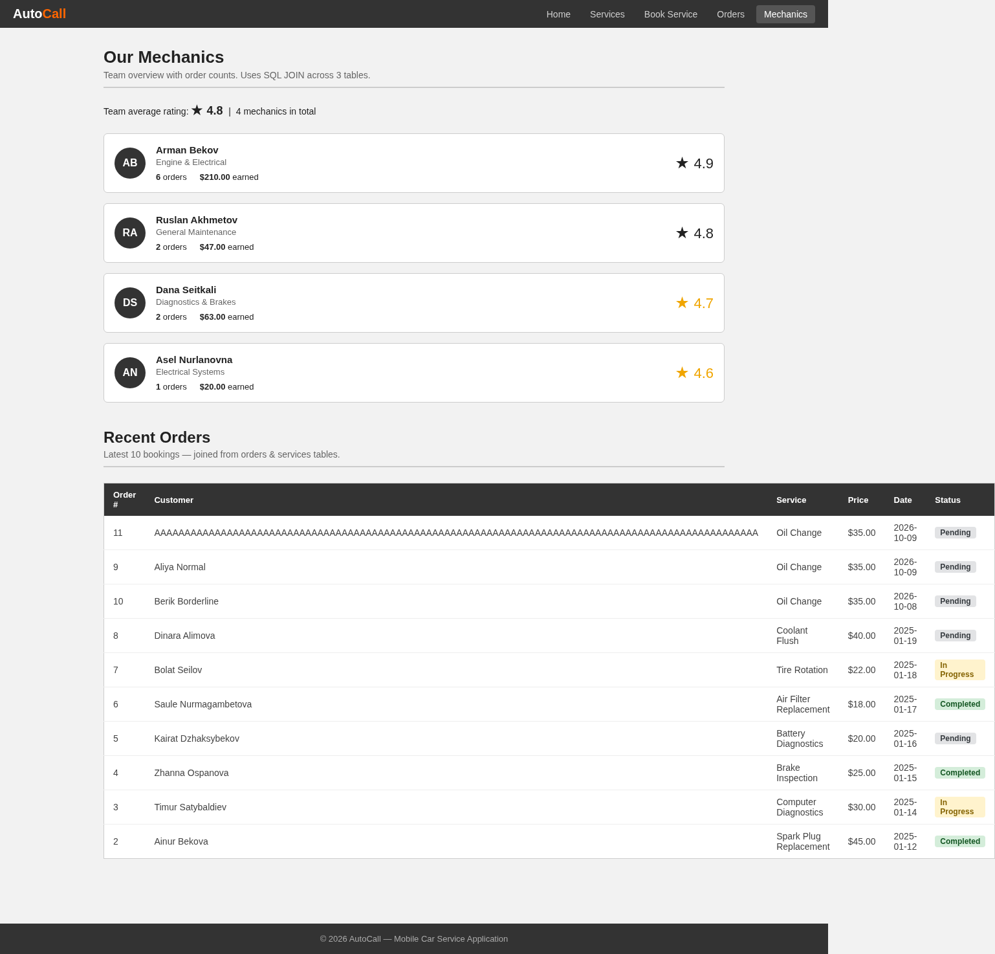

Evidence screenshots

TC01_home_stats.png
Actual result (Test 1): The cards showed 8 Services Available, 4 Expert Mechanics and 4+ Jobs Completed. PASS.

TC02_services_by_price.png
Actual result (Test 2): The URL changed to services.php?sort=price. The cards ran from Air Filter Replacement ($18.00) to Spark Plug Replacement ($45.00) in rising order. The boxes showed $18.00, $45.00, $29.38 and 8. PASS.

TC03_sort_invalid.png
Actual result (Test 3): The page loaded with no error. The cards ran A–Z from Air Filter Replacement to Tire Rotation. PASS.

TC04_live_estimate.png
Actual result (Test 4): The Estimated total box appeared with $44.20 and the note “Includes $5.00 call-out fee + 12% VAT”. PASS.

TC05_booking_tomorrow.png
Actual result (Test 5): The alert said “Your booking is confirmed! Order #9”. The Order Summary listed Oil Change $35.00, call-out fee $5.00, VAT $4.20, duration 30 min and Total $44.20. PASS.

TC06_booking_today.png
Actual result (Test 6): The alert said “Your booking is confirmed! Order #10”. The summary showed Same-day surcharge (20%) +$7.00 and Total $51.20. PASS.

TC07_client_validation.png
Actual result (Test 7): The browser first showed the tooltip “Value must be 08.10.2026 or later.” (evidence/TC07_client_validation.png). With browser validation off, the server answered “Please select a future date.” and showed no Order Summary. No order was saved. PASS.

TC07_past_date_rejected.png
Actual result (Test 7): The browser first showed the tooltip “Value must be 08.10.2026 or later.” (evidence/TC07_client_validation.png). With browser validation off, the server answered “Please select a future date.” and showed no Order Summary. No order was saved. PASS.

TC08_blank_name.png
Actual result (Test 8): The page showed “Please enter your name.” and no Order Summary. No order was saved. PASS.

TC09_name_100.png
Actual result (Test 9): The alert said “Your booking is confirmed! Order #11” with Total $44.20. The Orders page lists the full 100-character name. PASS.

TC10_name_101.png
Actual result (Test 10): The server answered HTTP 500 and the browser showed a blank white page with no message. The PHP log recorded “Uncaught mysqli_sql_exception: Data too long for column 'customer_name'”. No order was saved (the Orders page in Test 12 still has 11 orders). FAIL. Defect: order.php has no length check, so MySQL rejects the INSERT at line 84 and the uncaught exception stops the page.

TC11_name_apostrophe.png
Actual result (Test 11): The server answered HTTP 500 and the browser showed a blank white page. The PHP log recorded “You have an error in your SQL syntax … near 'Connor'”. No order was saved. FAIL. Defect: order.php line 81 puts the name straight into the SQL text without escaping, so the apostrophe ends the string. The same gap allows SQL injection.

TC12_orders_list.png
Actual result (Test 12): The page showed 11 Total orders, $340.00 Total revenue and $30.91 Average order value. The table listed all 11 orders with service and mechanic names from the joined tables, newest date first. PASS. Note: the 100-character name from Test 9 stretches the table past the page width.

TC13_search_order1.png
Actual result (Test 13): The page showed “Order #1 not found.” although order 1 (Marat Usenov) is in the table below. FAIL. Defect: orders.php line 63 compares order_id, which MySQL returns as text, with the number from the form using ===. Text never equals a number, so the search never finds any order.

TC14_search_order999.png
Actual result (Test 14): The page showed “Order #999 not found.” above the full order table. PASS.

TC15_mechanics.png
Actual result (Test 15): The page showed “Team average rating: ★ 4.8” and “4 mechanics in total”. Cards: Arman Bekov 6 orders, $210.00; Ruslan Akhmetov 2, $47.00; Dana Seitkali 2, $63.00; Asel Nurlanovna 1, $20.00. PASS.

