Joe’s Electronics Inventory Management System - Test Results
Executed 08/10/2026 on a clean database (PHP 8.4 built-in server + MySQL). All 10 tests passed; screenshots follow the table.
# | Purpose | Description | Type of validation | Test data | Expected result | Actual result / Evidence
1 | Check that the administrator can log in. | Pre: fresh database import.  1. Open /login.php.  2. Enter username admin and password password.  3. Click Sign In.  4. Look at the dashboard and the navbar. | Functional, valid login | Username admin; password password | The dashboard opens and the navbar shows the Users link. | The browser went to index.php. The dashboard showed the summary cards (8 products, 0 units sold today, 2 low-stock items, $19,479.19 inventory value) and the Users link. The navbar showed “Administrator”. PASS. Evidence: evidence/TC01_admin_login.png  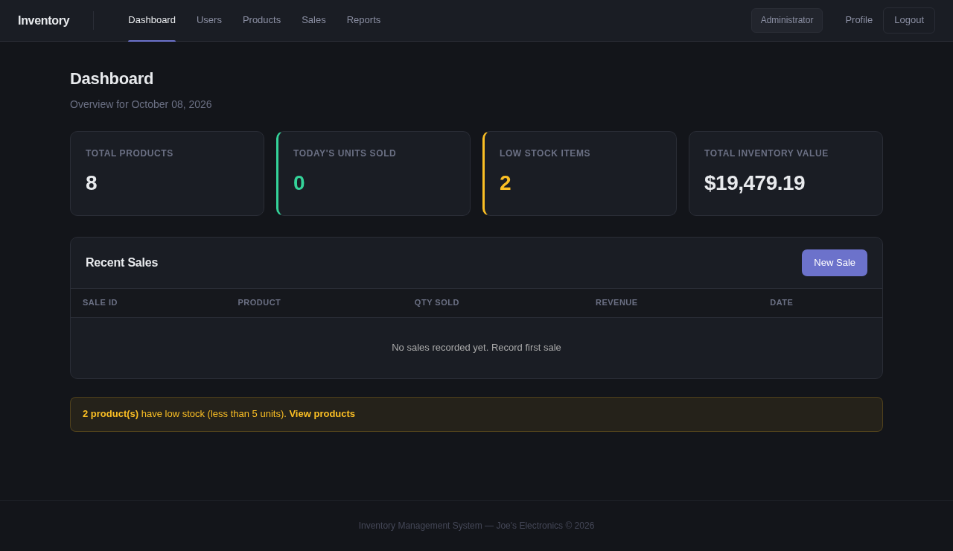
2 | Check that a wrong password is rejected. | 1. Open /login.php.  2. Enter username admin and password wrong-password-123.  3. Click Sign In.  4. Read the page and the alert. | Security, invalid input | Username admin (exists); password wrong-password-123 (wrong) | The login page stays open and shows “Invalid username or password.” | The browser stayed on login.php and showed a red alert, “Invalid username or password.” The username field kept admin, the password field was empty, and no dashboard opened. PASS. Evidence: evidence/TC02_invalid_login.png  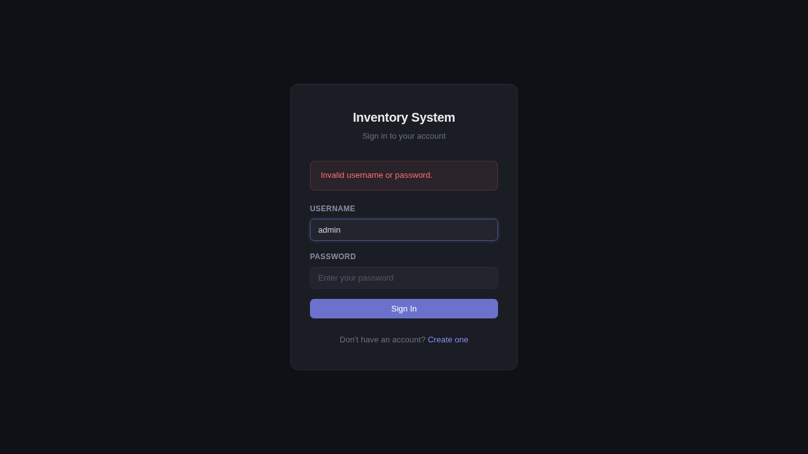
3 | Check the minimum username length on the registration form. | 1. Open /register.php.  2. Enter full name Boundary Test User, username ab (2 characters, one below the minimum of 3), password pass1234 and confirm password different123 (does not match).  3. Click Create Account. | Boundary, invalid input | Full name Boundary Test User; username ab; password pass1234; confirm password different123 | The form rejects the registration, stays on register.php and shows “Username must be at least 3 characters.” | The page stayed on register.php and showed “Username must be at least 3 characters.” The app checks the username before the password match, so it did not report the mismatch. No account was created. PASS. Evidence: evidence/TC03_registration_boundary.png  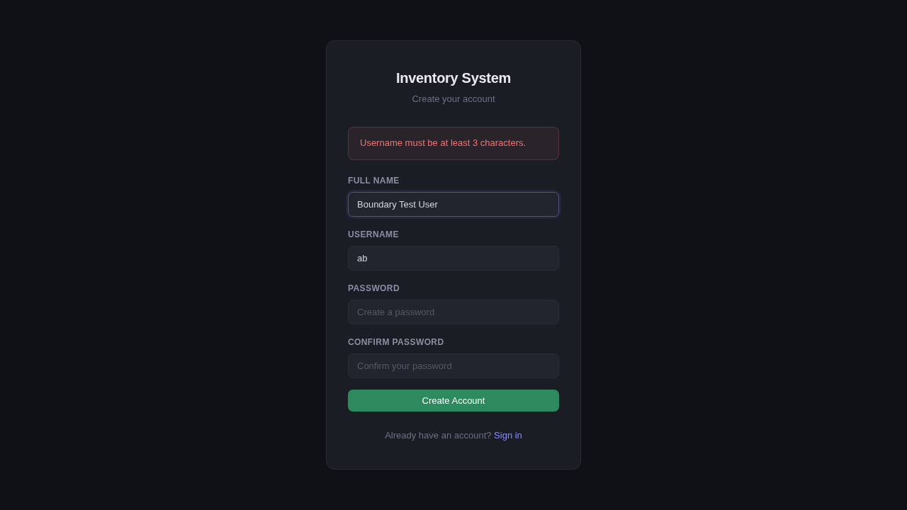
4 | Check that an administrator can add a product. | Pre: logged in as admin.  1. Open Products.  2. Fill in the Add Product form with the test data.  3. Click Add Product.  4. Read the alert and find the new row in the product table. | Functional, valid input | Name Test Wireless Charger; category Accessories; price 29.99; stock 10 | The alert “Product 'Test Wireless Charger' added successfully!” appears, and the table shows a row with Accessories, $29.99 and stock 10. | The alert “Product 'Test Wireless Charger' added successfully!” appeared. The table now holds 9 products and lists ID 9, Test Wireless Charger, Accessories, $29.99, stock 10, in alphabetical order. PASS. Evidence: evidence/TC04_add_product.png  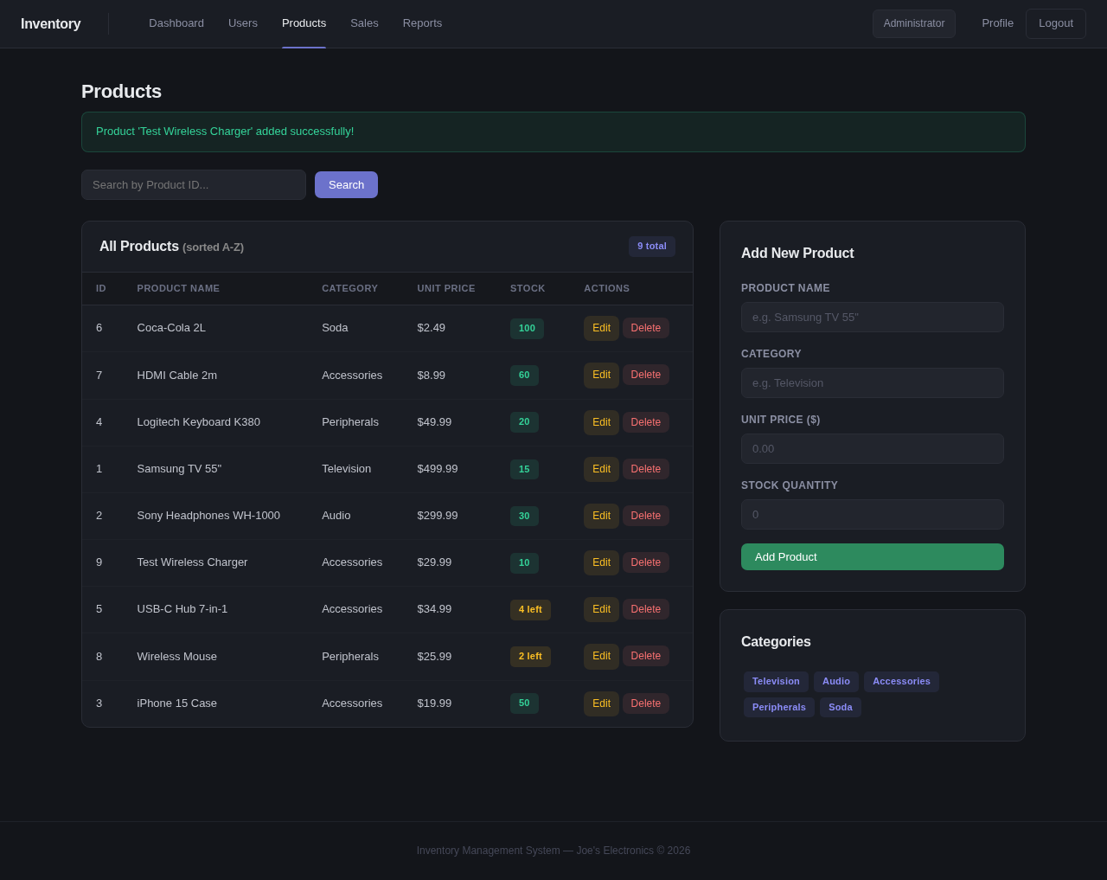
5 | Check the Product ID search with a valid ID and a boundary ID. | Pre: logged in as admin, on Products.  1. Enter the existing ID 1 in Search by Product ID and click Search.  2. Enter the boundary value 0 and click Search. | Functional, boundary | Valid ID 1 (Samsung TV 55"); boundary ID 0 | ID 1 finds Samsung TV 55" and shows “Product found using Binary Search”. ID 0 shows “Product ID must be a positive number.” | ID 1 showed “Product found using Binary Search (index: 0)” and a Search Result row: Samsung TV 55", Television, $499.99, stock 15. ID 0 showed “Product ID must be a positive number.” and no result panel. PASS. Evidence: evidence/TC05_search_valid.png, evidence/TC05_search_zero.png  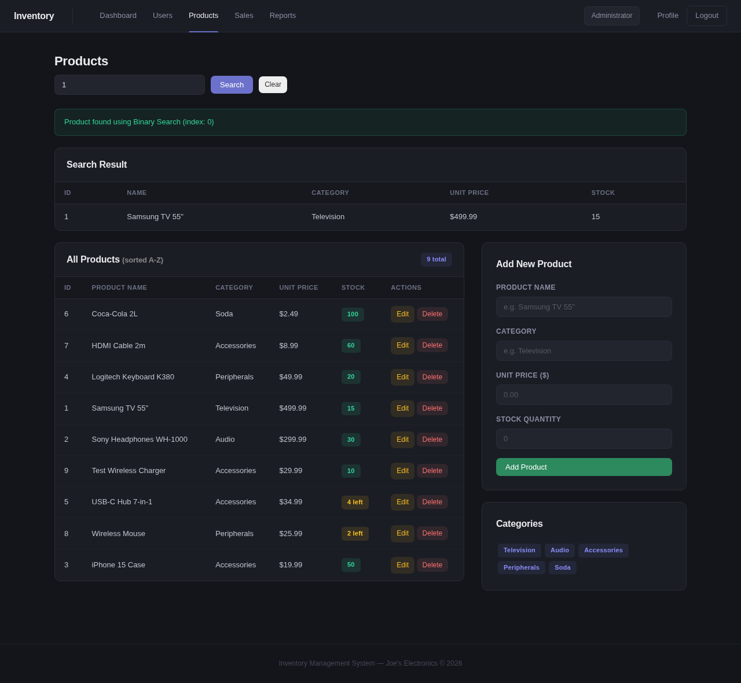  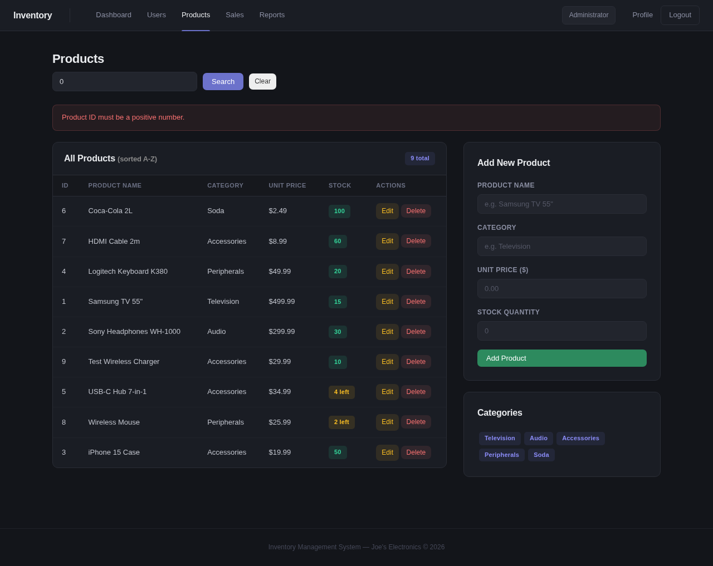
6 | Check that a regular user cannot open the Users page. | 1. Open /login.php and sign in as user / password.  2. Look for a Users link in the navbar.  3. Type /users.php in the address bar. | Security, access control | Username user; password password; URL /users.php | The navbar has no Users link, and users.php redirects to the dashboard. | After login as user (“Regular User”) the navbar showed Dashboard, Products, Sales, Reports and Profile, with no Users link. Opening users.php redirected to index.php, and no user list appeared. PASS. Evidence: evidence/TC06_user_access.png, evidence/TC06_users_blocked.png  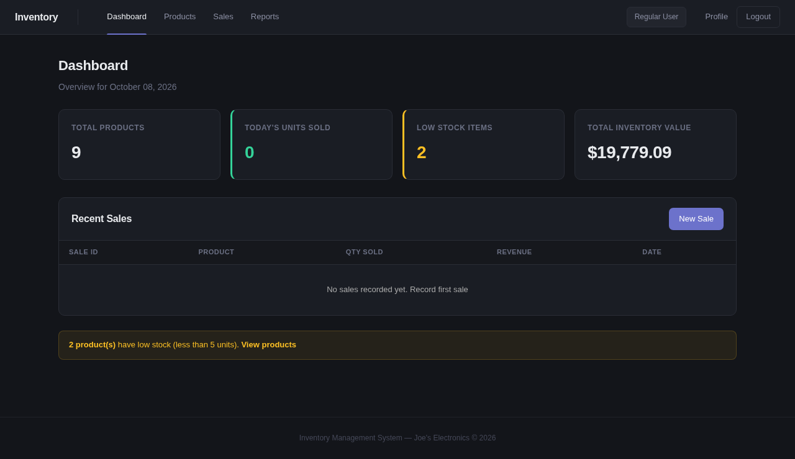
7 | Check that a sale updates the preview, the history and the stock. | Pre: logged in as admin; Samsung TV 55" stock is 15.  1. Open Sales.  2. Select Samsung TV 55" (Stock: 15), enter quantity 2, and keep today's date.  3. Read the preview box.  4. Click Record Sale.  5. Read the alert, the Sales History and the stock. | Functional, calculation | Product Samsung TV 55" (price $499.99, stock 15); quantity 2; date = today (08/10/2026); expected revenue $999.98 | The preview shows $499.99 and $999.98, the sale appears in the history, and stock drops from 15 to 13. | The preview showed Unit Price $499.99 and Estimated Revenue $999.98. After Record Sale the alert said “Sale recorded! 2 unit(s) … New stock: 13 units.” Sales History gained row #1 (quantity 2, $499.99, $999.98, 08/10/2026). Stock fell from 15 to 13, and the database shows the same. PASS. Defect: the alert prints the product name as 'Samsung TV 55&quot;'. The app escapes the text twice, so the HTML entity appears as typed. The sale itself is correct. Evidence: evidence/TC07_sale_preview.png, evidence/TC07_sale_recorded.png  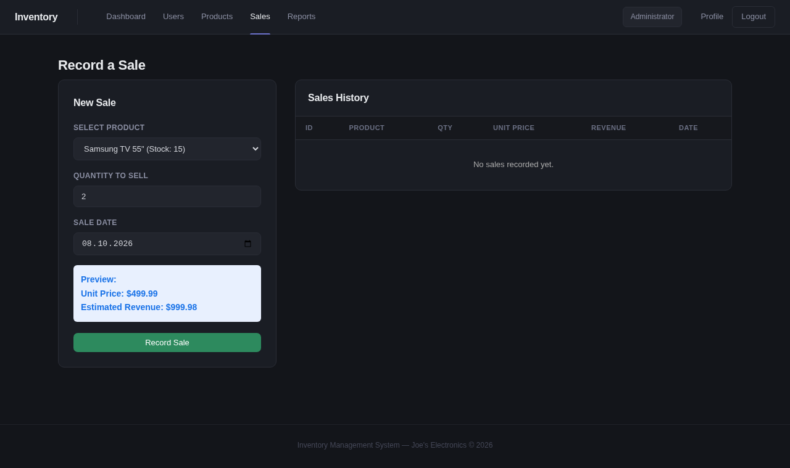  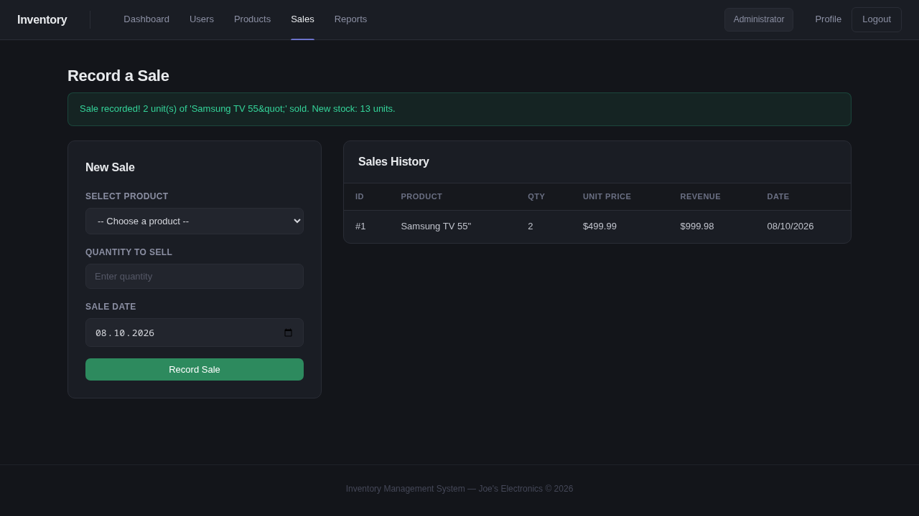
8 | Check that the app refuses to sell more than the stock. | Pre: logged in as admin; Wireless Mouse stock is 2 (seed value, not sold yet).  1. Open Sales.  2. Select Wireless Mouse (Stock: 2), enter quantity 3 and click Record Sale. The browser max check blocks the form first.  3. Turn off browser validation (form.noValidate, no source change) and submit again.  4. Read the message, the Sales History and the stock. | Boundary, business rule | Product Wireless Mouse (stock 2); quantity 3 (one above the stock) | A “Not enough stock” error appears, no sale is recorded and the stock stays the same. | The browser blocked the form first with the tooltip “Value must be less than or equal to 2.” because the page sets max to the stock value (evidence/TC08_client_validation.png). With browser validation off, the server answered “Not enough stock! Available: 2 units of 'Wireless Mouse'.” The history still held only sale #1, and the mouse stock stayed at 2. PASS. The browser and the server each stop overselling. Evidence: evidence/TC08_overselling_blocked.png, evidence/TC08_client_validation.png  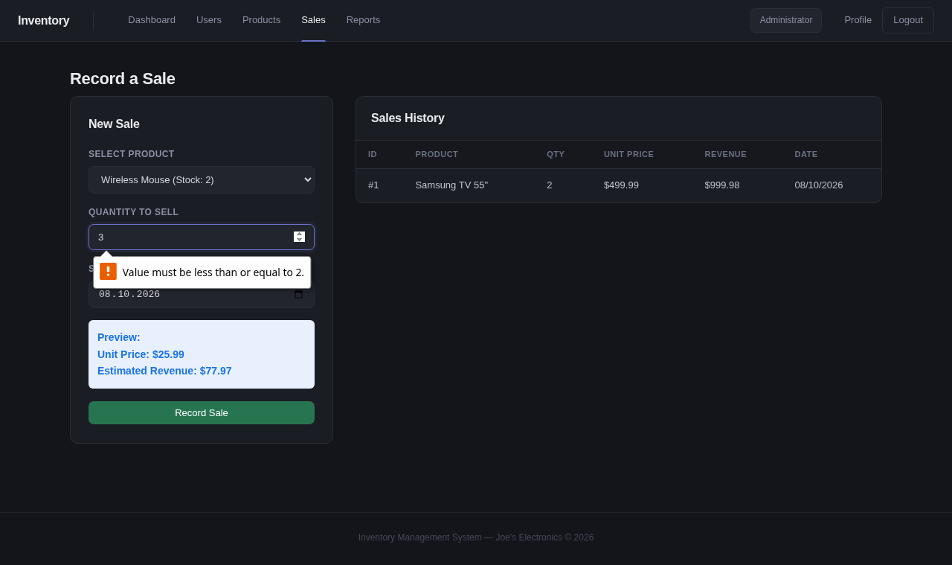  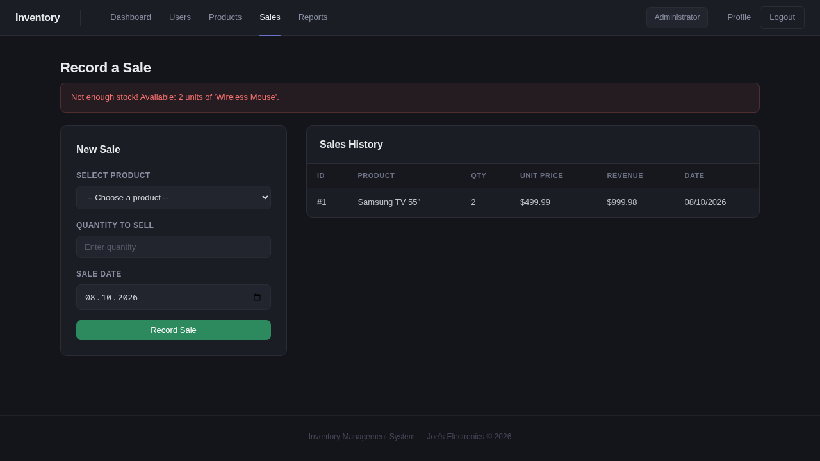
9 | Check the profile update and the wrong-password rejection. | Pre: logged in as admin.  1. Open Profile.  2. Change Full Name to Updated Test Name and click Update Profile.  3. Under Change Password enter current password wrong-current, new password newpass123 and confirmation newpass123, then click Change Password.  4. Restore the original name. | Functional, invalid input | Full name Updated Test Name; current password wrong-current (wrong); new and confirm password newpass123 | The name updates, and the password change fails with an error. | The full name changed to Updated Test Name. The alert said “Profile updated successfully!”, and both Account Information and the navbar showed the new name. The password change with the wrong current password (wrong-current) failed with “Current password is incorrect.” The stored password did not change. The test restored the name “Administrator” afterward. PASS. Evidence: evidence/TC09_profile_update.png, evidence/TC09_password_rejected.png  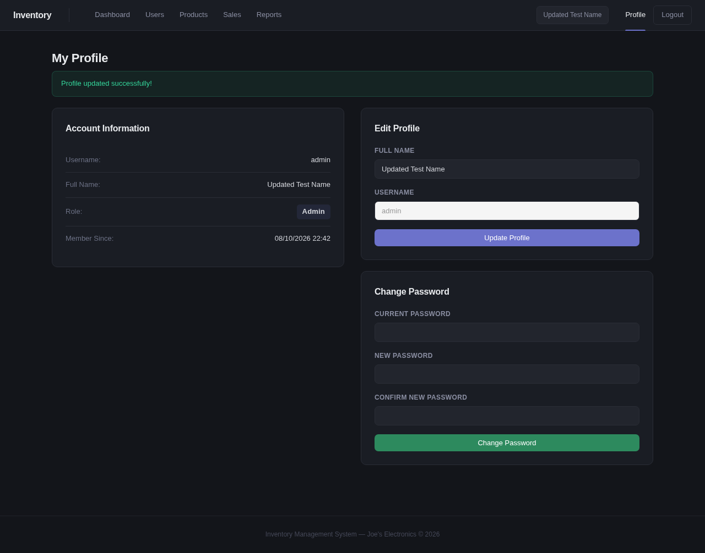  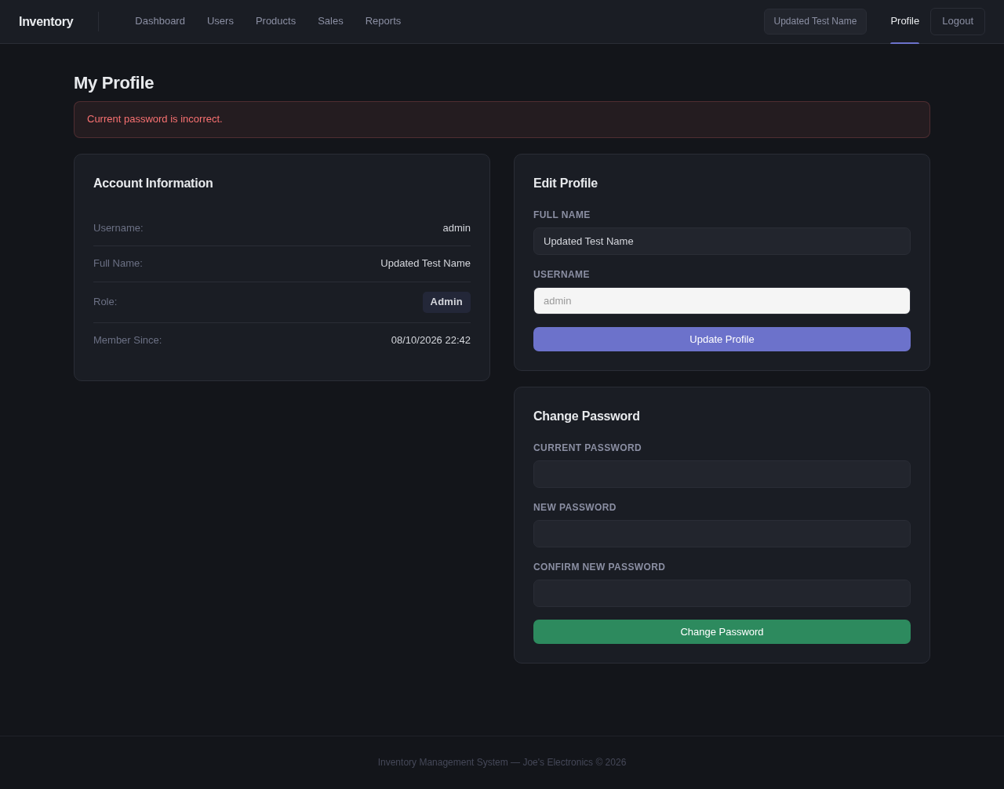
10 | Check that the report filters by date. | Pre: the TC07 sale exists (run the tests in order).  1. Open Reports.  2. Set the date to the TC07 sale date (2026-10-08) and click Generate Report.  3. Set the date to 2020-01-01 (no sales) and click Generate Report. | Functional, date filter and totals | Sale date 08/10/2026 (2 units, $999.98); no-sales date 01/01/2020 | The sale date shows the Samsung TV row and correct totals. The no-sales date shows a warning and zero totals. | The report for 08/10/2026 (the TC07 sale date) showed the Samsung TV 55" row with 2 units sold, 13 remaining and $999.98. Totals: 2 units, $999.98, 289 in stock, 9 products. The report for 01/01/2020 showed “No sales were recorded on 01/01/2020. The table below shows current inventory levels only.” with 0 units and $0.00 totals. PASS. Evidence: evidence/TC10_report_with_sales.png, evidence/TC10_report_no_sales.png  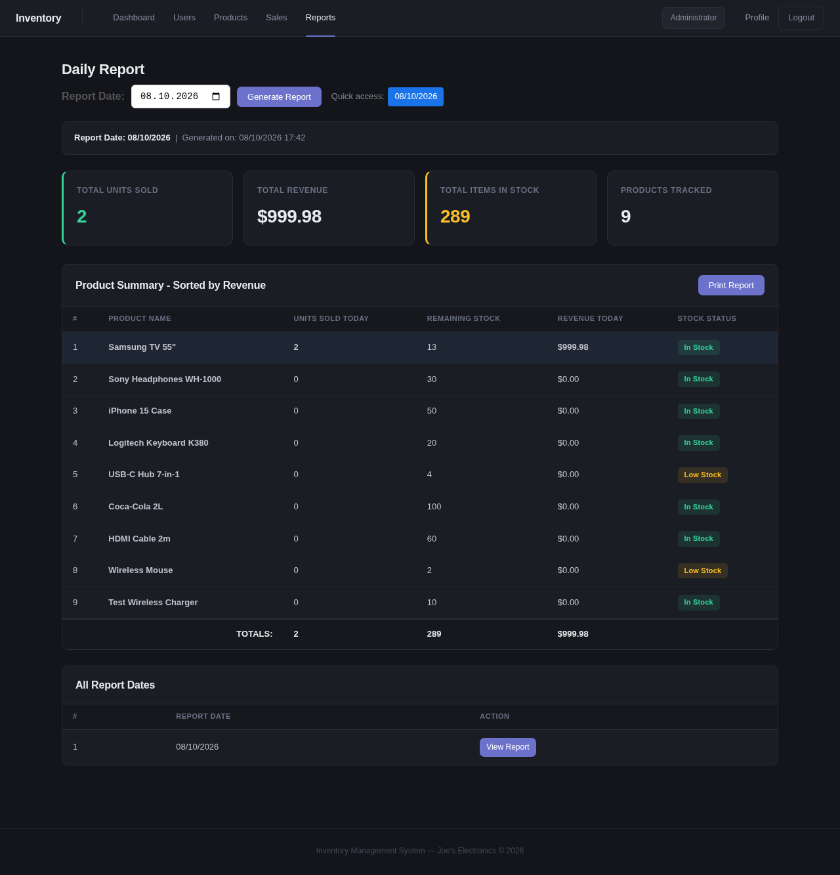  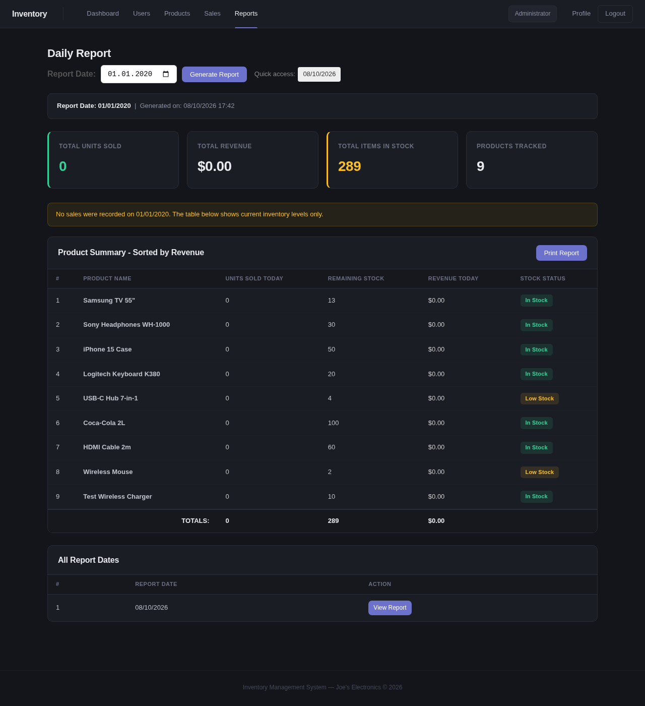

Evidence screenshots

TC01_admin_login.png

TC02_invalid_login.png

TC03_registration_boundary.png

TC04_add_product.png

TC05_search_valid.png

TC05_search_zero.png

TC06_user_access.png

TC06_users_blocked.png

TC07_sale_preview.png

TC07_sale_recorded.png

TC08_client_validation.png

TC08_overselling_blocked.png

TC09_profile_update.png

TC09_password_rejected.png

TC10_report_with_sales.png

TC10_report_no_sales.png

