The sinking of the Titanic is one of the most infamous shipwrecks in history. On April 15, 1912, during her maiden voyage, the Titanic sank after colliding with an iceberg, killing 1502 out of 2224 passengers and crew. That's why the name DieTanic. This is a very unforgetable disaster that no one in the world can forget.

It took about $7.5 million to build the Titanic and it sunk under the ocean due to collision. The Titanic Dataset is a very good dataset for beginners to start a journey in data science and participate in competitions in Kaggle.

The Objective of this document is to give an idea how is the workflow in any predictive modeling problem. How do we check features, how do we add new features and some Machine Learning Concepts. I have tried to keep the document as basic as possible so that even newbies can understand every phase of it.
This document provides a comprehensive guide on performing Exploratory Data Analysis (EDA) and predictive modeling on the Titanic dataset. It covers data cleaning, feature engineering, visualization, and model building using various algorithms. The notebook aims to predict passenger survival rates using machine learning techniques and offers insights into the factors influencing survival. sibsp is the number of siblings/spouses aboard. Parch is the number of parents/children aboard. For embarked, C = Cherbourg, Q = Queenstown, S = Southampton.

Id | Survived | Pclass | Name | Sex | Age | SibSp | Parch | Ticket | Fare | Cabin | Embarked
1 | 0 | 3 | Braund, Mr. Owen Harris | male | 22 | 1 | 0 | A/5 21171 | 7.25 |  | S
2 | 1 | 1 | Cumings, Mrs. John Bradley  (Florence Briggs Thayer) | female | 38 | 1 | 0 | PC 17599 | 71.2833 | C85 | C
3 | 1 | 3 | Heikkinen, Miss. Laina | female | 26 | 0 | 0 | STON/O2. 3101282 | 7.925 |  | S
4 | 1 | 1 | Futrelle, Mrs. Jacques Heath  (Lily May Peel) | female | 35 | 1 | 0 | 113803 | 53.1 | C123 | S
5 | 0 | 3 | Allen, Mr. William Henry | male | 35 | 0 | 0 | 373450 | 8.05 |  | S
6 | 0 | 3 | Moran, Mr. James | male |  | 0 | 0 | 330877 | 8.4583 |  | Q
7 | 0 | 1 | McCarthy, Mr. Timothy J | male | 54 | 0 | 0 | 17463 | 51.8625 | E46 | S
8 | 0 | 3 | Palsson, Master. Gosta Leonard | male | 2 | 3 | 1 | 349909 | 21.075 |  | S
9 | 1 | 3 | Johnson, Mrs. Oscar W | female | 27 | 0 | 2 | 347742 | 11.1333 |  | S

 |  |  | (Elisabeth Vilhelmina Berg)
10 | 1 | 2 | Nasser, Mrs. Nicholas (Adele  Achem) | female | 14 | 1 | 0 | 237736 | 30.0708 |  | C
11 | 1 | 3 | Sandstrom, Miss.  Marguerite Rut | female | 4 | 1 | 1 | PP 9549 | 16.7 | G6 | S
12 | 1 | 1 | Bonnell, Miss. Elizabeth | female | 58 | 0 | 0 | 113783 | 26.55 | C103 | S
13 | 0 | 3 | Saundercock,  Mr. William Henry | male | 20 | 0 | 0 | A/5. 2151 | 8.05 |  | S
14 | 0 | 3 | Andersson, Mr. Anders Johan | male | 39 | 1 | 5 | 347082 | 31.275 |  | S
15 | 0 | 3 | Vestrom, Miss. Hulda Amanda Adolfina | female | 14 | 0 | 0 | 350406 | 7.8542 |  | S
16 | 1 | 2 | Hewlett, Mrs.  (Mary D Kingcome) | female | 55 | 0 | 0 | 248706 | 16 |  | S
17 | 0 | 3 | Rice, Master. Eugene | male | 2 | 4 | 1 | 382652 | 29.125 |  | Q
18 | 1 | 2 | Williams, Mr. Charles Eugene | male |  | 0 | 0 | 244373 | 13 |  | S
19 | 0 | 3 | Vander Planke, Mrs. Julius  (Emelia Maria Vandemoortele) | female | 31 | 1 | 0 | 345763 | 18 |  | S

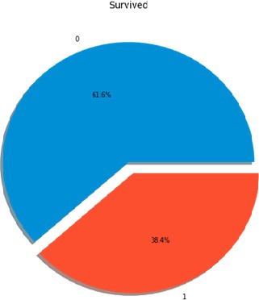

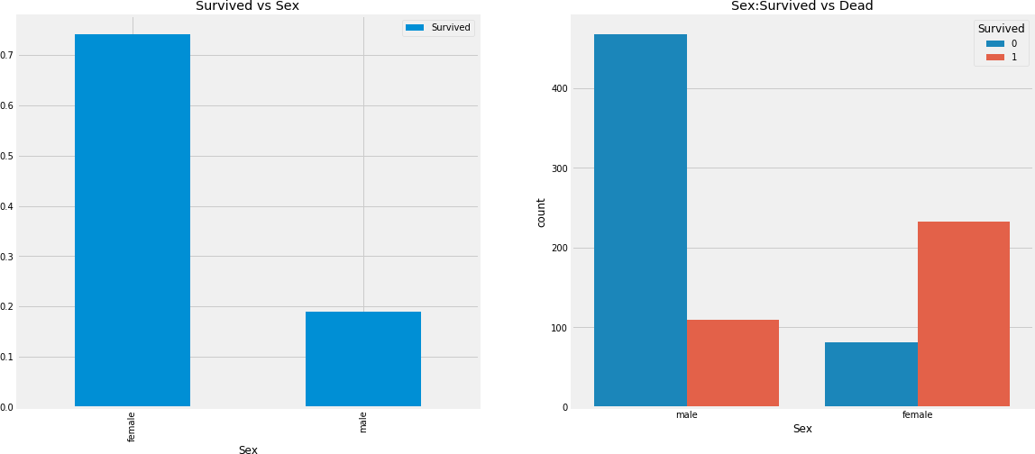

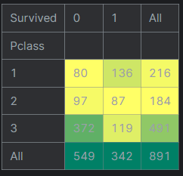

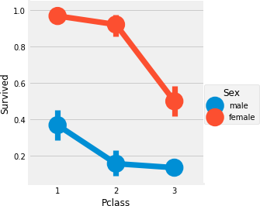

f
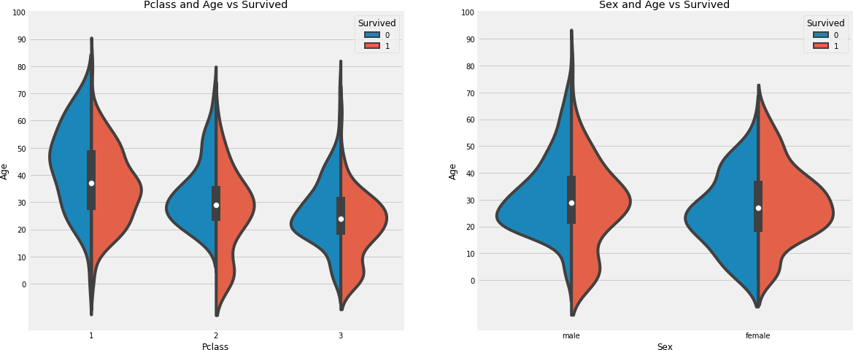

 | Sex | female |  | male | All
 | Survived |  | 0 | 1 | 0 | 1
Embarked | Pclass
 | 1 | 1 | 42 | 25 | 17 | 85
 | 2 | 0 | 7 | 8 | 2 | 17
C | 3 | 8 | 15 | 33 | 10 | 66
 | 1 | 0 | 1 | 1 | 0 | 2
 | 2 | 0 | 2 | 1 | 0 | 3
Q | 3 | 9 | 24 | 36 | 3 | 72
 | 1 | 2 | 46 | 51 | 28 | 127
 | 2 | 6 | 61 | 82 | 15 | 164
S | 3 | 55 | 33 | 231 | 34 | 353
All |  | 81 | 231 | 468 | 109 | 889

