**Major benefits of the Organic Food**

* **Health**

There are three major benefits from organic food to our health. We want to show to the readers how organic food can really become a wonderful things to health. First is about the nutrient content from organic food, second about the toxic metal contain in the food and the last is about the pesticide residue amount exposure in the conventional food.

A study in United Kingdom, particularly in Newcastle University has figure out the evidence that the food made from organic, are nutritionally better to than conventional food products. The report was published in the July 15 issue of the prestigious *British Journal of Nutrition*. They are analyzing 343 studies and successfully found out that organic crops and organic crop-based foods are having more than 60 percent number of antioxidants compared to conventionally crops. This research showed that pesticide residues are found more frequently in conventional foods, and revealed lower levels of a toxic, such as heavy metal in organic crops.

The most important thing in organic is safer to consume, researcher’s study found significantly lower amount of pesticide residues and lower levels of a toxic metal (Cadmium) in the organic food. From this study, we can know that conventional crops were four times to contain pesticide residues than the organic crops. The high exposure by pesticides will give bad affect to our body, particularly in brain development especially in young children, give risk for pregnant women. Newcastle study also found that organic crops had more or less 48 percent lower cadmium levels than conventional crops. For information Cadmium is a heavy metal which can cause kidney failure, bone softening and liver damage. Cadmium can accumulate inside the body and the body can’t remove it instantly, so even at low levels, Cadmium will cause danger to ours health.

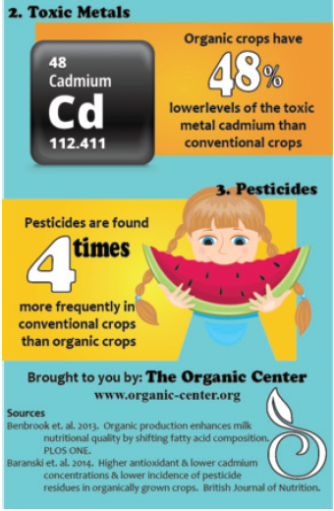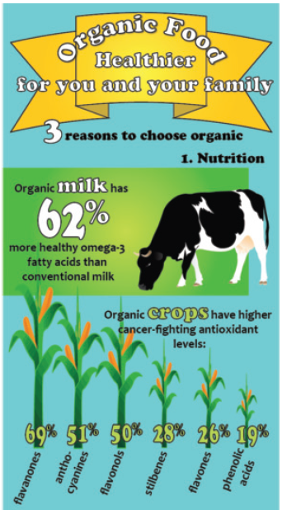

* **Environment**

There are six major benefit from organic crop to the environment, the first one is for the s**ustainability over the long term.** Organic farming thinks the medium term and long term can be influence by organic method. Organic farming not only produce food to fulfil human needs, but also keep the balance in ecology and preserve soil fertility and prevent pesticide problems. Organic farming takes the proactive approach to oppose treating problems before they occurred.

**Second is about s**oil, it building practices such as crop rotations, inter-cropping, symbiotic associations, cover crops, organic fertilizers and minimum tillage are central to organic practices. These encourage soil fauna and flora, improving soil formation and structure and creating more stable systems. In turn, nutrient and energy cycling is increased and the retentive abilities of the soil for nutrients and water are enhanced, compensating for the non-use of mineral fertilizers. Such management techniques also play an important role in soil erosion control. The length of time that the soil is exposed to erosive forces is decreased, soil biodiversity is increased, and nutrient losses are reduced, helping to maintain and enhance soil productivity. Crop export of nutrients is usually compensated by farm-derived renewable resources but it is sometimes necessary to supplement organic soils with potassium, phosphate, calcium, magnesium and trace elements from external sources.

**Third is groundwater**. In agriculture areas, many pollution of groundwater, and the usage of improper dosage of chemical fertilizers and pesticides become serious problem. The usage of any chemical substance now prohibited in organic agriculture, they are replaced by organic fertilizers (for example compost, animal manure, green manure) and through the use of greater biodiversity (in terms of species cultivated and permanent vegetation) to enhance soil structure and water infiltration. Organic systems which managed well shall greatly reduce the risk of groundwater pollution. In some areas where pollution become major problem, conversion to organic agriculture is highly encouraged as a restorative measure.

**The fourth is about air and climate change**. Organic agriculture reduces the usage of non-renewable energy by decreasing agrochemical needs which required a high amount of fossil fuel to be produced. Organic agriculture also mitigating and preventing the greenhouse effect through its ability to eliminate carbon in the soil. Organic agriculture uses many management practices such as minimum tillage, returning crop residues to the soil, the use of cover crops and rotations, increase the return of carbon to the soil, and raising productivity. A studies found out that by organic farming, soil organic carbon contents are higher compared to conventional farming. The more organic carbon is retained in the soil, the more the prevention against climate change.

**The fifth is biodiversity**. Organic farmers are custodians and users of biodiversity. Traditional and adapted seeds are more demanding because they possess more level of resistance to diseases and resilience to climatic stress. Diverse combinations of plants optimize nutrient and energy cycling for agricultural production. Moreover, the maintenance of natural areas within and around organic fields which absence from chemical inputs will create suitable habitats for wildlife. The frequent use of under-utilized species reduces erosion of agro-biodiversity. A recent study reporting on a meta-analysis of 766 scientific papers concluded that organic farming produces more biodiversity than other farming systems.

**The last is about the ecological services**. Ecological services is consist of soil forming and conditioning, soil stabilization, waste recycling, carbon sequestration, nutrients cycling, predation, pollination and habitats. The impact of organic agriculture will give interactions within the agro-ecosystem that are important to agricultural production and nature conservation. By choosing organic products, the consumer automatically promotes a less polluting agricultural system and more environmental friendly farming system. In result that the costs of agriculture to the environment in order to preserve the natural resource from degradation are reduced.

http://www.fao.org/organicag/oa-faq/oa-faq6/en/