**Rice price**

The increasing number of population is a great market to food industry. Particularly people now more concern about what they eat. In 2012, the world population is exceeding seven billion, and food security become major issue in world. Rice is highly consumed by majority people from Asia, Caribbean, Middle East and Africa. Since still a lot of people from those region still live under the poverty line, keeping the rice price stable is important to the government. According to Childs & Kiawu, 2009 the low of stock in rice contributed the large price of rice. The ASEAN (Association of Southeast Nation) has discussed to form the organization to deal with the rice issue. This organization called East Asia Emergency Rice Reserve (EAERR) which has trading partner with Japan, South Korea and China (ADB, 2011)

**Rice Demand and Market**

The development of farmer market is enormous. Before the year of 2000, there only less than 3000 farmer market in US, and after more than 10 years, there were more than 7000 registers in USDA national database. It means the current annual growth rate is about 10% (USDA Agricultural Marketing Service, 2013)

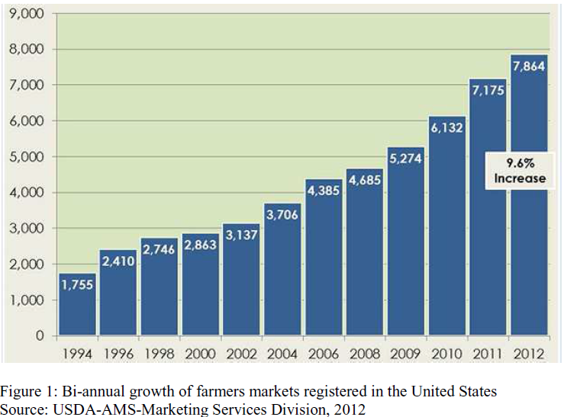

The spread of organic food market in US can be seen in map below:

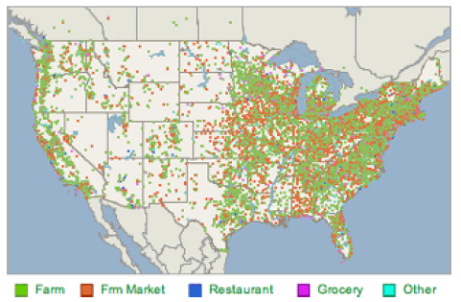

Map of local organic food markets in US. Source: CSA Database, www.localharvest.org

**Bibliography:**

Xianglin, Liu. 2013. The Global Food Price Crisis and China-World Rice Market Integration: A Spatial-Temporal Rational Expectations Equilibrium Model

Schrank, Zachary. 2013. An Inverted Market: Niche Market Dynamic of The Local Organic Food Movement. Dissertation The University of Arizona.