**Production rice**

The effect of inclement weather in 2014, particularly Asia is become one major challenge to the farming. The global production of rice is fallen slightly. At the country level, the largest downward is in Thailand because the disruption of water availability in irrigation caused by unseasonable dryness. In the other hand, the effect of monsoon make India rice production to deteriorate further.

Production rice globally is increase gradually from 2006 until 2014. At 2006 the production showed approximately 640 million ton with the farming land reach 155 million hectares, while in the closure of 2014 data recorded reach 740 million ton with the usage of land 163 million hectares. Since 2006 production rate and the farming land is increasing but in fluctuating pattern. The main reason for decreasing is inclement weather, although the number population who needs rice is increasing each year. In the 2015 Food and Agriculture Organization (FAO) forecast the production will reach 750 million ton.

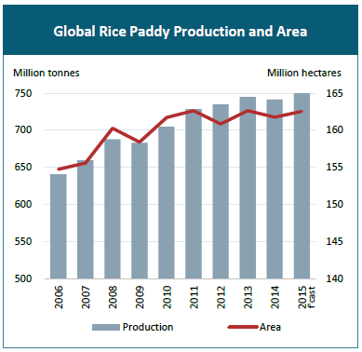

**Asia**

More specific to Asia as the bigger rice production, the highest rice producer is China then followed by India. Those two countries can produced almost 350 million ton. It almost half of global production. The total production for Asia is steady from 2011 to 2014, averagely their production capacity is around 780 million ton rice.

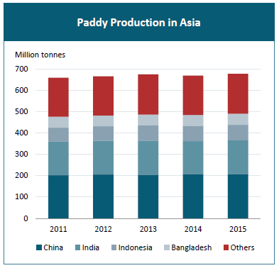

**Africa**

The total production for Africa continent is almost 30 million ton, which half of them are produced in Egypt, Nigeria and Madagascar.

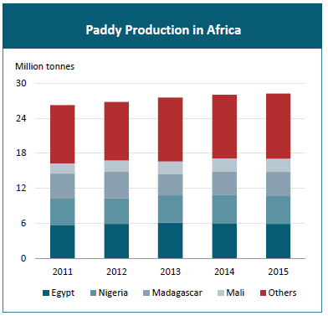

**Latin America**

The South America produced almost the same with Africa, almost reach 30 million ton rice. However, in South America is dominated by Brazil as the highest rice producer which the production around 12 million ton of rice.

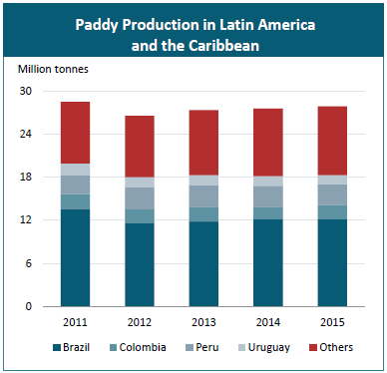

**Organic food production**

Healthy growth is continuing in the global market for organic product. Latest research showed the international sales of organic product approached US64 billion in 2012, experience positive growth in all region. While in 1999 the total market size is only US15.2 billion (source: Organic Monitor). The leading countires in organic market are US with EUR22.6 billion, Germany EUR7 billion and France with EUR4 billion.

According to the latest FIBL-IFOAM survey on certified organic agriculture worldwide, which avalaible from 164 countries in 2012, it has increased from 162 contries in 2011. There were 37.5 million hectare of organic agricultural land in 2012. While if we see the data in 1999, the organic agricultural land only 11 milion hectare. The largest area of organic agricultural are Oceania with 12.2 milion hectares or almost 32% of world’s organic agricultural land. Then followed by Argentina with 3.6 million hectare and United States with 2.2 million hectare. In 2012, the organic agricultural land increased by almost 0.2 million hectares or about 0.5 percent.

The increasing of rice production means that people who consuming rice is increasing, moreover the organic agricultural land always grow gradually too, hence the organic rice is the great opportunity with a high propect market.