**Regulation**

To start organic product business we need to pay more attention to the regulation that valid in the nation that we want to start business. We should concern about domestic regulation, however as a developed country and reputed as modern agriculture industry, United States regulation usually seen as guideline by the other countries.

**Farming regulation**

Based on the United States regulation (Electronic Code of Federal Regulation) we can know the list of each substance to be used as a production or handling input, indicating its composition, source, location(s) where it will be used, and documentation of commercial availability, as applicable;

A description of the monitoring practices and procedures to be performed and maintained, including the frequency with which they will be performed, to verify that the plan is effectively implemented

How to select and implement tillage and cultivation practices that maintain or improve the physical, chemical, and biological condition of soil and minimize soil erosion.

The producer must manage crop nutrients and soil fertility through rotations, cover crops, and the application of plant and animal materials.

**How to make the rotation crop**

*Crop rotation.* The practice of alternating the annual crops grown on a specific field in a planned pattern or sequence in successive crop years so that crops of the same species or family are not grown repeatedly without interruption on the same field. Perennial cropping systems employ means such as alley cropping, intercropping, and hedgerows to introduce biological diversity in lieu of crop rotation.

The producer must implement a crop rotation including but not limited to sod, cover crops, green manure crops, and catch crops that provide the following functions that are applicable to the operation:

(a) Maintain or improve soil organic matter content;

(b) Provide for pest management in annual and perennial crops;

(c) Manage deficient or excess plant nutrients; and

(d) Provide erosion control.

The producer must manage plant and animal materials to maintain or improve soil organic matter content in a manner that does not contribute to contamination of crops, soil, or water by plant nutrients, pathogenic organisms, heavy metals, or residues of prohibited substances. Animal and plant materials include:

**Labelling and Certification**

In United Stated if we want to seek for organic products in the marketplace, consumers should find for the USDA Organic Seal or a certifier name on the label. The U.S. Department of Agriculture categorized four kind of organic labels. This labelling based on the percentage of organic content in that product. This means that not only the organic ingredients in processed products certified, but also the facilities that handle and process the products are inspected and certified as well.

**1. 100 % ORGANIC**

Products produced using exclusively organic methods, containing only organic ingredients, are allowed to carry a label declaring “100 percent organic” and may use the USDA Organic Seal.

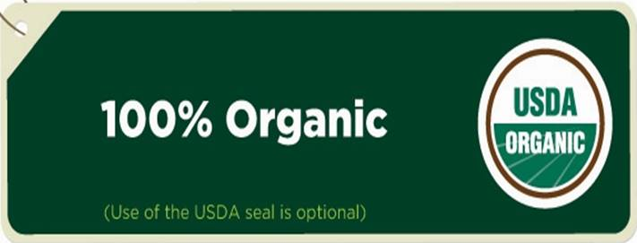

**2. ORGANIC**

Products produced using exclusively organic methods that contain at least 95% organic ingredients may use the USDA Organic Seal.

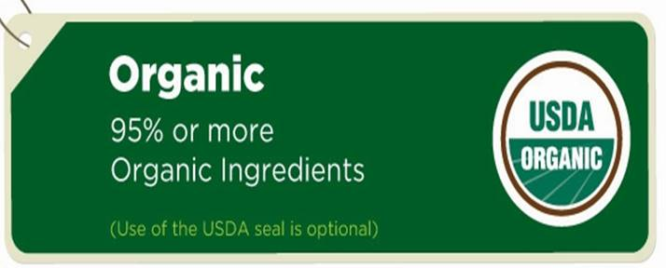

**3. MADE WITH ORGANIC**

Products with 70% to 95% organic ingredients may display "Made with organic [with up to three specified ingredients or food groups]" on the front panel. The USDA Organic Seal may not be used, however products in this category MUST be certified through the same USDA organic certification process that is required for "100% Organic" and "Organic" label.

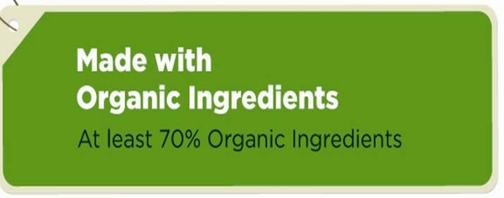

**INGREDIENT PANEL**

Products with less than 70% organic ingredients can only list the organic items on the ingredient panel. The USDA Organic Seal must not be used. No organic claim is allowed on the front panel of the product.

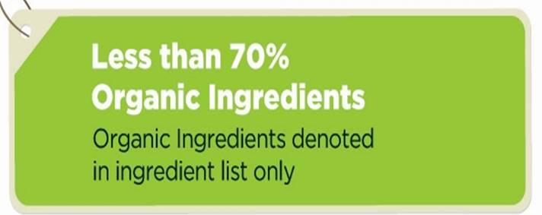

Bibliography

<http://www.epa.gov/agriculture/tlan.html>

http://www.ota.com/learn-about-organic/labeling