DOKUMENTASI EKSTERNAL  External Documentation | 
[TUGAS MANDIRI / PROYEK ]
[Assignment / Project]
MATAKULIAH <COMP6176> – <Human and Computer Interaction>
Subject

SEMESTER [GANJIL/GENAP/PENDEK] 2016/2017
[Odd/Even/Compact] Semester Year 2016/2017

Judul Proyek
[Assignment / Project] Title
Mister Loco

Abstrak [50 – 200 words]
Abstract

Mister Loco needs a logo that represents the image of organization that has professional reputation. Consider the customer segment, shape and colors when designing the logo. The logo will be created using Adobe Photoshop CS3, ensure no layers are merged. Mister Loco wants you to design the blueprint of your homepage first before starting the development on the HTML files. The blueprint will be created using Adobe Photoshop CS3. Ensure the blueprint that you create are the exact same with the website that you will make later. The homepage blueprint will contain header, navigation, content, and footer as its structure. Mister Loco wants their company website to provide information about their products and new promotions available, and have feature that allow customer to order, see partner companies of Mister Loco, and see the contact information of Mister Loco. Mister Loco wants you to build the website attractive, appealing, and fully functioning, furthermore Mister Loco wants you to create the website with responsive design. The website should be accessible by using mobile phone in a perfect way. To achieve that, use 5 kinds of CSS properties and JavaScript. Use Meta viewport tag and media screen rule that will be applied if the screen width is below 500px.

Pendahuluan
Introduction

Mister Loco is a name for clothing shop that formed in April 15, 2015 and based in Jakarta, Indonesia. Mister Loco clothing shop focuses on selling all kinds of clothes for women, and the clothes can be used for all ages. Mister Loco already has many reputable partners who support the sale of clothes, so it can be sold at an affordable price. There will always be a new model of clothes every day, so customer will not be bored.
Currently the technology has grown very rapidly, and now it's the time many people interested to shopping online because it is easy and practical. Mister Loco decided to create a website that will be used by customer who want to shop online can easily access Mister Loco store. Mister Loco also asked you to create logo that represents their company. In matter of that, Mister Loco is looking for a web designer to create the logo and website.

Catatan
Notes

Jangan lupa untuk menginstal font terlebih dahulu. Nama font yaitu Montserrat.ttf

Dokumentasi
Report / Documentation

Page Home

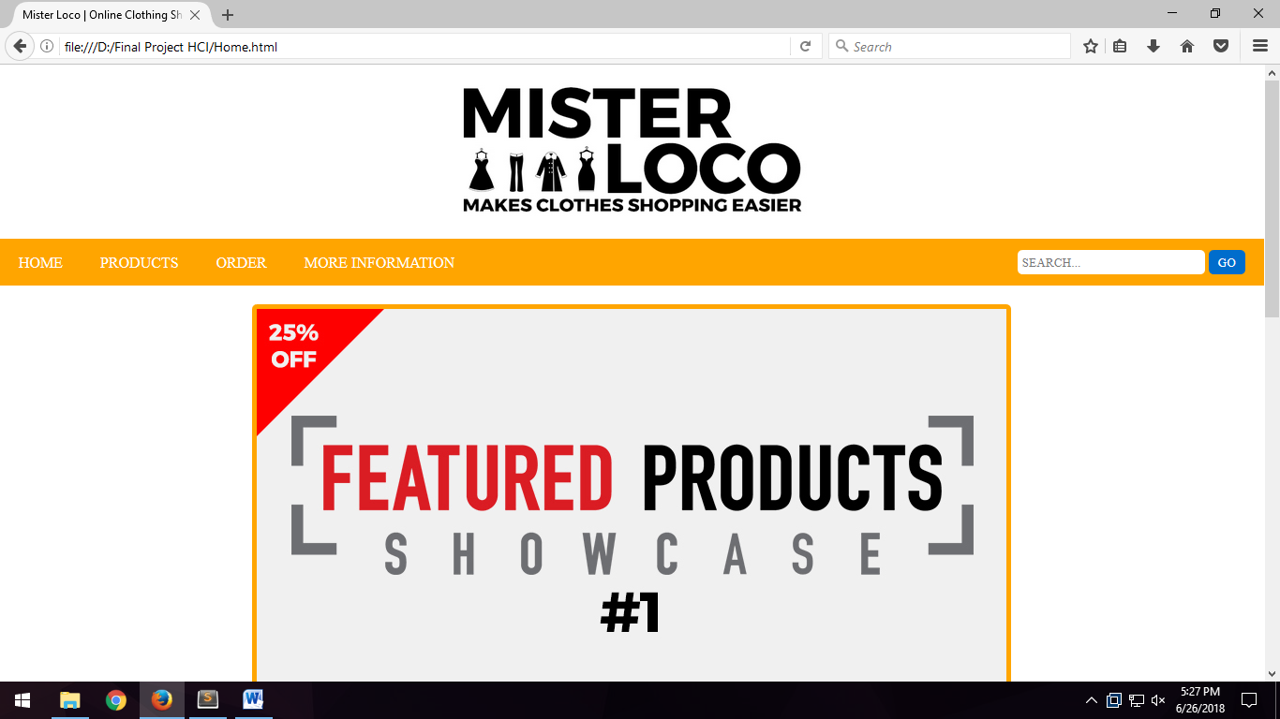

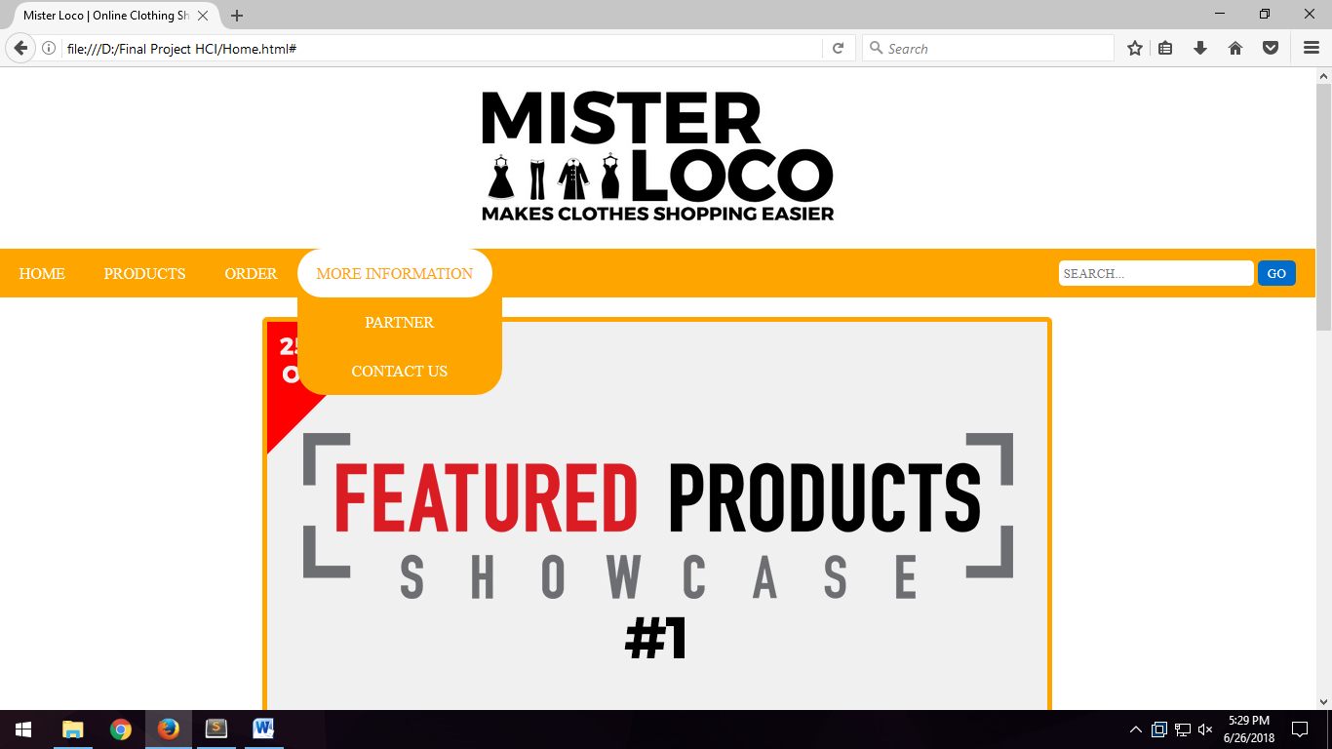
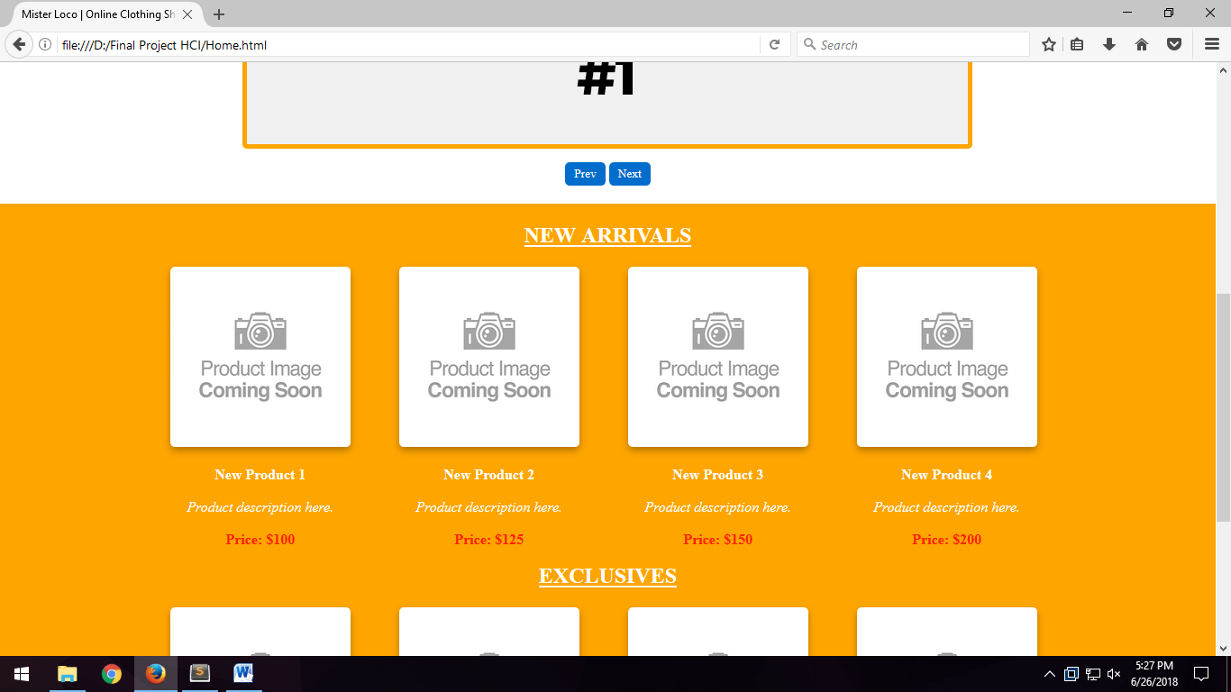

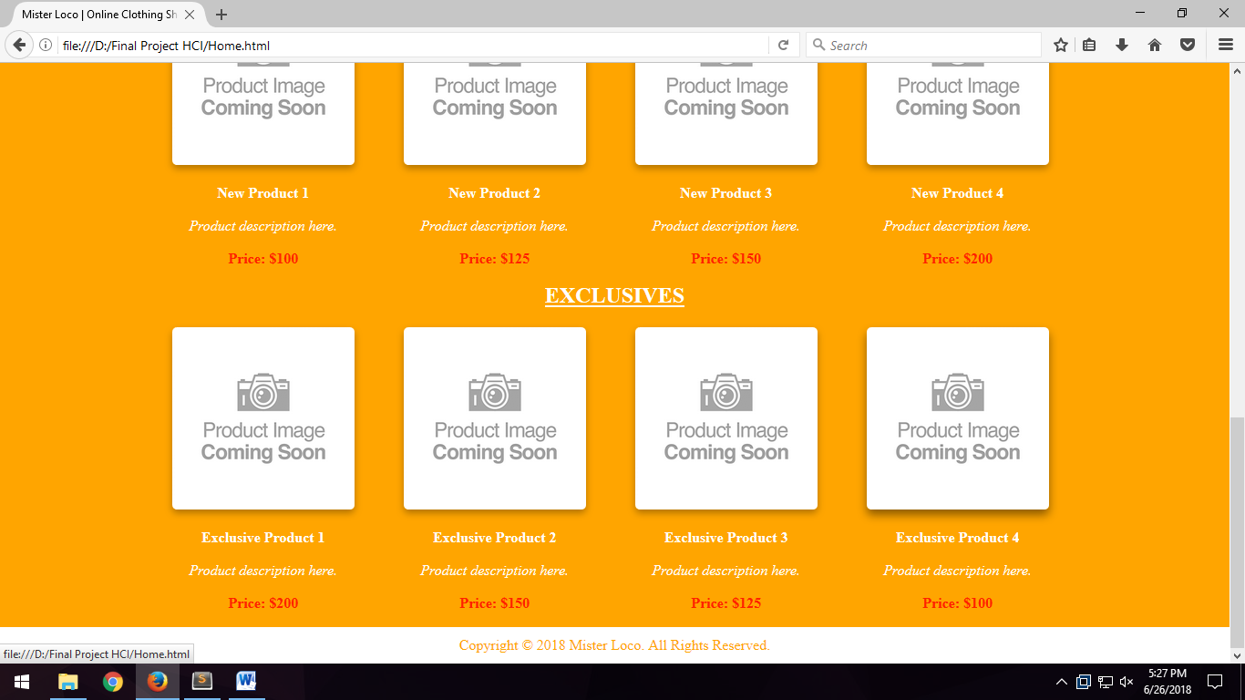

Disini kita bisa melihat halaman utama dari sebuah website dimana terbata logo, menu navigasi yang bisa hover di menu more information beserta dengan search, dan diisi product new arrivals dan exclusives product. Tak lupa juga menyertakan copyright.

Page Product
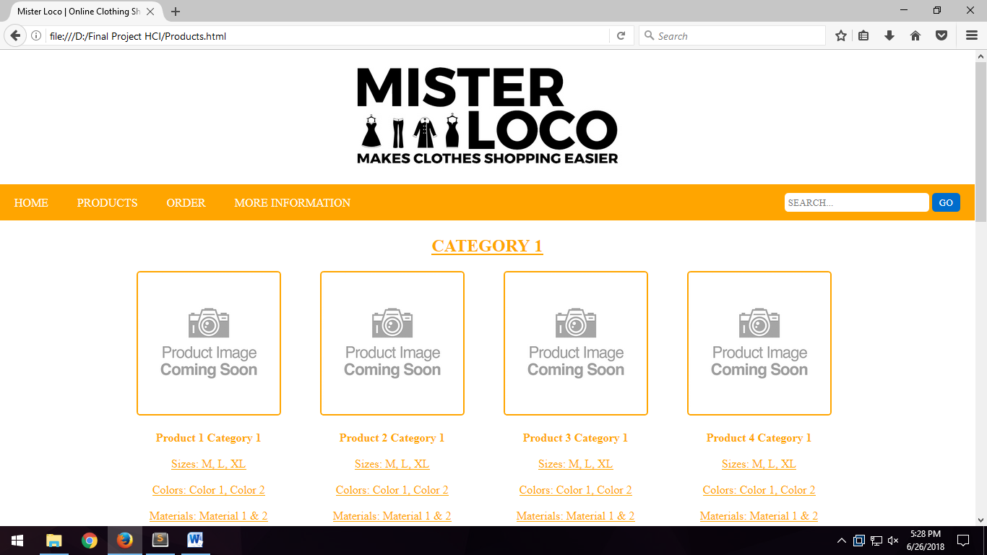

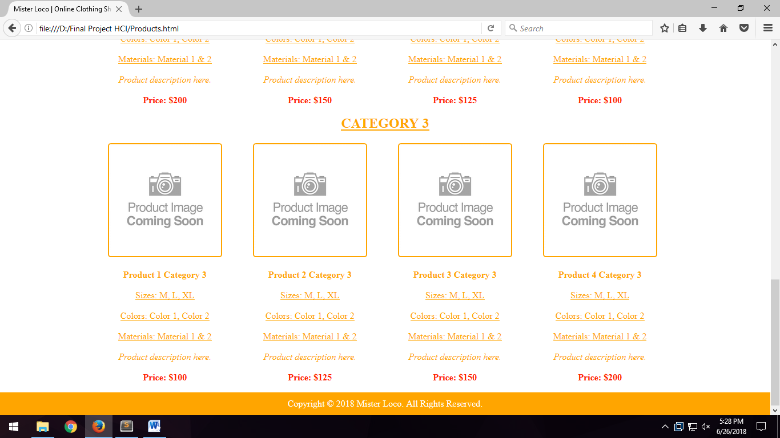

Di page product, kita bisa melihat ada 3 kategori product yang kita bisa lihat gambarnya beserta dengan size, warna, material yang dipakai, serta harga dan deskripsi produk.

Page Order

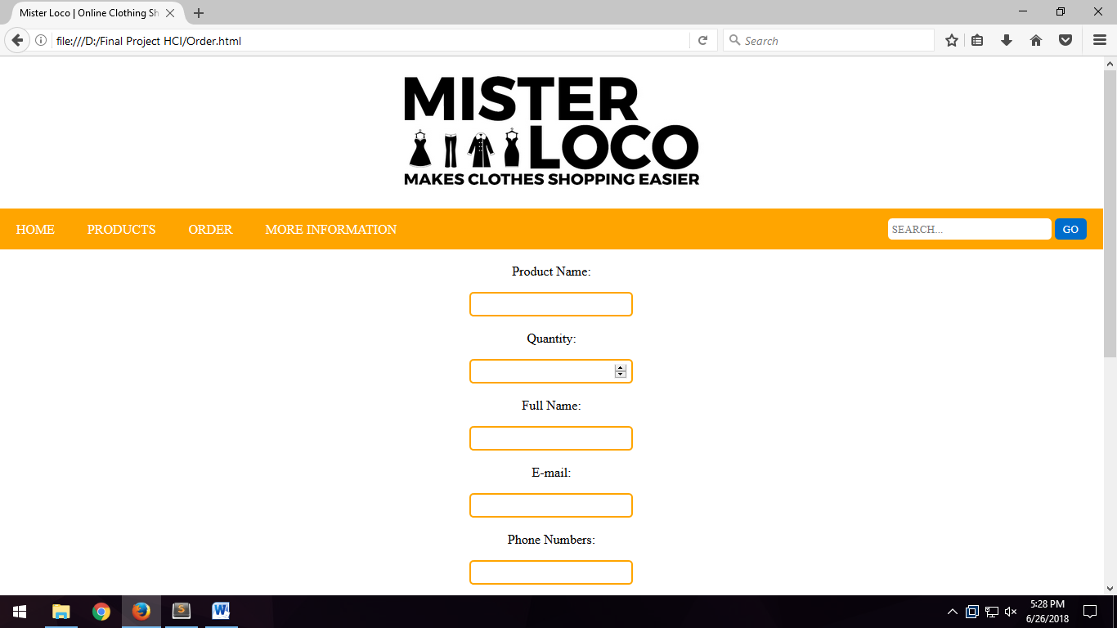

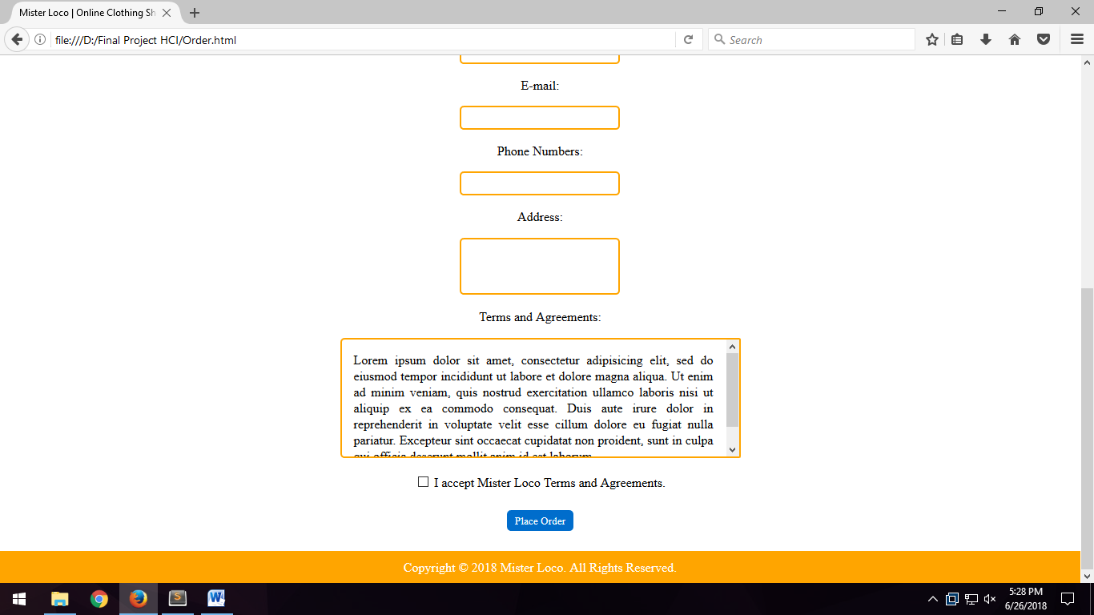

Didalam page order, kita bisa menuliskan apa yang mau kita pesan berserta dengan data diri yaitu banyak produk, nama, email, no hp, dan alamat. Tak lupa juga menyertakan syarat dan ketentuan / agreements. Disitu juga terdapat validasi untuk meminimalisasi terjadinya kesalahan saat melakukan pemesanan.

Page Partner

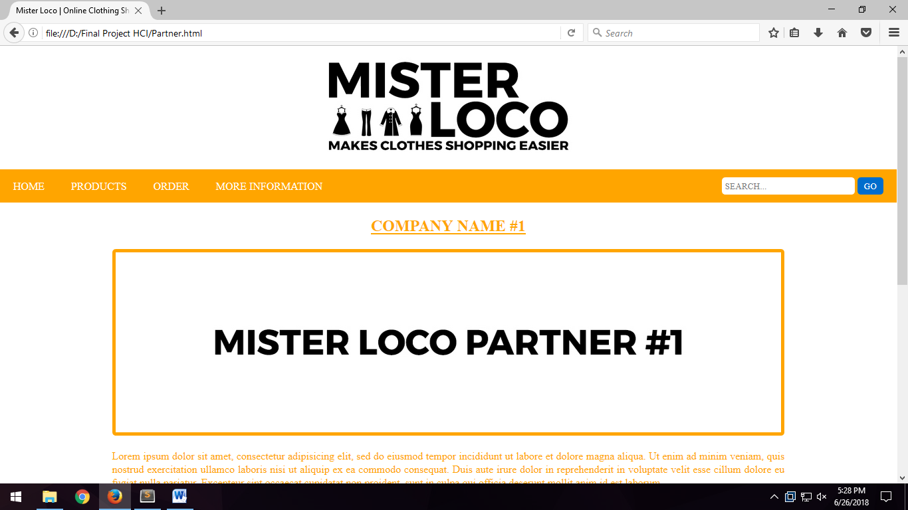

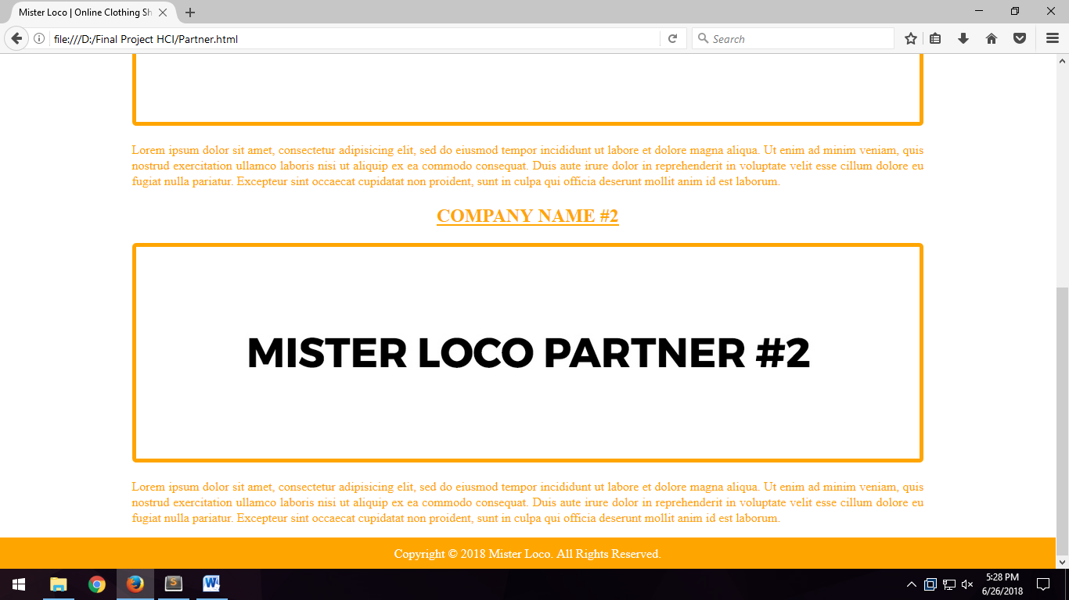

Didalam Page partner terdapat daftar partner yang bekerjasama dengan Mister Loco beserta dengan deskripsi nya.

Page Contact

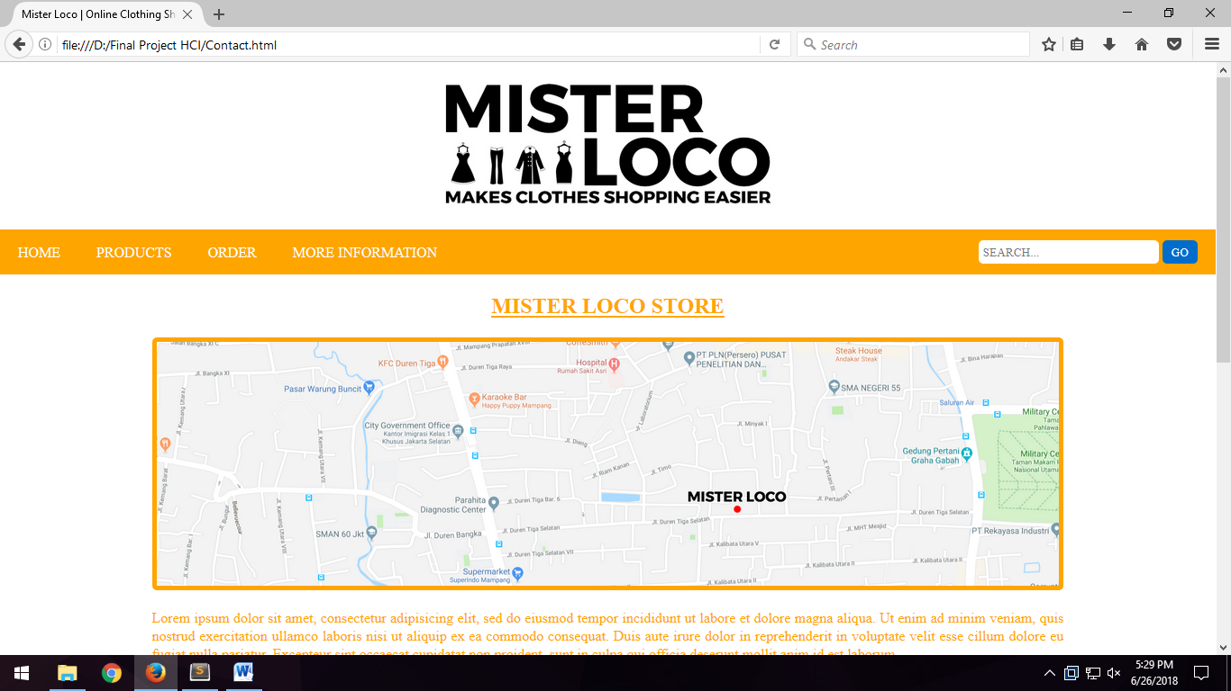

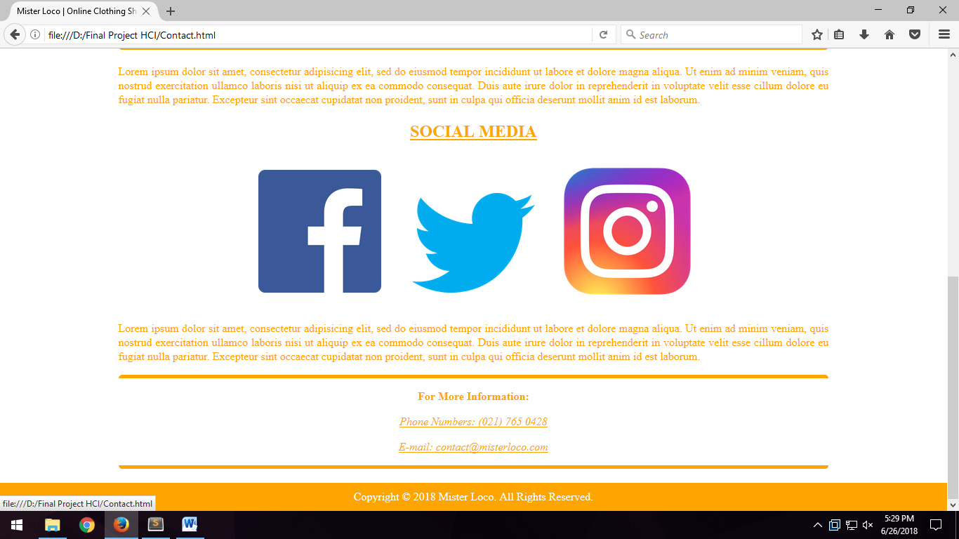
Disini, kita mencantumkan alamat dari Mister Loco beserta dengan sosial media yang dapat dikunjungi oleh pengunjung dunia maya. Ini bertujuan apabila ada pertanyaan seputar Mister Loco ataupun terjadi kejanggalan dalam melakukan pemesanan. Atau juga bisa mengajukan pemesanan dalam jumlah banyak dan melihat promo-promo yang di bagikan di sosial media Mister Loco.

Referensi
References

- Fashion Vector.jpg
- dreamstime.com

- Product CS.png
- blackberrycafe.cz

- jquery-3.1.1.js
- https://blog.jquery.com/2016/09/22/jquery-3-1-1-released

- Montserrat-Regular.ttf
- https://fonts2u.com/montserrat-regular.font

- fb.png
- facebook.com

- ig.png
- https://commons.wikimedia.org/wiki/File:Instagram_logo_2016.svg

- twt.png
- https://logos-download.com/169-twitter-logo-download.html

Disiapkan Oleh,
Prepared by,

- <2001541554> - <Hengky Chandra>
- <2001564135> - <Jonathan>
- <2001608585> - <Kurniawan Pratama>

