Windows Platform Design
Designing Hardware for the Microsoft® Windows® Family of Operating Systems
Support for USB Telephony Devices in Microsoft Windows
Abstract: The paper introduces the architecture for support planned for USB-connected telephony peripherals in future versions of the Microsoft® Windows® 2000 operating system. This paper presents the information—including Audio and HID Class firmware requirements and options—which a hardware manufacturer needs to know to build a USB telephony device that will work with Windows native support and with Windows-based TAPI applications.
Version 0.91 — January 11, 1999 — REVIEW DRAFT
Disclaimer: This document is for informational purposes only. MICROSOFT MAKES NO WARRANTIES, EXPRESS OR IMPLIED, IN THIS DOCUMENT.
Microsoft Corporation may have patents or pending patent applications, trademarks, copyrights, or other intellectual property rights covering subject matter in this document. The furnishing of this document does not give you any license to the patents, trademarks, copyrights, or other intellectual property rights except as expressly provided in any written license agreement from Microsoft Corporation.
Microsoft does not make any representation or warranty regarding specifications in this document or any product or item developed based on these specifications. Microsoft disclaims all express and implied warranties, including but not limited to the implied warranties or merchantability, fitness for a particular purpose and freedom from infringement. Without limiting the generality of the foregoing, Microsoft does not make any warranty of any kind that any item developed based on these specifications, or any portion of a specification, will not infringe any copyright, patent, trade secret or other intellectual property right of any person or entity in any country. It is your responsibility to seek licenses for such intellectual property rights where appropriate. Microsoft shall not be liable for any damages arising out of or in connection with the use of these specifications, including liability for lost profit, business interruption, or any other damages whatsoever. Some states do not allow the exclusion or limitation of liability or consequential or incidental damages; the above limitation may not apply to you.
DirectShow, Microsoft, MS-DOS, NetMeeting, Win32, Win64, Windows, and Windows NT are either registered trademarks or trademarks of Microsoft Corporation in the United States and/or other countries. Other product and company names mentioned herein may be the trademarks of their respective owners.

© 1999 Microsoft Corporation. All rights reserved.

Contents

1 Introduction 5
1.1 Terminology and Acronyms 5
1.2 Background 5
1.3 Examples of USB Handset Interaction Using the Phone Manager 8
1.3.1 Outgoing Calls 9
1.3.2 Incoming Calls 10
2 Basic Requirements 10
2.1 Optional Features that TAPI Supports 11
2.2 Features that TAPI Does Not Support 11
2.3 Power Management 12
2.4 Unique Serial Number 12
2.5 Table 2: Valid Serial Number Characters 13
3 Descriptor Hierarchy 13
4 Audio Device Class for Telephony 14
4.1 Input Terminal 14
4.2 Output Terminal 15
4.3 USB Audio Device Class Telephone Terminal Types 15
4.3.1 Bi-directional Terminal Types 15
4.3.2 Selector Unit 16
4.3.3 Feature Unit 16
4.4 Audio Topology Diagram 17
4.5 Device Descriptors 17
4.6 Configuration Descriptor 18
4.6.1 AudioControl Interface Descriptor 18
4.6.2 Standard AC Interface Descriptor 18
4.6.3 Class-specific Interface Descriptor 19
4.6.4 Input Terminal Descriptor (ID1) 19
4.6.5 Input Terminal Descriptor (ID2) 20
4.6.6 Feature Unit Descriptor (ID3) 20
4.6.7 Feature Unit Descriptor (ID4) 21
4.6.8 Output Terminal Descriptor (ID5) 21
4.6.9 Output Terminal Descriptor (ID6) 22
4.6.10 AudioStreaming Interface 1 Descriptor 22
4.6.11 AudioStreaming Interface 2 Descriptor 24
4.6.12 String Descriptors 26
4.6.13 Requests 27
4.6.14 Mute Control 28
4.6.15 Volume Control 29
4.6.16 Get Feature Unit Control Request 29
4.6.17 Topology Diagram 30
4.6.18 Descriptors 32
4.6.19 Device Descriptor 32
4.6.20 Configuration Descriptor 33
4.6.21 AudioControl Interface Descriptor 33
4.6.22 Standard AC Interface Descriptor 33
4.6.23 Class-specific Interface Descriptor 34
4.6.24 Input Terminal Descriptor (ID1) 34
4.6.25 Input Terminal Descriptor (ID2) 35
4.6.26 Input Terminal Descriptor (ID3) 35
4.6.27 Feature Unit Descriptor (ID4) 36
4.6.28 Feature Unit Descriptor (ID5) 36
4.6.29 Feature Unit Descriptor (ID6) 36
4.6.30 Feature Unit Descriptor (ID7) 37
4.6.31 Selector Unit Descriptor (ID8) 37
4.6.32 Output Terminal Descriptor (ID9) 38
4.6.33 Output Terminal Descriptor (ID10) 38
4.6.34 Output Terminal Descriptor (ID11) 38
4.6.35 Zero-bandwidth Alternate Setting 0 39
4.6.36 Standard Interface Descriptor 39
4.6.37 Operational Alternate Setting 1 39
4.6.38 Standard AS Interface Descriptor 39
4.6.39 Class-specific AS Interface Descriptor 40
4.6.40 Type I Format Type Descriptor 40
4.6.41 Standard Endpoint Descriptor 40
4.6.42 Class-specific Isochronous Audio Data Endpoint Descriptor 41
4.6.43 AudioStreaming Interface 2 Descriptor 41
4.6.44 Zero-bandwidth Alternate Setting 0 41
4.6.45 Standard Interface Descriptor 41
4.6.46 Operational Alternate Setting 1 42
4.6.47 Standard AS Interface Descriptor 42
4.6.48 Class-specific AS Interface Descriptor 42
4.6.49 Type I format type descriptor 42
4.6.50 Standard Endpoint descriptor 43
4.6.51 Class-specific Isochronous Audio Data Endpoint Descriptor 43
4.6.52 String Descriptors 43
4.6.53 Manufacturer String Descriptor 43
4.6.54 Product String Descriptor 44
4.6.55 Example Control Requests 44
4.6.56 44
5 HID Usages Supported 46
5.1 Application-layer HID Extensibility 48
5.2 Sample HID Firmware Design 48
5.2.1 Interface Descriptor 49
5.2.2 HID Descriptor 49
5.2.3 Endpoint Descriptor 49
5.2.4 HID Report Descriptor 50
6 References 51

Figures

Figure 1: Current TAPI 3.0 Architecture (prior to addition of USB handset support) 6
Figure 2: Map of Future TAPI infrastructure for USB Handsets 8
Figure 3: USB Handset Descriptor Hierarchy 13
Figure 4: Input Terminal Icon 15
Figure 5: Output Terminal Icon 15
Figure 6: Selector Unit Icon 16
Figure 7: Feature Unit Icon 16
Figure 8: Simple Telephone TAPI Phone Device 17

Tables

Table 1:Example Serial Number Format 12
2.5 Table 2: Valid Serial Number Characters 13
Table 3: Bi-directional Terminal Types 15
Table 4: USB Handset Device Descriptor 17
Table 5: USB Handset Configuration Descriptor 18
Table 6: USB Handset Standard AC Interface Descriptor 18
Table 7: USB Handset Class-specific Interface Descriptor 19
Table 8: USB Handset Input Terminal Descriptor (ID1) 19
Table 9: USB Handset Input Terminal Descriptor (ID2) 20
Table 10: USB Handset Feature Unit Descriptor (ID3) 20
Table 11: USB Handset Feature Unit Descriptor (ID4) 21
Table 12: USB Handset Output Terminal Descriptor (ID5) 21
Table 13: USB Handset Output Terminal Descriptor (ID6) 22
Table 14: USB Handset Standard Interface Descriptor (Alt. Set. 0) 22
Table 15: USB Handset Standard AS Interface Descriptor 23
Table 16: USB Handset Class-specific AS Interface Descriptor 23
Table 17: USB Handset Type I Format Type Descriptor 23
Table 18: USB Handset Standard Endpoint Descriptor 24
Table 19: USB Handset Class-specific Isoc. Audio Data Endpoint Descriptor 24
Table 20: USB Handset Standard Interface Descriptor (Alt. Set. 0) 24
Table 21: USB Handset Standard AS Interface Descriptor 25
Table 22: USB Handset Class-specific AS Interface Descriptor 25
Table 23: USB Handset Type I Format Type Descriptor 25
Table 24: USB Handset Standard Endpoint Descriptor 26
Table 25: USB Handset Class-specific Isoc. Audio Data Endpoint Descriptor 26
Table 26: USB Handset Manufacturer String Descriptor 27
Table 27: USB Handset Product String Descriptor 27
Table 28: Set Interface Request Values 27
Table 29: Set Selector Unit Control Request Values 28
Table 30: Mute Control Parameter Block 28
Table 31: First Form of the Volume Control Parameter Block 29
Table 32: Get Selector Unit Control Request Values 30
Table 33: USB Speakerphone Device Descriptor 32
Table 34: USB Speakerphone Configuration Descriptor 33
Table 35: USB Speakerphone Standard AC Interface Descriptor 33
Table 36: USB Telephone Class-specific Interface Descriptor 34
Table 37: USB Speakerphone Input Terminal Descriptor (ID1) 34
Table 38: USB Speakerphone Input Terminal Descriptor (ID2) 35
Table 39: USB Speakerphone Input Terminal Descriptor (ID3) 35
Table 40: USB Speakerhone Feature Unit Descriptor (ID4) 36
Table 41: USB Speakerphone Feature Unit Descriptor (ID5) 36
Table 42: USB Speakerphone Feature Unit Descriptor (ID6) 37
Table 43: USB Speakerphone Feature Unit Descriptor (ID7) 37
Table 44: USB Speakerphone Selector Unit Descriptor (ID7) 37
Table 45: USB Speakerphone Output Terminal Descriptor (ID9) 38
Table 46: USB Speakerphone Output Terminal Descriptor (ID10) 38
Table 47: USB Speakerphone Output Terminal Descriptor (ID11) 39
Table 48: USB Speakerphone Standard Interface Descriptor (Alt. Set. 0) 39
Table 49: USB Speakerphone Standard AS Interface Descriptor 39
Table 50: USB Speakerphone Class-specific AS Interface Descriptor 40
Table 51: USB Speakerphone Type I Format Type Descriptor 40
Table 52: USB Speakerphone Standard Endpoint Descriptor 40
Table 53: USB Speakerphone Class-specific Isoc. Audio Data Endpoint Descriptor 41
Table 54: USB Telephone Standard Interface Descriptor (Alt. Set. 0) 41
Table 55: USB Telephone Standard AS Interface Descriptor 42
Table 56: USB Telephone Class-specific AS Interface Descriptor 42
Table 57: USB Telephone Type I format type descriptor 42
Table 58: USB Telephone Standard Endpoint descriptor 43
Table 59: USB Telephone Class-specific Isoc. Audio Data Endpoint Descriptor 43
Table 60: USB Telephone Manufacturer String Descriptor 43
Table 61: USB Telephone Product String Descriptor 44
Table 62. Telephony Device Page Usages Supported by TAPI 46
Table 63. Consumer Device Page Usages Supported by TAPI 48
Table 64: Interface Descriptor 49
Table 65: HID Descriptor 49
Table 66: Endpoint Descriptor 49

Introduction

Terminology and Acronyms
The terms “input” and “output” are often confusing when talking about a PC and a peripheral device, as their meanings depend on the frame of reference. It may be helpful to keep the following in mind:
- For Human Interface Device (HID) reports, the frame of reference is the PC – an “input report” is a report generated by the HID device and sent to the PC, and an “output report” is a report generated on the PC and sent to the HID device.
- For Universal Serial Bus (USB) audio descriptors, the frame of reference is the USB device. An “input terminal” describes audio flowing into the USB device, either from a microphone or from the PC. An “output terminal” describes audio flowing out from the USB device, either to a speaker or to the PC.
- When talking about audio processing on the PC, the canonical terminology is “capture” and “render.” Capture refers to audio flowing from a device (e.g., microphone) to the PC. Render refers to audio flowing from the PC to a device (e.g., speaker).

For the purposes of this document, the term "USB handset" is used to refer to a device that implements phoneset-like user interface capabilities, connects to a PC via USB, and does not connect directly to a telephony network. The use of the word "handset" is not meant to exclude devices with other form factors, such as headsets or speakerphones.

The following acronyms are used throughout this document:
API Application programming interface  CDC Communications device class  DLL Dynamic-link library  DTMF Dual-tone multiple-frequency  FU Feature unit  HID Human Interface Device  HUT HID Usage Tables  IT Input terminal  LCD Liquid crystal display  LED Light emitting diode  MC Momentary control  MSP TAPI media service provider  MSPI SPI for MSPs  OOC On-off control  OSC One-shot control | OT Output terminal  PC Personal computer  PCM Pulse-code modulation  PNP Plug and Play  RR Review Request  SP Service provider  SPI SP interface  SU Selector unit  TAPI Telephony API  TBD To be determined  TSP TAPI call control service provider  TSPI SPI for TSPs  UI User interface  USB Universal Serial Bus

Background
In future releases of the Microsoft® Windows® operating systems based on Windows 2000, Microsoft is planning to provide built-in support for USB telephony devices. Support will initially be targeted for USB composite devices that implement audio functionality compliant with the USB Device Class Definition for Audio Devices, Version 1.0 and a human interface compliant with the USB Device Class Definition for Human Interface Devices (HID), Versions 1.0 and 1.1. Telephony devices will be supported by enhanced TAPI functionality and by TAPI-enabled applications such as future versions of Microsoft NetMeeting® conferencing software.
Disclaimer: All features referred to in this paper are in a planning stage only, and Microsoft has not committed to delivering these features in any form in any particular release of any product. Microsoft makes no warranty or guarantee with respect to these features -- please read the Disclaimer on page 1 of this document.
Microsoft Windows 2000 includes TAPI 3.0, a set of services and APIs for building telephony applications. TAPI 3.0 allows applications to make use of telephony infrastructure for both call control and media streaming in a device-independent, language-neutral manner. In addition, TAPI 3.0 includes native support for IP telephony protocols. For more information on TAPI 3.0, please refer to IP Telephony with TAPI 3.0 (reference locations are listed at the end of this paper).
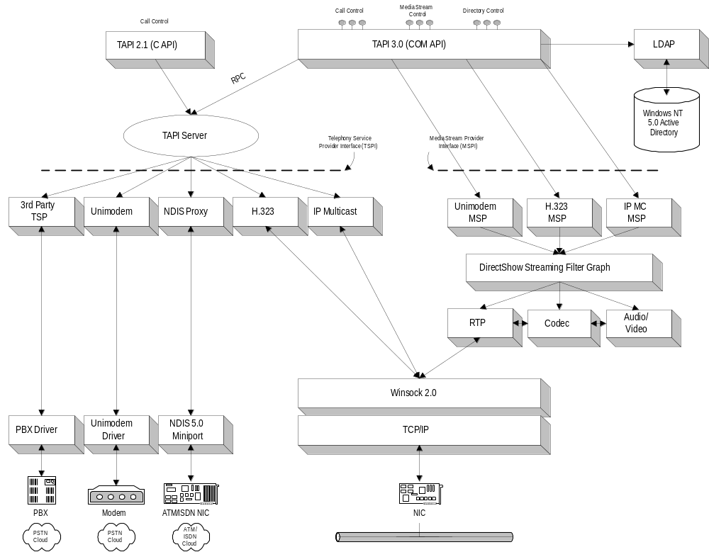

Figure 1: Current TAPI 3.0 Architecture (prior to addition of USB handset support)
Although TAPI 3.0 enables software developers to easily build advanced, interactive, PC-based IP telephony applications, a remaining obstacle to the large-scale adoption of IP telephony is the unfamiliarity of current PC-based user interfaces for telephony. When it comes to making telephone calls, many users prefer a telephone with a handset, a hook switch, and dial buttons instead of an on-screen UI. PC speakers and microphones are often difficult to connect and adjust, do not provide the privacy of a telephone handset, and introduce unwanted echo.
To encourage the development of USB telephony devices and to facilitate the adoption of PC-based IP telephony, as well as the use of the PC to make telephone calls over a variety of other media, Microsoft is adding support for USB-connected telephony peripherals to Microsoft Windows. The purpose of these USB telephony devices is to improve the user experience for PC-based telephony. They present the user with a handset and hook switch to provide the familiar audio streaming and call control interface.
Optionally, a phone keypad on the device can provide familiar dialing capabilities. Devices without a phone keypad are also useful, as dialing can also be accomplished via voice recognition, TAPI 3.0 directory integration, or even simply the numeric keypad on a PC keyboard.
Planned support in Windows will consist of default control of user interaction for this type of device, plus the ability to access and control the device in applications that are aware of this type of device. Users will be able to make telephone calls with no additional software simply by plugging such a device into a PC USB port. Third-party software will be able to take full advantage of the USB-connected telephone as a user interface mechanism by using device-independent, language-neutral TAPI interfaces.
This document presents the information that a hardware manufacturer needs to know to build such a device. Following the guidelines presented in this document will ensure that your device will work with Windows native support and with Windows-based TAPI applications. This document also outlines the Audio and HID Class firmware requirements and options for such a device.
Figure 2 illustrates how future support for USB handsets will fit with the overall TAPI architecture that was presented in Figure 1. New additions are shown in boldface.
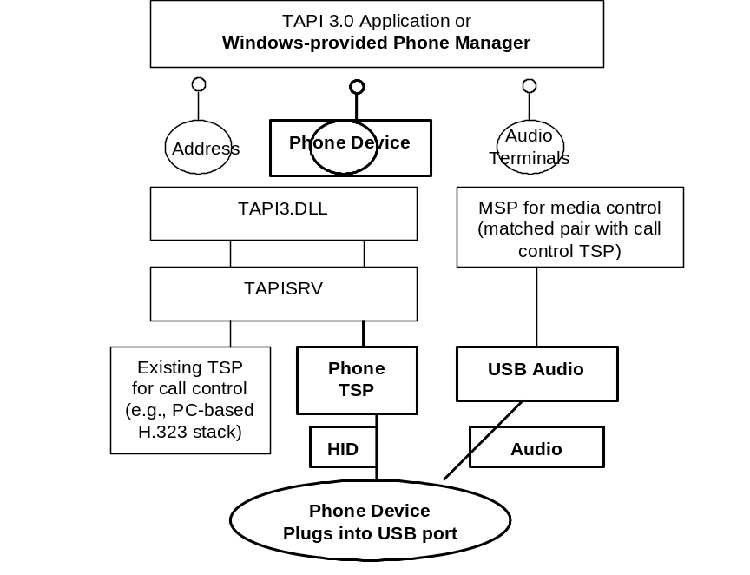
Figure 2: Map of Future TAPI infrastructure for USB Handsets
If the user is not running any third-party telephony application that takes responsibility for handling the USB handset via the phone device object in TAPI, then Windows will provide default handling for the USB handset via a component called the Phone Manager. The Phone Manager will handle tasks such as generating a dial tone on the USB handset and gathering dialed digits.
The Phone Manager will listen for calls reported by various existing TSPs and initiate audio streaming on those calls using the corresponding MSPs if the user picks up the USB handset (as reported via HID). Similarly, the Phone Manager will gather a phone number based on the user’s HID button presses (or other dialing methods) and initiate telephone calls on lines implemented by various TSP / MSP pairs.
The Phone Manager will be a system service, but the execution context and feature set have not yet been determined. However, the following section presents a typical, more detailed example of what sort of interaction the Phone Manager might support.

Examples of USB Handset Interaction Using the Phone Manager
As noted in the previous section, this provides a typical example of what the Phone Manager will accomplish using the underlying TAPI infrastructure. It is by no means a complete or exact description of the Phone Manager’s features.
When the system boots, or whenever the TAPI infrastructure needs to reread state, the PC reads the feature report for the hook switch state. Let’s assume for the purpose of this example that the phone is on hook initially.

Outgoing Calls
When the user lifts the handset, the device sends a HID input report to the PC indicating that it is now off hook. The PC responds by opening the audio render device on the phone and outputting a continuous dial tone to the audio device.
When the user pushes a dial button on the phone’s keypad, it sends a HID input report to the PC indicating that the button was pressed. The host responds by ceasing the dial tone output to the audio device, generating a DTMF tone on the audio device, and remembering which button was pressed.
As the user presses additional buttons, the PC continues to remember the button presses and send DTMF tones to the audio render device.
The PC determines when the phone number is complete. The user can press an optional Send button, the user can press the # key, a timeout can elapse, or the PC can recognize that a certain number of digits have been pressed (based on call routing rules). At that point, the PC software will make a call on the preferred line (typically the H.323 line) to the complete phone number. The line can be any line exposed on the system via a TAPI TSP. (The line that is the preferred line for outgoing calls may be a configurable setting on the PC; the exact mechanism for determining it is not yet defined.)
While the call is being offered to the remote party, the PC will send audio to the phone’s audio render device to play a ring-out tone to the user. (There are other cases, such as a busy remote party, and TAPI will send appropriate tones in each case.)
When the remote party accepts the call, TAPI stops generating the ring-out tone. At this point, the PC begins sending audio from the line device (e.g., H.323 audio received via Ethernet) to the phone’s audio render device. Simultaneously, the PC sends audio from the phone’s audio capture device to the line device (e.g., H.323 audio sent via Ethernet). TAPI MSPs encapsulate the implementations of the sources and sinks for audio on the line device.
While the call is streaming, if the user presses dial buttons, TAPI will notify the application of the button presses. Applications may have the capability to register themselves as handling calls while streaming is going on and let the Phone Manager handle all other interaction, or the Phone Manager can take the place of the application and handle the streaming phase of the call itself, including button presses during streaming. The Phone Manager will typically generate DTMF tones and mix them with the audio render stream on the phone to provide feedback to the user. They can also be propagated on the outgoing line for signaling purposes (e.g., control of interactive voice response (IVR) systems).
When the user hangs up the phone, a hook switch on-hook input report is generated via HID. On the PC, TAPI recognizes the message and indicates to the application handling the call (or to the Phone Manager, depending on the scenario) that the local user wishes to end the call. The call is then dropped at the TSP level.
As noted in other sections, the dial buttons are optional. With USB handsets that have no dial buttons, alternative interaction is possible. For example, the user could pick a destination from an on-screen directory, or the PC could instruct the user to dial using the numeric keypad on their keyboard.

Incoming Calls
Suppose that a line exposed by a TSP on the system (such as an H.323 line) indicates an incoming call and TAPI is configured to use the USB handset with this line.
As noted in the Optional Features section, the phone may or may not have a ringer. If the phone has a ringer, then it declares the ringer as an output report in its HID report descriptor. In this case, TAPI sends an output report to the phone to tell it to ring. If the phone does not have a ringer, then TAPI may indicate the call by playing a ring sound on the preferred audio render device (typically a pair of speakers) and/or various other types of indications.
If the user does not pick up the phone handset and the calling party hangs up instead, then TAPI will cease ringing. In the case of the ringer on the phone, TAPI will send another output report to the phone to tell it to stop ringing. At this point TAPI and the phone are ready to place or receive another call.
If, instead, the user picks up the phone handset, then the HID device sends a hook-switch off-hook input report to the PC. As described earlier, TAPI causes the ringing to stop. At this point, the TSP that offered the call is informed that the call is accepted / answered, and streaming is initiated to the phone’s audio devices. Thereafter, DTMF tones and ending the call work the same as for outgoing calls.

Basic Requirements
A USB handset device for use with the TAPI infrastructure described in the previous section must adhere to the following basic requirements:
- Implement bi-directional, full-duplex audio functionality compliant with the USB Audio Class specification. Bi-directional means both capture and render. Full-duplex means that the device can both capture audio and render audio at the same time. For both capture and render, the device must support at least the following formats:
- 16 KHz, 16-bit linear mono PCM
- 8 KHz, 16-bit linear mono PCM
- Implement a HID-compliant hook switch to indicate if the telephone is on hook or off hook. This switch needs to be implemented both as an Input and Feature control in order to enable TAPI to read the initial state of the hook switch when the device is plugged in.
- To allow TAPI to associate the audio and HID device as belonging to the same telephone, the audio device and HID device must present the same Vendor ID, Product ID, and Revision to the PC, and must be part of the same compound or composite device. The example descriptors in this document show how to do this.
- Audio and HID are completely separate on the telephone device, and there are no dependencies or interactions between them from the device’s point of view. The PC controls all audio streaming. For example, there is no dial tone generation on the device; the PC outputs a dial tone to the audio device based on an indication from the HID hook switch that the telephone is off hook.
A simple USB telephony device could be designed in a form factor similar to a standard telephone handset, or alternatively as a headset.

Optional Features that TAPI Supports
A TAPI-supported USB telephony device can also be equipped with any combination of the following optional features, which TAPI will support and use:
- Additional audio formats. The audio portion of the phone device is free to support any additional audio formats, as long as the required formats are supported (see previous section). The following optional formats are particularly encouraged:
- 8 KHz, 8-bit Mu-law encoded mono PCM
- 8 KHz, 8-bit A-law encoded mono PCM
- HID-compliant telephony keypad. If present, the keypad must include at least dial buttons “0” through “9” plus the “*” and “#” buttons. The keypad may optionally include buttons “A” through “D” for certain military or government applications. Note that the telephone device must not generate any DTMF sounds. The one and only effect of pressing one of these buttons must be the generation of a HID input report to the PC.
- A HID control for a “Send” button. The user can press this button after dialing a number to indicate that the number is complete.
- A range of HID-compliant call control buttons, such as Hold, Forward, Conference, Mute, etc. Please see Table 31 in this document for a list of the HID controls supported.
- A HID control for a hardware ringer. This is a simple mechanism for generating an audible ring to indicate an incoming call, without streaming audio to any audio devices.
- HID-compliant audio controls for phone mute and speaker volume.
- Speaker-phone functionality, including additional external speaker and microphone. This includes a HID-compliant Speaker Phone toggle button, and/or the ability to switch between handset and speakerphone devices under the control of software running on the host system.

Features that TAPI Does Not Support
The details of the operation of the following features and TAPI support for these features have not yet been designed or defined. These features may or may not be supported in the future.
- LEDs that indicate the state of certain call control functionality (e.g. a Speaker Phone LED that is lit whenever this feature is active).
- A HID-compliant alphanumeric display (typically an LCD) used for displaying information such as Caller ID, etc.
- A communications device class (CDC) –based line device, for representing an analog or digital POTS line that is plugged into the USB handset device.
- Device-specific extensions allowing access to specialized, vendor-specific features through TAPI interfaces.

Power Management
A simple telephone handset must be bus powered, and it must not consume more than 100 mA of current. This allows the handset to operate connected to an un-powered hub. A speaker phone must be bus powered, but it may draw up to 500 mA of power.
The device must support the suspend and resume modes. During the suspend mode, the device must enter a low power suspend state. There are two ways for a telephone handset to exit the suspend mode, which are 1) detection of USB resume signaling and 2) detection of a local remote wake-up event such as off hook signal or the user pressing a button. When the device wakes up because of a local wake-up event, it must generate a remote wakeup event to wake up the host.

Unique Serial Number
A unique serial number is desirable. It may be specified in the device descriptor iSerialNumber field.
Serial Number:
The shall be set to the index of the string descriptor that contains the serial number. The serial number shall contain at least 12 valid digits, represented as a UNICODE string. The last 12 digits of the serial number shall be unique to each USB idVendor and idProduct pair.
The host may generate a globally unique identifier by concatenating the 16 bit idVendor, the 16 bit idProduct and the value represented by the last 12 characters of the string descriptor indexed by iSerialNumber The field iSerialNumber is an index to a string descriptor and does not contain the string itself. An example format for the String descriptor is shown below.

Table 1:Example Serial Number Format
Offset | Field | Size | Value | Description
0 | bLength | Byte | ??h | Size of this descriptor in bytes - Minimum of 26 (1Ah)
1 | bDescriptorType | Byte | 03h | STRING descriptor type
2 | wString1 | Word | 00??h | Serial number character 1
4 | wString2 | Word | 00??h | Serial number character 2
6 | wString3 | Word | 00??h | Serial number character 3
: | : | Word | : | :
: | : | Word | : | :
n x 2 | wStringn | Word | 00??h | Serial number character n Shall be at least 12 characters long

The following table defines the valid characters that the device shall use for the serial number.

Table 2: Valid Serial Number Characters
Numeric | ASCII
0030h through 0039h | "0" through "9"
0041h through 0046h | "A" through "F"

Descriptor Hierarchy
This USB handset device includes an AudioControl interface (0), two AudioStreaming interfaces (1 and 2 – one for capture and one for render), and a HID interface (3). The device and configuration descriptors are specified in this section, and all of the interface descriptors are described in subsequent sections of this document. The following figure presents the descriptor hierarchy:

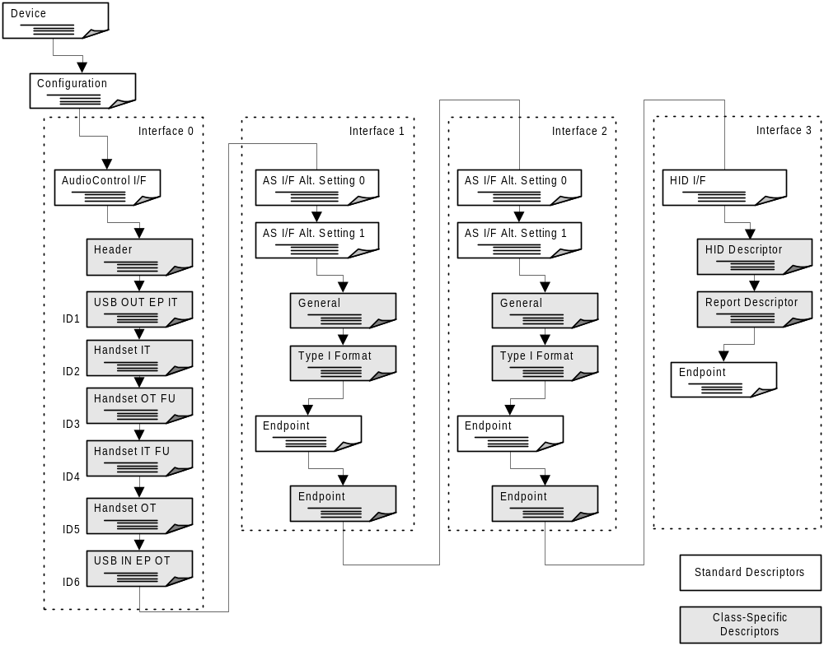Figure 3: USB Handset Descriptor Hierarchy
The AudioStreaming interfaces both feature two alternate settings:
- The first alternate setting (Alternate Setting 0) has zero bandwidth associated with it so that switching to this alternate setting effectively frees all allocated bandwidth on the USB for this device. Zero bandwidth is indicated by the lack of a streaming endpoint.
- Alternate Setting 1 is the operational part of the interface and it has one isochronous endpoint.

Audio Device Class for Telephony
Telephone sets based on USB can deliver flexible telephone services to the desktop PC. USB allows a wide variety of phone sets to connect to a PC. Whether a phone set is a key set, PBX or an Internet phone, each phone set can retain its unique nature connect to the PC in a standard fashion.
The real power of the USB audio device class architecture is “discoverable topology.” When an audio device sends its descriptors to the USB class driver, it describes itself as a set of terminals and units arranged in a network topology. More precisely, it describes itself as a set of trees with the output terminal nodes as the root of each tree.
Conforming to the object-oriented nature of USB architecture in general, each terminal node and internal unit node is addressable and capable of receiving messages from the host or responding to polls from the host.
A USB audio function is described as a set of input terminals, output terminals, and internal units. Internal units may have many input pins, but they have only one output pin. One should note that input relative to the USB device will be output relative to the PC, so when making reference to audio flow on the PC we use the less ambiguous “capture” and “render” terminology.
There are many types of internal units that have been defined for USB audio. Only input terminals, output terminals, switches, and function units (volume control and mute) are supported by TAPI. More complicated audio topologies can be accessed directly by TAPI applications to support additional features.
Definitions of these elements are condensed from the USB audio specification. The symbols defined below can be used to describe a USB audio device in terms of a topology diagram.

Input Terminal
The Input Terminal (IT) is used to interface between the audio function’s ‘outside world’ and other Units in the audio function. It serves as a receptacle for audio information flowing into the audio function. The symbol for the Input Terminal is depicted in the following figure:
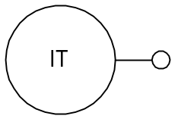

Figure 4: Input Terminal Icon

Output Terminal
The Output Terminal (OT) is used to interface between Units inside the audio function and the ‘outside world’. It serves as an outlet for audio information, flowing out of the audio function.
The symbol for the Output Terminal is depicted in the following figure:
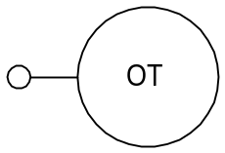

Figure 5: Output Terminal Icon

USB Audio Device Class Telephone Terminal Types

Bi-directional Terminal Types
TAPI supports only bi-directional terminal types as all connections must be full-duplex. These Terminal Types describe an Input and an Output Terminal for voice communication that are closely related. They should be used together for bi-directional voice communication. They may be used separately for input only or output only. These types require two Terminal descriptors. Both have the same type. The two Terminals are linked together through the bAssocTerminal fields in their respective Terminal descriptors. The Associated Interfaces descriptor can be used to reference a HID interface for conferencing functions.
Table 3: Bi-directional Terminal Types
Terminal Type | Code | I/O | Description
Bi-directional Undefined | 0x0400 | I/O | Bi-directional Terminal, undefined Type.
Handset | 0x0401 | I/O | Hand-held bi-directional audio device.
Headset | 0x0402 | I/O | Head-mounted bi-directional audio device.
Speakerphone, no echo reduction | 0x0403 | I/O | A hands-free audio device designed for host-based echo cancellation.
Echo-suppressing speakerphone | 0x0404 | I/O | A hands-free audio device with echo suppression capable of half-duplex operation.
Echo-canceling speakerphone | 0x0405 | I/O | A hands-free audio device with echo cancellation capable of full-duplex operation.

Selector Unit
The Selector Unit (SU) selects from n audio channel clusters, each containing m logical input channels and routes them unaltered to the single output audio channel cluster, containing m output channels. It represents a multi-channel source selector, capable of selecting between n m-channel sources. It has n Input Pins and a single Output Pin.
The symbol for the Selector Unit can be found in the following figure.
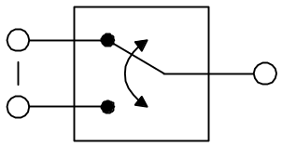

Figure 6: Selector Unit Icon

Feature Unit
The Feature Unit (FU) is essentially a multi-channel processing unit that provides basic manipulation of the incoming logical channels. For each logical channel, the Feature Unit optionally provides audio controls. Volume and Mute are supported for telephone devices:
Feature Units must be readable as well as settable, but Feature Unit settings need not be preserved over power cycle. On system initialization, host TAPI code will initialize any feature units to match settings of corresponding HID controls or retained values if HID controls are not present.
The symbol for the Feature Unit is depicted in the following figure:
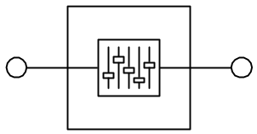

Figure 7: Feature Unit Icon
These symbols are used to document audio devices, and they can be arranged so as to describe arbitrarily complex devices. Microsoft will support a simple telephone with handset and a simple speakerphone as defined below. Vendors may build more complex devices, but they will have to provide support for any additional features.

Audio Topology Diagram
USB audio topology diagrams describe an audio device. Inputs to the device are on the left and outputs are on the right. Some units such as the selector unit may have several inputs, but only one output; however, these outputs may connect to the input of several units.
The Simple Telephone TAPI phone device consists of a handset and USB connections joined by feature units that control the volume of the handset speaker and sensitivity of the handset microphone. (Volume is used to describe both microphone sensitivity, and speaker volume.)
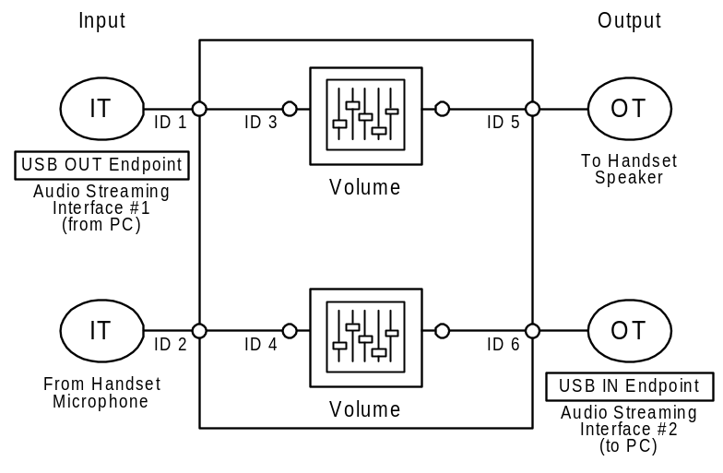

Figure 8: Simple Telephone TAPI Phone Device

Device Descriptors
Table 4: USB Handset Device Descriptor
Offset | Field | Size | Value | Description
0 | bLength | 1 | 0x12 | Size of this descriptor, in bytes.
1 | bDescriptorType | 1 | 0x01 | DEVICE descriptor.
2 | bcdUSB | 2 | 0x0100 | 1.00 - current revision of USB spec.
4 | bDeviceClass | 1 | 0x00 | Device defined at Interface level.
5 | bDeviceSubClass | 1 | 0x00 | Unused.
6 | bDeviceProtocol | 1 | 0x00 | Unused.
7 | bMaxPacketSize0 | 1 | 0x08 | 8 bytes.
8 | idVendor | 2 | 0xXXXX | Vendor ID.
10 | idProduct | 2 | 0xXXXX | Product ID.
12 | bcdDevice | 2 | 0xXXXX | Device Release Code.
14 | iManufacturer | 1 | 0x01 | Index to string descriptor that contains the string <Your Name> in Unicode.
15 | iProduct | 1 | 0x02 | Index to string descriptor that contains the string <Your Product Name> in Unicode.
16 | iSerialNumber | 1 | 0x00 | Optional, but encouraged because it helps the system keep track of the phone across system reboots and whether the phone is disconnected and reconnected. If included, it should refer to a GUID string, such as the following: {10E4AA05-7510-4a61-B278-D77ED132C17C}. Please see http://www.microsoft.com/asf/spec2/c.htm for information on how to generate a GUID.
17 | bNumConfigurations | 1 | 0x01 | One configuration.

Configuration Descriptor
Table 5: USB Handset Configuration Descriptor
Offset | Field | Size | Value | Description
0 | bLength | 1 | 0x09 | Size of this descriptor, in bytes.
1 | bDescriptorType | 1 | 0x02 | CONFIGURATION descriptor.
2 | wTotalLength | 2 | 0x00XX | Length of the total configuration block, including this descriptor, in bytes.
4 | bNumInterfaces | 1 | 0x04 | Four interfaces.
5 | bConfigurationValue | 1 | 0x01 | ID of this configuration.
6 | iConfiguration | 1 | 0x00 | Unused.
7 | bmAttributes | 1 | 0xA0 | Bus Powered Remote Wakeup capable.
8 | MaxPower | 1 | 0x32 | 100mA allows operation with un-powered hubs

AudioControl Interface Descriptor
The AudioControl interface describes the device structure and is used to manipulate the Audio Controls.

Standard AC Interface Descriptor
The AudioControl interface has no dedicated endpoints associated with it. It uses the default pipe (endpoint 0) for all communication purposes. Class-specific AudioControl Requests are sent using the default pipe. There is no Status Interrupt endpoint provided.
Table 6: USB Handset Standard AC Interface Descriptor
Offset | Field | Size | Value | Description
0 | bLength | 1 | 0x09 | Size of this descriptor, in bytes.
1 | bDescriptorType | 1 | 0x04 | INTERFACE descriptor.
2 | bInterfaceNumber | 1 | 0x00 | Index of this interface.
3 | bAlternateSetting | 1 | 0x00 | Index of this setting.
4 | bNumEndpoints | 1 | 0x00 | 0 endpoints.
5 | bInterfaceClass | 1 | 0x01 | AUDIO.
6 | bInterfaceSubclass | 1 | 0x01 | AUDIO_CONTROL.
7 | bInterfaceProtocol | 1 | 0x00 | Unused.
8 | iInterface | 1 | 0x00 | Unused.

Class-specific Interface Descriptor
The Class-specific AC interface descriptor is always headed by a Header descriptor that contains general information about the AudioControl interface. It contains all the pointers needed to describe the Audio Interface Collection, associated with the described audio function.
Table 7: USB Handset Class-specific Interface Descriptor
Offset | Field | Size | Value | Description
0 | bLength | 1 | 0x0A | Size of this descriptor, in bytes.
1 | bDescriptorType | 1 | 0x24 | CS_INTERFACE.
2 | bDescriptorSubtype | 1 | 0x01 | HEADER subtype.
3 | bcdADC | 2 | 0x0100 | Revision of class specification - 1.0
5 | wTotalLength | 2 | 0x0046 | Total size of class specific descriptors.
7 | bInCollection | 1 | 0x02 | Number of streaming interfaces
8 | baInterfaceNr(1) | 1 | 0x01 | AudioStreaming interface 1 belongs to this AudioControl interface.
9 | BaInterfaceNr(2) | 1 | 0x02 | AudioStreaming interface 2 belongs to this AudioControl interface.

Input Terminal Descriptor (ID1)
This descriptor describes the telephone handset input microphone. The audio channel cluster on the single Output Pin contains a single logical channel (bNrChannels=1) and there is no spatial location associated with this mono channel (wChannelConfig=0x0000).
This is the input part of a bi-directional Terminal and therefore has an associated Output Terminal (ID5).
Table 8: USB Handset Input Terminal Descriptor (ID1)
Offset | Field | Size | Value | Description
0 | bLength | 1 | 0x0C | Size of this descriptor, in bytes.
1 | bDescriptorType | 1 | 0x24 | CS_INTERFACE.
2 | bDescriptorSubtype | 1 | 0x02 | INPUT_TERMINAL subtype.
3 | bTerminalID | 1 | 0x01 | ID of this Terminal.
4 | wTerminalType | 2 | 0x0401 | Terminal is Handset In.
6 | bAssocTerminal | 1 | 0x05 | Associated with Handset Out Terminal.
7 | bNrChannels | 1 | 0x01 | One channel.
8 | wChannelConfig | 2 | 0x0000 | Mono sets no position bits.
10 | iChannelNames | 1 | 0x00 | Unused.
11 | iTerminal | 1 | 0x00 | Unused.

Input Terminal Descriptor (ID2)
This descriptor describes the USB stream from the Host to the telephone set. The audio channel cluster on the single Output Pin contains a single logical channel (bNrChannels=1) and there is no spatial location associated with this mono channel (wChannelConfig=0x0000).
This is the input part of a bi-directional Terminal and therefore has an associated Output Terminal (ID6).
Table 9: USB Handset Input Terminal Descriptor (ID2)
Offset | Field | Size | Value | Description
0 | bLength | 1 | 0x0C | Size of this descriptor, in bytes.
1 | bDescriptorType | 1 | 0x24 | CS_INTERFACE.
2 | bDescriptorSubtype | 1 | 0x02 | INPUT_TERMINAL subtype.
3 | bTerminalID | 1 | 0x02 | ID of this Terminal.
4 | wTerminalType | 2 | 0x0101 | Terminal is USB Streaming In.
6 | bAssocTerminal | 1 | 0x06 | Associated with USB Streaming out Terminal.
7 | bNrChannels | 1 | 0x01 | One channel.
8 | wChannelConfig | 2 | 0x0000 | Mono sets no position bits.
10 | iChannelNames | 1 | 0x00 | Unused.
11 | iTerminal | 1 | 0x05 | Unused.

Feature Unit Descriptor (ID3)
This descriptor describes the Feature Unit connected to the Handset Output Terminal (ID 5). Volume and Mute controls are supported.
Table 10: USB Handset Feature Unit Descriptor (ID3)
Offset | Field | Size | Value | Description
0 | bLength | 1 | 0x09 | Size of this descriptor, in bytes.
1 | bDescriptorType | 1 | 0x24 | CS_INTERFACE.
2 | bDescriptorSubtype | 1 | 0x06 | FEATURE_UNIT subtype.
3 | bUnitD | 1 | 0x03 | ID of this Unit.
4 | bSourceID | 1 | 0x01 | From USB Streaming Out Terminal.
5 | bControlSize | 1 | 0x01 | One Byte Control Array.
6 | bmaControls(0) | 1 | 0x03 | Volume and Mute Supported.
7 | bmaControls(1) | 1 | 0x00 | Only Master Control Supported.
8 | iFeature | 1 | 0x00 | Index to name of feature.

Feature Unit Descriptor (ID4)
This descriptor describes the Feature Unit connected to the USB Output Terminal (ID 6). Volume and Mute controls are supported.
Table 11: USB Handset Feature Unit Descriptor (ID4)
Offset | Field | Size | Value | Description
0 | bLength | 1 | 0x09 | Size of this descriptor, in bytes.
1 | bDescriptorType | 1 | 0x24 | CS_INTERFACE.
2 | bDescriptorSubtype | 1 | 0x06 | FEATURE_UNIT subtype.
3 | bUnitD | 1 | 0x04 | ID of this Unit.
4 | bSourceID | 1 | 0x02 | From Handset Microphone.
5 | bControlSize | 1 | 0x01 | One Byte Control Array.
6 | bmaControls(0) | 1 | 0x03 | Volume and Mute Supported.
7 | bmaControls(1) | 1 | 0x00 | Only Master Control Supported.
8 | iFeature | 1 | 0x00 | Index to name of feature.

Output Terminal Descriptor (ID5)
This descriptor describes the telephone handset output earpiece. The audio channel cluster on the single Input Pin contains a single logical channel.
This is the output part of a bi-directional Terminal and therefore has an associated Input Terminal (ID2).
Table 12: USB Handset Output Terminal Descriptor (ID5)
Offset | Field | Size | Value | Description
0 | bLength | 1 | 0x09 | Size of this descriptor, in bytes.
1 | bDescriptorType | 1 | 0x24 | CS_INTERFACE.
2 | bDescriptorSubtype | 1 | 0x03 | OUTPUT_TERMINAL subtype.
3 | bTerminalID | 1 | 0x05 | ID of this Terminal.
4 | wTerminalType | 2 | 0x0401 | Terminal is Handset Out.
6 | bAssocTerminal | 1 | 0x02 | Associated with Handset In Terminal.
7 | bSourceID | 1 | 0x03 | From Handset Feature Unit.
8 | iTerminal | 1 | 0x00 | Unused.

Output Terminal Descriptor (ID6)
This descriptor describes the USB stream from the telephone set to the Host. The audio channel cluster on the single Input Pin contains a single logical channel.
This is the output part of a bi-directional Terminal and therefore has an associated Input Terminal (ID3).
Table 13: USB Handset Output Terminal Descriptor (ID6)
Offset | Field | Size | Value | Description
0 | bLength | 1 | 0x09 | Size of this descriptor, in bytes.
1 | bDescriptorType | 1 | 0x24 | CS_INTERFACE.
2 | bDescriptorSubtype | 1 | 0x03 | OUTPUT_TERMINAL subtype.
3 | bTerminalID | 1 | 0x06 | ID of this Terminal.
4 | wTerminalType | 2 | 0x0101 | Terminal is USB Streaming Out.
6 | bAssocTerminal | 1 | 0x02 | Associated with USB Streaming In Terminal.
7 | bSourceID | 1 | 0x04 | From USB Feature Unit.
8 | iTerminal | 1 | 0x00 | Unused.

AudioStreaming Interface 1 Descriptor
The AudioStreaming interface 1 is used for streaming audio from the Host to the USB Handset device. AudioStreaming interface 1 has two alternate settings:
- The zero bandwidth alternate setting (Alternate Setting 0), used to reclaim USB bandwidth. This is also the default alternate setting.
- The alternate setting (1) is the fully operational setting for the Host to Device streaming communication.

Zero-bandwidth Alternate Setting 0

Standard Interface Descriptor
Table 14: USB Handset Standard Interface Descriptor (Alt. Set. 0)
Offset | Field | Size | Value | Description
0 | bLength | 1 | 0x09 | Size of this descriptor, in bytes.
1 | bDescriptorType | 1 | 0x04 | INTERFACE descriptor.
2 | bInterfaceNumber | 1 | 0x01 | Index of this interface.
3 | bAlternateSetting | 1 | 0x00 | Index of this setting.
4 | bNumEndpoints | 1 | 0x00 | 0 endpoints.
5 | bInterfaceClass | 1 | 0x01 | AUDIO.
6 | bInterfaceSubclass | 1 | 0x02 | AUDIO_STREAMING.
7 | bInterfaceProtocol | 1 | 0x00 | Unused.
8 | iInterface | 1 | 0x00 | Unused.

Operational Alternate Setting 1

Standard AS Interface Descriptor
Table 15: USB Handset Standard AS Interface Descriptor
Offset | Field | Size | Value | Description
0 | bLength | 1 | 0x09 | Size of this descriptor, in bytes.
1 | bDescriptorType | 1 | 0x04 | INTERFACE descriptor.
2 | bInterfaceNumber | 1 | 0x01 | Index of this interface.
3 | bAlternateSetting | 1 | 0x01 | Index of this setting.
4 | bNumEndpoints | 1 | 0x01 | 1 endpoint.
5 | bInterfaceClass | 1 | 0x01 | AUDIO.
6 | bInterfaceSubclass | 1 | 0x02 | AUDIO_STREAMING.
7 | bInterfaceProtocol | 1 | 0x00 | Unused.
8 | iInterface | 1 | 0x00 | Unused.

Class-specific AS Interface Descriptor
Table 16: USB Handset Class-specific AS Interface Descriptor
Offset | Field | Size | Value | Description
0 | bLength | 1 | 0x07 | Size of this descriptor, in bytes.
1 | bDescriptorType | 1 | 0x24 | CS_INTERFACE descriptor.
2 | bDescriptorSubtype | 1 | 0x01 | GENERAL.
3 | bTerminalLink | 1 | 0x02 | Linked to USB Streaming In Terminal.
4 | bDelay | 1 | 0x01 | Interface delay.
5 | wFormatTag | 2 | 0x0001 | PCM format.

Type I Format Type Descriptor
Table 17: USB Handset Type I Format Type Descriptor
Offset | Field | Size | Value | Description
0 | bLength | 1 | 0x0E | Size of this descriptor, in bytes.
1 | bDescriptorType | 1 | 0x24 | CS_INTERFACE.
2 | bDescriptorSubtype | 1 | 0x02 | FORMAT_TYPE.
3 | bFormatType | 1 | 0x01 | FORMAT_TYPE_I.
4 | bNrChannels | 1 | 0x01 | One channel.
5 | bSubFrameSize | 1 | 0x02 | Two bytes per slot.
6 | bBitResolution | 1 | 0x10 | 16 bits.
7 | bSamFreqType | 1 | 0x02 | Two sampling frequencies.
8 | tSamFreq | 3 | 0x01F40 | 8000Hz Encouraged sampling frequency.
11 | tSamFreq | 3 | 0X03E80 | 16000Hz Required sampling frequency.

Standard Endpoint Descriptor
Table 18: USB Handset Standard Endpoint Descriptor
Offset | Field | Size | Value | Description
0 | bLength | 1 | 0x09 | Size of this descriptor, in bytes.
1 | bDescriptorType | 1 | 0x05 | ENDPOINT descriptor.
2 | bEndpointAddress | 1 | 0x01 | OUT Endpoint 1.
3 | bmAttributes | 1 | 0x09 | Adaptive Isochronous is preferred
4 | wMaxPacketSize | 2 | 0x0022 | 34 bytes per packet (17 two-byte samples).
6 | bInterval | 1 | 0x01 | One packet every frame.
7 | bRefresh | 1 | 0x00 | Unused.
8 | bSynchAddress | 1 | 0x00 | Unused.

Class-specific Isochronous Audio Data Endpoint Descriptor
Table 19: USB Handset Class-specific Isoc. Audio Data Endpoint Descriptor
Offset | Field | Size | Value | Description
0 | bLength | 1 | 0x07 | Size of this descriptor, in bytes.
1 | bDescriptorType | 1 | 0x25 | CS_ENDPOINT.
2 | bDescriptorSubtype | 1 | 0x01 | GENERAL.
3 | bmAttributes | 1 | 0x01 | Sampling frequency control, no pitch control.
4 | bLockDelayUnits | 1 | 0x?? | Device Specific for adaptive devices.
5 | wLockDelay | 2 | 0x?? | Device Specific.

AudioStreaming Interface 2 Descriptor
The AudioStreaming interface 2 is used for streaming audio from the USB Handset device to the Host. AudioStreaming interface 2 has two alternate settings:
- The zero bandwidth alternate setting (Alternate Setting 0), used to reclaim USB bandwidth. This is also the default alternate setting.
- The alternate setting (1) is the fully operational setting for the Device to Host streaming communication.

Zero-bandwidth Alternate Setting 0

Standard Interface Descriptor
Table 20: USB Handset Standard Interface Descriptor (Alt. Set. 0)
Offset | Field | Size | Value | Description
0 | bLength | 1 | 0x09 | Size of this descriptor, in bytes.
1 | bDescriptorType | 1 | 0x04 | INTERFACE descriptor.
2 | bInterfaceNumber | 1 | 0x01 | Index of this interface.
3 | bAlternateSetting | 1 | 0x00 | Index of this setting.
4 | bNumEndpoints | 1 | 0x00 | 0 endpoints.
5 | bInterfaceClass | 1 | 0x01 | AUDIO.
6 | bInterfaceSubclass | 1 | 0x02 | AUDIO_STREAMING.
7 | bInterfaceProtocol | 1 | 0x00 | Unused.
8 | iInterface | 1 | 0x00 | Unused.

Operational Alternate Setting 1

Standard AS Interface Descriptor
Table 21: USB Handset Standard AS Interface Descriptor
Offset | Field | Size | Value | Description
0 | bLength | 1 | 0x09 | Size of this descriptor, in bytes.
1 | bDescriptorType | 1 | 0x04 | INTERFACE descriptor.
2 | bInterfaceNumber | 1 | 0x01 | Index of this interface.
3 | bAlternateSetting | 1 | 0x01 | Index of this setting.
4 | bNumEndpoints | 1 | 0x01 | 1 endpoint.
5 | bInterfaceClass | 1 | 0x01 | AUDIO.
6 | bInterfaceSubclass | 1 | 0x02 | AUDIO_STREAMING.
7 | bInterfaceProtocol | 1 | 0x00 | Unused.
8 | iInterface | 1 | 0x00 | Unused.

Class-specific AS Interface Descriptor
Table 22: USB Handset Class-specific AS Interface Descriptor
Offset | Field | Size | Value | Description
0 | bLength | 1 | 0x07 | Size of this descriptor, in bytes.
1 | bDescriptorType | 1 | 0x24 | CS_INTERFACE descriptor.
2 | bDescriptorSubtype | 1 | 0x01 | GENERAL.
3 | bTerminalLink | 1 | 0x06 | USB Streaming Out Terminal.
4 | bDelay | 1 | 0x01 | Interface delay.
5 | wFormatTag | 2 | 0x0001 | PCM format.

Type I format type descriptor
Table 23: USB Handset Type I Format Type Descriptor
Offset | Field | Size | Value | Description
0 | bLength | 1 | 0x0E | Size of this descriptor, in bytes.
1 | bDescriptorType | 1 | 0x24 | CS_INTERFACE.
2 | bDescriptorSubtype | 1 | 0x02 | FORMAT_TYPE.
3 | bFormatType | 1 | 0x01 | FORMAT_TYPE_I.
4 | bNrChannels | 1 | 0x01 | One channel.
5 | bSubFrameSize | 1 | 0x02 | Two bytes per slot.
6 | bBitResolution | 1 | 0x10 | 16 bits.
7 | bSamFreqType | 1 | 0x02 | Two sampling frequency.
8 | tSamFreq | 3 | 0x01F40 | 8000Hz Encouraged sampling frequency.
11 | tSamFreq | 3 | 0x03E80 | 16000Hz Required sampling frequency.

Standard Endpoint descriptor
Table 24: USB Handset Standard Endpoint Descriptor
Offset | Field | Size | Value | Description
0 | bLength | 1 | 0x09 | Size of this descriptor, in bytes.
1 | bDescriptorType | 1 | 0x05 | ENDPOINT descriptor.
2 | bEndpointAddress | 1 | 0x82 | IN Endpoint 1.
3 | bmAttributes | 1 | 0x09 | Adaptive Isochronous.
4 | wMaxPacketSize | 2 | 0x0022 | 34 bytes (17 two-byte samples).
6 | bInterval | 1 | 0x01 | One packet every frame.
7 | bRefresh | 1 | 0x00 | Unused.
8 | bSynchAddress | 1 | 0x00 | Unused.

Class-specific Isochronous Audio Data Endpoint Descriptor
Table 25: USB Handset Class-specific Isoc. Audio Data Endpoint Descriptor
Offset | Field | Size | Value | Description
0 | bLength | 1 | 0x07 | Size of this descriptor, in bytes.
1 | bDescriptorType | 1 | 0x25 | CS_ENDPOINT.
2 | bDescriptorSubtype | 1 | 0x01 | GENERAL.
3 | bmAttributes | 1 | 0x01 | Sampling frequency control, no pitch control.
4 | bLockDelayUnits | 1 | 0x?? | Device Specific.
5 | wLockDelay | 2 | 0x???? | Device Specific.

String Descriptors
There are two string descriptors available. The first string descriptor contains the Manufacturer information and the second one contains Product related information. The following sections present an example of what these descriptors could look like.

Manufacturer String Descriptor
Table 26: USB Handset Manufacturer String Descriptor
Offset | Field | Size | Value | Description
0 | bLength | 1 | 0x18 | Size of this descriptor, in bytes.
1 | bDescriptorType | 1 | 0x03 | STRING descriptor.
2 | bString | 1 | 0x0054  0x0048  0x0045  0x0020  0x0043  0x004F  0x004D  0x0050  0x0041  0x004E  0x0059 | “THE COMPANY”

Product String Descriptor
Table 27: USB Handset Product String Descriptor
Offset | Field | Size | Value | Description
0 | bLength | 1 | 0x14 | Size of this descriptor, in bytes.
1 | bDescriptorType | 1 | 0x03 | STRING descriptor.
2 | bString | 1 | 0x0054  0x0065  0x006C  0x0065  0x0070  0x0068  0x006F  0x006E  0x0065 | “Telephone”

Requests

Standard Requests
All standard Requests necessary to operate the device are supported. The next section presents the Set Interface Request as an example.

Set Interface Requests
This request selects the alternate setting on interface 1 or 2 to control bandwidth allocation.
Table 28: Set Interface Request Values
Offset | Field | Size | Value | Description
0 | bmRequestType | 1 | 0x01 | D7: 0 = Host to Device.  D6..5: 00 = Standard Request.  D4..0: 00001 = Recipient is interface.
1 | bRequest | 1 | 0x0B | SET_INTERFACE.
2 | wValue | 2 | 0x0000  or  0x0001 | 0x00 is zero bandwidth alternate setting.  0x01 is normal isochronous operation.
4 | wIndex | 2 | 0x0001  or  0x0002 | Interface number of one of the AudioStreaming interfaces.
6 | wLength | 2 | 0x0000 | No Parameter Block

Class-specific Requests
The only class-specific Request supported is the Set/Get Selector Control Request. The following sections describe these requests in detail.

Set Feature Unit Control Request
This Request sets the Selector Unit Control to the desired value.
Table 29: Set Selector Unit Control Request Values
Offset | Field | Size | Value | Description
0 | bmRequestType | 1 | 0x21 | D7: 0 = Host to Device.  D6..5: 01 = Class Request.  D4..0: 00001 = Recipient is interface.
1 | bRequest | 1 | 0x01 | SET_CUR.
2 | wValue | 2 | CS CN | Control Selector (CS) in High Byte  MUTE_CONTROL 1  VOLUME_CONTROL 2  Channel Number (CN) in Low Byte  Always 0
4 | wIndex | 2 | 0x0000 | Interface number of the AudioControl interface.
6 | wLength | 2 | 1 or 2 | Parameter Block Length  Mute 1  Volume 2

Mute Control
The position of a Mute Control CUR attribute can be either TRUE or FALSE. The particular Mute Control within a Feature Unit is addressed through the Unit ID and Channel Number fields of the Set/Get Feature Unit Control request. The valid range for the Channel Number field is zero (the ‘master’ channel) as telephone devices support only one channel of audio.
Table 30: Mute Control Parameter Block
Control Selector |  | MUTE_CONTROL
wLength |  | 1
Offset | Field | Size | Value | Description
0 | bMute | 1 | Bool | The setting for the addressed Mute Control’s CUR attribute. Muted when TRUE, not muted when FALSE.

Volume Control
A Volume Control can support all possible Control attributes (CUR, MIN, MAX, and RES). The settings for the CUR, MIN, and MAX attributes can range from +127.9961 dB (0x7FFF) down to -127.9961 dB (0x8001) in steps of 1/256 dB or 0.00390625 dB (0x0001). The range for the CUR attribute is extended by code 0x8000, representing silence, i.e., -∞ dB. The settings for the RES attribute can only take positive values and range from 1/256 dB (0x0001) to +127.9961 dB (0x7FFF). The Volume Control honors the request to the best of its abilities. It may round the wVolume attribute value to its closest available setting. It will report this rounded setting when queried during a Get Control request.
A particular Volume Control within a Feature Unit is addressed through the Unit ID and Channel Number fields of the Set/Get Feature Unit Control request. The valid range for the Channel Number field is zero (the ‘master’ channel) because the telephone device only supports one channel of audio.
Table 31: First Form of the Volume Control Parameter Block
Control Selector |  | VOLUME_CONTROL
wLength |  | 2
Offset | Field | Size | Value | Description
0 | wVolume | 2 | Number | The setting for the attribute of the addressed Volume Control:  0x7FFF: 127.9961 dB  …  0x0100: 1.0000 dB  …  0x0002: 0.0078 dB  0x0001: 0.0039 dB  0x0000: 0.0000 dB  0xFFFF: -0.0039 dB  0xFFFE: -0.0078 dB  …  0xFE00: -1.0000 dB  …  0x8002: -127.9922 dB  0x8001: -127.9961 dB  0x8000 -∞ dB  (CUR attribute only)

Get Feature Unit Control Request
This Request retrieves the Selector Unit Control parameter.
Table 32: Get Selector Unit Control Request Values
Offset | Field | Size | Value | Description
0 | bmRequestType | 1 | 0xA1 | D7: 1 = Device to Host.  D6..5: 01 = Class Request.  D4..0: 00001 = Recipient is interface.
1 | bRequest | 1 | 0x81  0x82  0x83  0x84 | GET_CUR.  GET_MIN.  GET_MAX.  GET_RES.
2 | wValue | 2 | CS CN | Control Selector (CS) in High Byte  MUTE_CONTROL 1  VOLUME_CONTROL 2  Channel Number (CN) in Low Byte  Always 0
4 | wIndex | 2 | 0x0000 | Interface number of the AudioControl interface.
6 | wLength | 2 | 1 or 2 | Parameter Block Length  Mute 1  Volume 2

See the earlier definitions of parameter blocks for mute and volume controls.

Topology Diagram
Below is a diagram for a speakerphone. Note that a switch selects the input, but the volume controls are used to select whether the speaker or handset is selected.

A speakerphone may be implemented using a chip that has been designed for stereo use if it can render or capture a monaural stream. The handset could take the right channel, and the speaker could take the left channel. Note that that while audio may render simultaneously on the handset and speakerphone, only one monaural audio stream may be sent to the device.
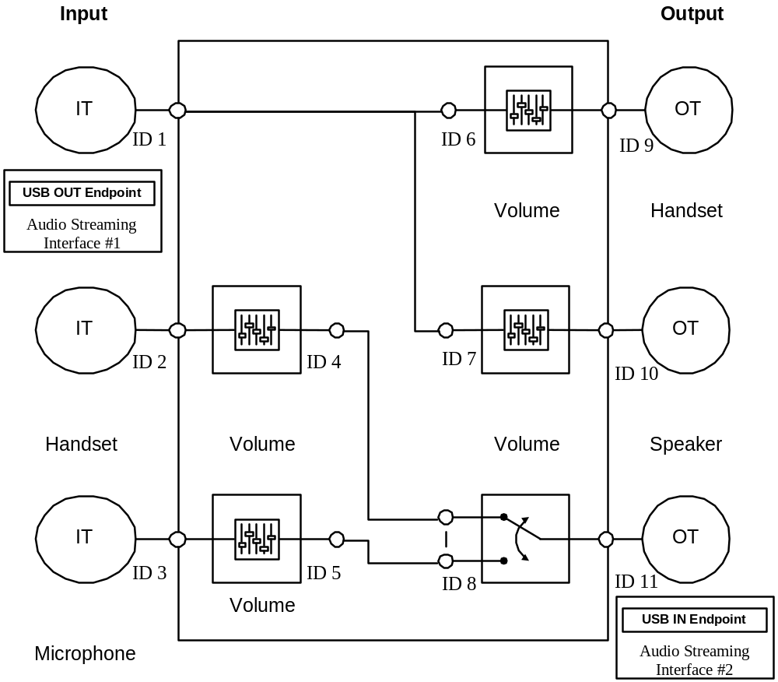
Figure 9: Speakerphone TAPI Phone Device

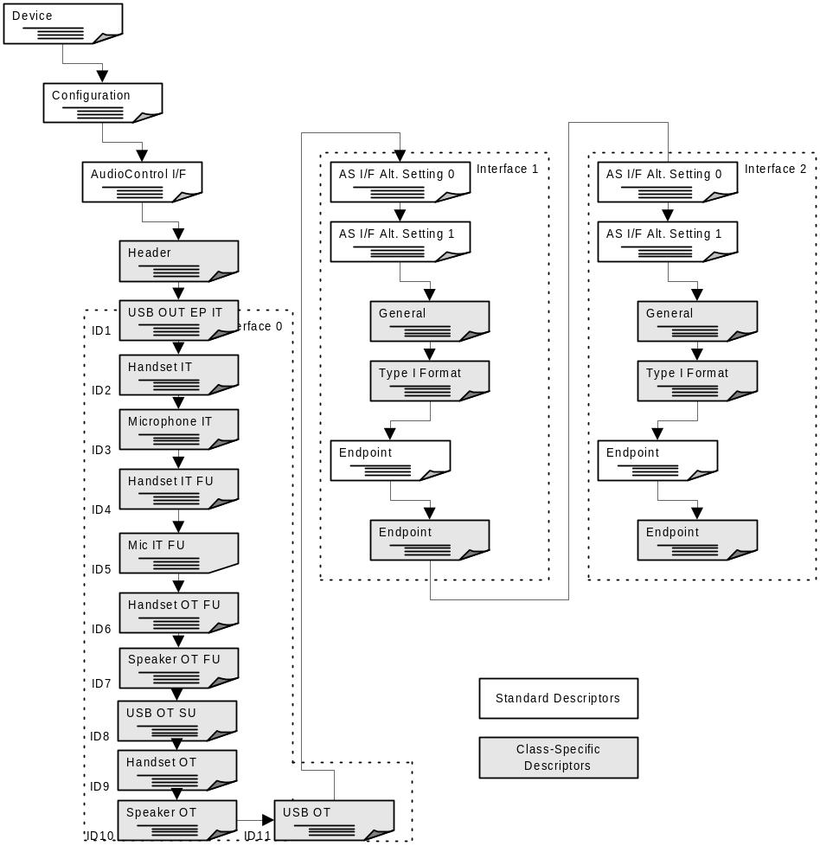
Feature units ID4 and ID5 are not necessary. In fact it would be preferred if there were no need for control of microphone sensitivity. A well engineered telephone should have the microphone preamplifier tuned well enough that manual control is not necessary. Similarly there is no need for both a selector switch (ID 8) and mute controls on both microphones. This example is illustrative and an actual implementation may feature a variation on this scheme.

Descriptors
The following sections present all the descriptors that are used to describe the device.

Device Descriptor
Table 33: USB Speakerphone Device Descriptor
Offset | Field | Size | Value | Description
0 | BLength | 1 | 0x12 | Size of this descriptor, in bytes.
1 | bDescriptorType | 1 | 0x01 | DEVICE descriptor.
2 | bcdUSB | 2 | 0x0100 | 1.00 - current revision of USB spec.
4 | bDeviceClass | 1 | 0x00 | Device defined at Interface level.
5 | bDeviceSubClass | 1 | 0x00 | Unused.
6 | bDeviceProtocol | 1 | 0x00 | Unused.
7 | bMaxPacketSize0 | 1 | 0x08 | 8 bytes.
8 | idVendor | 2 | 0xXXXX | Vendor ID.
10 | idProduct | 2 | 0xXXXX | Product ID.
12 | bcdDevice | 2 | 0xXXXX | Device Release Code.
14 | iManufacturer | 1 | 0x01 | Index to string descriptor that contains the string <Your Name> in Unicode.
15 | iProduct | 1 | 0x02 | Index to string descriptor that contains the string <Your Product Name> in Unicode.
16 | iSerialNumber | 1 | 0x03 | Use of an individual serial number is encouraged, but not required.
17 | bNumConfigurations | 1 | 0x01 | One configuration.

Configuration Descriptor
Table 34: USB Speakerphone Configuration Descriptor
Offset | Field | Size | Value | Description
0 | bLength | 1 | 0x09 | Size of this descriptor, in bytes.
1 | bDescriptorType | 1 | 0x02 | CONFIGURATION descriptor.
2 | wTotalLength | 2 | 0x00XX | Length of the total configuration block, including this descriptor, in bytes.
4 | bNumInterfaces | 1 | 0x03 | Three interfaces
5 | bConfigurationValue | 1 | 0x01 | ID of this configuration
6 | iConfiguration | 1 | 0x00 | Unused.
7 | bmAttributes | 1 | 0x20 | Bus Powered Remote Wakeup capable.
8 | MaxPower | 1 | 0xFA | 500 mA is maximum allowed. Anything above 200mA requires a powered port.

AudioControl Interface Descriptor
The AudioControl interface describes the device structure and is used to manipulate the Audio Controls.

Standard AC Interface Descriptor
The AudioControl interface has no dedicated endpoints associated with it. It uses the default pipe (endpoint 0) for all communication purposes. Class-specific AudioControl Requests are sent using the default pipe. There is no Status Interrupt endpoint provided.
Table 35: USB Speakerphone Standard AC Interface Descriptor
Offset | Field | Size | Value | Description
0 | bLength | 1 | 0x09 | Size of this descriptor, in bytes.
1 | bDescriptorType | 1 | 0x04 | INTERFACE descriptor.
2 | bInterfaceNumber | 1 | 0x00 | Index of this interface.
3 | bAlternateSetting | 1 | 0x00 | Index of this setting.
4 | bNumEndpoints | 1 | 0x00 | 0 endpoints.
5 | bInterfaceClass | 1 | 0x01 | AUDIO.
6 | bInterfaceSubclass | 1 | 0x01 | AUDIO_CONTROL.
7 | bInterfaceProtocol | 1 | 0x00 | Unused.
8 | iInterface | 1 | 0x00 | Unused.

Class-specific Interface Descriptor
The Class-specific AC interface descriptor is always headed by a Header descriptor that contains general information about the AudioControl interface. It contains all the pointers needed to describe the Audio Interface Collection, associated with the described audio function.
Table 36: USB Telephone Class-specific Interface Descriptor
Offset | Field | Size | Value | Description
0 | bLength | 1 | 0x0A | Size of this descriptor, in bytes.
1 | bDescriptorType | 1 | 0x24 | CS_INTERFACE.
2 | bDescriptorSubtype | 1 | 0x01 | HEADER subtype.
3 | bcdADC | 2 | 0x0100 | Revision of class specification - 1.0
5 | wTotalLength | 2 | 0x00XX | Total size of class specific descriptors.
7 | bInCollection | 1 | 0x02 | Number of streaming interfaces
8 | baInterfaceNr(1) | 1 | 0x01 | AudioStreaming interface 1 belongs to this AudioControl interface.
9 | BaInterfaceNr(2) | 1 | 0x02 | AudioStreaming interface 2 belongs to this AudioControl interface.

Input Terminal Descriptor (ID1)
This descriptor describes the USB stream from the Host to the speakerphone set. The audio channel cluster on the single Output Pin contains a single logical channel (bNrChannels=1) and there is no spatial location associated with this mono channel (wChannelConfig=0x0000).
This is the input part of a bi-directional Terminal and therefore has an associated Output Terminal (ID11).

Table 37: USB Speakerphone Input Terminal Descriptor (ID1)
Offset | Field | Size | Value | Description
0 | bLength | 1 | 0x0C | Size of this descriptor, in bytes.
1 | bDescriptorType | 1 | 0x24 | CS_INTERFACE.
2 | bDescriptorSubtype | 1 | 0x02 | INPUT_TERMINAL subtype.
3 | bTerminalID | 1 | 0x01 | ID of this Terminal.
4 | wTerminalType | 2 | 0x0101 | Terminal is USB Streaming In.
6 | bAssocTerminal | 1 | 0x0B | Associated with USB Streaming out Terminal.
7 | bNrChannels | 1 | 0x01 | One channel.
8 | wChannelConfig | 2 | 0x0000 | Mono sets no position bits.
10 | iChannelNames | 1 | 0x00 | Unused.
11 | iTerminal | 1 | 0x05 | Unused.

Input Terminal Descriptor (ID2)
This descriptor describes the speakerphone handset input microphone. The audio channel cluster on the single Output Pin contains a single logical channel (bNrChannels=1) and there is no spatial location associated with this mono channel (wChannelConfig=0x0000).
This is the input part of a bi-directional Terminal and therefore has an associated Output Terminal (ID9).

Table 38: USB Speakerphone Input Terminal Descriptor (ID2)
Offset | Field | Size | Value | Description
0 | bLength | 1 | 0x0C | Size of this descriptor, in bytes.
1 | bDescriptorType | 1 | 0x24 | CS_INTERFACE.
2 | bDescriptorSubtype | 1 | 0x02 | INPUT_TERMINAL subtype.
3 | bTerminalID | 1 | 0x02 | ID of this Terminal.
4 | wTerminalType | 2 | 0x0401 | Terminal is Handset In.
6 | bAssocTerminal | 1 | 0x09 | Associated with Handset Out Terminal.
7 | bNrChannels | 1 | 0x01 | One channel.
8 | wChannelConfig | 2 | 0x0000 | Mono sets no position bits.
10 | iChannelNames | 1 | 0x00 | Unused.
11 | iTerminal | 1 | 0x00 | Unused.

Input Terminal Descriptor (ID3)
This descriptor describes the telephone input microphone for hands-free use. The audio channel cluster on the single Output Pin contains a single logical channel (bNrChannels=1) and there is no spatial location associated with this mono channel (wChannelConfig=0x0000).
This is the input part of a bi-directional Terminal and therefore has an associated Output Terminal (ID10).

Table 39: USB Speakerphone Input Terminal Descriptor (ID3)
Offset | Field | Size | Value | Description
0 | bLength | 1 | 0x0C | Size of this descriptor, in bytes.
1 | bDescriptorType | 1 | 0x24 | CS_INTERFACE.
2 | bDescriptorSubtype | 1 | 0x02 | INPUT_TERMINAL subtype.
3 | bTerminalID | 1 | 0x03 | ID of this Terminal.
4 | wTerminalType | 2 | 0x0403 | Terminal is Speakerphone In. No Echo cancellation or suppression.
6 | bAssocTerminal | 1 | 0x0A | Associated with Speakerphone Out Terminal.
7 | bNrChannels | 1 | 0x01 | One channel.
8 | wChannelConfig | 2 | 0x0000 | Mono sets no position bits.
10 | iChannelNames | 1 | 0x00 | Unused.
11 | iTerminal | 1 | 0x00 | Unused.

Feature Unit Descriptor (ID4)
This descriptor describes the Feature Unit connected to the Handset Input Terminal. Volume and Mute controls are supported. A Mute control is required. The volume control is optional.

Table 40: USB Speakerhone Feature Unit Descriptor (ID4)
Offset | Field | Size | Value | Description
0 | bLength | 1 | 0x09 | Size of this descriptor, in bytes.
1 | bDescriptorType | 1 | 0x24 | CS_INTERFACE.
2 | bDescriptorSubtype | 1 | 0x06 | FEATURE_UNIT subtype.
3 | bUnitD | 1 | 0x04 | ID of this Unit.
4 | bSourceID | 1 | 0x02 | From Handset IN Terminal.
5 | bControlSize | 1 | 0x01 | One Byte Control Array.
6 | bmaControls(0) | 1 | 0x03 | Volume and Mute Supported.
7 | bmaControls(1) | 1 | 0x00 | Only Master Control Supported.
8 | iFeature | 1 | 0x00 | Index to name of feature.

Feature Unit Descriptor (ID5)
This descriptor describes the Feature Unit connected to the Speakerphone Input Terminal. Volume and Mute controls are supported.

Table 41: USB Speakerphone Feature Unit Descriptor (ID5)
Offset | Field | Size | Value | Description
0 | bLength | 1 | 0x09 | Size of this descriptor, in bytes.
1 | bDescriptorType | 1 | 0x24 | CS_INTERFACE.
2 | bDescriptorSubtype | 1 | 0x06 | FEATURE_UNIT subtype.
3 | bUnitD | 1 | 0x05 | ID of this Unit.
4 | bSourceID | 1 | 0x03 | From Speakerphone IN Terminal.
5 | bControlSize | 1 | 0x01 | One Byte Control Array.
6 | bmaControls(0) | 1 | 0x03 | Volume and Mute Supported.
7 | bmaControls(1) | 1 | 0x00 | Only Master Control Supported.
8 | iFeature | 1 | 0x00 | Index to name of feature.

Feature Unit Descriptor (ID6)
This descriptor describes the Feature Unit connected to the Handset Output Terminal. Volume and Mute controls are supported.

Table 42: USB Speakerphone Feature Unit Descriptor (ID6)
Offset | Field | Size | Value | Description
0 | bLength | 1 | 0x09 | Size of this descriptor, in bytes.
1 | bDescriptorType | 1 | 0x24 | CS_INTERFACE.
2 | bDescriptorSubtype | 1 | 0x06 | FEATURE_UNIT subtype.
3 | bUnitD | 1 | 0x06 | ID of this Unit.
4 | bSourceID | 1 | 0x01 | From USB Streaming Out Terminal.
5 | bControlSize | 1 | 0x01 | One Byte Control Array.
6 | bmaControls(0) | 1 | 0x03 | Volume and Mute Supported.
7 | bmaControls(1) | 1 | 0x00 | Only Master Control Supported.
8 | iFeature | 1 | 0x00 | Index to name of feature.

Feature Unit Descriptor (ID7)
This descriptor describes the Feature Unit connected to the Handset Output Terminal. Volume and Mute controls are supported.

Table 43: USB Speakerphone Feature Unit Descriptor (ID7)
Offset | Field | Size | Value | Description
0 | bLength | 1 | 0x09 | Size of this descriptor, in bytes.
1 | bDescriptorType | 1 | 0x24 | CS_INTERFACE.
2 | bDescriptorSubtype | 1 | 0x06 | FEATURE_UNIT subtype.
3 | bUnitD | 1 | 0x07 | ID of this Unit.
4 | bSourceID | 1 | 0x01 | From USB Streaming Out Terminal.
5 | bControlSize | 1 | 0x01 | One Byte Control Array.
6 | bmaControls(0) | 1 | 0x03 | Volume and Mute Supported.
7 | bmaControls(1) | 1 | 0x00 | Only Master Control Supported.
8 | iFeature | 1 | 0x00 | Index to name of feature.

Selector Unit Descriptor (ID8)
This descriptor describes the Selector Unit connected to the USB Streaming Out Output Terminal. Either Handset In or Speakerphone In signals can be selected.
Table 44: USB Speakerphone Selector Unit Descriptor (ID7)
Offset | Field | Size | Value | Description
0 | bLength | 1 | 0x09 | Size of this descriptor, in bytes.
1 | bDescriptorType | 1 | 0x24 | CS_INTERFACE.
2 | bDescriptorSubtype | 1 | 0x05 | SELECTOR_UNIT subtype.
3 | bUnitD | 1 | 0x08 | ID of this Unit.
4 | bNrInPins | 1 | 0x02 | Number of input pins.
6 | baSourceID(1) | 1 | 0x04 | From Feature Unit connected to Handset In Terminal.
7 | baSourceID(2) | 1 | 0x05 | From Feature Unit connected to Speakerphone IN terminal.
8 | iSelector | 1 | 0x00 | Unused.

Output Terminal Descriptor (ID9)
This descriptor describes the telephone handset output earpiece. The audio channel cluster on the single Input Pin contains a single logical channel.
This is the output part of a bi-directional Terminal and therefore has an associated Input Terminal (ID2).

Table 45: USB Speakerphone Output Terminal Descriptor (ID9)
Offset | Field | Size | Value | Description
0 | bLength | 1 | 0x09 | Size of this descriptor, in bytes.
1 | bDescriptorType | 1 | 0x24 | CS_INTERFACE.
2 | bDescriptorSubtype | 1 | 0x03 | OUTPUT_TERMINAL subtype.
3 | bTerminalID | 1 | 0x09 | ID of this Terminal.
4 | wTerminalType | 2 | 0x0401 | Terminal is Handset Out.
6 | bAssocTerminal | 1 | 0x02 | Associated with Handset In Terminal.
7 | bSourceID | 1 | 0x06 | From Feature Unit connected to USB Streaming Out Terminal.
8 | iTerminal | 1 | 0x00 | Unused.

Output Terminal Descriptor (ID10)
This descriptor describes the telephone speakerphone output speaker. The audio channel cluster on the single Input Pin contains a single logical channel.
This is the output part of a bi-directional Terminal and therefore has an associated Input Terminal (ID3).

Table 46: USB Speakerphone Output Terminal Descriptor (ID10)
Offset | Field | Size | Value | Description
0 | bLength | 1 | 0x09 | Size of this descriptor, in bytes.
1 | bDescriptorType | 1 | 0x24 | CS_INTERFACE.
2 | bDescriptorSubtype | 1 | 0x03 | OUTPUT_TERMINAL subtype.
3 | bTerminalID | 1 | 0x0A | ID of this Terminal.
4 | wTerminalType | 2 | 0x0403 | Terminal is Speakerphone with no echo suppression or cancellation.
6 | bAssocTerminal | 1 | 0x03 | Associated with speakerphone microphone In Terminal.
7 | bSourceID | 1 | 0x07 | From Feature Unit connected to USB Streaming Out Terminal.
8 | iTerminal | 1 | 0x00 | Unused.

Output Terminal Descriptor (ID11)
This descriptor describes the USB stream from the telephone set to the Host. The audio channel cluster on the single Input Pin contains a single logical channel.
This is the output part of a bi-directional Terminal and therefore has an associated Input Terminal (ID1).

Table 47: USB Speakerphone Output Terminal Descriptor (ID11)
Offset | Field | Size | Value | Description
0 | bLength | 1 | 0x09 | Size of this descriptor, in bytes.
1 | bDescriptorType | 1 | 0x24 | CS_INTERFACE.
2 | bDescriptorSubtype | 1 | 0x03 | OUTPUT_TERMINAL subtype.
3 | bTerminalID | 1 | 0x0B | ID of this Terminal.
4 | wTerminalType | 2 | 0x0101 | Terminal is USB Streaming Out.
6 | bAssocTerminal | 1 | 0x01 | Associated with USB Streaming In Terminal.
7 | bSourceID | 1 | 0x08 | From Selector Unit selecting handset or speakerphone capture.
8 | iTerminal | 1 | 0x00 | Unused.

Zero-bandwidth Alternate Setting 0

Standard Interface Descriptor
Table 48: USB Speakerphone Standard Interface Descriptor (Alt. Set. 0)
Offset | Field | Size | Value | Description
0 | bLength | 1 | 0x09 | Size of this descriptor, in bytes.
1 | bDescriptorType | 1 | 0x04 | INTERFACE descriptor.
2 | bInterfaceNumber | 1 | 0x01 | Index of this interface.
3 | bAlternateSetting | 1 | 0x00 | Index of this setting.
4 | bNumEndpoints | 1 | 0x00 | 0 endpoints.
5 | bInterfaceClass | 1 | 0x01 | AUDIO.
6 | bInterfaceSubclass | 1 | 0x02 | AUDIO_STREAMING.
7 | bInterfaceProtocol | 1 | 0x00 | Unused.
8 | iInterface | 1 | 0x00 | Unused.

Operational Alternate Setting 1

Standard AS Interface Descriptor
Table 49: USB Speakerphone Standard AS Interface Descriptor
Offset | Field | Size | Value | Description
0 | bLength | 1 | 0x09 | Size of this descriptor, in bytes.
1 | bDescriptorType | 1 | 0x04 | INTERFACE descriptor.
2 | bInterfaceNumber | 1 | 0x01 | Index of this interface.
3 | bAlternateSetting | 1 | 0x01 | Index of this setting.
4 | bNumEndpoints | 1 | 0x01 | 1 endpoint.
5 | bInterfaceClass | 1 | 0x01 | AUDIO.
6 | bInterfaceSubclass | 1 | 0x02 | AUDIO_STREAMING.
7 | bInterfaceProtocol | 1 | 0x00 | Unused.
8 | iInterface | 1 | 0x00 | Unused.

Class-specific AS Interface Descriptor
Table 50: USB Speakerphone Class-specific AS Interface Descriptor
Offset | Field | Size | Value | Description
0 | bLength | 1 | 0x07 | Size of this descriptor, in bytes.
1 | bDescriptorType | 1 | 0x24 | CS_INTERFACE descriptor.
2 | bDescriptorSubtype | 1 | 0x01 | GENERAL.
3 | bTerminalLink | 1 | 0x01 | Linked to USB Streaming In Terminal.
4 | bDelay | 1 | 0x01 | Interface delay.
5 | wFormatTag | 2 | 0x0001 | PCM format.

Type I Format Type Descriptor
Table 51: USB Speakerphone Type I Format Type Descriptor
Offset | Field | Size | Value | Description
0 | bLength | 1 | 0x0E | Size of this descriptor, in bytes.
1 | bDescriptorType | 1 | 0x24 | CS_INTERFACE.
2 | bDescriptorSubtype | 1 | 0x02 | FORMAT_TYPE.
3 | bFormatType | 1 | 0x01 | FORMAT_TYPE_I.
4 | bNrChannels | 1 | 0x01 | One channel.
5 | bSubFrameSize | 1 | 0x02 | Two bytes per slot.
6 | bBitResolution | 1 | 0x10 | 16 bits.
7 | bSamFreqType | 1 | 0x02 | Two sampling frequencies.
8 | tSamFreq | 3 | 0x01F40 | 8000Hz.
11 | tSamFreq | 3 | 0X03E80 | 16000Hz.

Standard Endpoint Descriptor
Table 52: USB Speakerphone Standard Endpoint Descriptor
Offset | Field | Size | Value | Description
0 | bLength | 1 | 0x09 | Size of this descriptor, in bytes.
1 | bDescriptorType | 1 | 0x05 | ENDPOINT descriptor.
2 | bEndpointAddress | 1 | 0x01 | OUT Endpoint 1.
3 | bmAttributes | 1 | 0x09 | Adaptive Isochronous is preferred
4 | wMaxPacketSize | 2 | 0x0022 | 34 bytes per packet (17 two-byte samples).
6 | bInterval | 1 | 0x01 | One packet every frame.
7 | bRefresh | 1 | 0x00 | Unused.
8 | bSynchAddress | 1 | 0x00 | Unused.

Class-specific Isochronous Audio Data Endpoint Descriptor
Table 53: USB Speakerphone Class-specific Isoc. Audio Data Endpoint Descriptor
Offset | Field | Size | Value | Description
0 | bLength | 1 | 0x07 | Size of this descriptor, in bytes.
1 | bDescriptorType | 1 | 0x25 | CS_ENDPOINT.
2 | bDescriptorSubtype | 1 | 0x01 | GENERAL.
3 | bmAttributes | 1 | 0x01 | Sampling frequency control, no pitch control.
4 | bLockDelayUnits | 1 | 0x?? | Device Specific for adaptive devices.
5 | wLockDelay | 2 | 0x?? | Device Specific.

AudioStreaming Interface 2 Descriptor
The AudioStreaming interface 2 is used for streaming audio from the USB Speakerphone device to the Host. AudioStreaming interface 2 has two alternate settings. The first is the zero bandwidth alternate setting (Alternate Setting 0), used to reclaim USB bandwidth. It is also the default alternate setting. The second alternate setting (1) is the fully operational setting for the Device to Host streaming communication.

Zero-bandwidth Alternate Setting 0

Standard Interface Descriptor
Table 54: USB Telephone Standard Interface Descriptor (Alt. Set. 0)
Offset | Field | Size | Value | Description
0 | bLength | 1 | 0x09 | Size of this descriptor, in bytes.
1 | bDescriptorType | 1 | 0x04 | INTERFACE descriptor.
2 | bInterfaceNumber | 1 | 0x01 | Index of this interface.
3 | bAlternateSetting | 1 | 0x00 | Index of this setting.
4 | bNumEndpoints | 1 | 0x00 | 0 endpoints.
5 | bInterfaceClass | 1 | 0x01 | AUDIO.
6 | bInterfaceSubclass | 1 | 0x02 | AUDIO_STREAMING.
7 | bInterfaceProtocol | 1 | 0x00 | Unused.
8 | iInterface | 1 | 0x00 | Unused.

Operational Alternate Setting 1

Standard AS Interface Descriptor
Table 55: USB Telephone Standard AS Interface Descriptor
Offset | Field | Size | Value | Description
0 | bLength | 1 | 0x09 | Size of this descriptor, in bytes.
1 | bDescriptorType | 1 | 0x04 | INTERFACE descriptor.
2 | bInterfaceNumber | 1 | 0x01 | Index of this interface.
3 | bAlternateSetting | 1 | 0x01 | Index of this setting.
4 | bNumEndpoints | 1 | 0x01 | 1 endpoint.
5 | bInterfaceClass | 1 | 0x01 | AUDIO.
6 | bInterfaceSubclass | 1 | 0x02 | AUDIO_STREAMING.
7 | bInterfaceProtocol | 1 | 0x00 | Unused.
8 | iInterface | 1 | 0x00 | Unused.

Class-specific AS Interface Descriptor
Table 56: USB Telephone Class-specific AS Interface Descriptor
Offset | Field | Size | Value | Description
0 | bLength | 1 | 0x07 | Size of this descriptor, in bytes.
1 | bDescriptorType | 1 | 0x24 | CS_INTERFACE descriptor.
2 | bDescriptorSubtype | 1 | 0x01 | GENERAL.
3 | bTerminalLink | 1 | 0x0B | USB Streaming Out Terminal
4 | bDelay | 1 | 0x01 | Interface delay.
5 | wFormatTag | 2 | 0x0001 | PCM format.

Type I format type descriptor
Table 57: USB Telephone Type I format type descriptor
Offset | Field | Size | Value | Description
0 | bLength | 1 | 0x0E | Size of this descriptor, in bytes.
1 | bDescriptorType | 1 | 0x24 | CS_INTERFACE.
2 | bDescriptorSubtype | 1 | 0x02 | FORMAT_TYPE.
3 | bFormatType | 1 | 0x01 | FORMAT_TYPE_I.
4 | bNrChannels | 1 | 0x01 | One channel.
5 | bSubFrameSize | 1 | 0x02 | Two bytes per slot.
6 | bBitResolution | 1 | 0x10 | 16 bits.
7 | bSamFreqType | 1 | 0x02 | Two sampling frequencies.
8 | tSamFreq | 3 | 0x01F40 | 8000Hz.
11 | tSamFreq | 3 | 0x03E80 | 16000Hz.

Standard Endpoint descriptor
Table 58: USB Telephone Standard Endpoint descriptor
Offset | Field | Size | Value | Description
0 | bLength | 1 | 0x09 | Size of this descriptor, in bytes.
1 | bDescriptorType | 1 | 0x05 | ENDPOINT descriptor.
2 | bEndpointAddress | 1 | 0x81 | IN Endpoint 1.
3 | bmAttributes | 1 | 0x09 | Adaptive Isochronous.
4 | wMaxPacketSize | 2 | 0x0022 | 34 bytes (17 two-byte samples).
6 | bInterval | 1 | 0x01 | One packet every frame.
7 | bRefresh | 1 | 0x00 | Unused
8 | bSynchAddress | 1 | 0x00 | Unused.

Class-specific Isochronous Audio Data Endpoint Descriptor
Table 59: USB Telephone Class-specific Isoc. Audio Data Endpoint Descriptor
Offset | Field | Size | Value | Description
0 | bLength | 1 | 0x07 | Size of this descriptor, in bytes.
1 | bDescriptorType | 1 | 0x25 | CS_ENDPOINT.
2 | bDescriptorSubtype | 1 | 0x01 | GENERAL.
3 | bmAttributes | 1 | 0x01 | Sampling frequency control, no pitch control.
4 | bLockDelayUnits | 1 | 0x?? | Device Specific.
5 | wLockDelay | 2 | 0x???? | Device Specific.

String Descriptors
There are three string descriptors available. The first string descriptor contains the Manufacturer information. The second one contains Product related information. The third presents a unique serial number. The following sections present an example of how these descriptors could look like.

Manufacturer String Descriptor
Table 60: USB Telephone Manufacturer String Descriptor
Offset | Field | Size | Value | Description
0 | bLength | 1 | 0x18 | Size of this descriptor, in bytes.
1 | bDescriptorType | 1 | 0x03 | STRING descriptor.
2 | bString | 1 | 0x0054  0x0048  0x0045  0x0020  0x0043  0x004F  0x004D  0x0050  0x0041  0x004E  0x0059 | “THE COMPANY”

Product String Descriptor
Table 61: USB Telephone Product String Descriptor
Offset | Field | Size | Value | Description
0 | bLength | 1 | 0x16 | Size of this descriptor, in bytes.
1 | bDescriptorType | 1 | 0x03 | STRING descriptor.
2 | bString | 1 | 0x0054  0x0065  0x006C  0x0065  0x0070  0x0068  0x006F  0x006E  0x0065 | “Telephone”

Example Control Requests

In order to switch between speaker phone mode and handset mode a series of control requests must be made.

Here are the five requests necessary to set the phone into speakerphone mode:

Set Feature Unit 4 to Mute
Offset | Field | Size | Value | Description
0 | bmRequestType | 1 | 0x21 | D7: 0 = Host to Device.  D6..5: 01 = Class Request.  D4..0: 00001 = Recipient is interface.
1 | bRequest | 1 | 0x01 | SET_CUR.
2 | wValue | 2 | CS CN  01 00 | Control Selector (CS) in High Byte  MUTE_CONTROL 1  VOLUME_CONTROL 2  Channel Number (CN) in Low Byte  Always 0
4 | wIndex | 2 | 0x0400 | Interface number of the AudioControl interface. ID 4 is feature unit connected to handset input terminal
6 | wLength | 2 | 1 | Parameter Block Length
7 | bMute | 1 | 1 | Set Handset IN to MUTE

Set Feature Unit 5 to NOT Mute
Offset | Field | Size | Value | Description
0 | bmRequestType | 1 | 0x21 | D7: 0 = Host to Device.  D6..5: 01 = Class Request.  D4..0: 00001 = Recipient is interface.
1 | bRequest | 1 | 0x01 | SET_CUR.
2 | wValue | 2 | CS CN  01 00 | Control Selector (CS) in High Byte  MUTE_CONTROL 1  VOLUME_CONTROL 2  Channel Number (CN) in Low Byte  Always 0
4 | wIndex | 2 | 0x0500 | Interface number of the AudioControl interface. ID 5 is feature unit connected to speakerphone input terminal
6 | wLength | 2 | 1 | Parameter Block Length
7 | bMute | 1 | 0 | Set Speakerphone IN to NOT MUTE

Set Feature Unit 6 to Mute
Offset | Field | Size | Value | Description
0 | bmRequestType | 1 | 0x21 | D7: 0 = Host to Device.  D6..5: 01 = Class Request.  D4..0: 00001 = Recipient is interface.
1 | bRequest | 1 | 0x01 | SET_CUR.
2 | wValue | 2 | CS CN  01 00 | Control Selector (CS) in High Byte  MUTE_CONTROL 1  VOLUME_CONTROL 2  Channel Number (CN) in Low Byte  Always 0
4 | wIndex | 2 | 0x0600 | Interface number of the AudioControl interface. ID 6 is feature unit connected to handset OUT terminal
6 | wLength | 2 | 1 | Parameter Block Length
7 | bMute | 1 |  | Set Handset OUT to MUTE
Set Feature Unit 7 to NOT Mute
Offset | Field | Size | Value | Description
0 | bmRequestType | 1 | 0x21 | D7: 0 = Host to Device.  D6..5: 01 = Class Request.  D4..0: 00001 = Recipient is interface.
1 | bRequest | 1 | 0x01 | SET_CUR.
2 | wValue | 2 | CS CN  01 00 | Control Selector (CS) in High Byte  MUTE_CONTROL 1  VOLUME_CONTROL 2  Channel Number (CN) in Low Byte  Always 0
4 | wIndex | 2 | 0x0700 | Interface number of the AudioControl interface. ID 7 is feature unit connected to speakerphone output terminal
6 | wLength | 2 | 1 | Parameter Block Length
7 | bMute | 1 | 0 | Set Speakerphone OUT to NOT MUTE
Set Selector Unit 8
Offset | Field | Size | Value | Description
0 | bmRequestType | 1 | 0x21 | D7: 0 = Host to Device.  D6..5: 01 = Class Request.  D4..0: 00001 = Recipient is interface.
1 | bRequest | 1 | 0x01 | SET_CUR.
2 | wValue | 2 | 0x0000 | Must be zero.
4 | wIndex | 2 | 0x0700 | Interface number of the AudioControl interface.
6 | wLength | 2 | 0x0001 | Parameter Block Length
7 | bSelector | 1 | 0x02 | Second Input connects to Speakerphone IN terminal.

HID Usages Supported
A HID device wanting to be to recognized as a HID telephony device must declare itself as being a Phone device (usage 0x01), as defined in the Telephony Device Page (page 0x0B) in the Universal Serial Bus HID Usage Tables Version 1.0 and 1.1 specifications. This means that its top-level application collection should be Usage Page (Telephony Device), Usage (Phone).
When such a device is enumerated by the operating system, the supporting TAPI software is guaranteed to be either already present on the system or demand-loaded. Table 31 outlines the Telephony Device Page usages that will be supported by TAPI.
Table 62. Telephony Device Page Usages Supported by TAPI
Usage ID | Usage Name | Usage Type | TAPI Requirements
0x20 | Hook Switch | OOC (On/Off control) | Mandatory. Report types: Input + Feature
0x21 | Flash | MC (Momentary control) | Optional. Report types: Input + Feature
0x23 | Hold | OOC (On/off control) | Optional. Report types: Input + Feature
0x24 | Redial | OSC (One-shot control) | Optional. Report types: Input
0x25 | Transfer | OSC (One-shot control) | Optional. Report types: Input
0x26 | Drop | OSC (One-shot control) | Optional. Report types: Input
0x27 | Park | OOC (On/off control) | Optional. Report types: Input + Feature
0x28 | Forward Calls | OOC (On/off control) | Optional. Report types: Input + Feature
0x2A | Line | OSC (One-shot control) | Optional. Report types: Input
0x2B | Speakerphone | OOC (On/Off control) | Optional. Report types: Input + Feature
0x2C | Conference | OOC (On/off control) | Optional. Report types: Input + Feature
0x2E | Ring Select | OSC (One-shot control) | Optional. Report types: Input
0x2F | Phone Mute | OOC (On/off control) | Optional. Report types: Input + Feature  Note: Mutes only the outgoing audio. When muted, you can still hear incoming audio from the other party.
0x30 | Caller ID | MC (Momentary control) | Optional. Report types: Input + Feature
0x72 | Do Not Disturb | OOC (On/off control) | Optional. Report types: Input + Feature
0x9E | Ringer | OOC (On/off control) | Optional. Report types: Output + Feature  Note: See References section for location of the approved HID usage table Review Request that contains this usage.
0x31 | Send | OOC (On/off control) | Optional. Report types: Input  Note: See References section for location of the approved HID usage table Review Request that contains this usage.
0xB0 | Phone Key 0 | Sel (Selector) | Input. Optional, but see text in section 2.1
0xB1 | Phone Key 1 | Sel (Selector) | Input. Optional, but see text in section 2.1
0xB2 | Phone Key 2 | Sel (Selector) | Input. Optional, but see text in section 2.1
0xB3 | Phone Key 3 | Sel (Selector) | Input. Optional, but see text in section 2.1
0xB4 | Phone Key 4 | Sel (Selector) | Input. Optional, but see text in section 2.1
0xB5 | Phone Key 5 | Sel (Selector) | Input. Optional, but see text in section 2.1
0xB6 | Phone Key 6 | Sel (Selector) | Input. Optional, but see text in section 2.1
0xB7 | Phone Key 7 | Sel (Selector) | Input. Optional, but see text in section 2.1
0xB8 | Phone Key 8 | Sel (Selector) | Input. Optional, but see text in section 2.1
0xB9 | Phone Key 9 | Sel (Selector) | Input. Optional, but see text in section 2.1
0xBA | Phone Key Star (*) | Sel (Selector) | Input. Optional, but see text in section 2.1
0xBB | Phone Key Pound (#) | Sel (Selector) | Input. Optional, but see text in section 2.1
0xBC | Phone Key A | Sel (Selector) | Input. Optional, but see text in section 2.1
0xBD | Phone Key B | Sel (Selector) | Input. Optional, but see text in section 2.1
0xBE | Phone Key C | Sel (Selector) | Input. Optional, but see text in section 2.1
0xBF | Phone Key D | Sel (Selector) | Input. Optional, but see text in section 2.1

Some additional audio control usages are supported via the Consumer Page (0xC). The following table lists these usages.
Table 63. Consumer Device Page Usages Supported by TAPI
0xE0 | Volume | LC (Linear Control) | Optional. Report types: Input. + Feature  Note: controls both microphone sensitivity and speaker volume.

Application-layer HID Extensibility
Notice that while Windows will only provides built-in support for the HID controls listed in Table 31, vendors can easily add support for any number of additional controls in value-add software.
TAPI will provide a mechanism to make such additional support work as smoothly as possible. This will allow applications to add value while leveraging the TAPI infrastructure, rather than going around TAPI and using HID directly, which duplicates effort and causes potential incompatibilities. The details of this mechanism have not yet been determined.

Sample HID Firmware Design
The following are the descriptors that are needed for the HID portion of the phone.

Interface Descriptor
Table 64: Interface Descriptor
Offset | Field | Size | Value | Description
0 | bLength | 1 | 0x09 | Size of this descriptor, in bytes.
1 | bDescriptorType | 1 | 0x04 | INTERFACE descriptor.
2 | bInterfaceNumber | 1 | 0x01 | Index of this interface.
3 | bAlternateSetting | 1 | 0x00 | Index of this setting.
4 | bNumEndpoints | 1 | 0x01 | 1 endpoint.
5 | bInterfaceClass | 1 | 0x03 | HID.
6 | bInterfaceSubclass | 1 | 0x00 | Not a boot device.
7 | bInterfaceProtocol | 1 | 0x00 | Unused.
8 | iInterface | 1 | 0x00 | Unused.

HID Descriptor
Table 65: HID Descriptor
Offset | Field | Size | Value | Description
0 | bLength | 1 | 0x09 | Total size of the HID device descriptor.
1 | bDescriptorType | 1 | 0x21 | Constant name specifying type of HID descriptor.
2 | bcdHID | 2 | 0x0100 | Numeric expression identifying the HID Class Specification release.
4 | bCountryCode | 1 | 0x00 | This value indicates that the hardware is not localized for any country.
5 | bNumDescriptors | 1 | 0x01 | Numeric expression specifying the number of class descriptors (always at least one, i.e. Report descriptor).
6 | bDescriptorType | 1 | 0x22 | Constant name identifying type of class descriptor.
7 | wDescriptorLength | 2 | 0x3F | Numeric expression that is the total size of the Report descriptor (replace with actual size).

Endpoint Descriptor
Table 66: Endpoint Descriptor
Offset | Field | Size | Value | Description
0 | bLength | 1 | 0x07 | Size of this descriptor, in bytes.
1 | bDescriptorType | 1 | 0x05 | ENDPOINT descriptor.
2 | bEndpointAddress | 1 | 0x83 | IN Endpoint 3.
3 | bmAttributes | 1 | 0x03 | Interrupt
4 | wMaxPacketSize | 2 | 0x0001 | 1 bytes.
6 | bInterval | 1 | 0x0A | Expressed in ms.

HID Report Descriptor
As is customary for HID report descriptors, the contents of the report descriptor are described here in a readable notation that can be readily assembled into binary form.
The following example is for a simple phone with the following features:
- A hookswitch for the handset. (This is mandatory.)
- A standard telephone keypad. (This is optional.)
- A volume control. (This is optional.)

USAGE_PAGE (Telephony Devices) 05 0B
USAGE (Phone) 09 01
COLLECTION (Application) A1 01
USAGE (Telephony Key Pad) 09 06
COLLECTION (Logical) A1 02
USAGE_MINIMUM (Phone Key 0) 19 B0
USAGE_MAXIMUM (Phone Key Pound) 29 BB
LOGICAL_MINIMUM (0) 15 00
LOGICAL_MAXIMUM (12) 25 0C
REPORT_SIZE (4) 75 04
REPORT_COUNT (1) 95 01
INPUT (Data,Ary,Abs) 81 00
END_COLLECTION C0
;
;VOLUME
USAGE (Handset) 09 04
COLLECTION (Logical) A1 02
USAGE_PAGE (Consumer Devices) 05 0C
USAGE (Volume) 09 E0
LOGICAL_MINIMUM (-1) 15 FF
LOGICAL_MAXIMUM (1) 25 01
REPORT_SIZE (2) 75 02
REPORT_COUNT (1) 95 01
INPUT (Data,Var,Rel) 81 06
END_COLLECTION C0
;
;HOOK SWITCH
USAGE (Hook Switch) 09 20
LOGICAL_MINIMUM (0) 15 00
LOGICAL_MAXIMUM (1) 25 01
REPORT_SIZE (1) 75 01
REPORT_COUNT (1) 95 01
INPUT (Data,Var,Abs) 81 02
USAGE (Hook Switch) 09 20
LOGICAL_MINIMUM (0) 15 00
LOGICAL_MAXIMUM (1) 25 01
REPORT_SIZE (1) 75 01
REPORT_COUNT (1) 95 01
FEATURE (Data,Var,Abs) B1 02
;
;PAD
REPORT_SIZE (1) 75 01
REPORT_COUNT (1) 95 01
INPUT (Cnst,Var,Abs) 81 03
REPORT_COUNT (7) 95 07
REPORT_SIZE (1) 75 01
FEATURE (Cnst,Var,Rel) B1 07
END_COLLECTION C0

Note that for the phone buttons, the value 0 means no button pressed. Values 1 – 12 mean that that particular dial button was pressed. The HID software stack on the PC shifts these values to indicate the correct usages to the applications. (For example, Phone Key 0 is the value 1 on the wire, presented as usage B0 (“Phone Key 0”) to TAPI on the host).

References
- IP Telephony With TAPI 3.0, available at http://www.microsoft.com/communications
- GUIDs and UUIDs, specification at http://www.microsoft.com/asf/spec2/c.htm
- Universal Serial Bus Specification, Versions 1.0 and 1.1, available at http://www.usb.org
- Universal Serial Bus Device Class Definition for Audio Devices, Version 1.0, available at http://www.usb.org
- Universal Serial Bus Device Class Definition for Human Interface Devices (HID), Versions 1.0 and 1.1, available at http://www.usb.org
- Universal Serial Bus HID Usage Tables, Version 1.0 and 1.1, available at http://www.usb.org
- Telephony Usage Cleanup, an approved Review Request (RR) for the USB HID Usage Tables (HUT), available at http://www.usb.org/members/dwg/wg-hid-class/downloads/rrs/HUTRR03.txt
- HID-based Audio Controls in Windows 98, available at http://www.microsoft.com/hwdev/devdes/hidaudiowp1.htm

