Property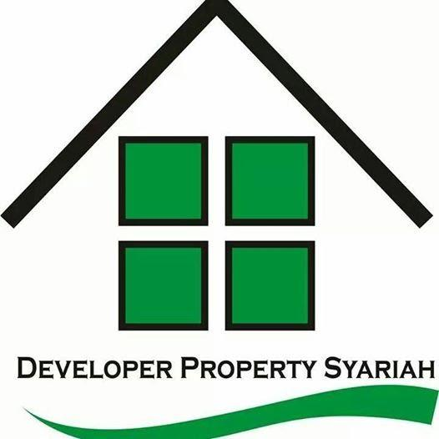

Syariah

**RUTE MENUJU TEMPAT TINGGAL KONSUMEN**

Rute Kendaraan Umum :

______________________________________________________________________________

______________________________________________________________________________

______________________________________________________________________________

______________________________________________________________________________

Denah Rute Menuju Tempat Tinggal Konsumen ( Digambarkan )



| #TanpaKPRBank | #TanpaRiba | #TanpaDenda | #TanpaSita | #TanpaAkadBermasalah |