Django Tutorial for Linux

- Install Django: sudo pip install Django
- Create a folder in your /hom/$USER/ for Django. Example : Django_linux. mkdir /home/$USER/Django_linux
- Create a django Project: django-admin startproject <project_name>
- We will use: django-admin startproject Django_linux
- This will create a folder with the project name Django_linux.
- Enter the folder ( cd /home/$USER/ Django_linux)
- You will have to items created:
  - The folder for you project ( Django_Linux)
    - Inside this folder, you will have the following created default items:
      - __init__.py settings.py urls.py wsgi.py
  - The manage.py file, which runs django commands from terminal

- Start the django server: python3 manage.py runserver You should get a screen like this
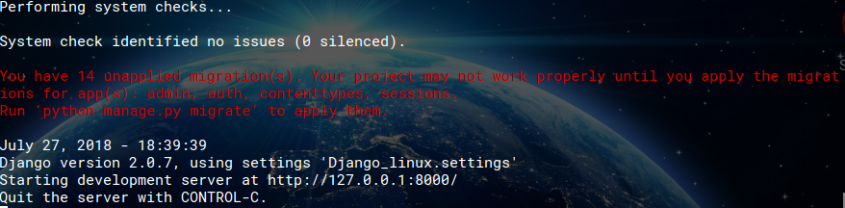
- If you get a warning stating the port 8000 is used, open a terminal and enter: sudo fuser -k 8000/tcp

- Migrate server: python3 manage.py migrate
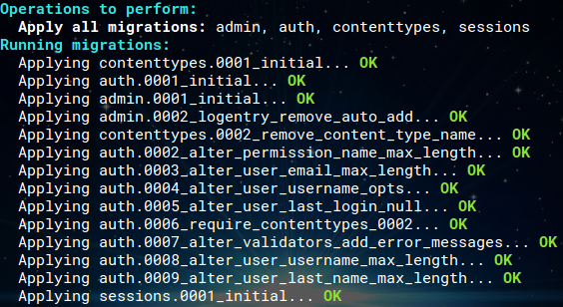

- Create a superuser: python3 manage.py createsuperuser
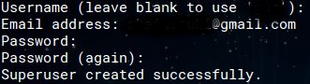

- Launch the browser: http://127.0.0.1:8000/admin/
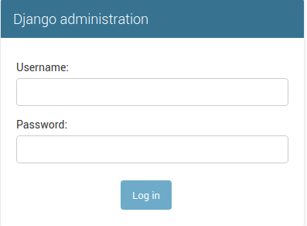

- After loging with the credentials, you should get a page like this:
