Notes for the Python presentation
Processing the data
- Origin
This dataset is public available for research. The details are described in [Cortez et al., 2009]. Please include this citation if you plan to use this database:
  - P. Cortez, A. Cerdeira, F. Almeida, T. Matos and J. Reis. Modeling wine preferences by data mining from physicochemical properties. In Decision Support Systems, Elsevier, 47(4):547-553. ISSN: 0167-9236.
- Explain
  - Wine database
  - Thousands of wine samples with 11 features such as pH and acidity.
  - Qualities evaluated by tree experts
  - Problem: determine usability of future samples.
- Process
  - Division
    - Data handled and processed using Pandas
    - It is unnecessary to divide the wine into 10 categories, so I divide it to three based on it’s usability.
Quality | Class/Usable
[0,5] | 1 / Unusable
]5,7] | 2 / Cheaper or maybe usable
]7,10] | 3 / Usable

  - Scale/normalize
    - Standard scaler
    - It subtracts the mean value of the observation and then divides it by the unit variance of the observation
    - This eliminates the dominating (if exist) fe
    - Normalizes
  - Feature selection LASSO (for linear regression only)

Alpha value | 0.1 | 0.01 | 0.0001
Total number of features used | 2/11 | 9/11 | 11/11
Accuracy (%) | 12 | 23 | 23

From the table can be seen that some features do not necessarily contribute to the regression. However the model still classifies poorly due to the non linearity (following).
Results from the Feature Importance by ExtraTreeClassifier: (Larger score → more important)
[0.07217551 0.10953069 0.0845641 0.08082555 0.0829807 0.09360738
0.08148188 0.07966577 0.07944639 0.07345181 0.16227022]
Feature selection for the SVM-linear using Recursive Feature Elimination:
Nro. of features | The importance of features
7 | [3 1 5 1 2 1 4 1 1 1 1]
8 | [2 1 4 1 1 1 3 1 1 1 1]
9 | [1 1 3 1 1 1 2 1 1 1 1]

Feature selection for the Random Forest Classifier using Recursive Feature Elimination:
Nro. of features | The importance of features
7 | [5 1 3 1 1 1 1 1 4 2 1]
8 | [4 1 2 1 1 1 1 1 3 1 1]
9 | [3 1 1 1 1 1 1 1 2 1 1]

Linear equivalence?
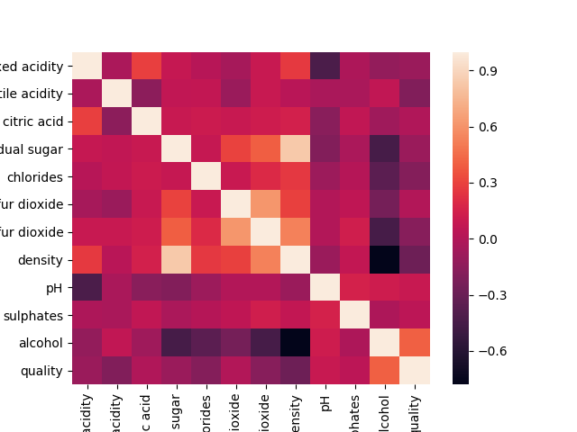
Read: -1 and 1 high linear correlation, 0 no linear correlation
  - → Not linearly correlated
Models
Model generated | Linear regression | Polynomial regression | Logistic regression | K- means | Random forest | Naive Bayes | SVM-linear | SVM-rbf
Accuracy (right/all)(%) | 23.0 | 25.4 | 70.5 | 72.5 | 79.4 | 64.8 | 70.2 | 73.6
Accuracy (Cross Validation)(%) | 21.9 | - | 70.6 | 62.3 | 72.6 | 65.5 | 71.0 | 62.7
Training and testing time | 2s | 1s | 103s | 5s | 8s | 2s | 986s | 11s

After removing the features in SVM-linear and Random Forest:
Model | Random forest | SVM-linear
Accuracy (right/all)(%) | 78.8 | 69.8
Accuracy (Cross Validation)(%) | 72.0 | 71.0
Training and testing time | 7s | 1478s

Analyze efficiency
- Table and plots
  - Pick the random forest classifier and do the confusion matrix
Label | Unusable (1) | Usable/cheap (2) | Usable (3)
Unusable (1) | 345 | 182 | 0
Usable/cheap (2) | 88 | 808 | 1
Usable (3) | 0 | 31 | 15

  - Permutation analysis
    - randomization test
    - statistical significance test (the value of the model)

Notes:
Nbayes: Probabilistic classifier with high independence assumption. Probability function (gaus) → calc the
Random Forest: Multiple tree classifiers with bagging. Uses multiple trees by going through a certain algorithm. Uses random subsets while branching trees and posteriori probabilities.
KnearestN: See what (k-values) are close to y and then predict the label with that info

