Notes for the Python presentation
Processing the data
- Origin
This dataset is public available for research. The details are described in [Cortez et al., 2009]. Please include this citation if you plan to use this database:
  - P. Cortez, A. Cerdeira, F. Almeida, T. Matos and J. Reis. Modeling wine preferences by data mining from physicochemical properties. In Decision Support Systems, Elsevier, 47(4):547-553. ISSN: 0167-9236.
- Explain
  - Wine database
  - Thousands of wine samples with 11 features such as pH and acidity.
  - Qualities given those features
  - Problem: determine usability of future samples.
- Process
  - Division
    - Handled and processed using Pandas
    - It is unnecessary to divide the wine into 10 categories, so I divide it to three based on it’s usability.
Quality | Class/Usable
[0,5] | 1 / Unusable
]5,7] | 2 / Cheaper or maybe usable
]7,10] | 3 / Usable

  - Scale/normalize
    - Standard scaler
    - It subtracts the mean value of the observation and then divides it by the unit variance of the observation
  - Feature selection LASSO (for linear regression only)
Alpha value | 0.1 | 0.01 | 0.0001
Total number of features | 2/11 | 9/11 | 11/11
Accuracy (%) | 12 | 23 | 23

From the table can be seen that some features do not necessarily contribute to the regression. However the model still classifies poorly due to the non linearity (following).
Linear equivalence?
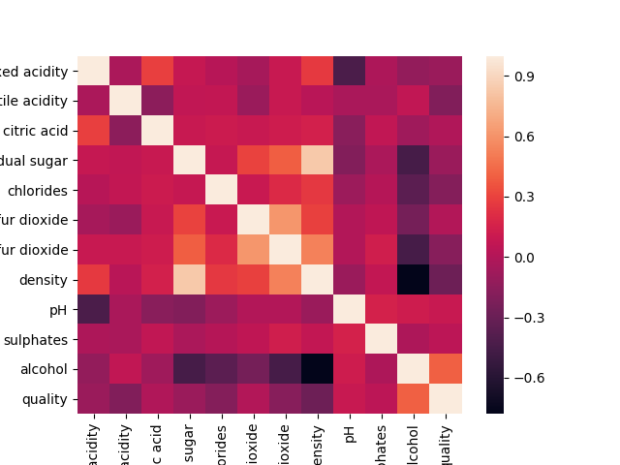
Read: -1 and 1 high linear correlation, 0 no linear correlation
  - → Not linearly correlated
Models
Model generated | Linear regression | Polynomial regression | Logistic regression | K- means | Random forest | Naive Bayes | SVM-linear | SVM-rbf
Accuracy (right/all)(%) | 23.0 | 25.4 | 70.5 | 72.5 | 79.4 | 64.8 | 70.2 | 73.6
Accuracy (Cross Validation)(%) | 21.9 | - | 70.6 | 62.3 | 72.6 | 65.5 | 71.0 | 62.7
Training and testing time | 2 | 1s | 103s | 5s | 8s | 2s | 986s | 11s

Analyze efficiency
- Table and plots

