hw1.R

asahikuroki222

2021-11-04

# Part 1  
# a)   
my_data = read.csv("LaptopSales (1).csv")  
head(my_data)

## Date Configuration Customer.Postcode Store.Postcode  
## 1 2008/01/01 00:01:19 163 EC4V 5BH SE1 2BN  
## 2 2008/01/01 00:02:52 320 SW4 0JL SW12 9HD  
## 3 2008/01/01 00:04:18 23 EC3V 1LR E2 0RY  
## 4 2008/01/01 00:04:40 169 SW1P 3AU SE1 2BN  
## 5 2008/01/01 00:06:04 365 EC4V 4EG SW1V 4QQ  
## 6 2008/01/01 00:12:26 309 W1B 5PX SW1V 4QQ  
## Retail.Price Screen.Size..Inches. Battery.Life..Hours. RAM..GB.  
## 1 455 15 5 1  
## 2 545 15 6 1  
## 3 515 15 4 1  
## 4 395 15 5 1  
## 5 585 15 6 2  
## 6 555 15 6 1  
## Processor.Speeds..GHz. Integrated.Wireless. HD.Size..GB.  
## 1 2 Yes 80  
## 2 2 No 300  
## 3 2 Yes 300  
## 4 2 No 40  
## 5 2 No 120  
## 6 2 Yes 120  
## Bundled.Applications. OS.X.Customer OS.Y.Customer OS.X.Store OS.Y.Store  
## 1 Yes 532041 180995 534057 179682  
## 2 No 529240 175537 528739 173080  
## 3 Yes 533095 181047 535652 182961  
## 4 Yes 529902 179641 534057 179682  
## 5 Yes 531684 180948 528924 178440  
## 6 Yes 529207 180969 528924 178440  
## CustomerStoreDistance  
## 1 2405.873  
## 2 2507.559  
## 3 3194.001  
## 4 4155.202  
## 5 3729.298  
## 6 2544.785

# b) missing data at OS.X.Store, OS.Y.store, and CustomerStoreDistance  
summary(my_data)

## Date Configuration Customer.Postcode Store.Postcode   
## Length:2514 Min. : 1.0 Length:2514 Length:2514   
## Class :character 1st Qu.: 78.0 Class :character Class :character   
## Mode :character Median :212.0 Mode :character Mode :character   
## Mean :209.9   
## 3rd Qu.:315.8   
## Max. :368.0   
##   
## Retail.Price Screen.Size..Inches. Battery.Life..Hours. RAM..GB.   
## Min. :300.0 Min. :15 Min. :4.00 Min. :1.000   
## 1st Qu.:455.0 1st Qu.:15 1st Qu.:4.00 1st Qu.:1.000   
## Median :490.0 Median :15 Median :5.00 Median :2.000   
## Mean :489.8 Mean :15 Mean :5.16 Mean :1.538   
## 3rd Qu.:530.0 3rd Qu.:15 3rd Qu.:6.00 3rd Qu.:2.000   
## Max. :665.0 Max. :15 Max. :6.00 Max. :2.000   
##   
## Processor.Speeds..GHz. Integrated.Wireless. HD.Size..GB.   
## Min. :1.500 Length:2514 Min. : 40.0   
## 1st Qu.:1.500 Class :character 1st Qu.: 80.0   
## Median :2.000 Mode :character Median :120.0   
## Mean :1.757 Mean :150.9   
## 3rd Qu.:2.000 3rd Qu.:300.0   
## Max. :2.000 Max. :300.0   
##   
## Bundled.Applications. OS.X.Customer OS.Y.Customer OS.X.Store   
## Length:2514 Min. :512253 Min. :164886 Min. :517917   
## Class :character 1st Qu.:529281 1st Qu.:178695 1st Qu.:528924   
## Mode :character Median :531190 Median :181082 Median :529902   
## Mean :530926 Mean :179837 Mean :530821   
## 3rd Qu.:533237 3rd Qu.:182049 3rd Qu.:534057   
## Max. :549065 Max. :199846 Max. :541428   
## NA's :4   
## OS.Y.Store CustomerStoreDistance  
## Min. :168302 Min. : 0   
## 1st Qu.:178440 1st Qu.: 2385   
## Median :179641 Median : 3368   
## Mean :179827 Mean : 3680   
## 3rd Qu.:182961 3rd Qu.: 4331   
## Max. :190628 Max. :19892   
## NA's :4 NA's :4

which(is.na(my_data$OS.X.Store))

## [1] 1675 1774 1969 2203

which(is.na(my_data$OS.Y.Store))

## [1] 1675 1774 1969 2203

which(is.na(my_data$CustomerStoreDistance))

## [1] 1675 1774 1969 2203

### missing values in row 1675 1774 1969 2203  
  
# c) mean: 489.8, median 490  
  
# d)   
data_integrated_wireless <- subset(my_data, Integrated.Wireless. ==  
 "Yes")  
data_non_intergrated_wireless <- subset(my_data, Integrated.Wireless. != "Yes")  
summary(data_integrated_wireless)

## Date Configuration Customer.Postcode Store.Postcode   
## Length:1301 Min. : 1.0 Length:1301 Length:1301   
## Class :character 1st Qu.: 71.0 Class :character Class :character   
## Mode :character Median :210.0 Mode :character Mode :character   
## Mean :202.6   
## 3rd Qu.:308.0   
## Max. :360.0   
##   
## Retail.Price Screen.Size..Inches. Battery.Life..Hours. RAM..GB.   
## Min. :320.0 Min. :15 Min. :4.00 Min. :1.000   
## 1st Qu.:460.0 1st Qu.:15 1st Qu.:4.00 1st Qu.:1.000   
## Median :495.0 Median :15 Median :5.00 Median :2.000   
## Mean :495.9 Mean :15 Mean :5.14 Mean :1.533   
## 3rd Qu.:535.0 3rd Qu.:15 3rd Qu.:6.00 3rd Qu.:2.000   
## Max. :665.0 Max. :15 Max. :6.00 Max. :2.000   
##   
## Processor.Speeds..GHz. Integrated.Wireless. HD.Size..GB.   
## Min. :1.500 Length:1301 Min. : 40.0   
## 1st Qu.:1.500 Class :character 1st Qu.: 80.0   
## Median :2.000 Mode :character Median :120.0   
## Mean :1.752 Mean :147.7   
## 3rd Qu.:2.000 3rd Qu.:300.0   
## Max. :2.000 Max. :300.0   
##   
## Bundled.Applications. OS.X.Customer OS.Y.Customer OS.X.Store   
## Length:1301 Min. :512253 Min. :164886 Min. :517917   
## Class :character 1st Qu.:529174 1st Qu.:178524 1st Qu.:528924   
## Mode :character Median :531065 Median :181063 Median :529902   
## Mean :530869 Mean :179822 Mean :530883   
## 3rd Qu.:533246 3rd Qu.:182055 3rd Qu.:534057   
## Max. :549065 Max. :199846 Max. :541428   
## NA's :1   
## OS.Y.Store CustomerStoreDistance  
## Min. :168302 Min. : 0   
## 1st Qu.:178440 1st Qu.: 2424   
## Median :179641 Median : 3418   
## Mean :179787 Mean : 3774   
## 3rd Qu.:182961 3rd Qu.: 4406   
## Max. :190628 Max. :19892   
## NA's :1 NA's :1

summary(data_non_intergrated_wireless)

## Date Configuration Customer.Postcode Store.Postcode   
## Length:1213 Min. : 9.0 Length:1213 Length:1213   
## Class :character 1st Qu.: 80.0 Class :character Class :character   
## Mode :character Median :219.0 Mode :character Mode :character   
## Mean :217.7   
## 3rd Qu.:318.0   
## Max. :368.0   
##   
## Retail.Price Screen.Size..Inches. Battery.Life..Hours. RAM..GB.   
## Min. :300.0 Min. :15 Min. :4.000 Min. :1.000   
## 1st Qu.:455.0 1st Qu.:15 1st Qu.:4.000 1st Qu.:1.000   
## Median :485.0 Median :15 Median :5.000 Median :2.000   
## Mean :483.3 Mean :15 Mean :5.182 Mean :1.544   
## 3rd Qu.:520.0 3rd Qu.:15 3rd Qu.:6.000 3rd Qu.:2.000   
## Max. :645.0 Max. :15 Max. :6.000 Max. :2.000   
##   
## Processor.Speeds..GHz. Integrated.Wireless. HD.Size..GB.   
## Min. :1.500 Length:1213 Min. : 40.0   
## 1st Qu.:1.500 Class :character 1st Qu.: 80.0   
## Median :2.000 Mode :character Median :120.0   
## Mean :1.763 Mean :154.3   
## 3rd Qu.:2.000 3rd Qu.:300.0   
## Max. :2.000 Max. :300.0   
##   
## Bundled.Applications. OS.X.Customer OS.Y.Customer OS.X.Store   
## Length:1213 Min. :512253 Min. :165028 Min. :517917   
## Class :character 1st Qu.:529342 1st Qu.:178835 1st Qu.:528924   
## Mode :character Median :531255 Median :181083 Median :529902   
## Mean :530987 Mean :179853 Mean :530753   
## 3rd Qu.:533180 3rd Qu.:182019 3rd Qu.:534057   
## Max. :549065 Max. :193894 Max. :541428   
## NA's :3   
## OS.Y.Store CustomerStoreDistance  
## Min. :168302 Min. : 0   
## 1st Qu.:178440 1st Qu.: 2322   
## Median :179641 Median : 3258   
## Mean :179871 Mean : 3579   
## 3rd Qu.:182961 3rd Qu.: 4228   
## Max. :190628 Max. :13530   
## NA's :3 NA's :3

### Average price of a laptop with Integrated Wireless $495.9  
### Average price of a laptop without Integrated Wireless $483.3   
  
# e)  
my_data_sorted <- my_data[order(my_data$Retail.Price, decreasing = TRUE),]  
my_data_sorted[1, ]

## Date Configuration Customer.Postcode Store.Postcode  
## 12 2008/01/01 01:03:25 359 W1T 1DG NW5 2QH  
## Retail.Price Screen.Size..Inches. Battery.Life..Hours. RAM..GB.  
## 12 665 15 6 2  
## Processor.Speeds..GHz. Integrated.Wireless. HD.Size..GB.  
## 12 2 Yes 300  
## Bundled.Applications. OS.X.Customer OS.Y.Customer OS.X.Store OS.Y.Store  
## 12 Yes 529584 181554 529248 185213  
## CustomerStoreDistance  
## 12 3674.395

### Configuration type with the highest price is 359  
  
# f)   
sum(my_data$HD.Size..GB. < 150)

## [1] 1749

### 1749  
  
# g)  
sum(my_data$Retail.Price)

## [1] 1231470

### Total price = $ 1231470  
  
  
### Part2  
library(ggplot2)  
# a)   
summary(my_data)

## Date Configuration Customer.Postcode Store.Postcode   
## Length:2514 Min. : 1.0 Length:2514 Length:2514   
## Class :character 1st Qu.: 78.0 Class :character Class :character   
## Mode :character Median :212.0 Mode :character Mode :character   
## Mean :209.9   
## 3rd Qu.:315.8   
## Max. :368.0   
##   
## Retail.Price Screen.Size..Inches. Battery.Life..Hours. RAM..GB.   
## Min. :300.0 Min. :15 Min. :4.00 Min. :1.000   
## 1st Qu.:455.0 1st Qu.:15 1st Qu.:4.00 1st Qu.:1.000   
## Median :490.0 Median :15 Median :5.00 Median :2.000   
## Mean :489.8 Mean :15 Mean :5.16 Mean :1.538   
## 3rd Qu.:530.0 3rd Qu.:15 3rd Qu.:6.00 3rd Qu.:2.000   
## Max. :665.0 Max. :15 Max. :6.00 Max. :2.000   
##   
## Processor.Speeds..GHz. Integrated.Wireless. HD.Size..GB.   
## Min. :1.500 Length:2514 Min. : 40.0   
## 1st Qu.:1.500 Class :character 1st Qu.: 80.0   
## Median :2.000 Mode :character Median :120.0   
## Mean :1.757 Mean :150.9   
## 3rd Qu.:2.000 3rd Qu.:300.0   
## Max. :2.000 Max. :300.0   
##   
## Bundled.Applications. OS.X.Customer OS.Y.Customer OS.X.Store   
## Length:2514 Min. :512253 Min. :164886 Min. :517917   
## Class :character 1st Qu.:529281 1st Qu.:178695 1st Qu.:528924   
## Mode :character Median :531190 Median :181082 Median :529902   
## Mean :530926 Mean :179837 Mean :530821   
## 3rd Qu.:533237 3rd Qu.:182049 3rd Qu.:534057   
## Max. :549065 Max. :199846 Max. :541428   
## NA's :4   
## OS.Y.Store CustomerStoreDistance  
## Min. :168302 Min. : 0   
## 1st Qu.:178440 1st Qu.: 2385   
## Median :179641 Median : 3368   
## Mean :179827 Mean : 3680   
## 3rd Qu.:182961 3rd Qu.: 4331   
## Max. :190628 Max. :19892   
## NA's :4 NA's :4

ggplot(data= my_data, aes(x = CustomerStoreDistance, fill = ..count..)) +   
 geom_histogram(alpha=1) +  
 scale_fill_gradient(low="purple", high="darkblue") +   
 ggtitle("Distrubution of Customer Store Distance")

## `stat_bin()` using `bins = 30`. Pick better value with `binwidth`.

## Warning: Removed 4 rows containing non-finite values (stat_bin).

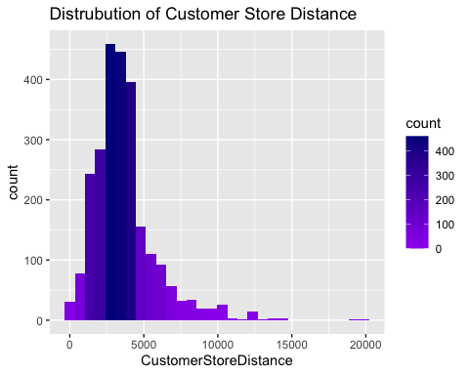

Insights: We could see from the data that as the distance grow, counts decreases. Therefore, distance is one of an important aspect of shopping for customers. Also, we could see that counts are the highest between 2500 – approximately 4000

# b)  
ggplot(data = my_data, aes(y=Retail.Price)) +  
 geom_boxplot(notch = TRUE, outlier.colour="orange", outlier.shape=2, outlier.size=3) +   
 ggtitle("Box plot for Retail Price")

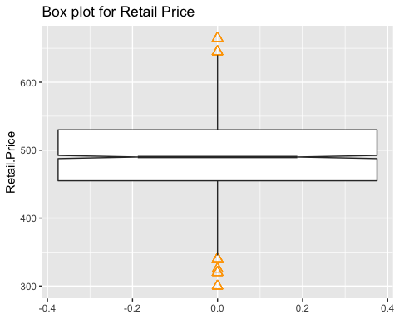

Insights: We could see from the boxplot that most of the Retail Prices are in the range from 455 – 530. Also, there are more outliers in the minimum side than the maximum side.

# c)   
ggplot(data <- my_data, aes(y=Retail.Price, group = HD.Size..GB.  
, color = HD.Size..GB.)) +  
 geom_boxplot(notch = TRUE, outlier.colour="red", outlier.shape=1, outlier.size=3)

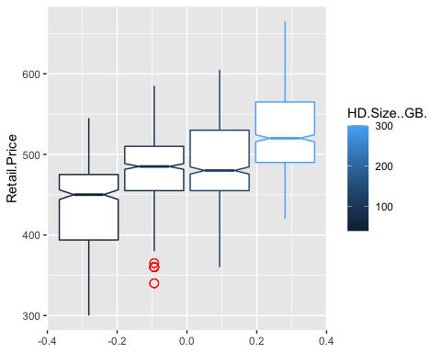

# d)   
# part a)   
ggplot(data <- my_data, aes(x= Battery.Life..Hours., y = Retail.Price, color = Battery.Life..Hours. )) +   
 geom_point() +   
 ggtitle("Relationship between Battery life and price")

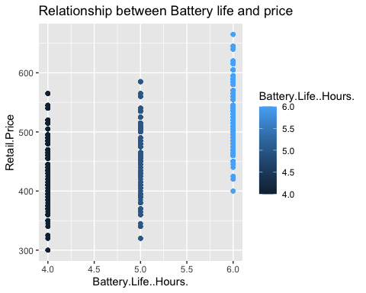

# part b)  
my_data$Battery.Cat[my_data$Battery.Life..Hours. == 4] <- "Battery Life 4 hours"  
my_data$Battery.Cat[my_data$Battery.Life..Hours. == 5] <- "Battery Life 5 hours"  
my_data$Battery.Cat[my_data$Battery.Life..Hours. == 6] <- "Battery Life 6 hours"  
ggplot(data= my_data, aes(x = Retail.Price, fill = Battery.Cat)) +   
 geom_histogram(alpha=0.8) +   
 ggtitle("Retail price by battery category")

## `stat_bin()` using `bins = 30`. Pick better value with `binwidth`.

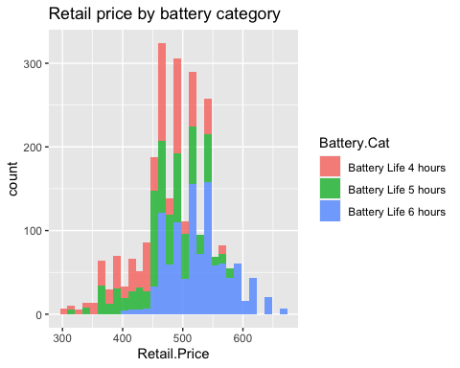

ggplot(data= my_data, aes(x = Retail.Price,group= Battery.Cat, fill = Battery.Cat)) +   
 geom_histogram(alpha=0.8) +   
 ggtitle("Retail price by battery category")

## `stat_bin()` using `bins = 30`. Pick better value with `binwidth`.

