hw1.R

asahikuroki222

2021-11-04

# Part 1  
# a)   
my_data = read.csv("LaptopSales (1).csv")  
head(my_data)

## Date Configuration Customer.Postcode Store.Postcode  
## 1 2008/01/01 00:01:19 163 EC4V 5BH SE1 2BN  
## 2 2008/01/01 00:02:52 320 SW4 0JL SW12 9HD  
## 3 2008/01/01 00:04:18 23 EC3V 1LR E2 0RY  
## 4 2008/01/01 00:04:40 169 SW1P 3AU SE1 2BN  
## 5 2008/01/01 00:06:04 365 EC4V 4EG SW1V 4QQ  
## 6 2008/01/01 00:12:26 309 W1B 5PX SW1V 4QQ  
## Retail.Price Screen.Size..Inches. Battery.Life..Hours. RAM..GB.  
## 1 455 15 5 1  
## 2 545 15 6 1  
## 3 515 15 4 1  
## 4 395 15 5 1  
## 5 585 15 6 2  
## 6 555 15 6 1  
## Processor.Speeds..GHz. Integrated.Wireless. HD.Size..GB.  
## 1 2 Yes 80  
## 2 2 No 300  
## 3 2 Yes 300  
## 4 2 No 40  
## 5 2 No 120  
## 6 2 Yes 120  
## Bundled.Applications. OS.X.Customer OS.Y.Customer OS.X.Store OS.Y.Store  
## 1 Yes 532041 180995 534057 179682  
## 2 No 529240 175537 528739 173080  
## 3 Yes 533095 181047 535652 182961  
## 4 Yes 529902 179641 534057 179682  
## 5 Yes 531684 180948 528924 178440  
## 6 Yes 529207 180969 528924 178440  
## CustomerStoreDistance  
## 1 2405.873  
## 2 2507.559  
## 3 3194.001  
## 4 4155.202  
## 5 3729.298  
## 6 2544.785

# b) missing data at OS.X.Store, OS.Y.store, and CustomerStoreDistance  
summary(my_data)

## Date Configuration Customer.Postcode Store.Postcode   
## Length:2514 Min. : 1.0 Length:2514 Length:2514   
## Class :character 1st Qu.: 78.0 Class :character Class :character   
## Mode :character Median :212.0 Mode :character Mode :character   
## Mean :209.9   
## 3rd Qu.:315.8   
## Max. :368.0   
##   
## Retail.Price Screen.Size..Inches. Battery.Life..Hours. RAM..GB.   
## Min. :300.0 Min. :15 Min. :4.00 Min. :1.000   
## 1st Qu.:455.0 1st Qu.:15 1st Qu.:4.00 1st Qu.:1.000   
## Median :490.0 Median :15 Median :5.00 Median :2.000   
## Mean :489.8 Mean :15 Mean :5.16 Mean :1.538   
## 3rd Qu.:530.0 3rd Qu.:15 3rd Qu.:6.00 3rd Qu.:2.000   
## Max. :665.0 Max. :15 Max. :6.00 Max. :2.000   
##   
## Processor.Speeds..GHz. Integrated.Wireless. HD.Size..GB.   
## Min. :1.500 Length:2514 Min. : 40.0   
## 1st Qu.:1.500 Class :character 1st Qu.: 80.0   
## Median :2.000 Mode :character Median :120.0   
## Mean :1.757 Mean :150.9   
## 3rd Qu.:2.000 3rd Qu.:300.0   
## Max. :2.000 Max. :300.0   
##   
## Bundled.Applications. OS.X.Customer OS.Y.Customer OS.X.Store   
## Length:2514 Min. :512253 Min. :164886 Min. :517917   
## Class :character 1st Qu.:529281 1st Qu.:178695 1st Qu.:528924   
## Mode :character Median :531190 Median :181082 Median :529902   
## Mean :530926 Mean :179837 Mean :530821   
## 3rd Qu.:533237 3rd Qu.:182049 3rd Qu.:534057   
## Max. :549065 Max. :199846 Max. :541428   
## NA's :4   
## OS.Y.Store CustomerStoreDistance  
## Min. :168302 Min. : 0   
## 1st Qu.:178440 1st Qu.: 2385   
## Median :179641 Median : 3368   
## Mean :179827 Mean : 3680   
## 3rd Qu.:182961 3rd Qu.: 4331   
## Max. :190628 Max. :19892   
## NA's :4 NA's :4

which(is.na(my_data$OS.X.Store))

## [1] 1675 1774 1969 2203

which(is.na(my_data$OS.Y.Store))

## [1] 1675 1774 1969 2203

which(is.na(my_data$CustomerStoreDistance))

## [1] 1675 1774 1969 2203

### missing values in row 1675 1774 1969 2203  
  
# c) mean: 489.8, median 490  
  
# d)   
data_integrated_wireless <- subset(my_data, Integrated.Wireless. ==  
 "Yes")  
data_non_intergrated_wireless <- subset(my_data, Integrated.Wireless. != "Yes")  
summary(data_integrated_wireless)

## Date Configuration Customer.Postcode Store.Postcode   
## Length:1301 Min. : 1.0 Length:1301 Length:1301   
## Class :character 1st Qu.: 71.0 Class :character Class :character   
## Mode :character Median :210.0 Mode :character Mode :character   
## Mean :202.6   
## 3rd Qu.:308.0   
## Max. :360.0   
##   
## Retail.Price Screen.Size..Inches. Battery.Life..Hours. RAM..GB.   
## Min. :320.0 Min. :15 Min. :4.00 Min. :1.000   
## 1st Qu.:460.0 1st Qu.:15 1st Qu.:4.00 1st Qu.:1.000   
## Median :495.0 Median :15 Median :5.00 Median :2.000   
## Mean :495.9 Mean :15 Mean :5.14 Mean :1.533   
## 3rd Qu.:535.0 3rd Qu.:15 3rd Qu.:6.00 3rd Qu.:2.000   
## Max. :665.0 Max. :15 Max. :6.00 Max. :2.000   
##   
## Processor.Speeds..GHz. Integrated.Wireless. HD.Size..GB.   
## Min. :1.500 Length:1301 Min. : 40.0   
## 1st Qu.:1.500 Class :character 1st Qu.: 80.0   
## Median :2.000 Mode :character Median :120.0   
## Mean :1.752 Mean :147.7   
## 3rd Qu.:2.000 3rd Qu.:300.0   
## Max. :2.000 Max. :300.0   
##   
## Bundled.Applications. OS.X.Customer OS.Y.Customer OS.X.Store   
## Length:1301 Min. :512253 Min. :164886 Min. :517917   
## Class :character 1st Qu.:529174 1st Qu.:178524 1st Qu.:528924   
## Mode :character Median :531065 Median :181063 Median :529902   
## Mean :530869 Mean :179822 Mean :530883   
## 3rd Qu.:533246 3rd Qu.:182055 3rd Qu.:534057   
## Max. :549065 Max. :199846 Max. :541428   
## NA's :1   
## OS.Y.Store CustomerStoreDistance  
## Min. :168302 Min. : 0   
## 1st Qu.:178440 1st Qu.: 2424   
## Median :179641 Median : 3418   
## Mean :179787 Mean : 3774   
## 3rd Qu.:182961 3rd Qu.: 4406   
## Max. :190628 Max. :19892   
## NA's :1 NA's :1

summary(data_non_intergrated_wireless)

## Date Configuration Customer.Postcode Store.Postcode   
## Length:1213 Min. : 9.0 Length:1213 Length:1213   
## Class :character 1st Qu.: 80.0 Class :character Class :character   
## Mode :character Median :219.0 Mode :character Mode :character   
## Mean :217.7   
## 3rd Qu.:318.0   
## Max. :368.0   
##   
## Retail.Price Screen.Size..Inches. Battery.Life..Hours. RAM..GB.   
## Min. :300.0 Min. :15 Min. :4.000 Min. :1.000   
## 1st Qu.:455.0 1st Qu.:15 1st Qu.:4.000 1st Qu.:1.000   
## Median :485.0 Median :15 Median :5.000 Median :2.000   
## Mean :483.3 Mean :15 Mean :5.182 Mean :1.544   
## 3rd Qu.:520.0 3rd Qu.:15 3rd Qu.:6.000 3rd Qu.:2.000   
## Max. :645.0 Max. :15 Max. :6.000 Max. :2.000   
##   
## Processor.Speeds..GHz. Integrated.Wireless. HD.Size..GB.   
## Min. :1.500 Length:1213 Min. : 40.0   
## 1st Qu.:1.500 Class :character 1st Qu.: 80.0   
## Median :2.000 Mode :character Median :120.0   
## Mean :1.763 Mean :154.3   
## 3rd Qu.:2.000 3rd Qu.:300.0   
## Max. :2.000 Max. :300.0   
##   
## Bundled.Applications. OS.X.Customer OS.Y.Customer OS.X.Store   
## Length:1213 Min. :512253 Min. :165028 Min. :517917   
## Class :character 1st Qu.:529342 1st Qu.:178835 1st Qu.:528924   
## Mode :character Median :531255 Median :181083 Median :529902   
## Mean :530987 Mean :179853 Mean :530753   
## 3rd Qu.:533180 3rd Qu.:182019 3rd Qu.:534057   
## Max. :549065 Max. :193894 Max. :541428   
## NA's :3   
## OS.Y.Store CustomerStoreDistance  
## Min. :168302 Min. : 0   
## 1st Qu.:178440 1st Qu.: 2322   
## Median :179641 Median : 3258   
## Mean :179871 Mean : 3579   
## 3rd Qu.:182961 3rd Qu.: 4228   
## Max. :190628 Max. :13530   
## NA's :3 NA's :3

### Average price of a laptop with Integrated Wireless $495.9  
### Average price of a laptop without Integrated Wireless $483.3   
  
# e)  
my_data_sorted <- my_data[order(my_data$Retail.Price, decreasing = TRUE),]  
my_data_sorted[1, ]

## Date Configuration Customer.Postcode Store.Postcode  
## 12 2008/01/01 01:03:25 359 W1T 1DG NW5 2QH  
## Retail.Price Screen.Size..Inches. Battery.Life..Hours. RAM..GB.  
## 12 665 15 6 2  
## Processor.Speeds..GHz. Integrated.Wireless. HD.Size..GB.  
## 12 2 Yes 300  
## Bundled.Applications. OS.X.Customer OS.Y.Customer OS.X.Store OS.Y.Store  
## 12 Yes 529584 181554 529248 185213  
## CustomerStoreDistance  
## 12 3674.395

### Configuration type with the highest price is 359  
  
# f)   
sum(my_data$HD.Size..GB. < 150)

## [1] 1749

### 1749  
  
# g)  
sum(my_data$Retail.Price)

## [1] 1231470

### Total price = $ 1231470  
  
  
### Part2  
library(ggplot2)  
# a)   
summary(my_data)

## Date Configuration Customer.Postcode Store.Postcode   
## Length:2514 Min. : 1.0 Length:2514 Length:2514   
## Class :character 1st Qu.: 78.0 Class :character Class :character   
## Mode :character Median :212.0 Mode :character Mode :character   
## Mean :209.9   
## 3rd Qu.:315.8   
## Max. :368.0   
##   
## Retail.Price Screen.Size..Inches. Battery.Life..Hours. RAM..GB.   
## Min. :300.0 Min. :15 Min. :4.00 Min. :1.000   
## 1st Qu.:455.0 1st Qu.:15 1st Qu.:4.00 1st Qu.:1.000   
## Median :490.0 Median :15 Median :5.00 Median :2.000   
## Mean :489.8 Mean :15 Mean :5.16 Mean :1.538   
## 3rd Qu.:530.0 3rd Qu.:15 3rd Qu.:6.00 3rd Qu.:2.000   
## Max. :665.0 Max. :15 Max. :6.00 Max. :2.000   
##   
## Processor.Speeds..GHz. Integrated.Wireless. HD.Size..GB.   
## Min. :1.500 Length:2514 Min. : 40.0   
## 1st Qu.:1.500 Class :character 1st Qu.: 80.0   
## Median :2.000 Mode :character Median :120.0   
## Mean :1.757 Mean :150.9   
## 3rd Qu.:2.000 3rd Qu.:300.0   
## Max. :2.000 Max. :300.0   
##   
## Bundled.Applications. OS.X.Customer OS.Y.Customer OS.X.Store   
## Length:2514 Min. :512253 Min. :164886 Min. :517917   
## Class :character 1st Qu.:529281 1st Qu.:178695 1st Qu.:528924   
## Mode :character Median :531190 Median :181082 Median :529902   
## Mean :530926 Mean :179837 Mean :530821   
## 3rd Qu.:533237 3rd Qu.:182049 3rd Qu.:534057   
## Max. :549065 Max. :199846 Max. :541428   
## NA's :4   
## OS.Y.Store CustomerStoreDistance  
## Min. :168302 Min. : 0   
## 1st Qu.:178440 1st Qu.: 2385   
## Median :179641 Median : 3368   
## Mean :179827 Mean : 3680   
## 3rd Qu.:182961 3rd Qu.: 4331   
## Max. :190628 Max. :19892   
## NA's :4 NA's :4

ggplot(data= my_data, aes(x = CustomerStoreDistance, fill = ..count..)) +   
 geom_histogram(alpha=1) +  
 scale_fill_gradient(low="purple", high="darkblue") +   
 ggtitle("Distrubution of Customer Store Distance")

## `stat_bin()` using `bins = 30`. Pick better value with `binwidth`.

## Warning: Removed 4 rows containing non-finite values (stat_bin).

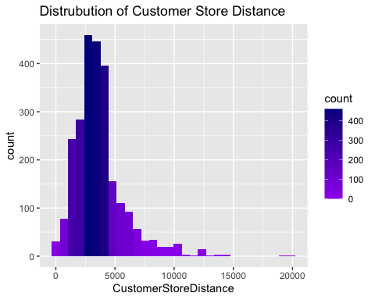

# b)  
ggplot(data = my_data, aes(y=Retail.Price)) +  
 geom_boxplot(notch = TRUE, outlier.colour="orange", outlier.shape=2, outlier.size=3) +   
 ggtitle("Box plot for Retail Price")

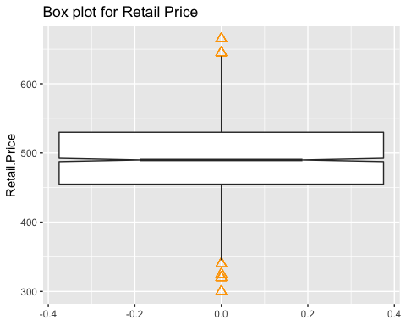

# c)   
ggplot(data <- my_data, aes(y=Retail.Price, group = HD.Size..GB.  
, color = HD.Size..GB.)) +  
 geom_boxplot(notch = TRUE, outlier.colour="red", outlier.shape=1, outlier.size=3)

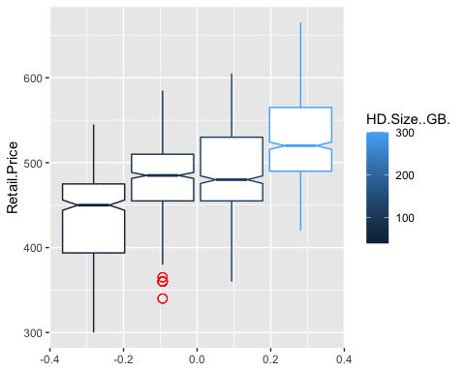

# d)   
# part a)   
ggplot(data <- my_data, aes(x= Battery.Life..Hours., y = Retail.Price, color = Battery.Life..Hours. )) +   
 geom_point() +   
 ggtitle("Relationship between Battery life and price")

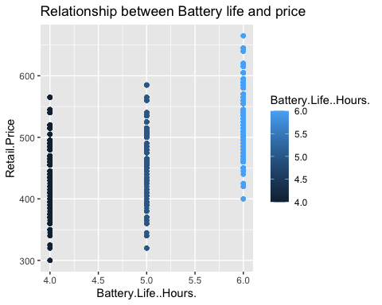

# part b)  
my_data$Battery.Cat[my_data$Battery.Life..Hours. == 4] <- "Battery Life 4 hours"  
my_data$Battery.Cat[my_data$Battery.Life..Hours. == 5] <- "Battery Life 5 hours"  
my_data$Battery.Cat[my_data$Battery.Life..Hours. == 6] <- "Battery Life 6 hours"  
ggplot(data= my_data, aes(x = Retail.Price, fill = Battery.Cat)) +   
 geom_histogram(alpha=0.8) +   
 ggtitle("Retail price by battery category")

## `stat_bin()` using `bins = 30`. Pick better value with `binwidth`.

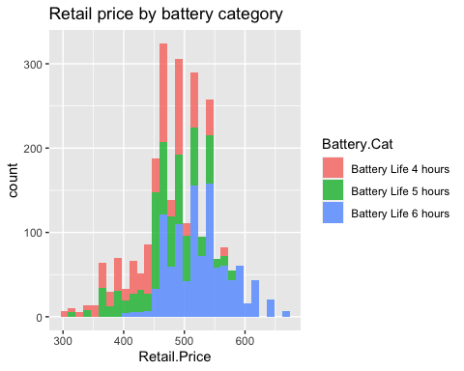

ggplot(data= my_data, aes(x = Retail.Price,group= Battery.Cat, fill = Battery.Cat)) +   
 geom_histogram(alpha=0.8) +   
 ggtitle("Retail price by battery category")

## `stat_bin()` using `bins = 30`. Pick better value with `binwidth`.

