hw5

Asahi (Ash) Kuroki

12/1/2021

knitr::opts_chunk$set(cache = TRUE)  
set.seed(123)

# import packages  
library(GGally)

## Loading required package: ggplot2

## Registered S3 method overwritten by 'GGally':  
## method from   
## +.gg ggplot2

library(caret)

## Loading required package: lattice

library(rpart.plot)

## Loading required package: rpart

library(gridExtra)  
library(labelVector)  
library(tidyverse)

## ── Attaching packages ─────────────────────────────────────── tidyverse 1.3.1 ──

## ✓ tibble 3.1.6 ✓ dplyr 1.0.7  
## ✓ tidyr 1.1.4 ✓ stringr 1.4.0  
## ✓ readr 2.1.1 ✓ forcats 0.5.1  
## ✓ purrr 0.3.4

## ── Conflicts ────────────────────────────────────────── tidyverse_conflicts() ──  
## x dplyr::combine() masks gridExtra::combine()  
## x dplyr::filter() masks stats::filter()  
## x dplyr::lag() masks stats::lag()  
## x purrr::lift() masks caret::lift()

Analysis

Processing and Visualizing data  
a) Load the data. Get a summary of the data, report it. Use ggplot to plot a histogram for the distribution of the number of bike-rides.

df <- read.csv("bike_day.csv")  
summary(df)

## cnt_bike atemp hum windspeed temp   
## Min. : 22 Min. : 3.95 Min. : 0.00 Min. : 1.50 Min. : 2.42   
## 1st Qu.:3152 1st Qu.:16.89 1st Qu.:52.00 1st Qu.: 9.04 1st Qu.:13.82   
## Median :4548 Median :24.34 Median :62.67 Median :12.13 Median :20.43   
## Mean :4504 Mean :23.72 Mean :62.79 Mean :12.76 Mean :20.31   
## 3rd Qu.:5956 3rd Qu.:30.43 3rd Qu.:73.02 3rd Qu.:15.62 3rd Qu.:26.88   
## Max. :8714 Max. :42.04 Max. :97.25 Max. :34.00 Max. :35.33   
## holiday workingday   
## Min. :0.00000 Min. :0.000   
## 1st Qu.:0.00000 1st Qu.:0.000   
## Median :0.00000 Median :1.000   
## Mean :0.02873 Mean :0.684   
## 3rd Qu.:0.00000 3rd Qu.:1.000   
## Max. :1.00000 Max. :1.000

ggplot(data = df, aes(cnt_bike)) +   
 xlim(0, 9000) +   
 ylim(0, 70) +   
 geom_histogram(colour = "grey", fill = "black") +   
 ggtitle("Distrubution of the number of bike-rides") +   
 labs(x = "Number of bikes")

## `stat_bin()` using `bins = 30`. Pick better value with `binwidth`.

## Warning: Removed 2 rows containing missing values (geom_bar).

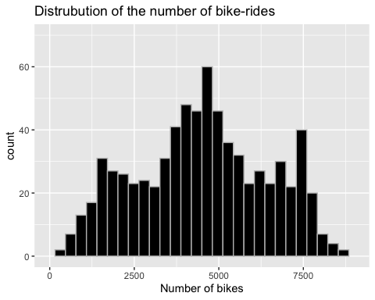

1. Use the function pairs() to produce a plot of the relationships among count, atemp and hum.

pairs(df[,1:3], col = "darkgreen")

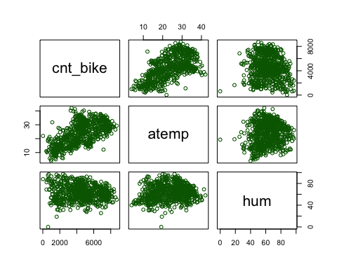 Comment on distribution

1. (0.2) Split the data into 80% training and 20% testing.

trainRows <- createDataPartition(y = df$cnt_bike, p = 0.8, list = FALSE)  
train_set <- df[trainRows,]  
test_set <- df[-trainRows,]

Train a K-NN model  
a) Decide whether you need to standardize the data or not  
Yes. We need to standardize the data in K-NN. We will standardize all the attributes besides cnt_bike

train_set_stand <- train_set  
test_set_stand <- test_set  
library(standardize)

##   
## ***********************************************************   
## Loading standardize package version 0.2.2   
## Call standardize.news() to see new features/changes   
## ***********************************************************

#Apply the standardization  
train_set_stand[,2:7] <- apply(train_set_stand[,2:7], MARGIN = 2, FUN = scale)  
test_set_stand[,2:7] <- apply(test_set_stand[,2:7], MARGIN = 2, FUN = scale)

1. Train a k-NN model on the appropriate attributes.

knn_model <- train(cnt_bike~., train_set_stand, method = "knn")  
knn_model

## k-Nearest Neighbors   
##   
## 587 samples  
## 6 predictor  
##   
## No pre-processing  
## Resampling: Bootstrapped (25 reps)   
## Summary of sample sizes: 587, 587, 587, 587, 587, 587, ...   
## Resampling results across tuning parameters:  
##   
## k RMSE Rsquared MAE   
## 5 1427.202 0.4673236 1175.851  
## 7 1384.433 0.4922404 1146.025  
## 9 1369.279 0.5015668 1138.378  
##   
## RMSE was used to select the optimal model using the smallest value.  
## The final value used for the model was k = 9.