IE 412 AI for Finance

Hands-on Practice on Session #2

Portfolio optimization with machine learning prediction models

Main TA for this assignment: Yoontae Hwang, E-mail: [yoontae@unist.ac.kr](mailto:yoontae@unist.ac.kr)

Here is the [Colab link](https://colab.research.google.com/drive/1a8_6DjD8BXSm-PxPvhqH07PGtKPF-Ns3?usp=sharing).

**Description**

You should write a report about the following.

1. **Main task (8 pts)**
2. You should complete the following function that outputs a mean-variance efficient portfolio given minimum expected return min_return.

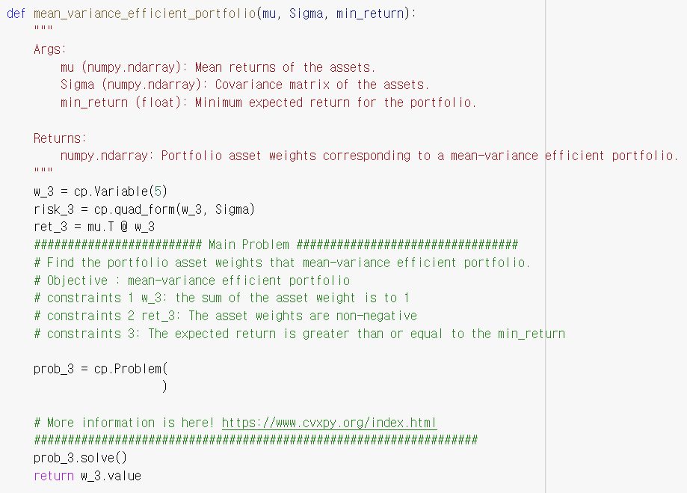

1. Obtain at least 5 different mean-variance efficient portfolios and plot them on the mean-standard deviation plane along with the minimum volatility portfolio and the maximum return portfolio. In specific, you need to draw four different figures and discuss the results.  
   a. Efficient portfolios calculated using historical mu and Sigma that are evaluated using historical mu and Sigma  
   b. Efficient portfolios calculated using historical mu and Sigma that are evaluated using actual future mu and Sigma  
   c. Efficient portfolios calculated using XGBoost predicted mu and Sigma that are evaluated using XGBoost predicted mu and Sigma  
   d. Efficient Portfolios calculated using XGBoost predicted mu and Sigma that are evaluated using actual future mu and Sigma
2. Quizzes (2 pts)
3. **Quiz 1:** Guess why we use shift(-1) in the following code.

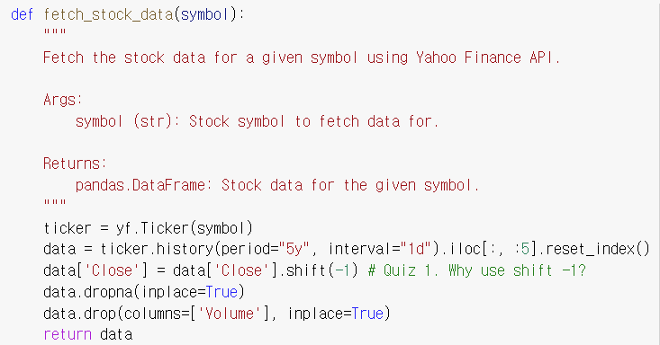

1. **Quiz 2-1: Explain why we should use cross validation.**
2. **Quiz 2-2: How can we cross validate a model for time series prediction task?**