**Exploratory Data Analysis**

**1️. Organization Overview:**

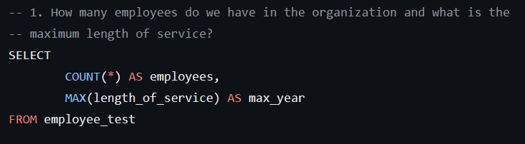……………………………………………………………………………..

Total Employees: 1470

Maximum Length of Service: 31

…………………………………………………………………………………

**2️. Departmental Breakdown:**

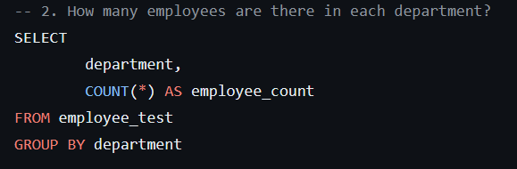

|  |  |
| --- | --- |
| **Department** | **Employees** |
| Sales & Marketing Employees | 446 |
| Operations Employees | 291 |
| Technology Employees | 198 |
| Procurement Employees | 183 |
| Analytics Employees | 153 |
| Finance Employees | 74 |
| Human Resource Employees | 66 |
| Legal Employees | 30 |
| R&D | 29 |

**3️. Gender** **Proportion**:

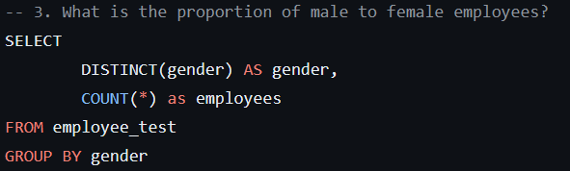

Male Employees: 1069 (73%) | Female Employees: 401 (27%)

**4️. Age Group Analysis:**

**Age Group with Highest and Lowest Employees**

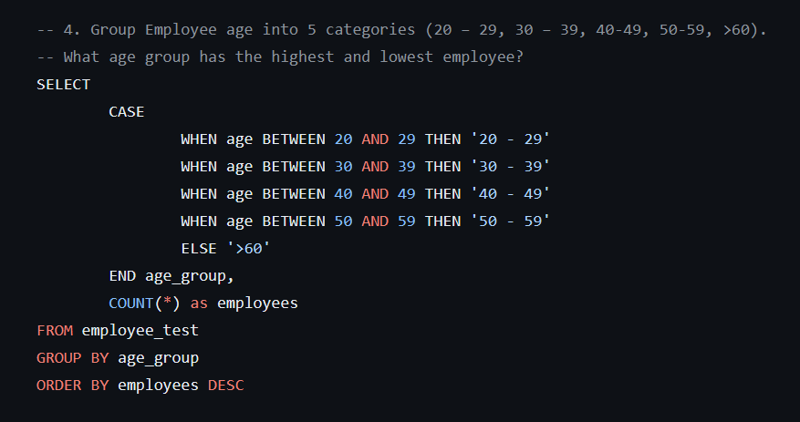

Highest Employee Age Group: 30-39

Lowest Employee Age Group: >60

**5️. Top Performers in Technology:**

Top 5 Performers in Technology

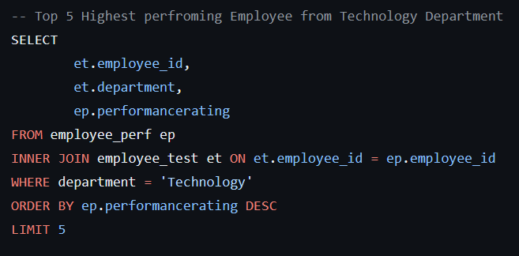

|  |  |
| --- | --- |
| **Employee_id** | **PerfromanceRating** |
| 19866 | 4 |
| 5677 | 4 |
| 66174 | 4 |
| 65450 | 4 |
| 19866 | 4 |

…………………………………………………………………………..

Top 5 Performers in Technology

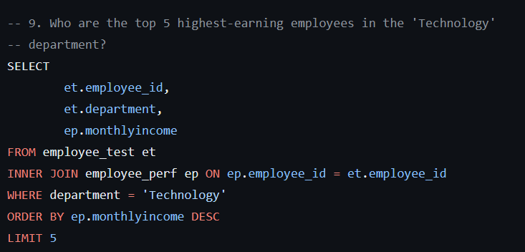

Top 5 Highest-Earning Employees in 'Technology':

|  |  |
| --- | --- |
| **Employee_id** | **Monthly Income** |
| 40814 | 19740 |
| 68267 | 19627 |
| 18640 | 19392 |
| 25879 | 19331 |
| 40814 | 19740 |

**6️. Training Excellence:**

Employee with the Highest Average Training Score:

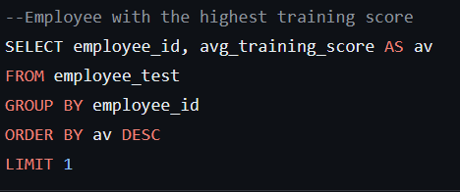

|  |  |
| --- | --- |
| **Employee_id** | **Highest Average Score** |
| 62212 | 97 |

**7️. Departure Hotspots:**

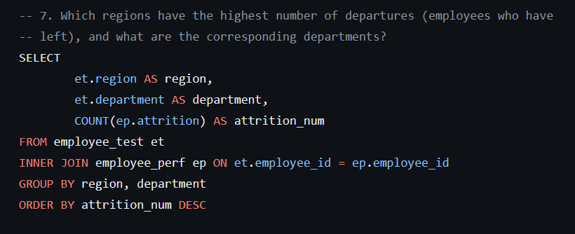

Regions 2 and 22 have the highest departures, mainly in Sales & Marketing and Operations.

**Tailored Data Analytics**

**1️. Training Excellence:**

Average Training Score by Department:

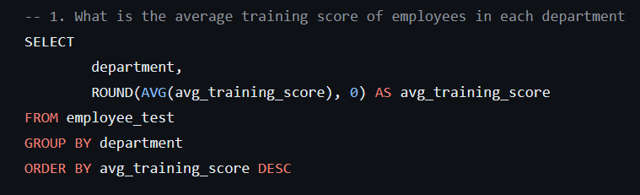

|  |  |
| --- | --- |
| **Department** | **avg_training_score** |
| Analytics | 85 |
| R&D | 85 |
| Technology | 80 |
| Procurement | 70 |
| Legal | 61 |
| Operations | 61 |
| Finance | 60 |
| HR | 50 |
| Sales & Marketing | 50 |

**2️. Previous Year Rating:**

Average Previous Year Rating by Department:

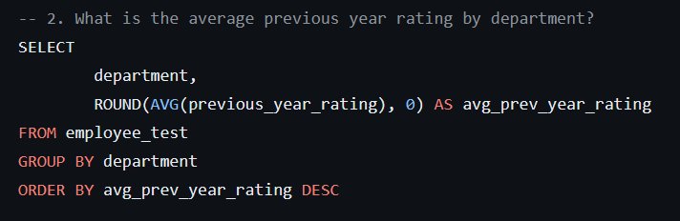

|  |  |
| --- | --- |
| **Department** | **avg_prev_year_rating** |
| Analytics | 4 |
| Operations | 4 |
| Finance | 4 |
| R&D | 4 |
| Sales & Marketing | 3 |
| Technology | 3 |
| HR | 3 |
| Legal | 3 |
| Procurement | 3 |

**3️. Education Impact:**

Average Training Score by Education Type:

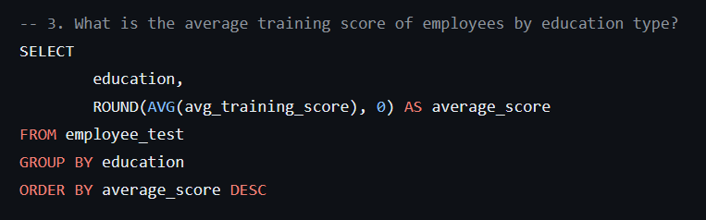

|  |  |
| --- | --- |
| **Education** | **average_training_score** |
| Below Secondary | 66 |
| Master's & above | 65 |
| Bachelor's | 63 |
| *null* | 58 |

**4️. Grade Breakdown:**

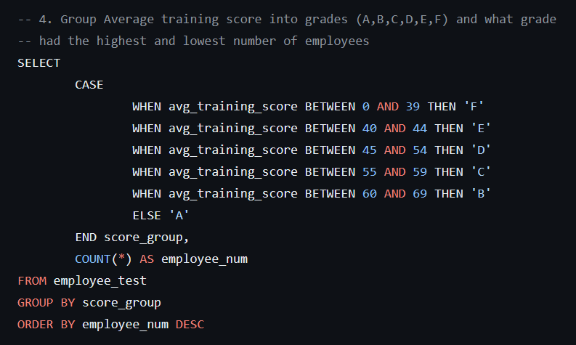

Grade with Highest Employee Count: A - 499

Grade with Lowest Employee Count: E – 15

**5️. Job Satisfaction Champions:**

Top 3 Departments with Highest Job Satisfaction for Bachelor's Degree holders:

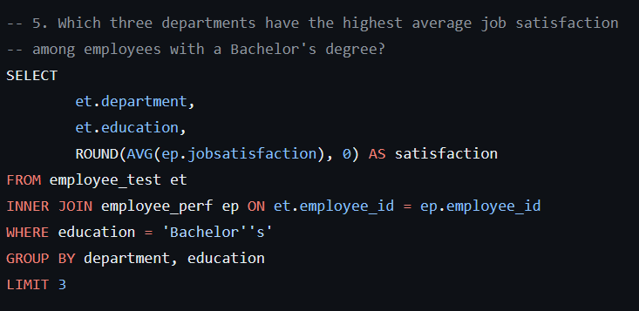

|  |  |
| --- | --- |
| **Department** | **Satisfaction** |
| R&D | 2 |
| Operations | 3 |
| Finance | 3 |

**6️. Recruitment Channel Influence:**

Average Previous Year Rating by Recruitment Channel:



|  |  |  |
| --- | --- | --- |
| **Recruitment channel** | | **Avg_previous_year_rating** |
| other | 3 | |
| Referred | 4 | |
| Sourcing | 3 | |

**7️. Gender-Rating Connection:**

Gender Split by Previous Year Rating:

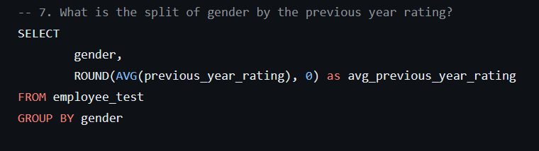

|  |  |
| --- | --- |
| **gender** | **avg_previous_year_rating** |
| m | 3 |
| F | 3 |

**8️. Age-Performance Correlation:**

Average Previous Year Rating and Training Score by Age Group

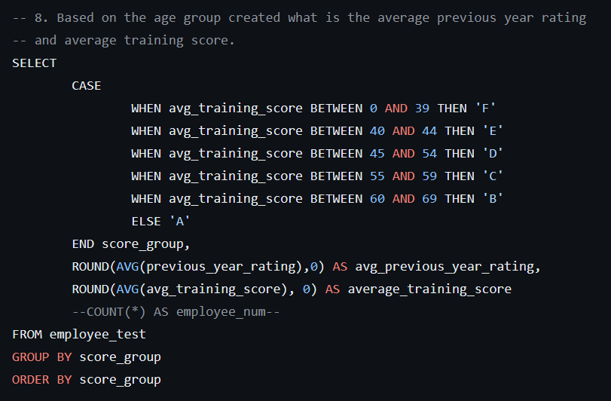

|  |  |  |
| --- | --- | --- |
| **Age group** | **avg_previous_year_rating** | **average_training_score** |
| 20 - 29 | 3 | 64 |
| 30 – 39 | 3 | 63 |
| 40 - 49 | 3 | 62 |
| 50 – 59 | 4 | 65 |
| >60 | 3 | 61 |

**9️. Demographic Statistics:**

Average Age of Male and Female Employees:

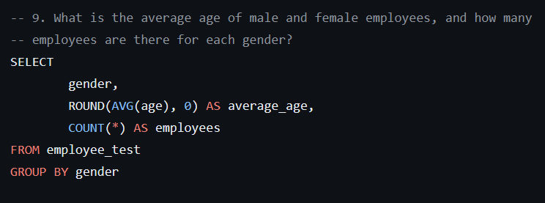

* Average age of male and female employees: 35 and 36, respectively.
* Male employees dominate with 1069 compared to 401 females.

Top Earners in Leadership:

Top 5 Highest-Earning Employees with JobLevel 3 or Higher:

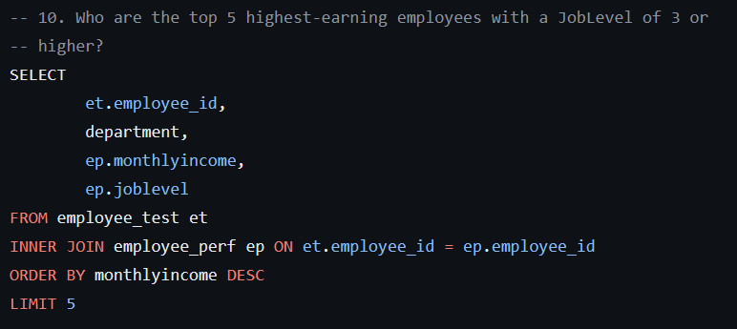

|  |  |  |  |
| --- | --- | --- | --- |
| **Employee_id** | **Department** | **Monthly Income** | **Job level** |
| 69413 | Sales & Marketing | 19999 | 5 |
| 54360 | Operations | 19973 | 5 |
| 31515 | Sales & Marketing | 19943 | 5 |
| 48813 | HR | 19926 | 5 |
| 61412 | Sales & Marketing | 19859 | 5 |