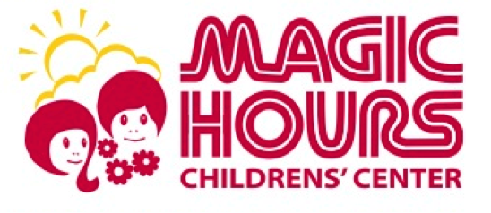

Health Condition/Attendance Exclusions

- Fever with behavior change or other signs of illness- oral temperature of 101 or greater, rectal temperature of 102 or greater, an axillary (armpit) temperature of 100 or greater.

- Symptoms or signs of possible severe illness- until medical evaluation allows inclusion. May include lethargy, uncontrollable coughing or wheezing, persistent crying, irritability or difficulty breathing.

- Uncontrollable diarrhea- (stool runs out of diaper or the child can not get to the toilet in time) until it is controlled or stopped.

- Vomiting- if your child vomits at school or home they may not return for 24 hours or until a health care provider determines that your child may return to the day care center and not be in danger of dehydration.

- Mouth sores with drooling-not until a health care provider determines that it is not from a communicable disease.

- Rash with fever or behavior changes- until a health care provider determines that your child may return to the day care center.

- Pink eye- (purulent conjunctivitis)- with a white or yellow discharge until 24 hours after treatment is started. (Viral conjunctivitis usually has a clear watery discharge and may not require medication or exclusion).

- Scabies, Head lice or other infestation- until 24 hours after treatment is started and in the case of head lice, the child is nit free.

- Tuberculosis (TB)- until treatment has begun, fever is gone and health care official states the child is non-infectious.

- Impetigo- until 24 hours after treatment has begun.

- Strep throat or other streptococcal infection- until 24 hours after antibiotic treatment has begun.

- Chicken pox- until 6 days after the onset of the rash or sooner if all sores have dried up and crusted over.

- Pertussis (whooping cough)- until 5 days after appropriate antibiotic treatment has begun.

- Mumps- until 9 days after onset of swelling.

- Hepatitis A- until 1 week after onset of illness and fever is gone, or as directed by a local health department official after immunoglobulin has been given to appropriate staff and children.
- Measles- until 6 days after onset of rash.

- Rubella- until 6 days after onset of rash.

- Shingles- until sores are crusted over or unless a health care provider determines that the child should otherwise be excluded.

- Herpetic gingivostomatitis- until sore crust over, or if the child does not have control of oral secretions, or as recommended by the child’s health care provider.

- Runny Nose – Thick yellow or green discharge is containable, and clears up, doctor has seen and allows child to return to school.

- Rash – Diaper rash should be treated. With other, a doctor determines the cause and gives child permission to return to school.

- Cough – Coughing subsides.

- Pale/Flushed skin – Color returns to what is normal for the child.

- Draining Sore – Until draining stops or scab begins to form.

- Biting – Biting is an unacceptable act of social behavior that we consider a health hazard. If a child has a biting problem, parents are expected to respect and cooperate with staff to prevent further occurrences and to protect the children involved. Parent may be required to remove the child from the center for the remainder of the day.

In the best interest of all of the children in our care, we have the right to refuse care for any child with any symptoms or signs of illness.

