Developer Guide

1. Basic Conceptual

There are 3 basic functions “initGait.m” , “divideGait.m” and “cycleCompare.m”. “initGait.m”： Read mvnx files into MATLAB and define the basic structure of gait object. “divideGait.m”：The core of dividing .

“CycleCompare.m” ：Plot the Joint Ankle Value of every cycle.

1. How we decide Initial Contact and Toe Off?

*Figure From B04-1-nor-wok-one.mvnx (Joints -> RightAnkle ->* ***JointAnkle****)*

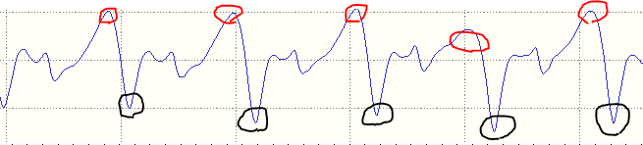

Red Circle： Left Initial Contact

Black Circle： Right Toe Off

1. Algorithm
   1. How to get Left Initial Contact? Below shows the pseudo code.

|  |
| --- |
| for i = [2:gait.frameLength]  if JointRightAngle(i) > ***maxRightAnkle***  if ( **(JointRightAngle(i) > JointRightAngle(i-1)) &&**  **(JointRightAngle(i) > JointRightAngle(i+1))** )  gait.LeftInitialContact = [ gait.LeftInitialContact i ]  end  end  end |

*Concept Visualization*

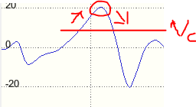

Assume that “Vc = maxRightAnkle”. When JointRightAnkle(Framei) > maxRightAnkle, starting to find the local peak.

* 1. How to decide Vc ?

|  |
| --- |
| % jointAngle(:,51) means “joint Angle of Right Angle”  JointRightAngle(:,1) = gait.jointAngle(:, 51)  % Unique then sort the value of JointRightAngle  u = sort(unique(JointRightAngle(:,1)))  % Then divide the data into ***X*** interval  intervalWidth = int32(length(u) / interval)  maxRightAnkle = median(u(end-intervalWidth:end)) |

Since the big numbers will categorize into last interval. We choose the median of last interval as Vc . **In other words, the interval value assigned by user is important**.