User Guide

1. Installation

* xml io toolbox sets into MATLAB Path
  + <http://www.mathworks.com/matlabcentral/fileexchange/12907-xmliotools>

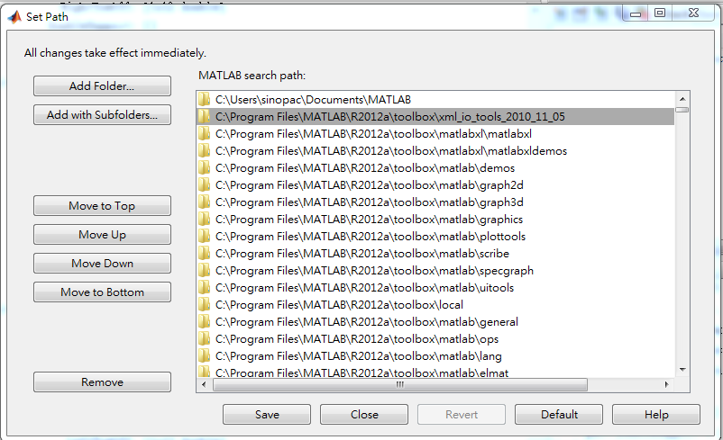

1. How to Use?

Sample Code to Run：

|  |
| --- |
| % initGait(‘filename’) to initialize the gait object  gait = initGait('..\Test Data\B04-1-nor-wok-one.mvnx')  % divideGait( gait, cycle, Rinterval, Linterval)  gait = divideGait(gait, 13, 5, 5)  % cycleCompare( gait, startCycle, endCycle, compareBy, sampleRate)  cycleCompare(gait, 3, 8, ‘R’, 120) |

Result may look like below：

|  |
| --- |
| gait =  sensorAcceleration: [3715x51 double]  jointAngle: [3715x66 double]  frameLength: 3714  LeftInitialContact: [1x14 double]  RightInitialContact: [1x13 double]  LeftToeOff: [1x13 double]  RightToeOff: [1x13 double] |

1. Deal with interval choosing

Here we are going to talk about how to choose a “better” interval value while we are dividing gait cycle. Interval setting will be different in different data set because the length of data or variation of data…etc. However, we still can use ***trial and error*** method to choose the best interval. The trial and error method is exhaustive, so here provide a better method to deal with interval choosing.

* Case 1 : decrease interval value
  + Assume that we know the total gait cycle is 13.
  + We choose “***Linterval = 5, Rinterval = 5***“
  + gait = divideGait(gait, 13, 5, 5)
  + Apply the above parameter to **B04-1-nor-wok-two.mvnx** and result is below

|  |
| --- |
| LeftInitialContact: [541 865 1024 1176 1322 1470 1617 …]  RightInitialContact: [1x14 double] |

* The length of LeftInitialContact is [1x12 double] which is smaller than gait cycle we expect. ( Where 12 < 13 )
* **In this case, it is suggested to decrease Rinterval value to get more data into LeftInitialContact.**
* Case 2: increase interval value
  + Again, assume that we know the total gait cycle is 13.
  + Now, We choose “***Linterval = 5, Rinterval = 2***“
  + gait = divideGait(gait, 13, 2, 5)
  + Apply the above parameter to **B04-1-nor-wok-two.mvnx** and result is below

|  |
| --- |
| LeftInitialContact: [1x20 double]  RightInitialContact: [1x14 double] |

* The length of LeftInitialContact is [1x20 double] which is bigger than gait cycle we expect. ( Where 20 > 13 )
* **In this case, it is suggested to increase Rinterval value to reduce data from LeftInitialContact.**