Developer Guide

1. Basic Conceptual

There are 3 basic functions “initGait.m” , “divideGait.m” and “cycleCompare.m”. “initGait.m”： Read mvnx files into MATLAB and define the basic structure of gait object. “divideGait.m”：The core of dividing .

“CycleCompare.m” ：Plot the Joint Ankle Value of every cycle.

1. Data preprocessing
   1. Find the actual gait cycle starting frame (nearly). Then drop the data before gait cycle starting frame.

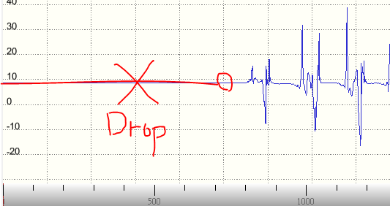

|  |
| --- |
| for i = [2:gait.frameLength]  **if (abs(LeftFootZ(i) - LeftFootZ(i-1)) > 3)**  LeftStart = i  break  end  end |

We guess the Z variance are not higher than 3 while standing.

* 1. %3th order lowpass 20Hz Filter

|  |
| --- |
| % 3th order lowpass 20Hz (Sample Rate: 120Hz)  [B,A]= butter(3, 20/60, 'low')  LeftFootZ(:,1) = filtfilt(B, A, LeftFootZ(:, 1))  RightFootZ(:,1) = filtfilt(B, A, RightFootZ(:, 1)) |

1. How we decide Initial Contact and Toe Off?

*Figure From B04-1-nor-wok-three.mvnx (Segements -> LeftFoot -> Sensor Data->****Acceleration****)*

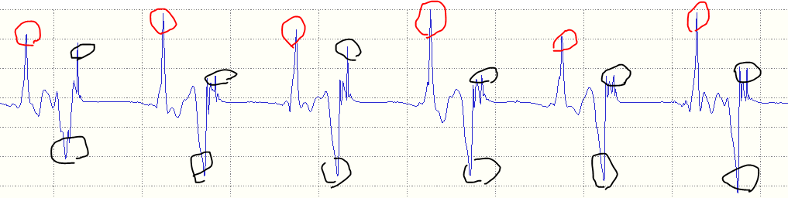

Red Circle： Toe Off

Black Circle： Initial Contact

The black circles close another will be chose one only.

1. Algorithm
   1. How to get Left Initial Contact? Below shows the pseudo code.

|  |
| --- |
| for i = [2:ActualFrameLength]  if LeftFootZ(i) < medianLeftFootZ_First  if (LeftFootZ(i) < LeftFootZ(i-1) && LeftFootZ(i) < LeftFootZ(i+1))  gait.LeftInitialContact = [gait.LeftInitialContact i+Start]  end  end  end |

*Concept Visualization*

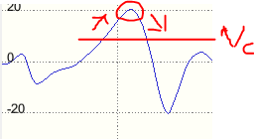

Assume that “Vc = medianLeftFootZ_First”. When LeftFootZ (Framei) > Vc, start to find the local peak.

* 1. How to decide Vc ?

|  |
| --- |
| u = sort(unique(LeftFootZ(:,1)))  intervalWidth = int32(length(u) / Linterval)  medianLeftFootZ_Last = median(u(end-intervalWidth+1:end))  medianLeftFootZ_First = median(u(1:intervalWidth)) |

Since the big numbers will categorize into last interval. We choose the median of last interval as Vc . **In other words, the interval value assigned by user is important**.

* 1. Initial Contact Validation By Toe Off

There are two possible peaks of Initial Contact (Black Circles) close to the Toe Off of opposite foot (red circle) and the nearest one will be drop.

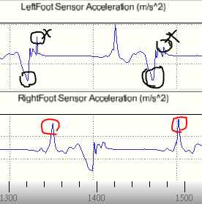

|  |
| --- |
| for i = [1:length(gait.LeftToeOff)]  for j = [1:length(gait.LeftInitialContact)]  **if (abs(gait.LeftToeOff(i) - gait.LeftInitialContact(j)) <= 20)**  DropLeft = [ DropLeft gait.LeftToeOff(i)]  end  end  end |