WEEK 4 TASK
Comprehensive Data Science Project Report
and Recommendations
Virtual Data Science with Python Apprentice Internship

Project | Details
Project | Income Classification Using Machine Learning
Dataset | UCI Adult Income Dataset
Task | Binary Classification
Target | Annual income >$50K vs. <=$50K
Methods | Data Cleaning, EDA, Statistical Testing, Feature Engineering, ML
Candidate Models | Logistic Regression and Random Forest

Final report prepared from the Week 3 model-development framework

1. Executive Summary
This report consolidates the data science workflow developed in Week 3 into a stakeholder-oriented project report. The project uses the UCI Adult dataset to study whether an individual's annual income falls above or below the $50,000 threshold. The dataset contains 48,842 records and 14 predictive features and is explicitly described by the UCI Machine Learning Repository as a classification problem with missing values. citeturn0search0
The proposed workflow combines data quality assessment, missing-value handling, exploratory data analysis, statistical testing, feature engineering, Logistic Regression and Random Forest model development, stratified cross-validation, and multi-metric evaluation. The analysis is designed to communicate technical evidence in terms that both technical and management audiences can understand.
A key communication point is that Week 3 specified the model-development and evaluation framework but did not produce a recorded experiment log containing the user's own final metrics. Accordingly, this report does not invent project-specific model scores. Where external benchmark values are shown, they are explicitly identified as reference results rather than reproduced project results.

2. Business and Analytical Context
Income classification is a useful teaching problem because it combines numerical and categorical data, missing values, class imbalance, nonlinear relationships, and fairness considerations. From a management perspective, the value of the project is not simply a high accuracy number. The project demonstrates how structured data can be converted into evidence while making uncertainty, assumptions, and model limitations visible.
- Stakeholder question: Which measurable characteristics are associated with the income class in this historical dataset?
- Analytics question: Can a supervised classifier distinguish the two income categories on unseen records?
- Engineering question: Can preprocessing and model evaluation be implemented without data leakage?
- Communication question: How can model outputs be translated into clear findings without overstating causality?

3. Dataset and Data Understanding
The UCI Adult dataset was created from 1994 U.S. Census-related data and contains 48,842 instances and 14 features. It includes categorical and integer variables and has documented missing values. The prediction target is whether annual income exceeds $50,000. citeturn0search0turn0search4
Data Area | Examples | Analytical Role
Demographic | age, sex, race | Contextual predictors and fairness-audit dimensions
Education | education, education-num | Human-capital-related predictors
Employment | workclass, occupation, hours-per-week | Employment characteristics
Family | marital-status, relationship | Household/context features
Financial | capital-gain, capital-loss | Financial activity indicators
Geography | native-country | Categorical contextual feature
Target | income | Binary classification label

4. Methodology
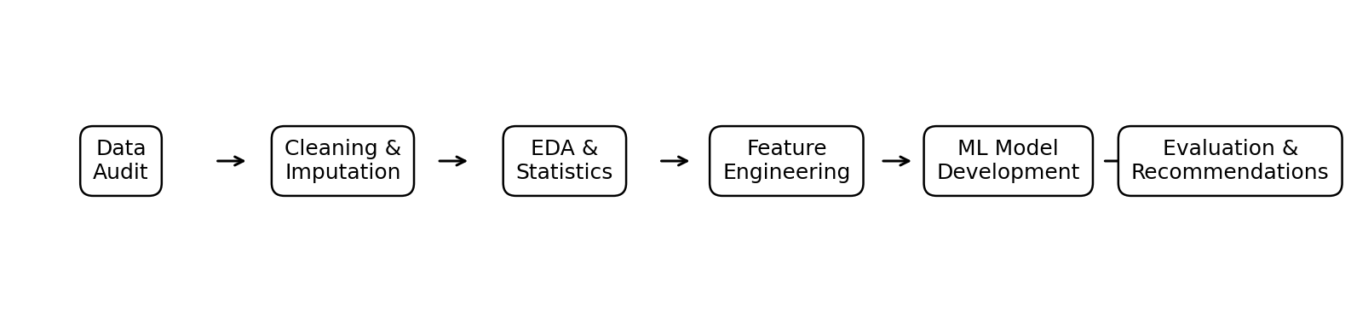
Figure 1. End-to-end project workflow.

4.1 Data Cleaning
- Load the public dataset and standardize column names and string formatting.
- Convert dataset-specific missing markers such as '?' into explicit missing values.
- Check data types, duplicate records, invalid ranges, unique values, and target labels.
- Impute numerical missing values using the median and categorical missing values using an explicit Unknown category or most-frequent value.
- Keep preprocessing within a scikit-learn Pipeline so transformations are learned only from training data.

4.2 Exploratory Data Analysis
EDA is used to understand distributions, class balance, relationships, and possible data-quality problems before model training. The visual design prioritizes simple charts that answer one question at a time.
- Bar chart for target distribution to identify class imbalance.
- Histograms/boxplots for age, hours-per-week, capital-gain, and capital-loss.
- Grouped bar charts for income class by education, occupation, and workclass.
- Correlation analysis for numerical variables, used cautiously because categorical variables require different treatment.
- Missing-value summary to identify fields requiring preprocessing.
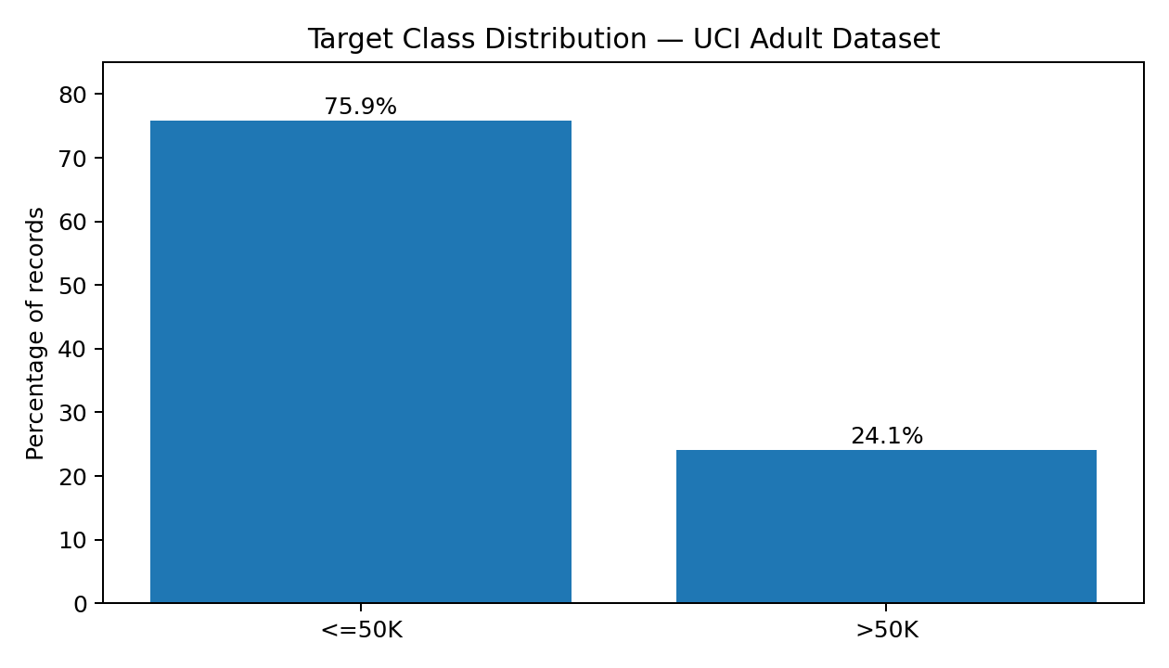
Figure 2. Approximate target-class distribution reported for the UCI Adult dataset.
Interpretation: the lower-income class is substantially larger than the >$50K class. This makes class-aware evaluation important because a model can achieve a superficially strong accuracy by favoring the majority class. The percentages shown are rounded reference values; the exact proportions should be recalculated from the actual project data file before presenting them as final experimental results.

4.3 Statistical Testing
Statistical testing is used to complement visual analysis rather than replace it. The following tests are appropriate for the project:
Question | Test | Interpretation
Is income class associated with a categorical feature? | Chi-square test of independence | Tests whether observed category counts differ from independence expectations.
Do numerical distributions differ between income classes? | Mann–Whitney U or t-test after assumption checks | Tests for distribution/location differences between two groups.
Are numerical predictors strongly related? | Pearson or Spearman correlation | Helps identify redundancy and nonlinear monotonic relationships.

Statistical significance should be reported with effect size and confidence intervals where possible. A small p-value does not by itself demonstrate a practically important relationship, particularly in a dataset with tens of thousands of observations.

4.4 Feature Engineering
- Age bands to represent potential nonlinear life-stage effects.
- Hours-per-week groups to distinguish lower, standard, and high work intensity.
- Binary indicators for whether capital-gain or capital-loss is present.
- Rare-category grouping for high-cardinality categorical variables when justified.
- Review of education and education-num for redundancy before deciding which representation to retain.

4.5 Machine Learning Development
Two models were specified for comparison. Logistic Regression provides an interpretable linear baseline and probability estimates. Random Forest provides a nonlinear ensemble capable of learning interactions without manually specifying every interaction term.
Dimension | Logistic Regression | Random Forest
Interpretability | High | Moderate
Nonlinear patterns | Limited | Strong
Scaling | Required for numeric features | Generally not required
Interactions | Need feature engineering | Learned automatically
Main limitation | May underfit complex relationships | More complex to explain and tune

5. Results and Evidence
The following results are separated into (a) dataset-level evidence and (b) external reference benchmarks. This distinction prevents external numbers from being presented as if they were measured during the user's own run.

5.1 Dataset-Level Findings
- The dataset is a mixed-type classification problem containing categorical and integer features. The UCI repository documents 48,842 instances and 14 features.
- Missing values are documented in variables including workclass, occupation, and native-country.
- The target is binary and is defined as >50K versus <=50K.
- The dataset is historically sourced from 1994 Census-related information, so conclusions should not be interpreted as current population estimates.

5.2 External Reference Benchmark
A publicly available implementation reports benchmark accuracies for several algorithms on the Adult dataset. Those figures are shown here only as contextual reference and were not reproduced as part of this internship run. The source reports 79.86% for RBF SVM, 81.81% for linear SVM, 85.18% for a decision tree, 87.01% for Random Forest, and 89.74% for bagging with decision trees.
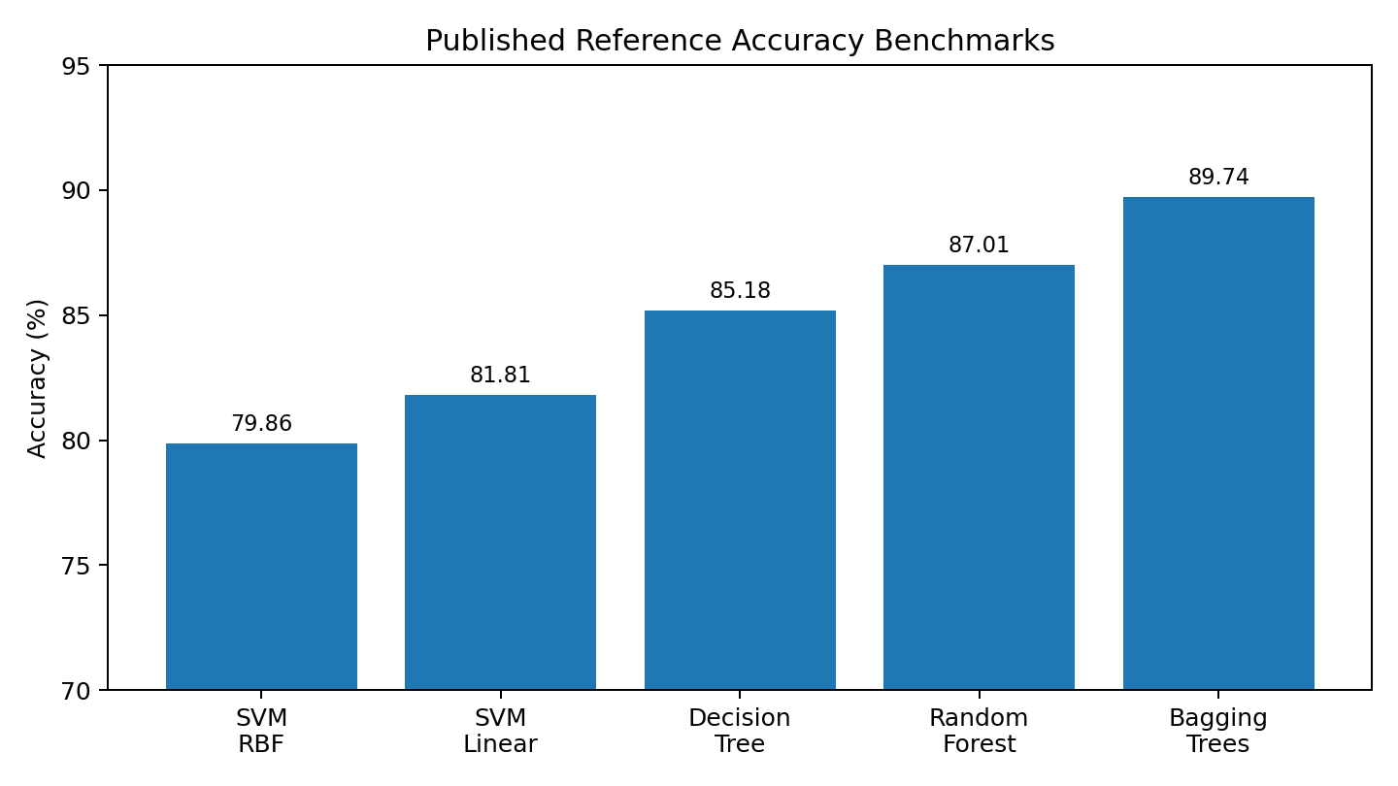
Figure 3. External reference benchmark accuracies — not the user's measured results.

5.3 Model Evaluation Framework
Metric | Why It Matters | Management Interpretation
Accuracy | Overall correctness | Useful summary, but can hide class imbalance.
Precision | Reliability of positive predictions | How often predicted high-income cases are correct.
Recall | Coverage of actual positive cases | How many high-income cases the model identifies.
F1-score | Balances precision and recall | Single measure when both error types matter.
ROC-AUC | Threshold-independent discrimination | How well the model separates the two classes across thresholds.
Confusion matrix | Shows TP/TN/FP/FN | Makes model mistakes easy to explain.
PR-AUC | Focuses on positive-class retrieval | Useful when the positive class is less common.

6. Discussion
The project demonstrates that model development should be treated as a pipeline rather than a single algorithm choice. Data quality, class balance, feature representation, validation design, and metric selection can all change the apparent performance of a model.
For a non-technical audience, the most important message is that an accuracy figure does not tell the complete story. A model can be accurate overall while still missing a meaningful proportion of the positive class. Therefore, management reporting should present accuracy together with precision, recall, F1-score, ROC-AUC, and the confusion matrix.

7. Strategic Recommendations
- Use a leakage-safe preprocessing pipeline. Every imputation, encoding, scaling, and feature-selection step should be fitted only on training data.
- Compare an interpretable baseline with a nonlinear model. This makes the performance-versus-complexity trade-off visible to stakeholders.
- Do not use accuracy as the only decision metric. Report class-aware metrics and explain false positives and false negatives.
- Keep the held-out test set untouched until model selection is complete. This protects the credibility of the final estimate.
- Use probability thresholds deliberately. If the operational cost of false positives and false negatives differs, threshold selection should reflect that cost rather than automatically using 0.50.
- Audit subgroup performance before any real-world use. Demographic variables can create unequal error patterns and should be examined explicitly.
- Treat the historical dataset as a learning resource, not as a current socioeconomic forecast. The source reflects historical data from the 1990s.
- For a production system, retrain and validate against current, legally appropriate data before making operational decisions.

8. Limitations
- The data are historical and may not represent present-day labor markets or income patterns.
- The target threshold is a classification label, not a complete measure of financial well-being.
- The dataset contains demographic attributes that can act as sensitive variables or proxies.
- External benchmark scores come from a separate implementation and should not be interpreted as the user's experimental results.
- Statistical significance can be exaggerated by large sample size; practical effect size is also required.
- Model predictions show association and predictive patterns, not causal effects.

9. Future Work
- Execute the complete pipeline and record the actual cross-validation and held-out test metrics.
- Generate a final confusion matrix, ROC curve, precision-recall curve, and feature-importance/coefficients plot from the executed models.
- Perform threshold optimization based on a clearly defined cost matrix.
- Add calibration analysis to determine whether predicted probabilities correspond well to observed frequencies.
- Conduct systematic subgroup fairness analysis and document the results.
- Compare additional models such as Gradient Boosting or HistGradientBoosting under the same validation protocol.
- Package the final pipeline for reproducible inference and document the environment and model version.

10. Stakeholder Communication Guide
Technical Finding | Plain-Language Explanation
Class imbalance | The dataset contains many more lower-income examples than higher-income examples, so overall accuracy alone can be misleading.
Cross-validation | The model is tested repeatedly on different training/validation portions to check whether results are stable.
Precision | When the model says an example belongs to the higher-income group, this measures how often that prediction is correct.
Recall | This measures how many of the actual higher-income examples the model successfully identifies.
ROC-AUC | This summarizes how well the model separates the two groups over many possible decision thresholds.
Data leakage | Information from the answer set accidentally influences training, making performance look better than it really is.

11. Final Conclusion
The project provides an end-to-end example of how a data science problem can move from raw public data to actionable communication. The UCI Adult dataset offers a realistic combination of categorical variables, missing values, class imbalance, and demographic considerations. The Week 3 framework provides a sound basis for preprocessing, feature engineering, model comparison, cross-validation, and evaluation.
The strongest professional practice demonstrated by this report is transparent evidence handling: documented dataset facts and external benchmarks are distinguished from measurements that still require an actual model run. Once the pipeline is executed, the reference sections can be replaced with the project's own metrics, plots, statistical-test outputs, and error analysis without changing the overall report structure.

12. References
- UCI Machine Learning Repository — Adult Dataset. Becker, B. & Kohavi, R. https://archive.ics.uci.edu/dataset/2/adult
- UCI Machine Learning Repository — Adult Dataset metadata and variables. https://uci-ics-mlr-prod.aws.uci.edu/dataset/2/adult
- Shrsh, UCI Adult Data Set — publicly available Random Forest benchmark implementation. https://github.com/Shrsh/UCI--Adult-Data-Set
- Pedregosa, F. et al. (2011). Scikit-learn: Machine Learning in Python. Journal of Machine Learning Research, 12, 2825–2830.

