WEEK 1 TASK
DATA EXPLORATION AND VISUALIZATION STRATEGY
Professional EDA Project Proposal
Theme: Global Health & Development — Exploring the Relationship Between Development Indicators and Population Health

Project Stage | Planning / Strategy before coding
Estimated Effort | 30–35 hours
Primary Tools | Python, pandas, NumPy, Matplotlib, Seaborn, Jupyter Notebook
Primary Sources | World Bank World Development Indicators; WHO Global Health Observatory
Expected Output | Clean analytical dataset, EDA notebook, visualizations, findings report/dashboard concept

Prepared as a structured project plan to guide a real exploratory data analysis workflow.

1. Executive Summary
This proposal defines a complete exploratory data analysis (EDA) strategy for examining how economic and demographic development indicators relate to population-health outcomes across countries and years. The project will combine publicly available World Bank World Development Indicators (WDI) with selected World Health Organization (WHO) Global Health Observatory (GHO) indicators. The analysis will focus on data quality, distributions, country and regional differences, temporal trends, relationships between variables, and careful interpretation of correlations.
The planning-first approach is intentional: before writing analytical code, the project identifies the questions, data sources, data model, cleaning rules, quality checks, statistical exploration methods, visualization designs, timeline, risks, and expected deliverables. This reduces rework and creates a reproducible path from raw public data to defensible insights.

1.1 Proposed project title
Global Health & Development EDA: Exploring Development Indicators and Population Health Outcomes

1.2 Core objective
To systematically explore whether and how development-related measures such as GDP per capita, population, access to services, and other socioeconomic indicators are associated with health outcomes such as life expectancy, healthy life expectancy, and mortality-related indicators across countries and over time.

2. Project Objectives
- Identify and document at least two reliable, publicly available datasets suitable for cross-country EDA.
- Acquire the data in reproducible formats or through documented APIs and preserve source metadata.
- Assess completeness, consistency, validity, duplication, data types, units, and outliers before analysis.
- Create a standardized country-year analytical structure so indicators can be compared consistently.
- Explore distributions, trends, regional patterns, rankings, and relationships among selected variables.
- Design clear visualizations that communicate patterns without overstating causality.
- Document assumptions, limitations, quality issues, and expected analytical challenges.
- Produce a professional project roadmap that can be directly converted into a Python/Jupyter implementation.

3. Scope and Analytical Boundaries
Included | Excluded / Deferred
Country-level and regional comparisons | Individual patient-level or clinical records
Year-over-year and long-term trends | Clinical diagnosis or treatment recommendations
Descriptive statistics and exploratory correlations | Causal inference and experimental conclusions
Selected development + health indicators | Predictive modeling as the main objective
Public aggregate data | Personally identifiable information
Python-based reproducible analysis | Production deployment in Week 1

The project is descriptive and exploratory. A strong correlation will be treated as a relationship worth investigating, not as proof that one variable causes another. Confounding factors, measurement differences, missing data, and estimation methods will be explicitly considered.

4. Public Data Sources

4.1 Dataset A — World Bank World Development Indicators
The World Bank WDI is the primary economic/development source. The World Bank describes WDI as a collection of development indicators compiled from officially recognized international sources, with national, regional, and global estimates. Its Indicators API provides programmatic access to nearly 16,000 time-series indicators, and API authentication is not required.
Planned indicator | Example code / type | Purpose
GDP (current US$) | NY.GDP.MKTP.CD | Overall economic scale
GDP per capita (current US$) | NY.GDP.PCAP.CD | Country-size-adjusted economic measure
Population, total | SP.POP.TOTL | Population context and visualization sizing
Life expectancy, total | SP.DYN.LE00.IN | Potential bridge/comparison with health source
Urban population (%) | SP.URB.TOTL.IN.ZS | Urbanization context
Other selected WDI indicator | To be finalized after profiling | Adds a meaningful socioeconomic dimension

Selection rule: use indicators with clear definitions, suitable country coverage, consistent units, and enough observations for the intended time window.
Official documentation: https://datahelpdesk.worldbank.org/knowledgebase/articles/889392
Indicator API documentation: https://datahelpdesk.worldbank.org/knowledgebase/articles/898599

4.2 Dataset B — WHO Global Health Observatory / Global Health Estimates
The WHO Global Health Observatory (GHO) will supply health-focused indicators. WHO states that its Global Health Estimates provide comparable time-series information on mortality, morbidity, life expectancy, healthy life expectancy, and burden of disease at global, regional, and country levels. The latest Global Health Estimates cover trends from 2000 through 2021.
Planned indicator | Unit | Purpose
Life expectancy at birth | Years | Primary health outcome
Healthy life expectancy (HALE) | Years | Health-adjusted longevity perspective
Adult mortality rate | Probability/rate | Mortality context
Selected cause-specific indicator | Depends on indicator | Optional deeper health pattern
Sex-disaggregated value where appropriate | Indicator-specific | Optional subgroup exploration

WHO notes that life expectancy is derived from life tables based on sex- and age-specific death rates. WHO also cautions that estimates may differ from nationally produced statistics because standardized methods and modelling are used. This will be recorded as a limitation rather than silently treating all values as directly observed measurements.
Official WHO life expectancy indicator: https://www.who.int/data/gho/data/indicators/indicator-details/GHO/life-expectancy
WHO Global Health Estimates: https://www.who.int/data/global-health-estimates
WHO data indicators: https://data.who.int/indicators

4.3 Why these datasets were chosen
Criterion | World Bank WDI | WHO GHO/GHE | Combined value
Relevance | Economic/development context | Health outcomes | Supports meaningful cross-domain EDA
Public accessibility | Open API/data portal | Public data portal/API/downloads | Reproducible acquisition
Time-series depth | Many indicators span decades | Core GHE trends cover 2000–2021 | Suitable for trend analysis
Geographic coverage | Global country/region coverage | Global country/region coverage | Country-year comparisons
Data documentation | Indicator metadata and API docs | Indicator definitions and methods | Traceable definitions
Analytical richness | Many socioeconomic variables | Health/mortality variables | Multiple EDA dimensions

5. Proposed Data Structure and Data Dictionary
The target analytical unit will be one country-year observation wherever the selected indicators support that structure. The preferred long-term structure is a tidy dataset with country code, country name, year, region/income metadata, indicator names, and numeric values. A wide analytical table can then be produced for correlation and visualization tasks.
Field | Type | Example | Validation rule
country_code | String | IND | Standardized code; non-null
country_name | String | India | Consistent spelling/name mapping
year | Integer | 2021 | Valid year within selected period
region | Categorical | South Asia | Controlled category list
income_group | Categorical | Lower middle income | Controlled category list where available
indicator | String | Life expectancy | Mapped to source metadata
value | Float | 67.2 | Numeric; valid unit/range
unit | String | Years | Must match metadata
source | String | WHO | Controlled source label

6. End-to-End EDA Workflow
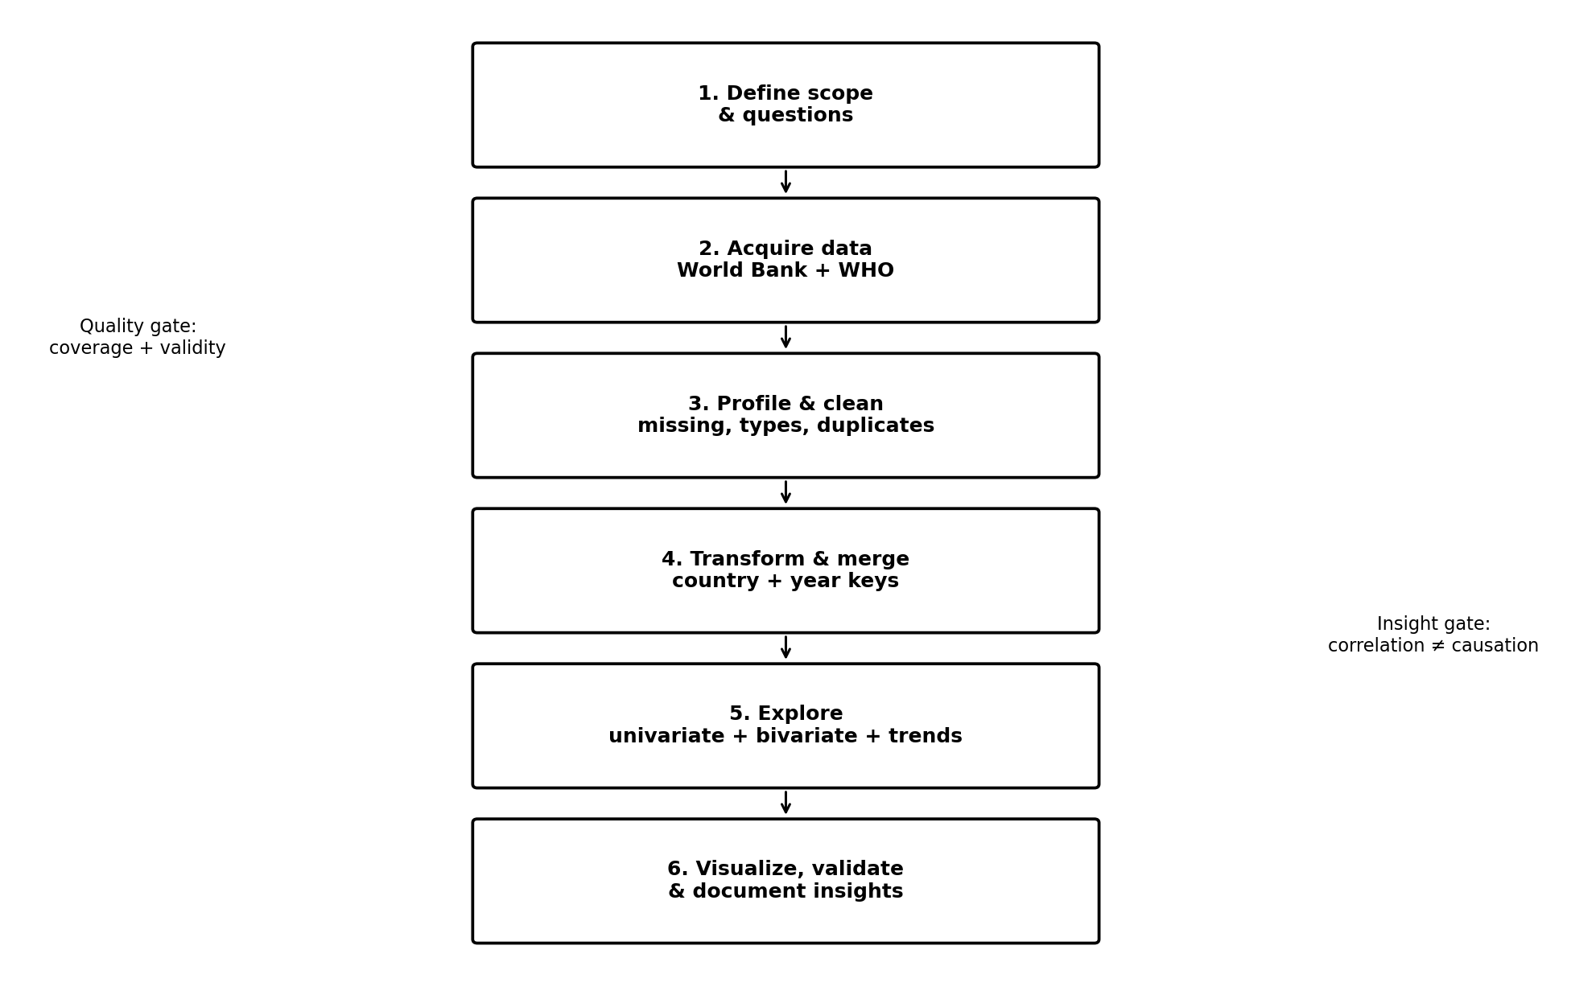
Figure 1. Planned workflow from project definition to validated visual communication.

6.1 Step 1 — Define analytical questions
- Translate the business/research objective into measurable questions and variables.
- Freeze the initial time period and country coverage after checking actual source availability.
- Define the unit of analysis: country-year, with subgroup dimensions retained only when analytically justified.

6.2 Step 2 — Acquire and preserve raw data
- Download/export source data or query official APIs.
- Save raw files unchanged in a raw_data folder.
- Record source URL, retrieval date, indicator codes, units, filters, and version/release information.
- Do not edit the raw files manually; perform transformations in Python.

6.3 Step 3 — Data profiling
- Inspect shape, columns, data types, unique countries, years, missingness, duplicates, and value ranges.
- Check whether country identifiers and names are consistent across sources.
- Calculate missing-value percentages by variable, country, and year.
- Create a data-quality summary before making cleaning decisions.

6.4 Step 4 — Cleaning
- Normalize column names to snake_case.
- Convert year to integer and measurement fields to numeric.
- Remove exact duplicate records after identifying the correct uniqueness key.
- Standardize country codes/names using an explicit mapping table rather than fuzzy replacement.
- Treat missing values according to indicator meaning; never replace missing observations with zero unless zero is semantically valid.
- Investigate impossible or suspicious values using source metadata before removing them.
- Retain a log of every transformation.

6.5 Step 5 — Transformation and integration
- Select a common time window supported by the chosen indicators.
- Reshape data into tidy long format and, where useful, pivot selected indicators to a wide analytical table.
- Merge datasets using stable country code + year keys where possible.
- Track unmatched countries/years and quantify the percentage lost during merging.
- Create derived fields such as GDP per capita growth, life-expectancy change, and percentage change only when mathematically and conceptually valid.

6.6 Step 6 — Exploratory analysis
- Univariate analysis: count, mean, median, standard deviation, quartiles, minimum, maximum, skewness.
- Distribution analysis: histograms, density plots, box plots, and log-scaled views for highly skewed economic measures.
- Bivariate analysis: scatter plots, grouped comparisons, rank comparisons, and correlation matrices.
- Time-series analysis: annual trends, rolling summaries where appropriate, and before/after period comparisons.
- Group analysis: region, income group, and selected country comparisons.
- Outlier analysis: IQR/z-score as screening tools followed by source/context verification.

6.7 Step 7 — Visualization and communication
- Build a small set of purposeful visualizations rather than maximizing chart count.
- Use consistent titles, units, labels, annotations, and source notes.
- Choose chart types based on analytical questions: line for trends, scatter for relationships, box plot for distributions, heatmap for correlation, map for geographic patterns.
- Avoid decorative effects that reduce readability.

6.8 Step 8 — Validation and documentation
- Recheck key aggregates against source data.
- Verify that transformations did not unexpectedly change record counts.
- Document missingness, limitations, assumptions, and possible biases.
- Write insights using evidence from the data and clearly distinguish descriptive findings from causal claims.

7. Detailed Data Cleaning and Transformation Strategy
Issue | Detection | Planned treatment | Reason
Missing values | isna(), coverage tables | Keep, exclude per analysis, or cautiously impute only if justified | Avoid introducing artificial information
Duplicates | Duplicate key checks | Remove only confirmed duplicate records | Preserve legitimate repeated observations
Wrong data types | dtypes / parsing errors | Convert to numeric/date/category types | Enable valid analysis
Inconsistent country names | Unique-value comparison | Use ISO-style code mapping | Reliable cross-source merge
Outliers | IQR, percentile, scatter plots | Investigate against source metadata; retain valid extremes | Extreme ≠ erroneous
Unit mismatch | Metadata comparison | Standardize units before comparison | Prevent false relationships
Unequal year coverage | Country-year coverage matrix | Use common window or indicator-specific analysis | Avoid misleading comparisons
Skewed GDP values | Histogram/quantiles | Use log axis or log-transformed analysis where appropriate | Improve visual interpretability
Modelled estimates | Source methodology | Flag and describe as estimates | Correct interpretation

7.1 Quality gates
- Gate 1: Every selected indicator has a documented definition and unit.
- Gate 2: Every merge key is validated before joining.
- Gate 3: Missingness is quantified before any imputation or row removal.
- Gate 4: Extreme values are investigated rather than automatically deleted.
- Gate 5: Final row counts and summary statistics are compared with the raw/official source.
- Gate 6: Every major chart contains a clear metric, unit, time period, and source note.

8. Key Questions the EDA Will Answer
1. How has life expectancy changed across countries and regions over the selected time period?
2. How does life expectancy differ between income groups and geographic regions?
3. Is higher GDP per capita associated with higher life expectancy in the exploratory data?
4. Does the relationship between economic development and life expectancy appear linear, nonlinear, or strongly influenced by outliers?
5. Which countries show the largest absolute or percentage changes in life expectancy over the selected period?
6. How do healthy life expectancy and overall life expectancy compare across countries?
7. Which indicators have the strongest pairwise correlations with selected health outcomes?
8. How much of the observed pattern is affected by missing data and unequal country-year coverage?
9. Do trends change noticeably around major global periods such as the COVID-19 years, while avoiding unsupported causal claims?
10. Which observations require additional investigation because they are extreme, incomplete, or methodologically different?

9. Planned EDA Methodologies
EDA layer | Methods | Expected output
Dataset profiling | shape, dtypes, unique counts, missingness | Data-quality report
Univariate | mean, median, quartiles, histograms, box plots | Distribution understanding
Bivariate | scatter, grouped box plots, correlations | Variable relationships
Time series | line charts, change calculations | Trend patterns
Categorical/group | region/income summaries | Group differences
Outlier screening | IQR, quantiles, contextual checks | Anomaly list for review
Correlation | Pearson/Spearman as appropriate | Relationship matrix
Sensitivity checks | compare raw vs log-scale / subsets | Robustness awareness

10. Visualization Strategy
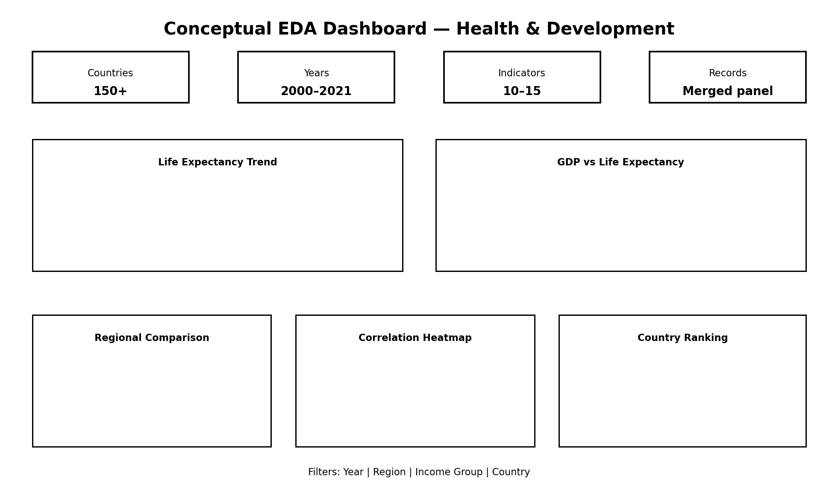
Figure 2. Dashboard-style conceptual wireframe for the final visual story.
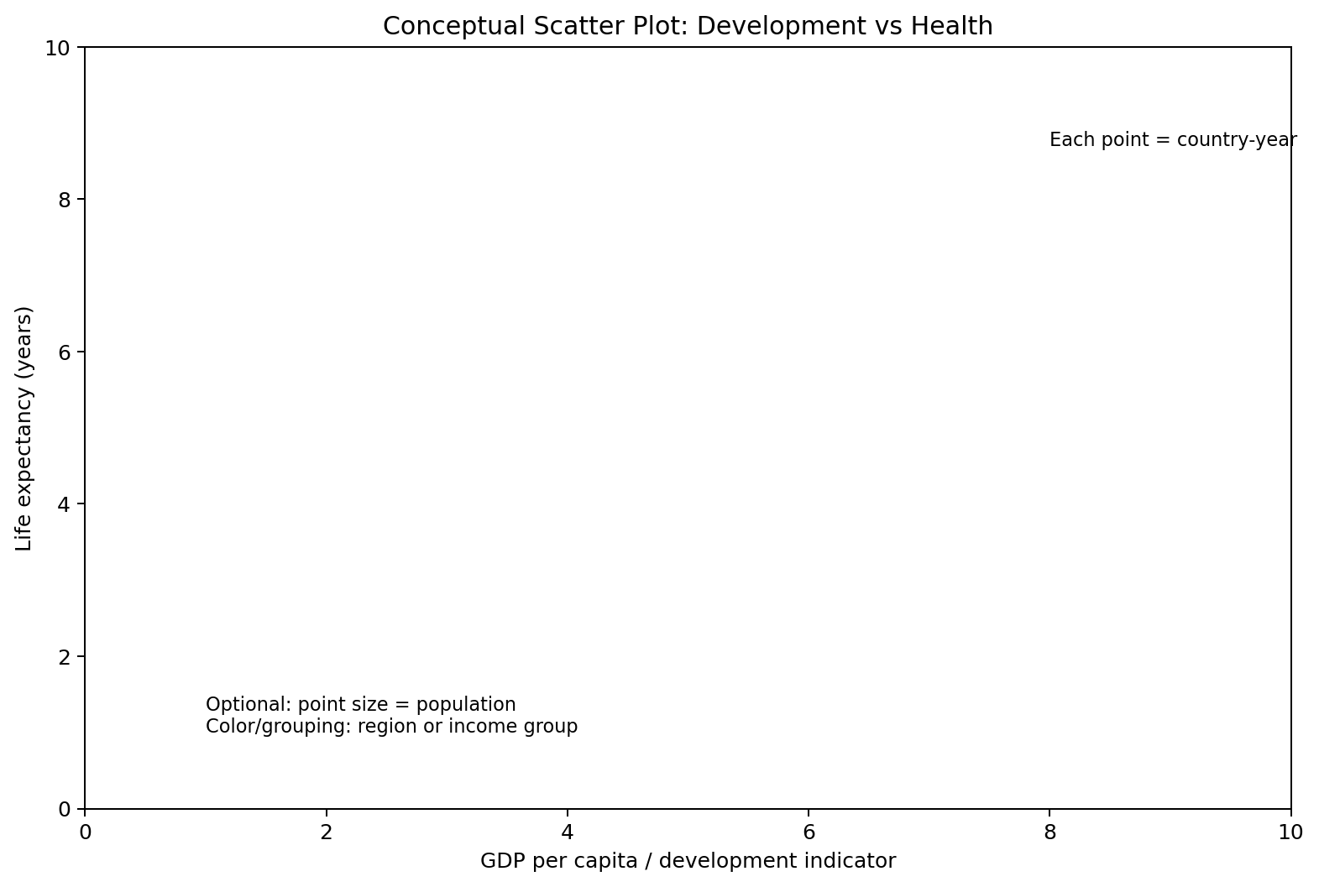
Figure 3. Conceptual relationship plot: development measure vs life expectancy.
Visualization | Question answered | Design notes
Line chart | How has an indicator changed over time? | Year on x-axis; selected countries/regions as lines
Scatter plot | Are development and health indicators related? | GDP per capita vs life expectancy; log x-axis may be appropriate
Box plot | How do distributions differ by region/income group? | Show median, spread, and outliers
Correlation heatmap | Which numeric variables move together? | Annotate only when readable; use consistent variable labels
Choropleth map | Where are values higher/lower geographically? | Use a normalized scale and state year
Ranked bar chart | Which countries changed the most? | Sort by absolute or percentage change; show period
Small multiples | How do regional trends compare? | Same scale where comparison is intended
KPI cards | What are the headline descriptive metrics? | Use only stable, clearly defined summary values

Visual design principle: every chart should answer a specific question. Titles should state the analytical subject, axes should show units, and source/period notes should be visible. A chart will not be used merely because it is visually attractive.

11. Project Timeline — 30 to 35 Hours
Phase | Activity | Time | Planned result
Phase 1 | Problem framing & research questions | 2.5 h | Scope, questions, variables, success criteria
Phase 2 | Dataset research & acquisition plan | 3.5 h | Source evaluation, metadata, API/download plan
Phase 3 | Data profiling | 4.0 h | Schema, coverage, missingness, duplicates, ranges
Phase 4 | Cleaning strategy + transformation design | 5.0 h | Rules, mappings, merge keys, derived fields
Phase 5 | Exploratory statistical analysis plan | 4.0 h | Univariate, bivariate, trend, group, correlation methods
Phase 6 | Visualization design & wireframes | 3.5 h | Chart selection, dashboard layout, annotations
Phase 7 | Implementation preparation | 3.0 h | Notebook structure, folder structure, reproducibility checklist
Phase 8 | Validation, limitations & documentation | 4.0 h | Quality gates, risks, assumptions, references
Phase 9 | Final review & presentation readiness | 2.0 h | Proofread, consistency, deliverable packaging

Total planned effort: 31.5 hours. The remaining 3.5 hours of the 30–35 hour window can be used as contingency for API/data-format issues, additional validation, or refinement of visual designs.

12. Proposed Project Folder Structure
eda_health_development/
├── data/
│ ├── raw/
│ ├── interim/
│ └── processed/
├── notebooks/
│ ├── 01_data_acquisition.ipynb
│ ├── 02_data_cleaning.ipynb
│ └── 03_eda_visualization.ipynb
├── src/
│ ├── data_loader.py
│ ├── cleaning.py
│ └── visualization.py
├── figures/
├── reports/
├── README.md
└── requirements.txt

13. Technology and Tool Plan
Tool | Planned use
Python | Primary analysis language
Jupyter Notebook | Exploration, narrative, reproducibility
pandas | Data loading, cleaning, reshaping, aggregation
NumPy | Numerical operations
Matplotlib | Core plotting and fine-grained chart control
Seaborn | Statistical visualization and heatmaps
Requests / API client | Official API acquisition where needed
Git/GitHub | Version control and project history
Optional Plotly | Interactive charts if the final dashboard requires them

14. Expected Challenges and Mitigation
Challenge | Potential impact | Mitigation
Different update/release schedules | Years may not align perfectly | Choose a defensible common window; document gaps
Country naming/code differences | Incorrect joins | Use standardized codes and explicit mapping checks
Missing observations | Biased comparisons | Report coverage and perform sensitivity checks
GDP skew | Unreadable scatter plots | Use log axis/transformation with explanation
Modelled health estimates | Misinterpretation as raw observations | Read metadata and label estimates clearly
Outliers | Distorted means/correlations | Compare median/robust summaries and investigate extremes
Correlation misinterpretation | Unsupported causal claims | Use careful wording and list confounders
Large datasets | Slow notebook operations | Filter early, select columns, use efficient dtypes
Changing source revisions | Results may differ later | Record retrieval date, source version/release, and metadata

15. Expected Analytical Outputs
- A documented raw-data acquisition plan with source metadata.
- A data-quality report covering missingness, duplicates, data types, coverage, and suspicious values.
- A clean country-year analytical dataset.
- A notebook containing reproducible EDA steps.
- A collection of 6–10 purposeful visualizations.
- A short narrative explaining major descriptive patterns and limitations.
- A conceptual dashboard or visualization layout for communicating results.
- A final README documenting how another analyst can reproduce the workflow.
The proposal intentionally does not claim specific final findings because the actual data will be inspected and validated during implementation. Expected findings are hypotheses to guide exploration, not predetermined conclusions.

16. Success Criteria
- At least two public datasets are documented with authoritative source references.
- Every selected variable has a definition, unit, and source.
- The cleaning process is reproducible and does not overwrite raw data.
- The merge has validated keys and documented unmatched records.
- Missingness and outlier handling are explicitly justified.
- Visualizations are directly connected to research questions.
- The analysis distinguishes descriptive association from causation.
- The final report is clear enough for another analyst to continue implementation without redesigning the project from scratch.

17. References and Source Documentation
World Bank Data — Indicators API Documentation — Official documentation for the World Bank Indicators API and programmatic access.
https://datahelpdesk.worldbank.org/knowledgebase/articles/889392
World Bank Data — Indicator API Queries — Official examples and indicator-query structure; includes GDP indicator example.
https://datahelpdesk.worldbank.org/knowledgebase/articles/898599
World Health Organization — Global Health Observatory: Life Expectancy — Definition, measurement, estimation, unit, and methodological notes for life expectancy.
https://www.who.int/data/gho/data/indicators/indicator-details/GHO/life-expectancy
World Health Organization — Global Health Estimates — Overview of global, regional, and country-level mortality and health estimates.
https://www.who.int/data/global-health-estimates
World Health Organization — Life Expectancy and Healthy Life Expectancy — Context on long-term life expectancy/HALE trends and pandemic-period changes.
https://www.who.int/data/gho/data/themes/mortality-and-global-health-estimates/ghe-life-expectancy-and-healthy-life-expectancy
World Health Organization — Data Indicators — Public indicator catalogue and downloadable data access.
https://data.who.int/indicators

18. Week 1 Submission Checklist
☐ Professional DOCX proposal completed
☐ At least two public datasets identified and justified
☐ Data-source links and metadata documented
☐ Cleaning and transformation workflow defined
☐ EDA methods and research questions defined
☐ Visualization strategy documented
☐ Flowchart included
☐ Visualization/dashboard wireframes included
☐ 30–35 hour timeline included
☐ Challenges and mitigation strategies included
☐ Success criteria and expected outputs included
☐ References included

