DOKUZ EYLUL UNIVERSITY
ENGINEERING FACULTY
DEPARTMENT OF COMPUTER ENGINEERING

CME 2210
Object Oriented Analysis and Design

HEALTHY DIET AND EXERCISE PROGRAMME

by

Kürşadcan AKAY
Ece KAZAN
Ümmünur KANDEMİR

CHAPTER ONE
INTRODUCTION

“Healthy Diet and Exercise Programme” helps the people who wants to take an advice about following and interpreting his/her own diet and exercise programme depending on lots of attributes and variables which hard to follow by human. As mentioned, instead of usage of papers, pencils and some kind of items which could called primitive, we present to people a program which make processes easier for users.

Firstly, our main difference is that most of diets programs are for nutrition only, but there are both personalized nutrition lists and personal exercises. Secondly, the user can choose from the menus tab what he/she wants to special menus and easily access the recipes of the dishes in the menu. In addition, the program shows the exercises to the user in the form of gifs and shows how to do the exercises. At the same time, it is ensured that the user is further motivated with motivation messages and the top three people list. As well as the user can see changes in his/her weight from the first day to the present day on graph. The top three people list is the people who try to achieve their goals in the most successful way. Thirdly, the user can see current information about himself/herself , for example, how many days his/her membership is left or if he/she has any illness or current weight by entering their profile. In according to the information entered by the user, food menus with special calories are given him/her, the program is given exercises to make is suitable for the user. If the user wants the update the special menu or weight, she/he can enter the program and update her/his information and exercise programs and menus are created accordingly from the program.

The program makes easy to save,focus and interpret personal informations about reaching their own ideal healthy life. With thanks to our visualized user-interfaces, progression graph, remainders, personal profile, personalized exercise guides, recipes, rich menu selections, motivational messages and the top three people list, the program becomes even more comprehensive and useful. While the user is registered to the program, error checks are made against incorrect entries, so that the program is registered correctly.

CHAPTER TWO
REQUIREMENTS
As mentioned, in chapter one our scope based on making diet and exercise process easier for users. Firstly, we display Sign In/Sign Up screen to user which allows register to our system or sign in to our system with an existing account which previously signed up. This login screen has some properties: warns about username or password type, length. Until their types and lengths be correct , we don’t let user to sign in and we give them meaningful error related warnings in proper error locations. We display password section with ‘*’ characters which doesn’t allow to another person to understand his/her password while he/she writing his/her password. In addition, we have hide/show button for password that allows to user control ability about writed password content.
Firstly, if user login we read his/her informations from txt file which includes lots of data about user such as program selection, begin and end time of total program, begin and target weight of user, height of user, age of user, gender of user, diet selection, nutritional disease of user, progress score of user and current menu which lastly selected by user. We have well-designed another graphical interface to display and interpret with nutritional scientific facts thanks to our methods. The user’s personal informations which previously mentioned taken to this interface contents to make manage and show this data easily for both of user and programmer.
Secondly, when this data transferred to our user-friendly interface which mentioned in previous paragragh we allow to user these operations: show my profile, show me menus which are suitable for me, show my exersices, show recipes, edit my last weight, show my progress, show top-3 users and motivation message. To get information flow of our system more clearly we need to explain register side of our program as well.
Thirdly, as mentioned in first paragraph we have sign up button in login screen as well. When a person decides to sign up to our system we navigate he/she to register screen thanks to sign up button. After navigation we take these informations by the order: username, password, gender, age, programme selection, diet selection, height, current weight, target weight, begin date, end date, nutritional disease, profile photo.These informations are very important for our program. To make these concepts more understandable we need to explain them all clearly: username and password are unique combinations for each user, gender is important for diet and exercise because of male/female needs changes, age is directly related with metabolism, programme selection has three submissions by the order: “Lose Weight Program”, “Gaining Weight Program”, “Preservation Program”, their purposes of these programs very clear with their names and we advice menus, exercises depending on their selection between them considering the calory needs. Nextly, diet selection involves three concepts: “Standard Nutrition”, “Vegeterian Nutrition”, “Vegan Nutrition”, so we present menus considering this selection. Height, current weight and target weight are important to calculate BMI(Body Mass Index) and daily needs of human body such as needs of water, calory need, sleep time need. Begin and end date informations are important to define period of membership and calculate progress score. Lastly, nutritional disease selection includes three disease: “Diabetes”, “Celiac” and “Reflux”. While recommending menus we consider about these diseases as well. All of these selections control in same screen for logical errors or type dependent errors. To decrease errors which caused by user input, we designed this page as an interface which forces user to select data from lists, radio buttons etc.
Finally, we will save meaningful user informations, we will design user-friendly interface, we will display exercise with GIF formats, we will display progress of user by using 2D graph depending on time, we will create recipe search unit, we will create competation dynamic with score board, we will fix the problem about diet that repatation or similarity in menus.
In conclusion, informations which previously mentioned will be interpreted by our program and related in a well-designed object oriented structure thanks to Java language with Java.Swing library, our system contains interfaces, abstract classes , polymorphism, inheritance and ADT. We considered about encapsulation principle as well.
- User based attributes given below:
- private String username;
- private String password
- private int programmeSelection;
- private Date beginDate;
- private Date endDate;
- private double beginWeight;
- private double targetWeight;
- private double currentWeight;
- private int height;
- private int age;
- private String gender;
- private int dietSelection;
- private int nutritionDisese;
- private double progressScore;
- private int menuID;
- private List<ProgressData> progressData = new ArrayList<ProgressData>();
- private double bmi;
- private double sleepingTime;
- private double dailyCaloryNeed;
- private double dailyWaterNeed;

//This method edits current date and current weight
- public void editCurrentData (Date date, double weight);
//This method calculates daily needs of person
- private void calculateValuesForUser ();
//This method calculates Body Mass Index(BMI) of user
- private void calculatorOfBMI();
//This method calculates daily need sleeping time of user
- private double sleepingTimeCalculator ();
//This method calculates daily need water of user
- private double dailyWaterNeedCalculator();
//This method calculates daily need calory of user
- private double dailyCaloryNeedCalculator();
//Warns if username does not exists
- public abstract boolean userNotFoundError(String usernameInput);
//Warns if username and passwords are not matching
- public abstract boolean usernameAndPasswordControl();
//If username exists in the system warn the user
- public abstract boolean usernameRepetation();
//If the relation between selected program and targets are unlogical
- public abstract String contentDependedLogicalErrors();
//If user selects not suitable file for profile photo warns
- public abstract String inputFileFormatError();
// If all informations taken from user are suitable this method writes them into a file.
- public abstract void writeInfoToUserDataFile();

- Date based attributes given below:
- private int day;
- private int month;
- private int year;
//Displays login screen
- public void LoginScreen();

//This method for converting char array to String because of after Java 1.2 Java Swing Libraries JPassword.getText() was not save, garbage collector is holding this String
value and it is not cyberly safe so instead of this it holds this data in char array, thanks to this method we make this conversion in backend to String.
- public String convert(char[] elements)
//This method reads file and looks for matching entered username and password in user data repository
- public void ReadFile(String username , String password);
- private Date date;
- private double userWeight;
- private User currentOnlineUser;
- private String userName;
- private String password;
- private String userWarning;
- private String passwordWarning;
//This method looks for general result of all controls
- public void fromSignUpToMainGeneralChecker()
//This method checks username type and length
- public boolean warnAboutUsernameType(String strUserName);
//This method checks password type and length
- public boolean notValidPassword(String strPassword);

- The attributes and methods given below from Java Swing library. These all methods and attributes are used for user-friendly interfaces, graphs and for other properties like display some visual content, set dynamic contents etc. In next steps new attributes and methods will be added between them from Java.Swing library.

- private JFrame loginScreen;
- private JTextField username;
- private JPasswordField passwordUnvisible;
- private JTextField passwordVisible;
- private boolean flagShow ;
- Icon iconEye = new ImageIcon();
- private JFrame frame;
- private JTextField username;
- private JTextField password;
- private JTextField txtProgrammeSelection;
- private JTextField txtDietSelection;
- private JTextField txtHeight;
- private JTextField txtCurrentWeight;
- private JTextField currKg;
- private JTextField currGr;
- private JTextField txtTargetWeight;
- private JTextField tarKg;
- private JTextField tarGr;
- private JTextField txtBeginDate;
- private JTextField txtEndDate;
- private JTextField nutriDisease;
- private void initialize();
- EventQueue.invokeLater(new Runnable())
- ActionListener(new ActionListener()
- public void actionPerformed(ActionEvent arg0)
- public void MainScreen();

- : This symbol means following struct is a method
- : This symbol means following struct is an attribute
Files in usage: (in TextFiles folder)
- menuData.txt : This txt file includes menus with their properties.
- usernameBasedProgress.txt : This txt file holds records of user weights with dates.
- userDataRepository.txt : This txt file holds informations of user.
- recipeData.txt : This txt file includes recipes.

And will be another folders which includes GIFs and images.

CHAPTER THREE
uml dıagrams

class dIAGRAM:

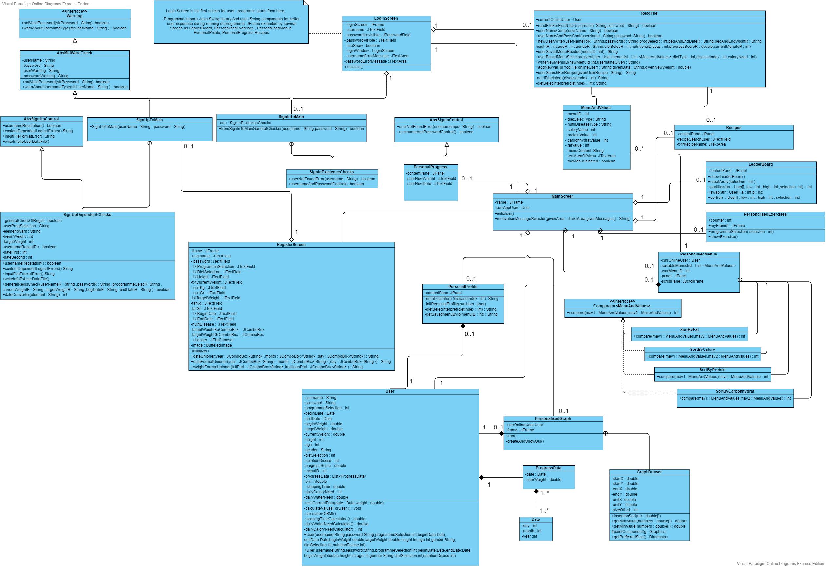

In this diagram, we display contents of our project depending on their relations in the level of classes and interfaces. All attributes and methods which are well-predicted and program needs depending on users enlarging requests will be required by our large scope design. Object oriented programming principles are implemented all around of our project. Inheritance, encapsulation and polymorphism principles are implemented as well when needed in our project. We tried to avoid pollution of code by usage of these principles and we concerned about task sharing to all members. Thanks to all of these we plan to complete our project with any missing point.

USE CASE DIAGRAM:

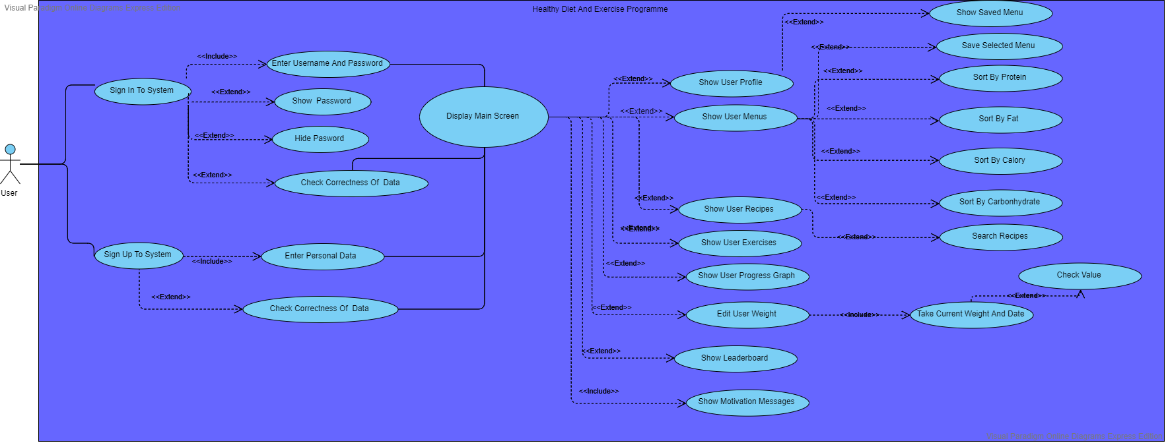

Thanks to this diagram we can think about user experience and analys from user sight.This diagram shows us functionallity of our program and scope of project. We can represent register or sign in options and after user signed up we allow to user select one of our versitale selections. All of these allows us to think about user story better and gives opinion about his/her experience.

SIGN IN ACTIVITY DIAGRAM:
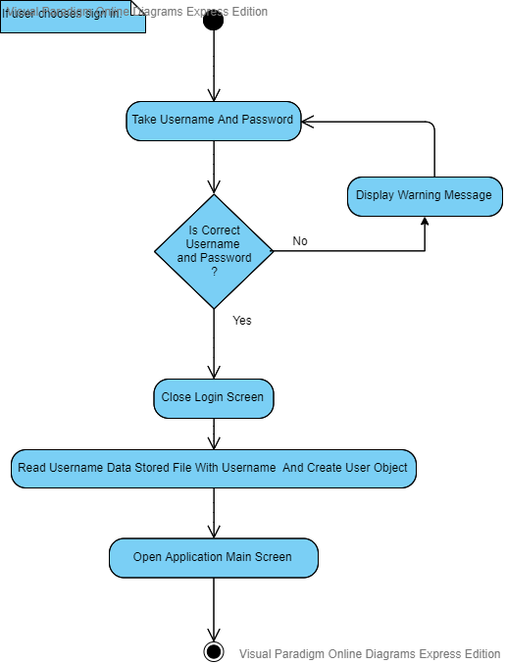
This diagram shows sign in process of user. When user tries to sign in these steps works by the order. We take needed data and check them to decide whether correct or not. When all of these steps completed user signs in successfully.

SIGN UP ACTIVITY DIAGRAM:
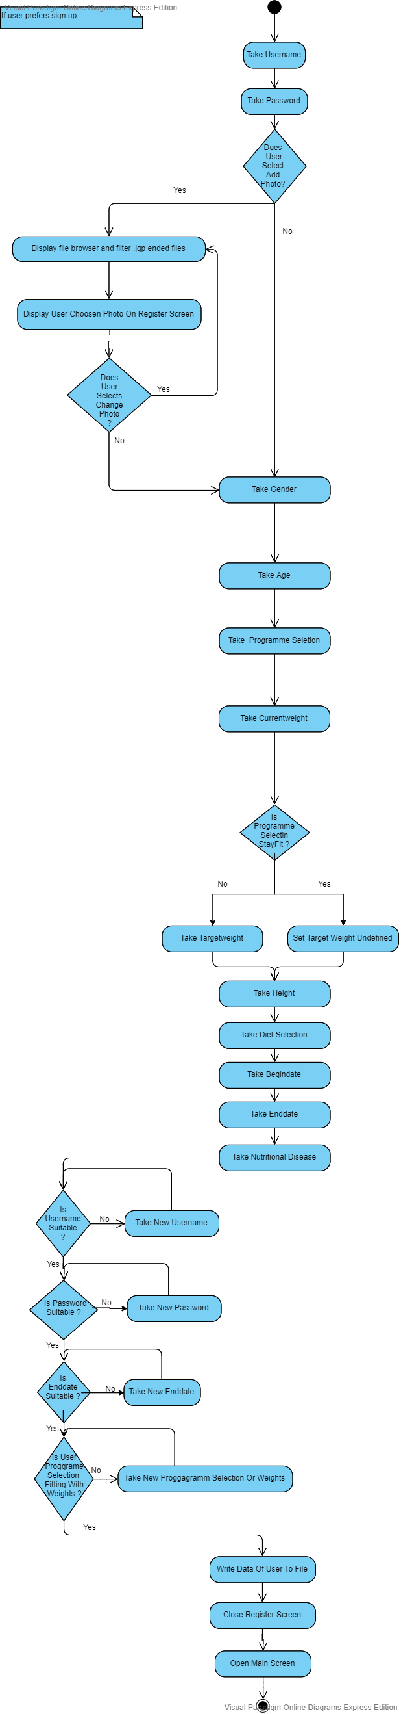

When user selects sign up the steps which are given above works by the order to create new user for our programme. We make all controls and apply register rules which are predefined. We take profile photo image, username,password,etc. which are given above. At the very very end we control them all. If they are correct we create a new user.

STATE DIAGRAM OF MENUANDVALUES:

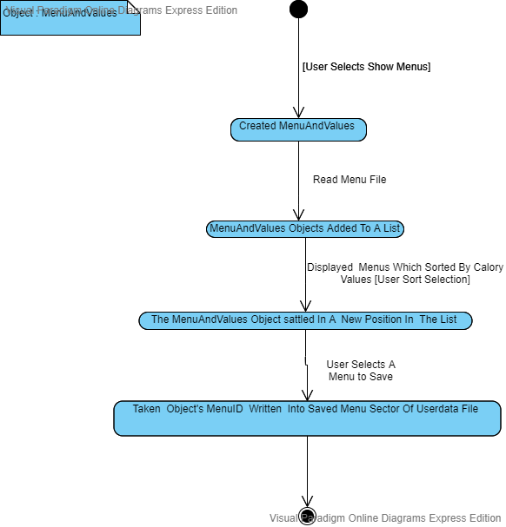

The diagram given above shows the object of MenuAndValues. This object’s life cycle defined above. It shows menu based properties and thanks to this struct we can sort this object for different attributes of foods which are protein,fat,carbonhydrate,calory.
SEQUENCE DIAGRAM OF RECIPES:
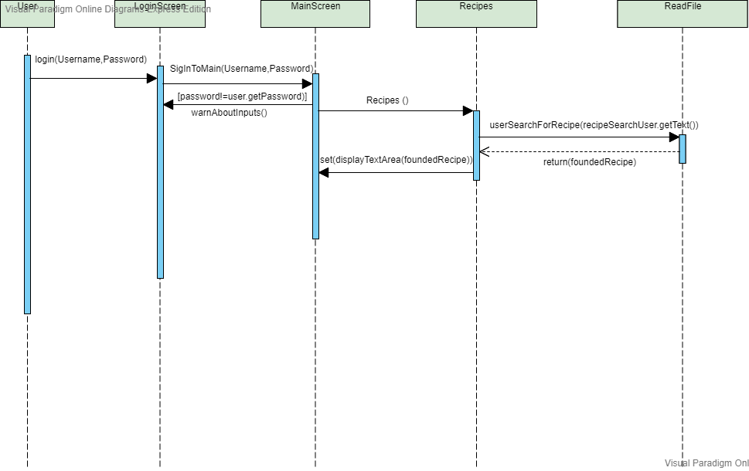

This diagram shows sequence of recipes work stream. When all of these processes works by the order and create objects by the order our method of display recipes to user works truly. User can search a recipe from our programme when completes all of these steps by the order which explained above by sequence diagram.

CHAPTER four
IMPLEMENTATION

We created two interface, three abstract classes, nine classes. The four principles of object-oriented programming are encapsulation, abstraction, inheritance, and polymorphism are implemented in these interface and classes.

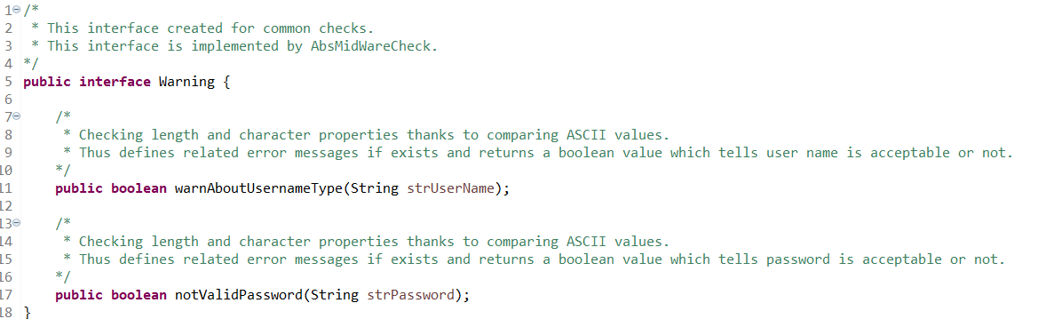
Interface of our program created for common checks as control of user name and password types. AbsMidWareCheck implements this Warning interface.

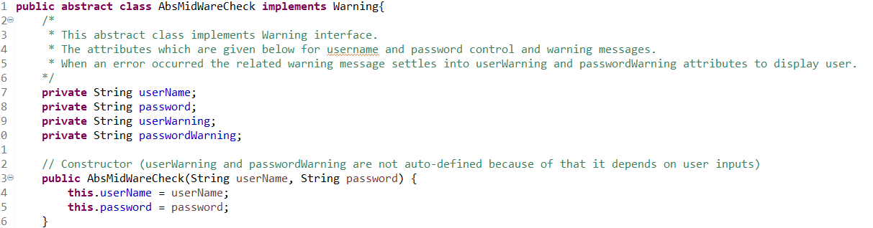
Warning interface is implemented by AbsMidWareCheck class. This is part of implementation/realization. In this class, program checks user inputs. SignInToMain and SignUpToMain classes extends AbsMidWareCheck class for their own input controls. This is an example of inheritance principle. If user enters input in wrong way, program displays related warning messages to fix the user input.

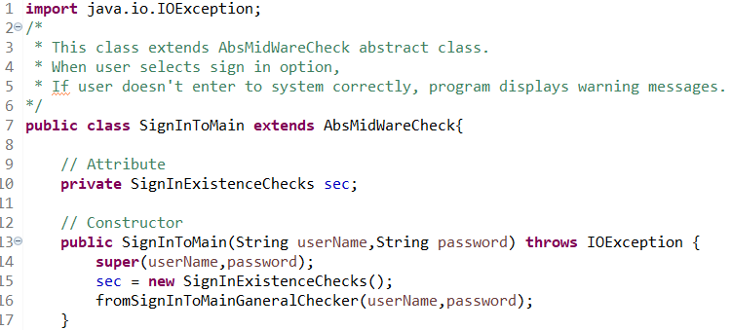
SignInToMain class extends AbsMidWareCheck class for its own controls. If user select sign in, user name and password inputs are checked in class. If there is a wrong input,
program displays related warning messages for user. This is an example of inheritance principle.

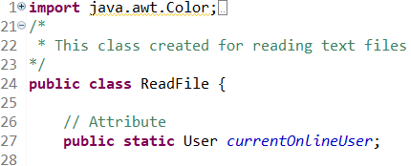
We have User class to keep user’s data if a exist user signs in to program or a new user signs up to program. When user signs in or signs up to system correctly, an user object is created to use user’s data for another operations(for example, user wants to see his/her personal profile, we used data that we keep.) These data are held in our text files. We created ReadFile class to use in general operations and controls (if user signs in we check validation user name and password, if user selects menus option we display menus depending on user’s data in text file, if user wants to register the system we check existence of user name input in text file, etc.). For these operations, we created an User object for current user in system. This is an example of encapsulation.

In User class, we have two constructors. When user registers to system , if user selects programmeSelection as loss weight or gain weight , program takes a target weight from user. If user selects programmeSelection as stay fit, program does not ask a target weight.
This is an example of polymorphism principle.
In the example given above, we implemented advanced abstraction structure to check user name and password inputs with implementation Warning interface as well.

Our project’s classes and interfaces:

Warning interface created for common checks.

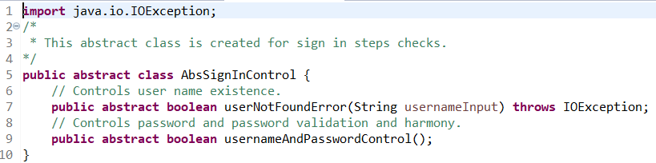
This class is created for sign in steps checks.

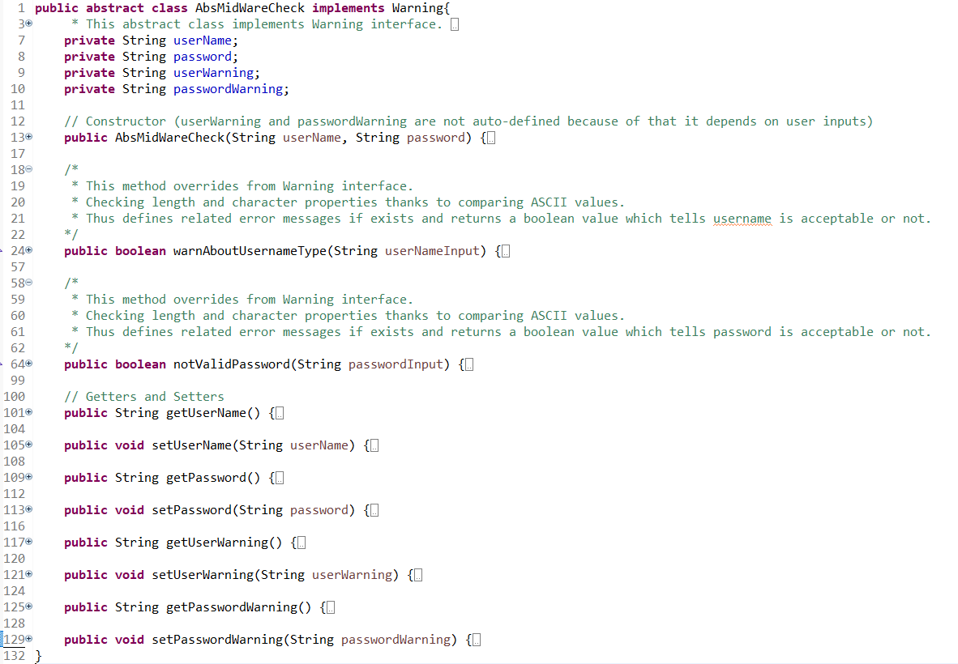
This abstract class implements Warning interface.The attributes which are given below for username and password control and warning messages.When an error occurred the related warning message settles into userWarning and passwordWarning attributes to display user.

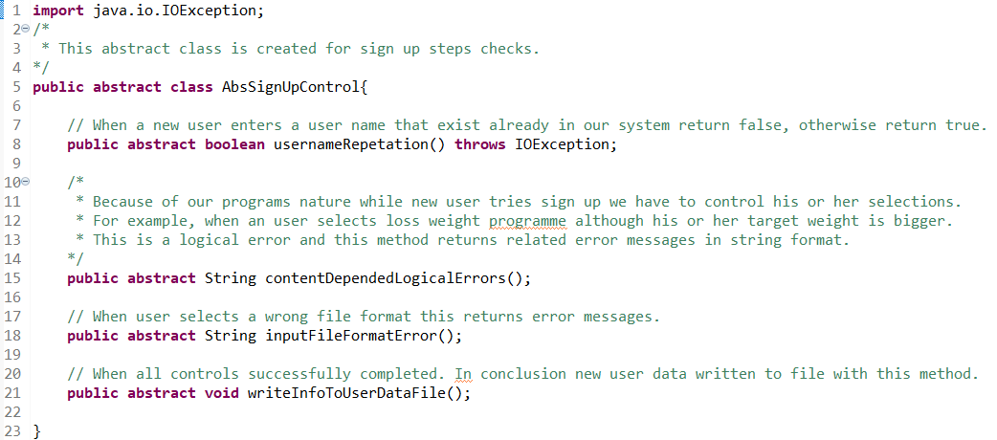
AbsSignUpControl is created for sign up steps checks.

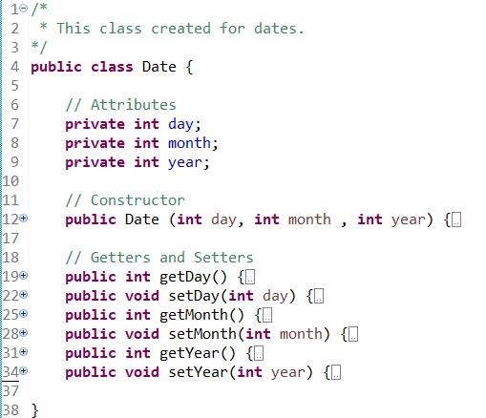
Date class is created for dates.

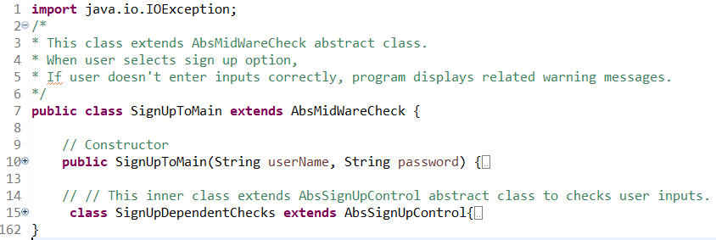
This class extends AbsMidWareCheck abstract class.When user selects sign up option,if user doesn't enter inputs correctly, program displays related warning messages.

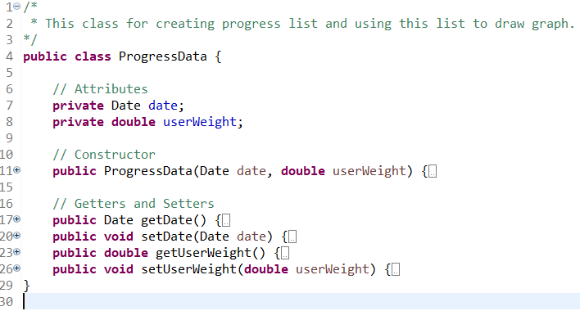
ProgressData is created for creating progress list and using this list to draw graph.

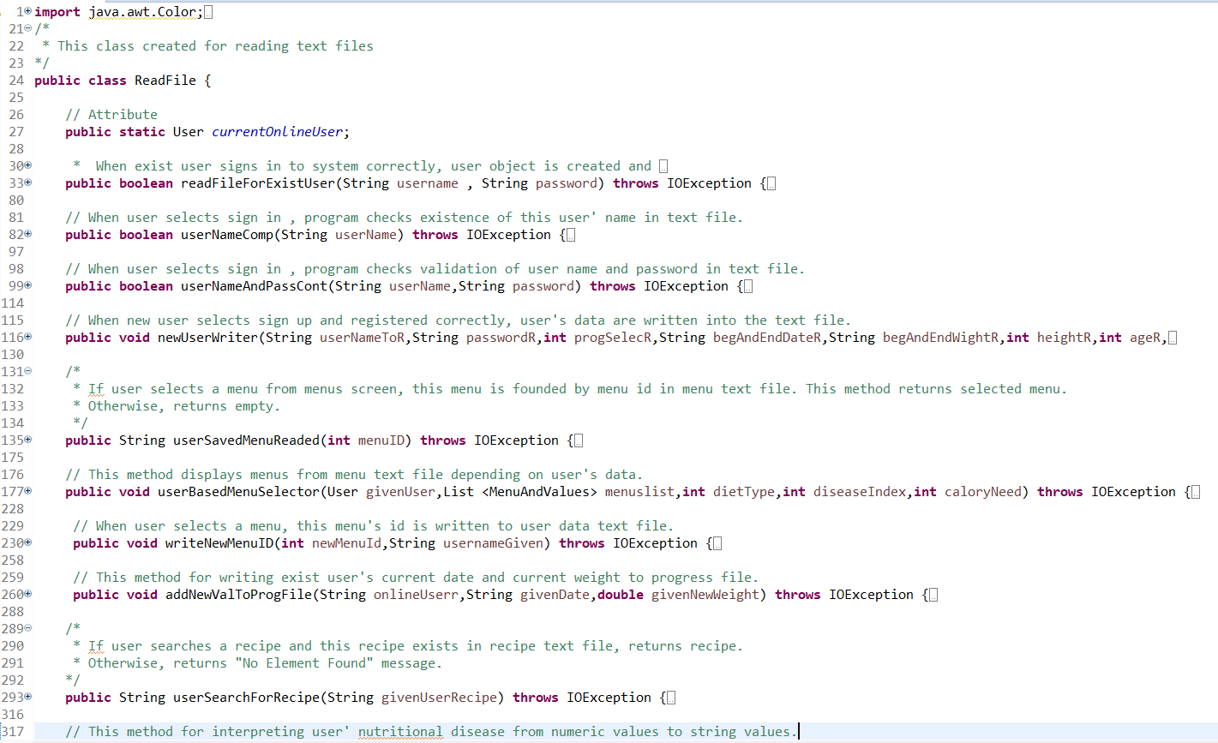
ReadFile is created for reading text files.

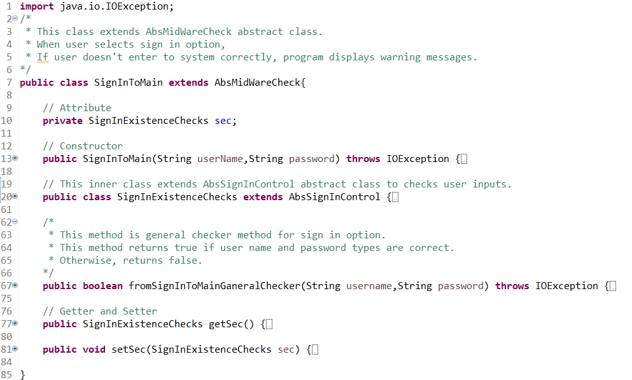
SignInToMain extends AbsMidWareCheck abstract class.When user selects sign in option,if user doesn't enter to system correctly, program displays warning messages.

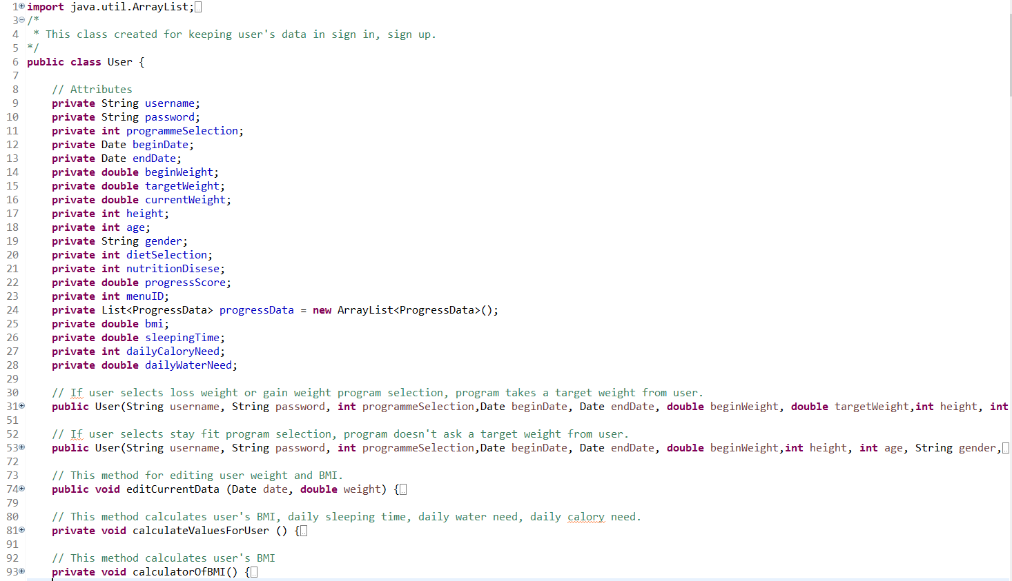
User is created for keeping user’s data in general operations.
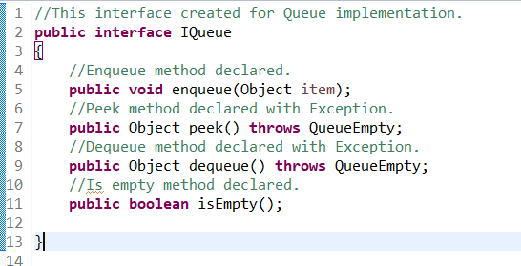
IQueue interface is created for Queue implementation and involves queue’ basic methods.

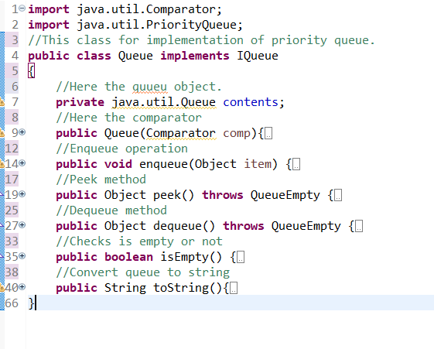
Queue class implements IQueue interface. This class is created for displaying leader board(top-3) that depending on user’s progress score and programme selection.

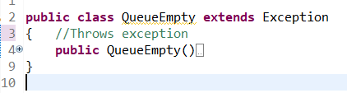
QueueEmpty class is an exception class.When queue is empty and some kind of operation as dequeue and peek are called, method throws this exception.

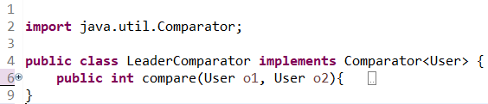
LeaderComparator class implements Comparator<User> for defining priority queue’s comparation criteria.

Progress Description:

Firstly, we implemented our project as object oriented, polymorphic and abstractly structured.This design needed some interfaces,classes,abstract classes ,file system etc.
For all of these needs, we coded firstly our Warning interface with warning related methods definations.Then the abstract class AbsMidWareCheck coded and it implemented Warning interface. This abstract layers completed for checking username and password related processes. After this step we coded AbsSignInControl and AbsSignUpControl abstract classes which are using AbsMidWareCheck abstact class related attributes and methods. This inheritance allowed us to make generic controls of username and password related checks which we are gonna need in both sign in and sign up steps.

Secondly, after definitions of these AbsSignInControl and AbsSignUpControl abstract classes we could able to define SignInToMain and SignUpToMain classes thanks to all needed control groups which came with inheritance of extended abstract classes and their related interfaces. We combined needed stages and added all logical, and format based error conditions. These all are able to be so specific. We designed sign in and sign up classes for all possible scenarios for different type of users with different selections of program selection, diet selection and nutritional diseases. For this versatile attribute groups for users we defined some numbers for making trackable indexing in the file system. This definitions written into files as header to make more readable and understandable for next programmers.

Thirdly, previously mentioned data had to be recorded in somewhere for reach , change and delete operations. We needed a secondary storage system. We created a file system. Which includes needed data content. This file system involves menus, user data, user progress, recipes. This file system also includes system images which drawn by us as programmers without any license concern. We created ReadFile class for reaching this data. These attributes which are meaningful for both programs file reader and users are includes following attributes as well, date and weight couples in user progress file which will be needed in the next steps for displaying graph and other related calculations like progress score calculation , current bmi calculation , sleep need calculation etc. This data will be executed as our ProgressData and Date classes objects. This weight and date updates values are gonna be reserved in a list so list attribute definition implemented , and other attributes added to this user data based classes which meaningful attribute names.

Fourthly, user related attributes defined under User class, this class includes all details and calculations for our users personalized needs. These methods and calculations are defined with strict relations of ReadFile based operations. Because for all situations sign in or sign up , we must read data from file and interpret them under some conditions and rules. After update and create operations for user , our programmers must be able to displaying graph , menus , recipes ,leader board , exercises as well. For all theses we need file read, write or interpret operations. This all needs systematically design in ReadFile class.

Fifthly, needed implementations completed while concerning users fair comparation. Priority queue based sorting implemented with comparator definition with progress score displays top-3 users in their own program selection. In addition, previously mentioned queue implementations completed with creating Queue class which implements IQueue interface and includes related exception. LeaderComparator class is defined for comparing factor selection.

