Multiple Scales:
Target:
Spectral Variables (Color attributes):
Bands of color:
Bright — Brightness
Mean_G — Mean Green Reflectance
Mean_R — Mean Red Reflectance
Mean_NIR — Mean Near-Infrared Reflectance
NDVI — Normalized Difference Vegetation Index
Shape Variables:
Area — Object Area (m²)
BordLngth — Border Length (m)
BrdIndx — Border Index
Round — Roundness
Compact — Compactness
ShpIndx — Shape Index
LW — Length/Width Ratio
Rect — Rectangularity
Dens — Density
Assym — Asymmetry
Texture Variables (Pixel variation):
SD_G — Standard Deviation of Green
SD_R — Standard Deviation of Red
SD_NIR — Standard Deviation of NIR
GLCM’s:
Ex:
GLCM1 — GLCM Texture Feature
GLCM2 — Second GLCM Texture Metric
GLCM3 — Third GLCM Texture Metric
Imports and Cleaning:

Instructions:
- Choose your own dataset, apply the whole data mining pipeline
- Dataset must have at least 100 data points and must include both numerical and
- categorial (or ordinal) variables.
  - You may also choose to join together more than one dataset, for example to merge data on health outcomes by US state with a dataset on food statistics per state
  - Merging data is not required and will earn you a bonus point in this step.
- Take notes on interesting findings/outcomes as you go, but all answers should be formatted in a report style that will be turned in as a separate document along with code
  - The report component specifically is about your overall takeaways from your data. What was interesting from your analysis?

Urban Land Cover:
https://archive.ics.uci.edu/dataset/295/urban+land+cover
“Classification of urban land cover using high resolution aerial imagery. Intended to assist sustainable urban planning efforts. Contains data for classifying a high resolution aerial image into 9 types of urban land cover.”
2014 dataset from Brian Johnson in UCI Repository
- Entire Dataset is one large aerial image of a cityscape/nature area
  - We are not classifying a whole image of a city block or a forest
  - Each row represents a segment of that larger image
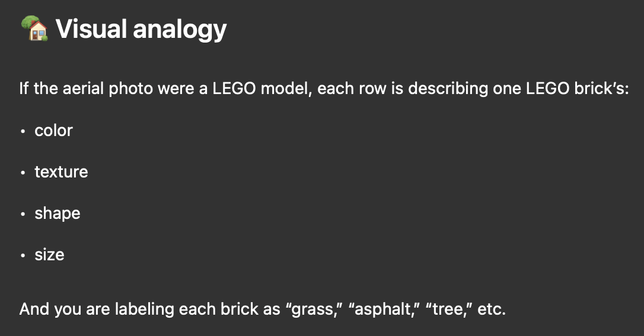
- We are classifying these segments of the one larger image in order to determine how well our classifier can do at distinguishing the specific component this row represents (A tree, car, section of roof, etc.)
  - You are not determining whether the whole image is urban or rural.
  - You are classifying each individual segment into a land-cover category such as:
    - Tree, Grass, Asphalt, Concrete, Building roof , Shadow, Water, Soil
      - These are urban land-cover classes, not large-area landscape classes.

Multiple Scales:
The variables in this dataset are computed at multiple granularity scales (20, 40, 60, … 140).
- Each scale corresponds to a different level of object granularity (blurriness/detail)
  - Fine scales behave like using a sharp, focused lens that picks up small details,
  - Coarse scales behave like using a smoother, more generalized view — similar to a slight blur or zoom-out that captures larger patterns.
    - The objects stay the same, but the way their texture and spectral values are summarized becomes more or less detailed.
- The same texture, spectral, and shape metrics are calculated at each scale to capture spatial patterns that appear differently depending on object size.
- This multiscale structure is common in object-based image analysis (OBIA) and significantly improves the ability of machine learning models to distinguish land-cover types.

We will use the scale of 80 because that is the middle most scale:
- 20, 40, 60, 80, 100, 120, 140
Say we are examining an image of a tree crown
- 20 is very fine → (Every individual leaf may be able to be distinguished)
- 140 is very coarse → (We may only see the general pattern of a green clump)

Observations/Features:
- 675 observations each representing a segment of the aerial image

Target:
Classification (Nominal)
- Land cover class label (categorical). Indicates the type of object
- trees, grass, soil, concrete, asphalt, buildings, cars, pools, shadows.

Spectral Variables (Color attributes):
- These describe how much light the object reflects in different wavelengths or combinations of wavelengths. They come directly from pixel values in the aerial image.
- Spectral features describe how much light the surface reflects in different parts of the electromagnetic spectrum (Red, Green, NIR, etc.). They measure the color signature of an object.
- Different materials reflect light differently:
  - Vegetation reflects strongly in NIR
  - Water absorbs almost all light (very dark in all bands)
  - Concrete and asphalt reflect more in visible bands
  - Soil reflects differently depending on moisture levels
- They help us to analyze qualities such as Material type, Vegetation health, Water presence, Soil vs built-up surface differences, Sunlit vs shadowed areas, General reflectance brightness

Bands of color:
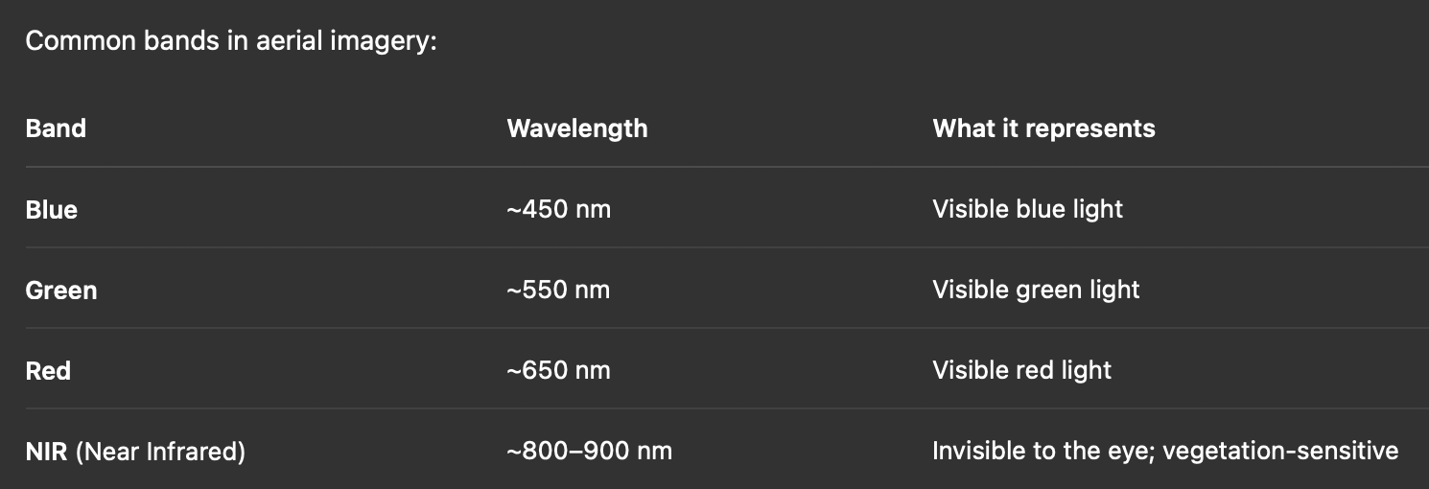
A band is a slice of the electromagnetic spectrum that a satellite or aerial sensor captures.
- Think of it like different “color channels,” but not limited to visible colors.
- Each band records how much light the surface reflects at that wavelength.

Bright — Brightness
- Overall reflectance intensity of the object across multiple spectral bands.
  - High values often indicate bright surfaces (concrete, rooftops, bare soil).

Mean_G — Mean Green Reflectance
- Average pixel value in the green band.
- Healthy vegetation reflects moderately in green (that’s why plants look green).
- Useful for distinguishing vegetation vs. non-vegetation surfaces.
  - Moderate for healthy vegetation
  - Lower for soils or built surfaces

Mean_R — Mean Red Reflectance
- Average pixel value in the red band.
- Healthy vegetation absorbs red light heavily (due to chlorophyll). → Vegetation appears dark when examined in the red band only
  - lower for healthy vegetation
  - higher for soils or built surfaces.

Mean_NIR — Mean Near-Infrared Reflectance
- Average NIR reflectance.
- VERY STRONG vegetation reflectance → Most important band for vegetation studies
- A strong indicator of vegetation health, since healthy plants reflect heavily in NIR.

NDVI — Normalized Difference Vegetation Index
- Vegetation index computed from NIR and Red:
  - From -1 to 1
- Unitless measurement that tells us how much healthy, green vegetation is in an area.

- Positive, higher values indicate healthy vegetation (RED < NIR)
- Negative values indicate water or asphalt (Red > NIR)
  - If red is low, the ratio will be closer to 1
  - If red is high, but still less than NIR the ratio will be closer to 0
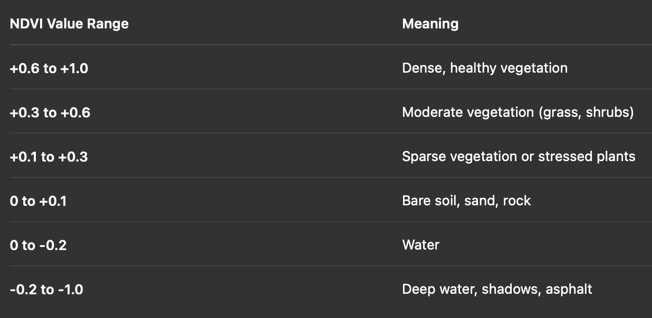

Shape Variables:
- These describe the geometry of each segmented object
- how big it is, how smooth its boundaries are, and its overall form.
- Different land features naturally have different shapes:
  - Buildings → rectangular, regular, high compactness
  - Roads, rivers → elongated, high length/width ratio
  - Trees → rounded crown shapes
  - Grass patches → irregular blobs
  - Shadows → long, dark, irregular forms
  - Water bodies → smooth, compact shapes
- Whether an object is man-made or natural
  - Whether the object is elongated (roads) or compact (buildings)
  - Boundary smoothness (lakes) vs jaggedness (vegetation)
  - Geographic structure such as patches, strips, or blocks

Area — Object Area (m²)
- Total surface area of the segment.
  - Larger values indicate bigger patches (fields, roofs)
  - Smaller values indicate fine-scale objects.

- Gives you square meters on a coordinate system

BordLngth — Border Length (m)
- Length of the object’s perimeter. Helps capture shape complexity and edge detail.

BrdIndx — Border Index
- Measures how irregular or jagged an object’s boundary is.
  - Low BrdIndx → If the border is perfectly smooth and compact, like a circle
  - High BrdIndx → If the border is complex, noisy, jagged, like a tree canopy
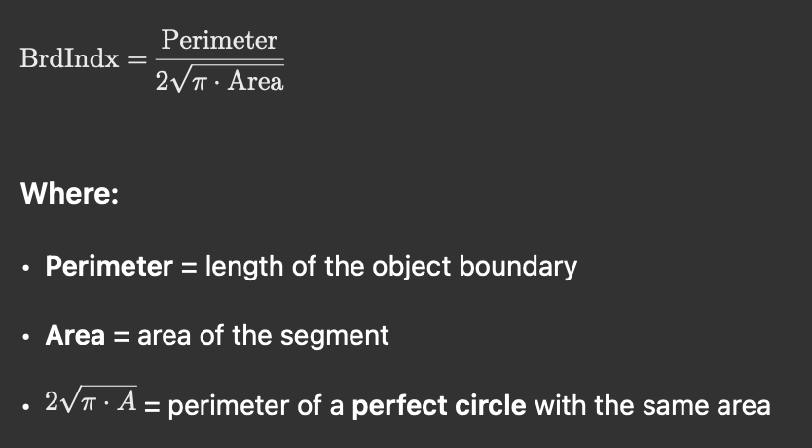
- A circle gives BrdIndx = 1/1 → P(Shape) = P(Circle) ~ Shape is a circle
  - Shapes with longer, more irregular borders produce BrdIndx > 1, The more jagged/complex the border → the larger the index

Round — Roundness
- Indicates how circular the object is.
  - A value of 1 means perfectly circular
  - Lower values indicate elongated or irregular shapes.

Compact — Compactness
- Describes how tightly the object fills its area relative to its perimeter.
  - Compact shapes (buildings) have higher values.

ShpIndx — Shape Index
- General measure of shape complexity.
  - Low ShpIndx → simple shape (square, rectangle, circle)
  - High ShpIndx → irregular, complex, non-geometric shape
 = 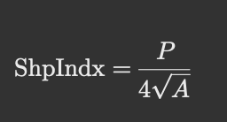
- If shape is a square → sqrt(A) = length of one side, so 4*length of one side would be hte perimeter → A square gives ShpIndx = 1
- A circle gives ShpIndx ≈ 0.89 (A little smaller perimeter than a square)
  - More elongated or irregular shapes (>4 sides) give ShpIndx > 1

LW — Length/Width Ratio
- Ratio between the object’s longest dimension and shortest dimension.
  - High LW indicates long, narrow shapes (roads, rivers).

Rect — Rectangularity
- How well the object fits inside its minimum bounding rectangle.
  - Higher values indicate shapes similar to rectangles (roofs, parking lots).

Dens — Density
- Ratio of area to perimeter length. Smoother, more filled-in shapes have higher density.
  - If area is high, but perimeter is small → Very dense

Assym — Asymmetry
- Measures how evenly mass is distributed around the object’s center.
  - High values indicate irregular, unbalanced shapes.

Texture Variables (Pixel variation):
- Texture measures describe pixel-to-pixel variation within the object—patterns that reflect surface roughness or uniformity.
  - More rough would generally indicate more organic shapes, such as tree crowns
  - More uniform shapes would generally indicate more precise constructions, such as man made roofs
- Texture is critical for distinguishing classes with similar colors but different physical patterns
- Computed from various pixel intensity (precision) levels…
  - Texture features describe the pattern, roughness, and pixel-to-pixel variability within an object. These differences often can’t be seen with simple averages but become obvious in texture measures.
- Different land covers have characteristic textures:
  - Water → extremely smooth, low variation
  - Asphalt → smooth but slightly noise
  - Grass → moderate variation
  - Tree canopies → highly rough, complex texture
  - Urban roofs → structured, repetitive patterns
  - Shadows → low variation but very dark

SD_G — Standard Deviation of Green
- Measures how much green-band reflectance varies within an object.
  - High values indicate a rough or heterogeneous surface (forest canopy).
  - Lots of different shades of green would be a more naturally occurring look for vegetation

SD_R — Standard Deviation of Red
- Measures how much red-band reflectance varies within a segment.
- Helps distinguish uniform surfaces (water, asphalt) from varied ones (trees, mixed vegetation).
  - Uniform surfaces (asphalt, water) = low SD_R
  - Vegetation patches (trees, shrubs) = high SD_R

SD_NIR — Standard Deviation of NIR
- Pixel variability in the NIR band.
- Measures how much NIR-band reflectance varies within an object.
  - Often high in dense or mixed vegetation areas.

GLCM’s:
A GLCM (Gray-Level Co-occurrence Matrix) describes how pairs of pixel values occur together in a neighborhood
- How often does a pixel with value i sit next to a pixel with value j?
- A smoother surface has predictable, similar neighboring pixels.
- A rough surface has lots of sharp changes between neighbors.

- Take a small window (e.g., 3×3 or 5×5 pixels).
- Look at every pair of neighboring pixels.
  - Each pixel (not on the edge of an image) will have 8 neighbors (TopR, TopCenter, TopL, L, R, LowR, LowCenter, LowL)
- Count how many times value A sits next to value B.
- Repeat for all pixel pairs across that window
  - The result is a matrix that encodes texture structure.
  - Then we compute summary statistics from that matrix.
    - Could it be considered a covariance matrix? –Since all are in the same units?
  - Each i,j entry represents a pixel pair
  - We then create a corresponding matrix where we take the count that that pixel pair occurred, and place it in the slot of that pixel pair

Common GLCM Metrics:
- Once you build the GLCM matrix, you can begin to extract different metrics from it that can be used as different GLCM feature variables
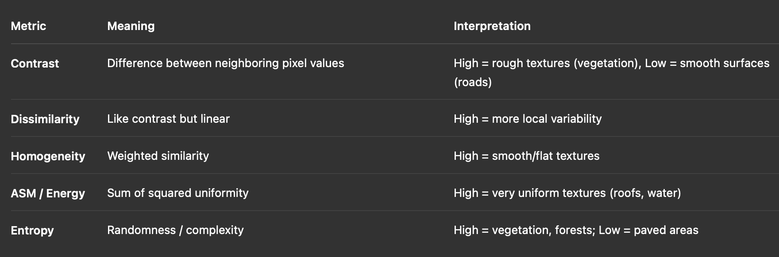
- Contrast: Difference between pixels → detects edges, roughness.
- Dissimilarity: Average difference between neighbors → like a simpler contrast.
- Homogeneity: How similar neighboring pixels are → detects smooth surfaces
- Energy / ASM: Uniformity → detects extremely smooth areas.
- Entropy: Randomness → detects complex patterns like vegetation.

Ex:
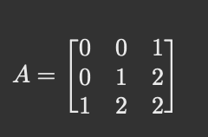
- We’ll only count neighbors as the entry directly to the right for direction simplicity here
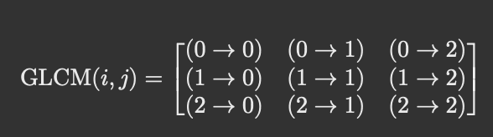
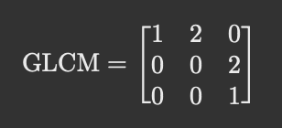
- This tells us that (0,0) happened 1 time, (0,1) happened 2 times, etc.

*We have no interpretation/explanation for the below GLCM features

GLCM1 — GLCM Texture Feature
- A Gray-Level Co-occurrence Matrix metric measuring spatial relationships between neighboring pixels (e.g., contrast, homogeneity, entropy).
  - Captures local texture patterns.

GLCM2 — Second GLCM Texture Metric
- Another GLCM-based descriptor representing a different aspect of spatial texture (e.g., dissimilarity, angular second moment).

GLCM3 — Third GLCM Texture Metric
- Another texture indicator derived from the GLCM.
  - Using multiple GLCM features helps discriminate smooth surfaces (water, asphalt) from textured ones (foliage).

1.Data Gathering and Integration
- Merge the Train and Test Data sets, will do resplitting later for validation
- Only work with the variables ending in _80 for that granularity scale
- Order the columns by their variable classification
  - Spectral → Shape → Texture
    - Spectral Variables (Color attributes):
      - Bright — Brightness
      - Mean_G — Mean Green Reflectance
      - Mean_R — Mean Red Reflectance
      - Mean_NIR — Mean Near-Infrared Reflectance
      - NDVI — Normalized Difference Vegetation Index
    - Shape Variables:
      - Area — Object Area (m²)
      - BordLngth — Border Length (m)
      - BrdIndx — Border Index
      - Round — Roundness
      - Compact — Compactness
      - ShpIndx — Shape Index
      - LW — Length/Width Ratio
      - Rect — Rectangularity
      - Dens — Density
      - Assym — Asymmetry
    - Texture Variables (Pixel variation):
      - SD_G — Standard Deviation of Green
      - SD_R — Standard Deviation of Red
      - SD_NIR — Standard Deviation of NIR
      - GLCM1 — GLCM Texture Feature
      - GLCM2 — Second GLCM Texture Metric
      - GLCM3 — Third GLCM Texture Metric

2.Data Exploration
- Get distributions of the 9 classifications for target
- Get correlation matrices for the variables within their feature classification subsets
  - I’d expect to see some extremely highly correlated variables here, as many of the features seem to be representative of the inverse of others
    - Ex: Mean_R and Mean_G usually will be representative of opposite things so it makes sense if observations have extremely similar scores for both

Variable Correlations:
Spectral Variables:
- All Means have high positive correlations with all others
- NDVI has negative correlations with all others

Shape Variables:
- Rect and Dens have the most strong negative correlations with others
- ShpIndx, BordLngth, Compact, BrdIndx have the most strong positive correlations with others
Texture Variables:
- All the SD's have strong positive correlations with each others
- GLCM1 and GLCM2 are very similar
  - GLCM1 has its strongest positive correlations with all the SDs, meaning that when the variability is high, it is also high, making me think that it would be some sort of randomness metric → Entropy
  - Also has negative correlations with all the Means, making me think that anytime a segment clearly shows one color (mean is high), this metric would be low, further indicating that it measures randomness/variability
- GLCM3 has negative correlations with almost everything
  - Has its strongest negative correlation with GLCM1, making me think that its a metric of uniformity
  - Also has its strongest positive correlations with Means/Bright telling me that as a segment reflects more uniformly, this metric captures that → Homogeneity

From All plot:
- Mean_R and Mean_G are basically the same variable, we can choose to just keep only one of them
  - Same with SD_G and SD_R as well
- Many of the strongest correlations are only within the feature classifications, as we see three main sub-groups of correlations
- We also see a section of negative correlations between many of the spectral and the texture variables (Bottom Left/Top Right)
  - Those could make up a Principle Component?

3.Data Cleaning + Outlier examination

Feature Boxplots to Examine Outliers:
Area, Border Length, Border Index, Round, Compact, LW
- Many high-end outliers → Likely tops of large buildings, parking garages, etc.
  - Could predict these to be “concrete”, “Asphalt”, “Building”
  - The LW outliers could be roads?

SD_G, SD_R
- Many high-end outliers → Very complex patterns, non-uniformity, could predict these to be “tree”, mixed “Grass” areas

Rect:
- Many low end outliers → Organic shapes such as Trees, water bodies

GLCM1 (Entropy?):
- Many low end outliers → Meaning that there are many points who are very uniform, we may be able to classify these as Roofs, “Pools”, “Asphalt”

GLCM3:
- Many high end outliers → Likely the same points from GLCM1 outliers

*Removing outliers doesn’t make sense here, as there really are no “bad” data points, maybe just a segment that has a greater mixture of the classes than we expect.
- I feel like I have done a good job finding metrics to help me classify trees vs. buildings
- How can I begin to look for metrics that may help me signal the classes such as:
  - grass, soil, concrete, asphalt, cars, pools, shadows.

Metrics to examine for each class:

Trees:
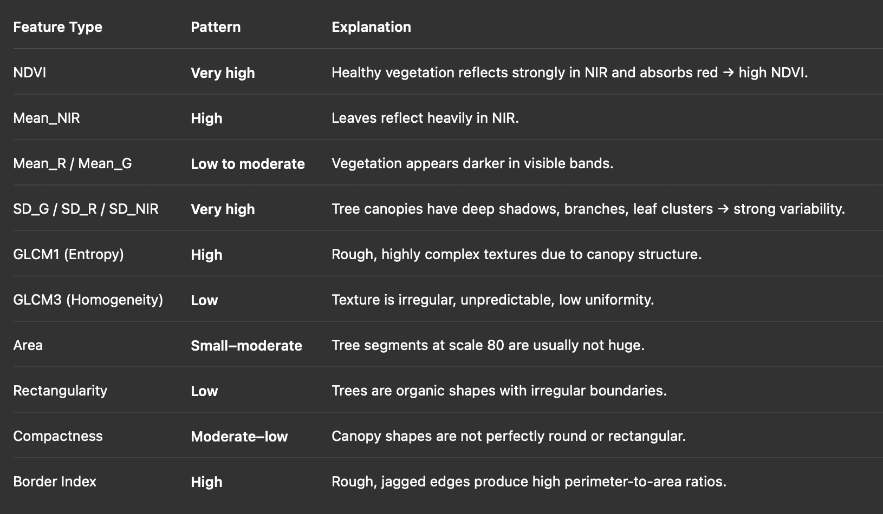

Buildings:
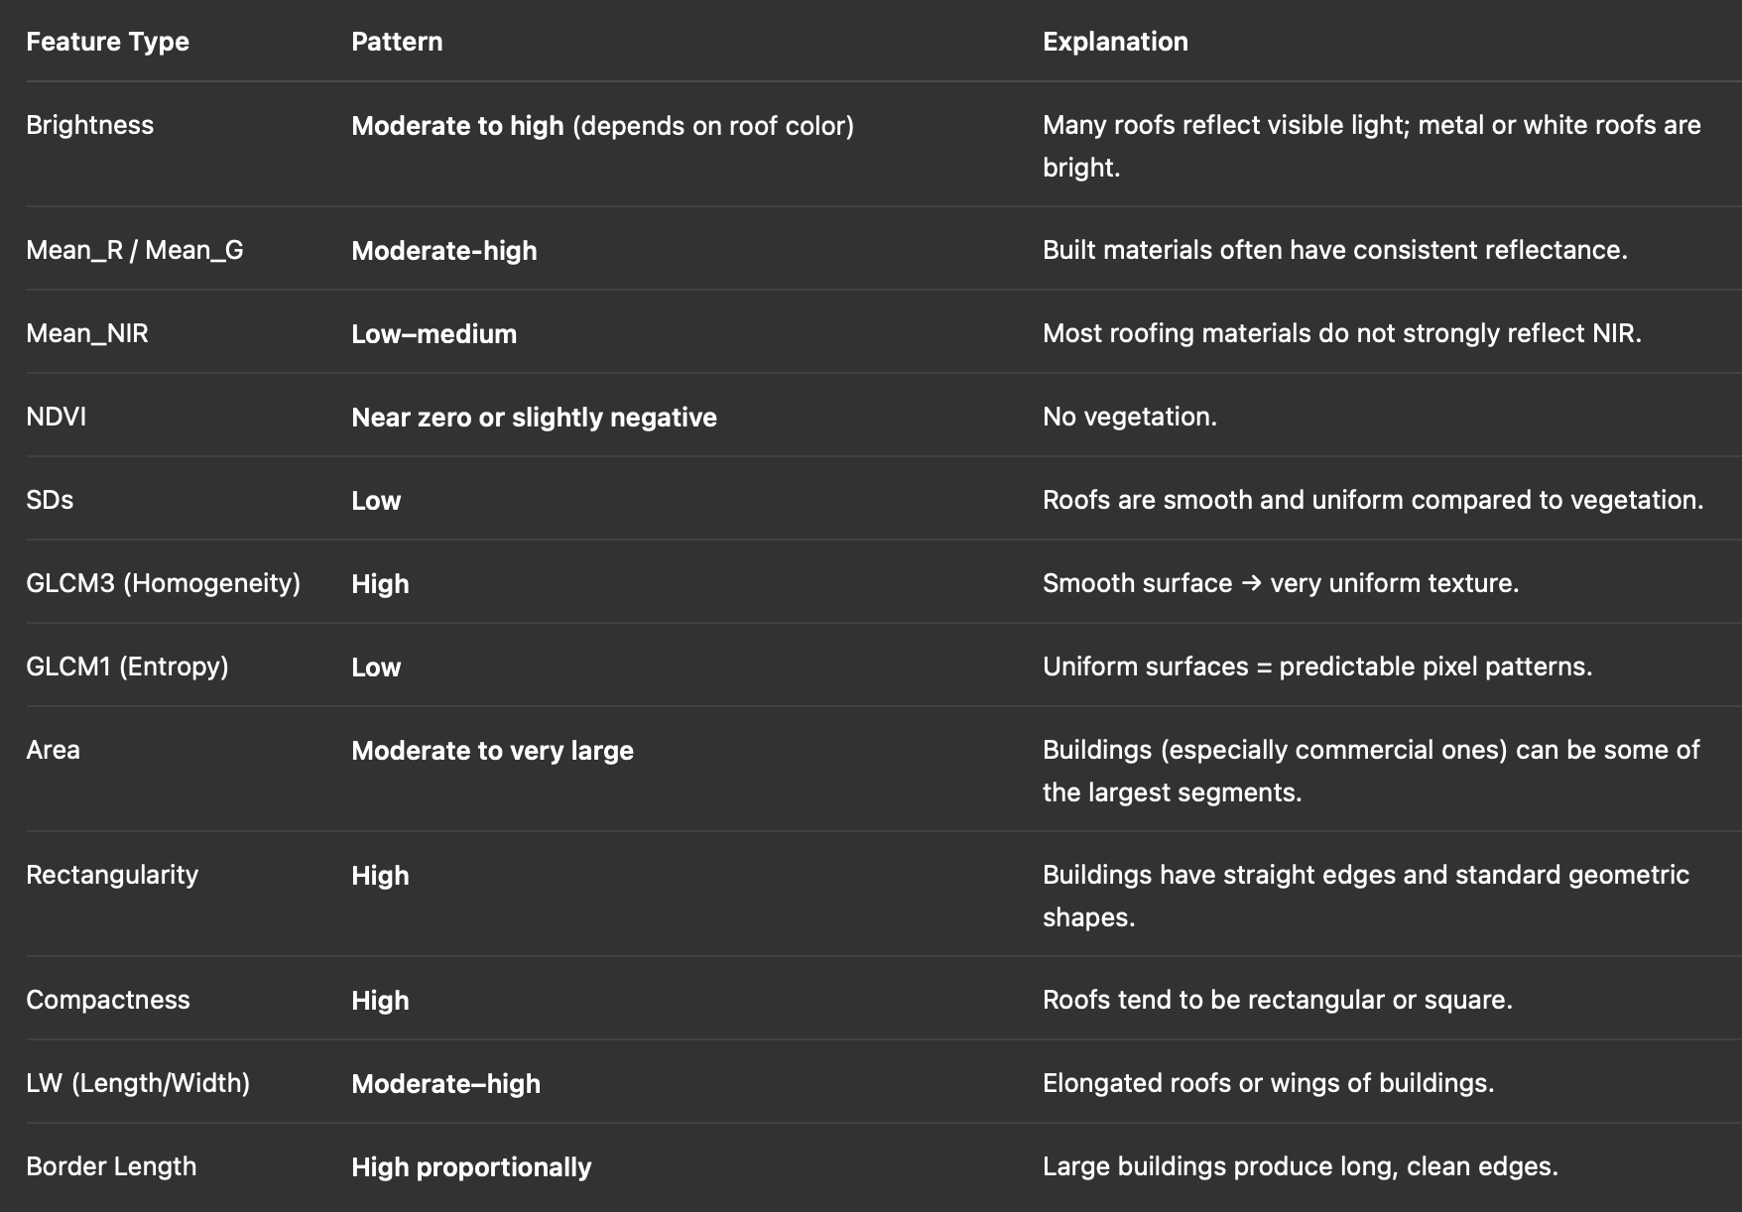

Grass:
- High value for Mean_G, Mean_NIR, NDVI
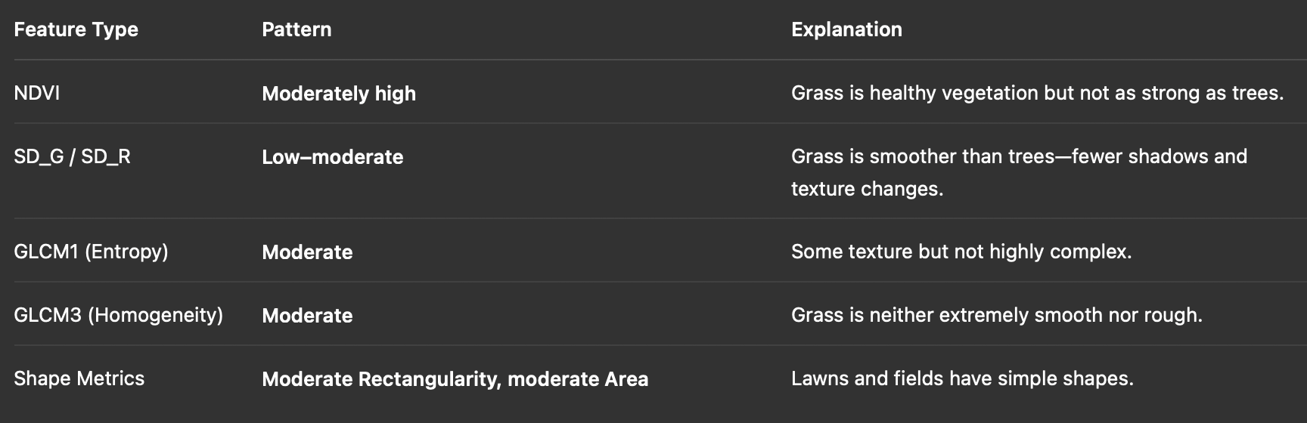

Soil:
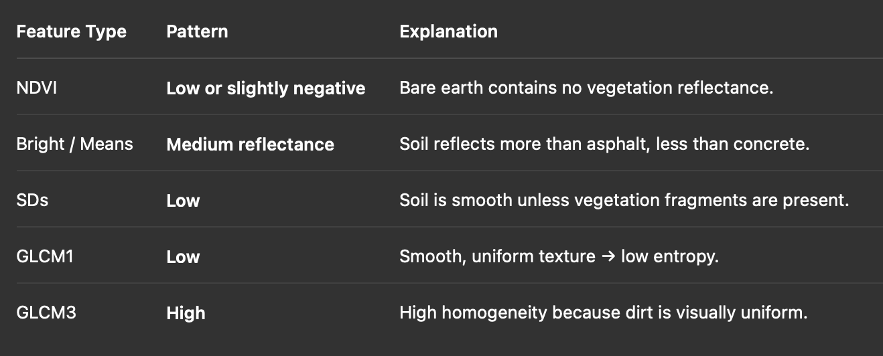

Concrete:
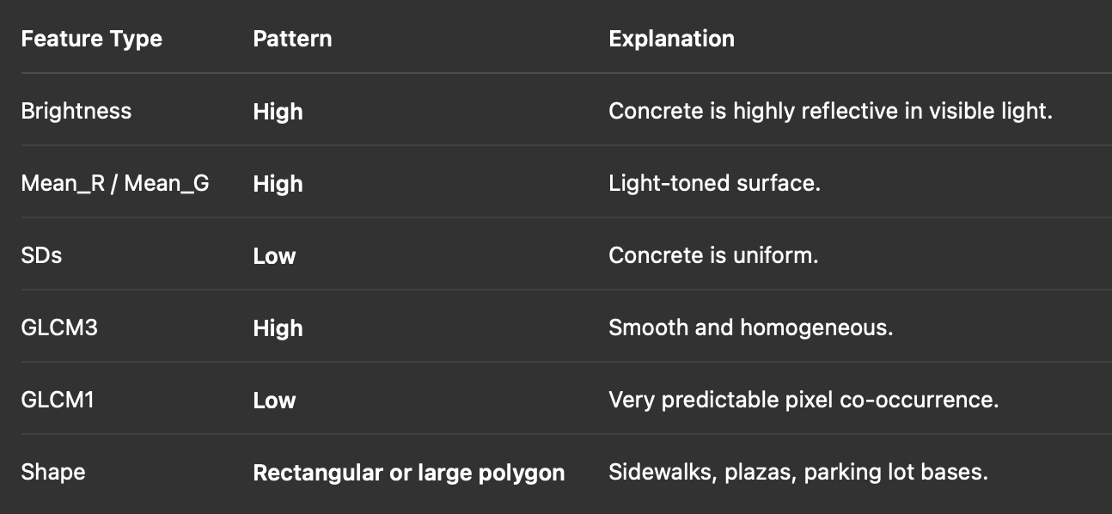

Asphalt:
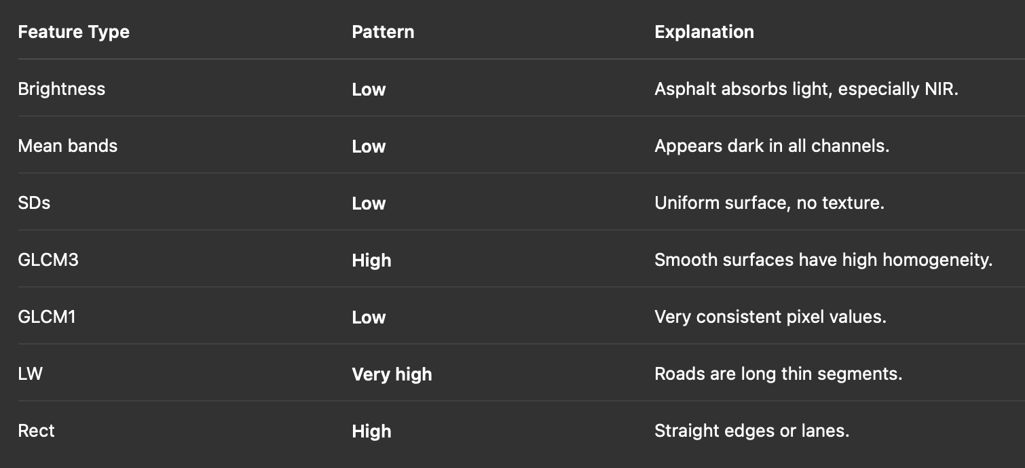

Cars:
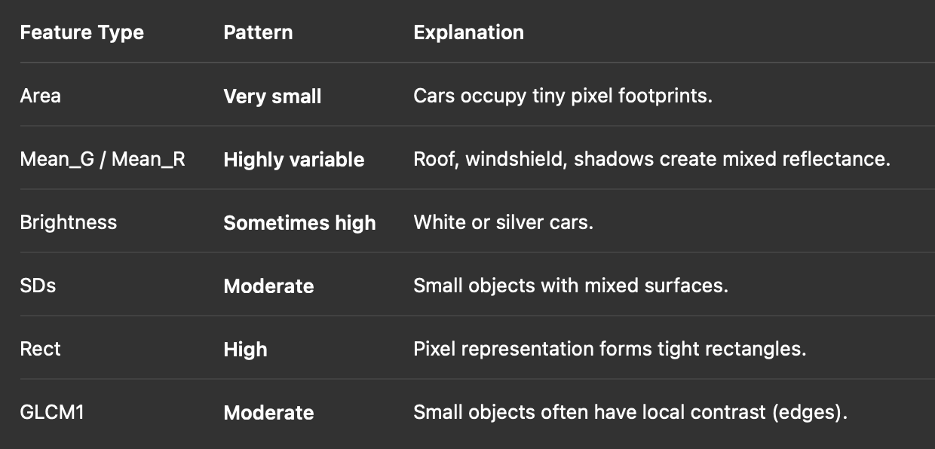

Pools:
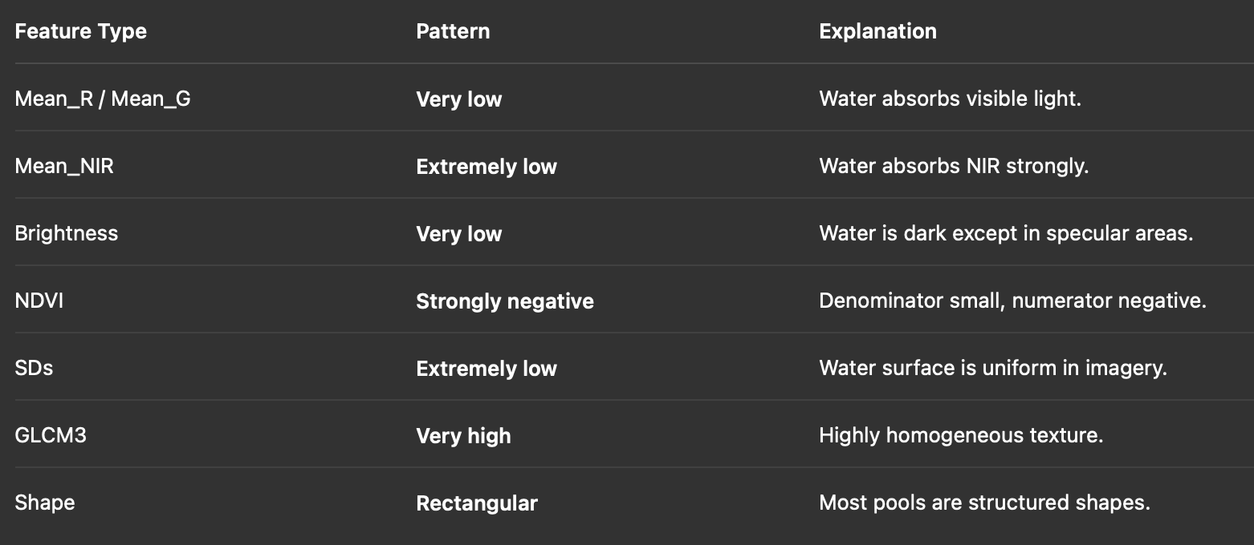

Shadows:
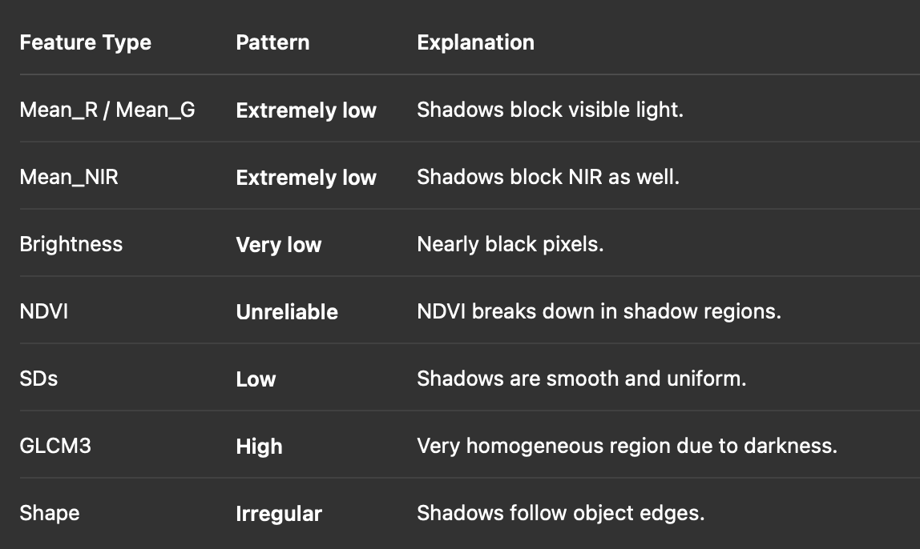

Correlation Significance:
- Many of the spectral variables (Bright, Mean_G, Mean_R, Mean_NIR) have many insignificant correlations with a lot of the texture variables
  - bright surfaces can be smooth (concrete) or rough (rocks)
  - dark surfaces can be either textured (trees) or uniform (asphalt, shade)
    - Thus there is no distinct pattern here, as you could have any value for Bright and it would tell you nothing about the texture components
  - This would further indicate that these sorts of variables tell us very different things and that the combination of having both of them is extremely helpful for predictive power

Feature Removal:
- Got the pairs with correlations > 0.9
Features to remove: "Bright" "Mean_G" "BrdIndx" "SD_G" "GLCM1"
- "Bright" "Mean_G" → Both can be represented by Mean_S so we will remove those ones and only keep Mean_S
- "BrdIndx" → Highly correlated with “ShpIndx”, can be represented by that as well
  - Since both metrics measure very similar things (see formulas), it makes sense for them to be highly correlated (both use Perimeter:Area ratio)
- SD_G → Can be represented by the inverse of SD_R
- GLCM1 → Can be represented by the inverse of GLCM3
  - GLCM2 is very similar to GLCM1 but doesn’t have as strong of correlations by magnitude

Feature Log Transformation +Normalization:
- Need to log scale many of the variable that I have lots of high end outliers for
Features to log₁₀(1+x) transform : Compact, LW, Area, BordLngth, SD_R, SD_NIR, Round, GLCM3
- The 1 + x just ensures that no features have a negative output value, as the log function makes anything <1 a negative output
  - Correlation between SD_R and SD_NIR = 0.8801941 → Consider removing one later on
- Need consistent scales prior to running any PCA for visualization or any classification metrics

- Feature Removal
- 16 remaining features (16/21 pred columns)
  - Removed 1."Bright" 2."Mean_G" 3."BrdIndx" 4."SD_G" 5. "GLCM1"
- Feature Transformation
- Feature Normalization
- 8 features were log transformed (8/16 pred columns)
  - Transformed: Compact, LW, Area, BordLngth, SD_R, SD_NIR, Round, GLCM3

Summary Statistics:
- Said this is needed in assignment directions
- Ensure that our target is a factor

4. Data Pre Processing
- Transformed variables already prior to normalization
- Normalization was included as a Data Preprocessing step on the rubric

5. Clustering
Steps:
- Remove target label
- Determine proper clustering algorithm to use
- Try k-means with k=9 since I have nine class labels
- Try hierarchical clustering to get an idea for the number X of clusters that “naturally occur”
  - Use “wards distance” as the linkage metrics
- Try running k-means with X clusters that resulted from Hierarchical
- Determine optimal number of clusters using..
  - Silhouette Score
  - Elbow Plot
- Run K-means with the “optimal” number of clusters

- Then run PCA:
  - Dimensionality Reduction?
  - See if we get any interpretable power from out PCs?
  - Visualize the first two PCs colored by our classification to see how well they can visualize as well?

Try k-means with k=9 since I have nine class labels:
- Cluster sizes are much more evenly distributed that the class labels
  - Indication that clusters will appear heterogenous
- Roughly 72% of variance is explained by the clusters
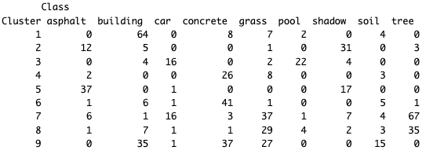
- Not the best separation from these
  - Cluster 1 is almost all buildings
    - High Rect score
    - Low Shape Index
  - Cluster 2 is mostly shadows
  - Cluster 3 is mix of car/pool
  - Cluster 4 is almost all concrete
  - Cluster 5 is almost all asphalt/shadow
    - Low score for any brightness metrics?
    - High score for smooth texture?
  - Cluster 6 is almost all concrete
  - Cluster 7 and 8 are mostly tree/grass
    - High NDVI scores
    - Low Mean_R scores
    - High Mean_NIR
    - High SD_R
  - Cluster 9 is very heterogeneous

Determine Optimal K from K-means:
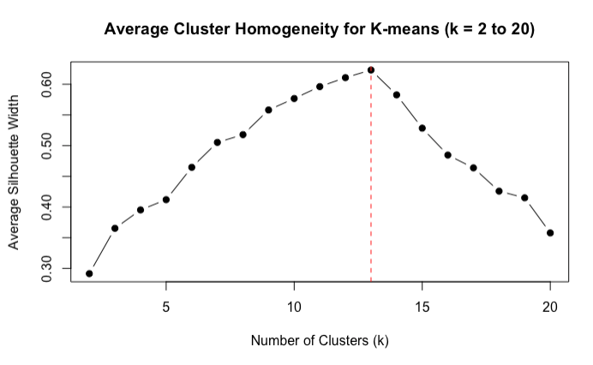
- 13 is optimal, 13 is very close

Try hierarchical clustering to get an idea for the number X of clusters that “naturally occur”
- Use “wards distance” as the linkage metrics
Dendrogram:
- At height = 15 → 16 clusters
- At height = 20 → 14 clusters
- At height = 25 and 30 → 11 clusters (good separation)
- At height = 35 → 9 clusters
  - Clusters 2 and 4 from k=11, merger when k=9
- At height = 45 → 6 clusters
- At height = 50 → 5 clusters → Optimal splitting based on class proportions
- At height = 60 → 4 clusters

Determine optimal K from Hierarchical:
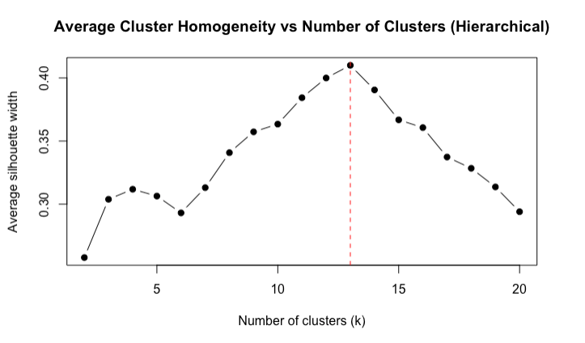
- Optimal was k = 13, 12 is very close

Try running each algorithm with the optimal K:
- k-means with k=13
- Hierarchical with k=13

Compare agreement between k=9 and k=13 directly (Contingency Tables):
- k=9 (number of class labels)
- k=13 (Optimal from hierarchical and k-means)
  - Look at overlap between points in all 4 clusters
The contingency tables show how much the two algorithms agree when using the same number of clusters → Think of the tables as confusion matrices between clusterings
- Want to see only one value in each row/col
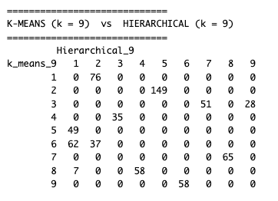
- K-means cluster 2 is the same as hierarchical cluster 5
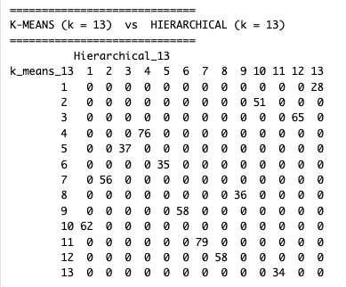
- Have perfect agreement (only one value per row/col)
- Every distinct cluster in k-means is exactly one distinct cluster in hierarchical
  - They found all the same clusters but just labeled them different numbers

Find any subcluster at any k-value that had perfect homogeneity
- Figure out the characteristics of the points in those clusters

PCA for visualization:
- visualize the clustering results by making a PCA projection and coloring the points by cluster assignment
- Run PCA on your scaled numeric features
- Build a PC1–PC2 scatterplot
- Color the points by any cluster assignment
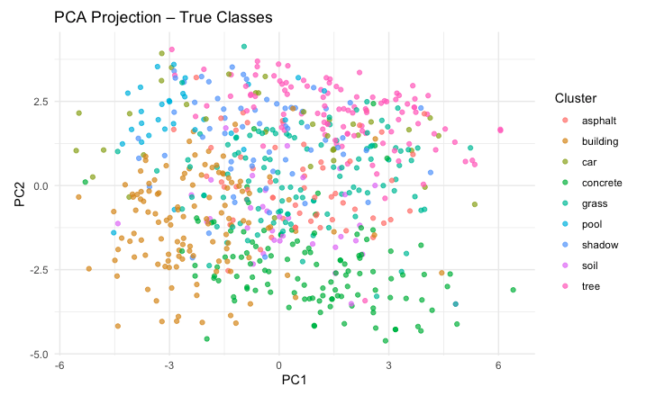
- The first 2 PCs only account for about 60% (0.5994647) but not many distinct “cluster” shapes
  - We can see some general patterns:
    - Buildings (yellow) are bottom left
    - Concrete/Grass (Greens) are bottom middle/right
    - Pool is top left
  - Knowing that these are not the most representative of the patterns in the entire dataset, this is a pretty good starting point

MDS Visualization:
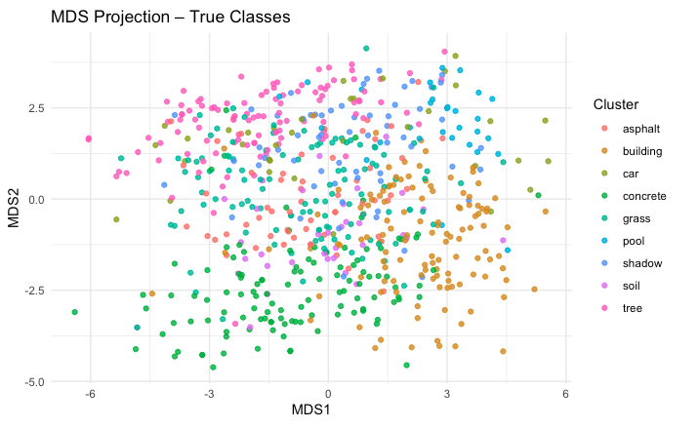

6. Classification:
Must do two methods:
- Follow the process for choosing the best parameters for your choice of classifier
- Compare the accuracy of the two.

k-NN, Random Forest, SVM

k-NN:
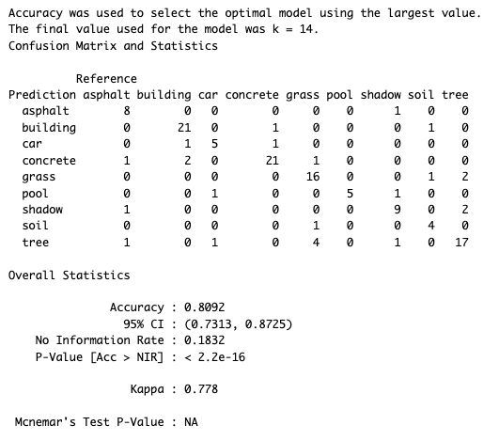

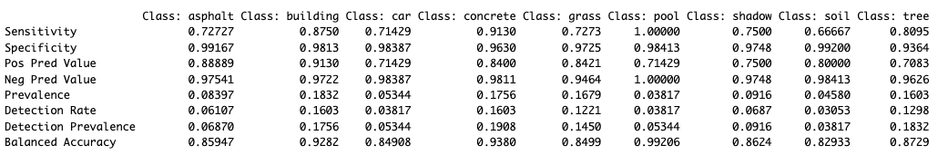

Sensitivity/Recall (Out of all actual in this class, how many did you find):
- pool (1.000) → Perfect
- concrete (0.913) → Excellent recall
- car (0.857) → Very strong
- tree (0.857) → Very strong
- building (0.7917) → Solid
- asphalt (0.7273) → Good
- grass (0.6364) → Weak
- shadow (0.6667) → Moderate
- soil (0.3333) → Very poor recall

Specificity is high across the board
- Not many false negatives

Precision (When you predicted this class, how often were you right?)
- soil (1.00) → High Precision but low sensitivity
  - The few times it predicted soil it was correct, but failed to predict it many times it actually was
- building (0.9048) → Excellent
- car (0.750) → Very good
- concrete (0.750) → Very good
- pool (0.8333) → Very high
- tree (0.6923) → Solid
- grass (0.7368) → Decent
- shadow (0.7272) → Good

Random Forest:
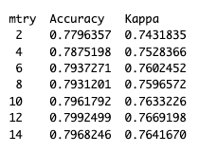
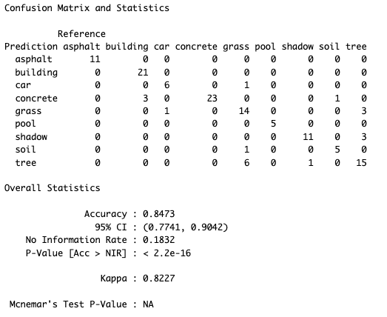
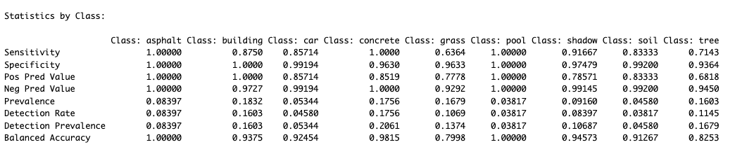

7. Evaluation
- Bin to two classes (Vegetation, Non-Vegetation)
  - (252) Vegetation: trees, grass, soil,
  - (423) Non-Vegetation: concrete, asphalt, buildings, cars, pools, shadows.
- Rerun the RF model with only the two classes
- produce a 2x2 confusion matrix (if your dataset has more than two classes, bin the classes into two groups and rebuild the model)
- calculate the precision and recall manually
- Produce an ROC plot
- Explain how these performance measures makes your classifier look compared to accuracy.

8. Report + Reflection
HW5 - Report

9. Reflection

