CSC 555 / DSC 333 – Spring 2026 Peter Bondarenko

Assignment 3
(Due: 5/6)

Kurtis Hausman
Please submit a .docx or .pdf file for your written responses and the requested screenshots. Please be sure to also submit all your Python code as a .py file. Please do not use zip.

1. (4 pts) CIDR Review
Please refer to the CIDR_Notation_Guide that was posted on D2L under Week 4 for background reading on this.
Find the number of IP addresses span by the following CIDR range: 140.192.182.72/32.
(note that this was the CIDR range that AWS filled out when I chose MyIP as I was configuring the inbound rules for the ElasticMapReduce-master security group to allow SSHing into the Hadoop primary node over port 22).
2⁽³²⁻³²⁾ = 2⁰ = 1
A /32 prefix means all 32 bits are locked to the network address, leaving 0 bits free to vary. This means the range describes exactly one specific IP address, namely 140.192.182.72. There is no distinction between network address and host address as the single address serves as both.

2. (4 pts) Copying Data: Laptop -> S3
In this exercise we will import a data file into the csc555-hw2-<youriamusername>/input S3 folder that we created on the last assignment.
Download the u.data file from D2L to your laptop and upload it to your S3 folder. Take a screenshot of your S3 folder with the data file in it (as below).
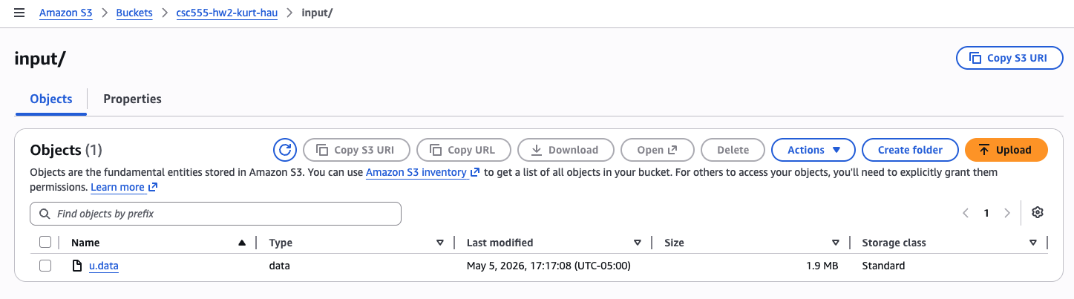
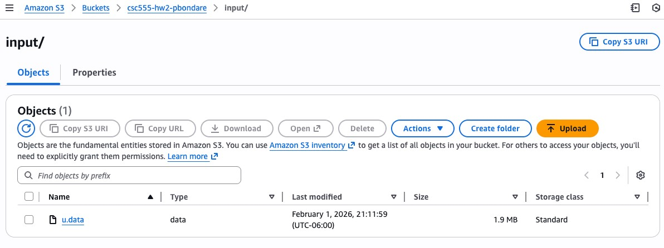

3. (8 pts) Elevate the Privileges of the EMR Service Role and the EC2 Instance Profile
As we have discussed in class, the AWS EMR service utilizes various other AWS services under the hood: for example, it uses the AWS EC2 service to create the cluster nodes, it needs to be able to read from AWS S3 for input data, and write to S3 to save any results, etc.
- An EMR service role is an IAM role that grants the EMR service permission to access and manage AWS resources like EC2 instances, S3, security groups, logs etc. It is crucial for provisioning clusters, launching instances, and performing automated tasks, functioning independently of user-specific permissions.
- An EC2 instance profile is a secure container for an IAM role, allowing us to pass temporary permissions to an Amazon EC2 instance when it launches, eliminating the need to embed AWS access keys directly on the instance. It acts as an identity for our EC2 instance, granting it access to other AWS services like S3 using temporary credentials provided via the instance metadata service, enhancing security and simplifying credential management.

- (4 pts) Elevate the privileges of the default AmazonEMR-ServiceRole so that it has administrator access to all AWS resources. Provide a screenshot of your service role’s permissions (as below).
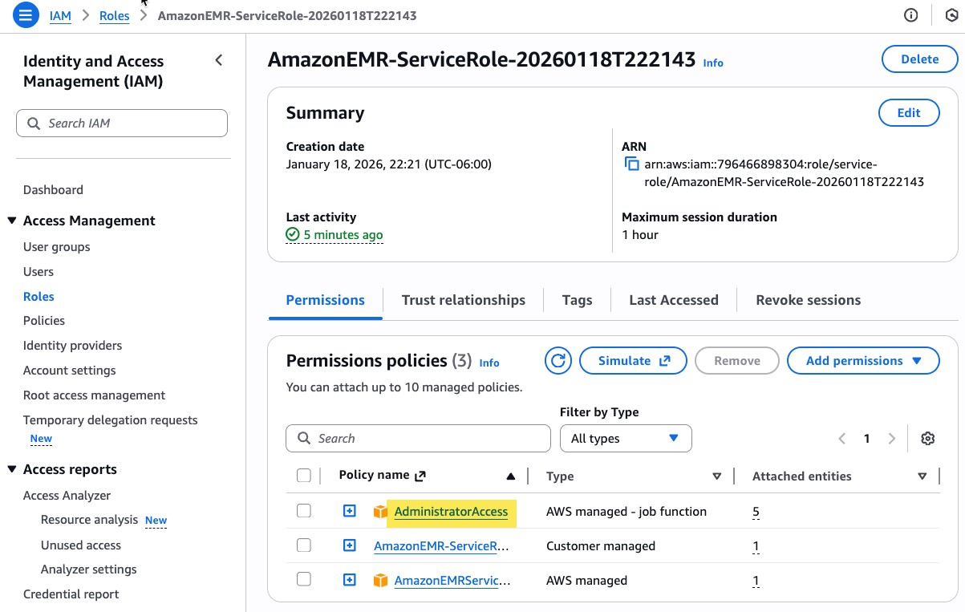
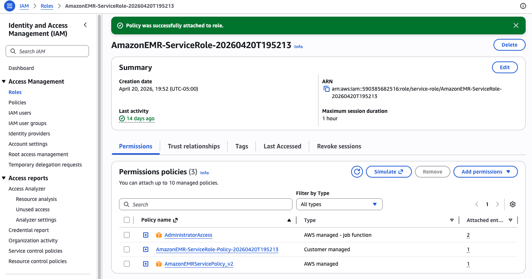
- (4 pts) Elevate the privileges of the default AmazonEMR-InstanceProfile so that it has administrator access to all AWS resources. Provide a screenshot of your instance profile’s permissions.

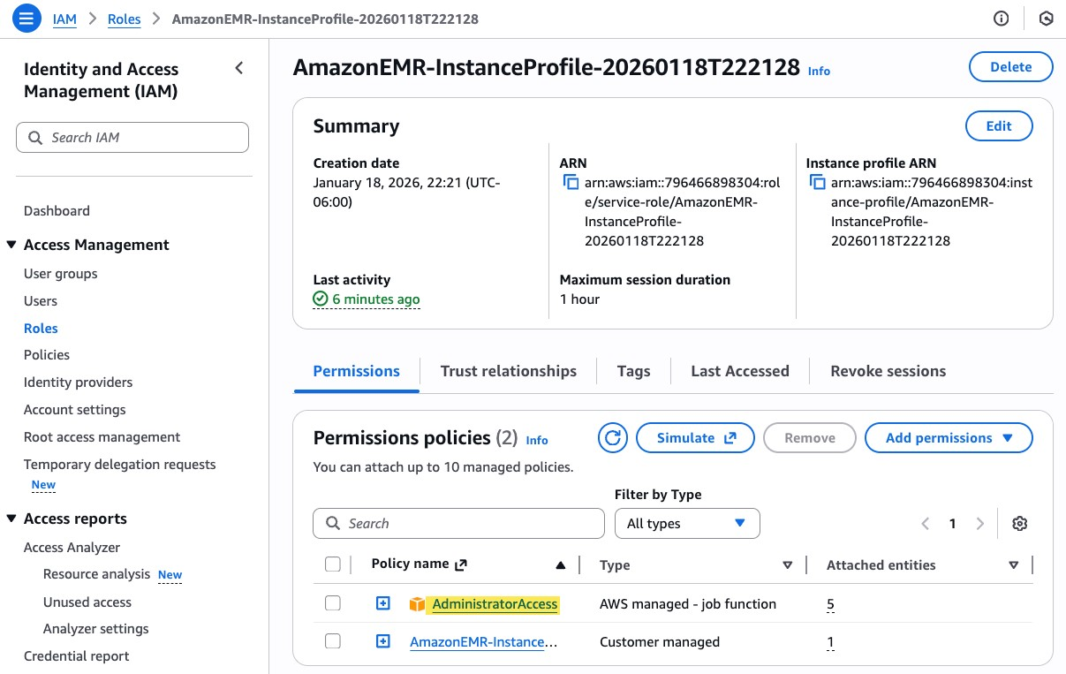
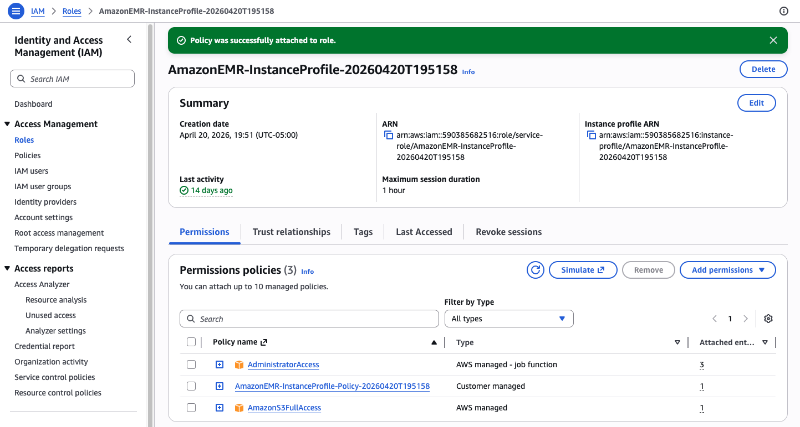

4. (30 pts) Creating a Hive Table and Querying Using SQL
Recall the Hadoop architecture from class:
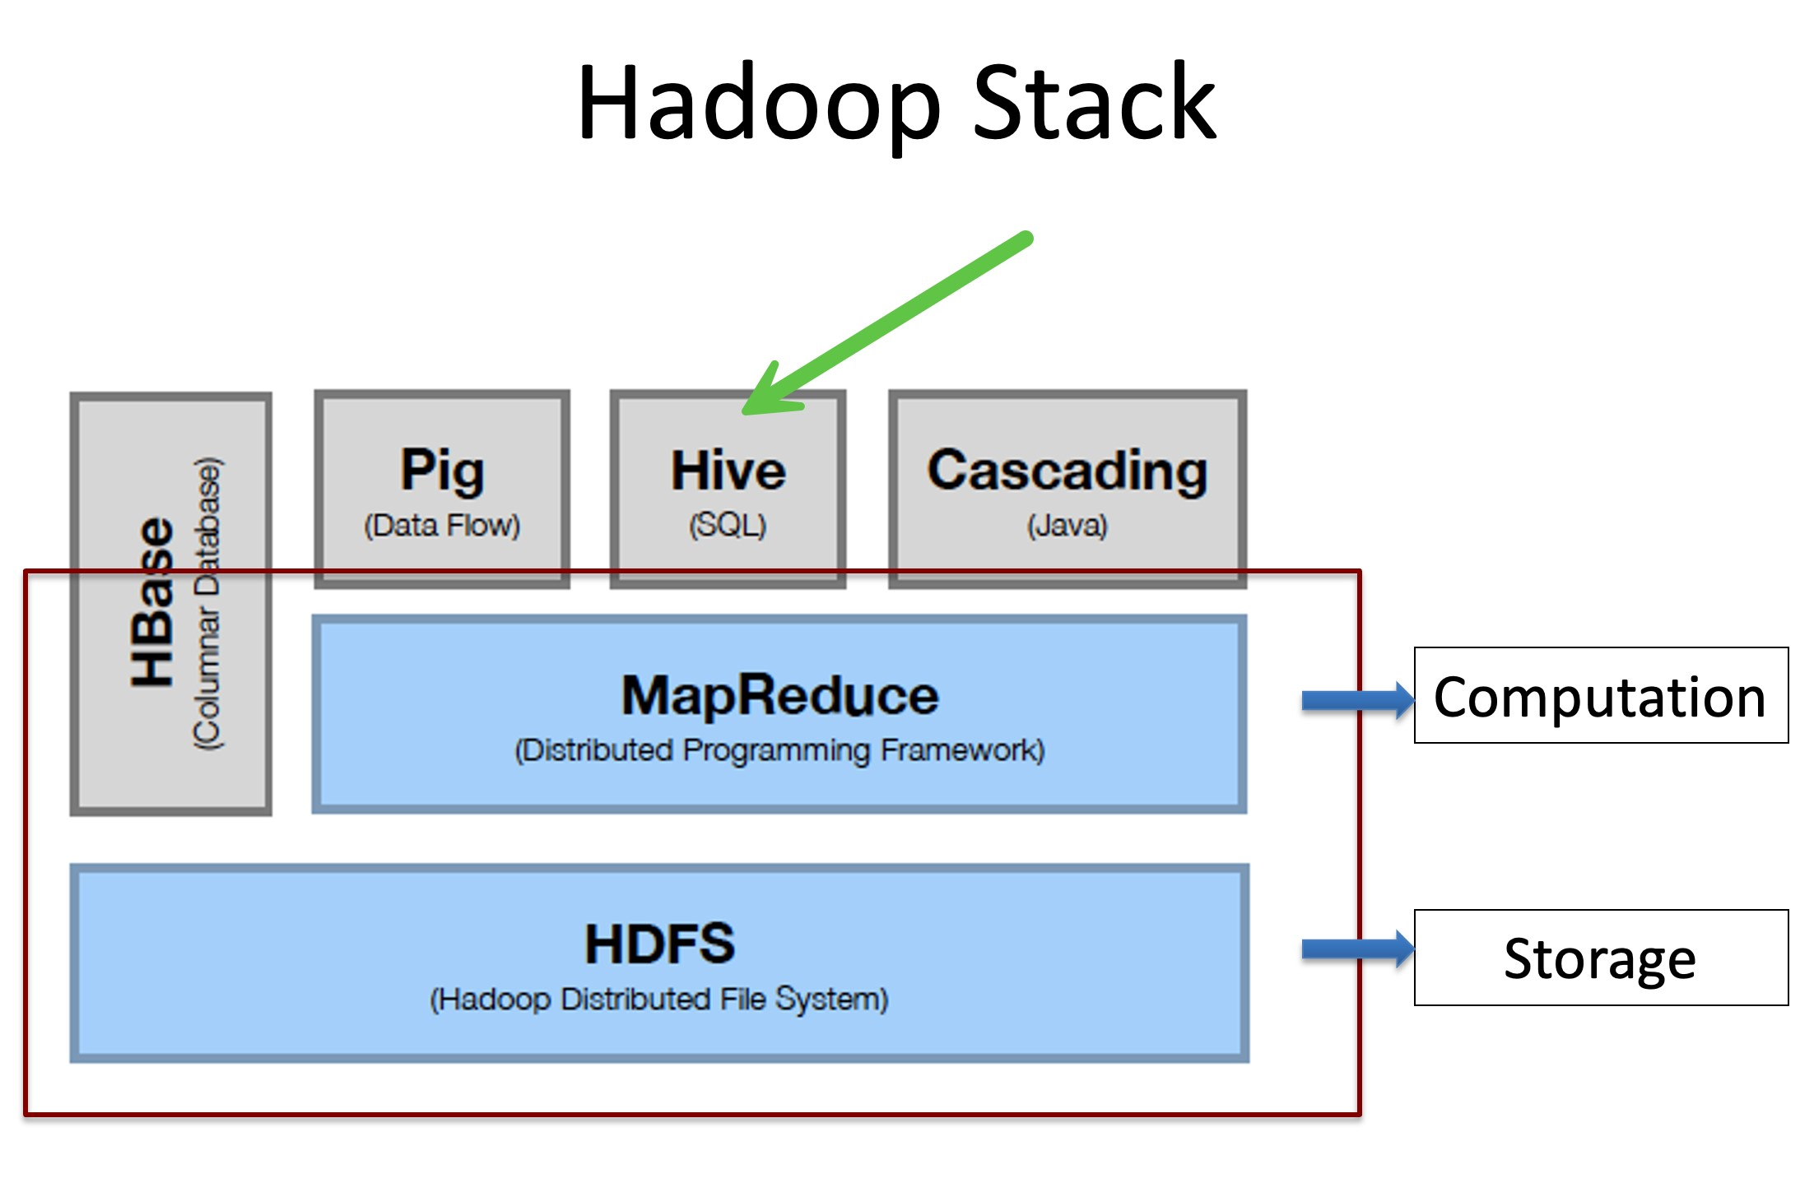
Hive allows us to use SQL to query the underlying data that is stored in HDFS as loose files. In this part of the homework, we are going to use Hive on the EMR cluster that we created to load a data set from S3 into HDFS and then query it using SQL.
- (4 pts) Use the EMR cluster that you created in Assignment 2 to clone a new Hadoop cluster. Please make sure to include your EC2 key pair as we will need that to SSH into the primary node.
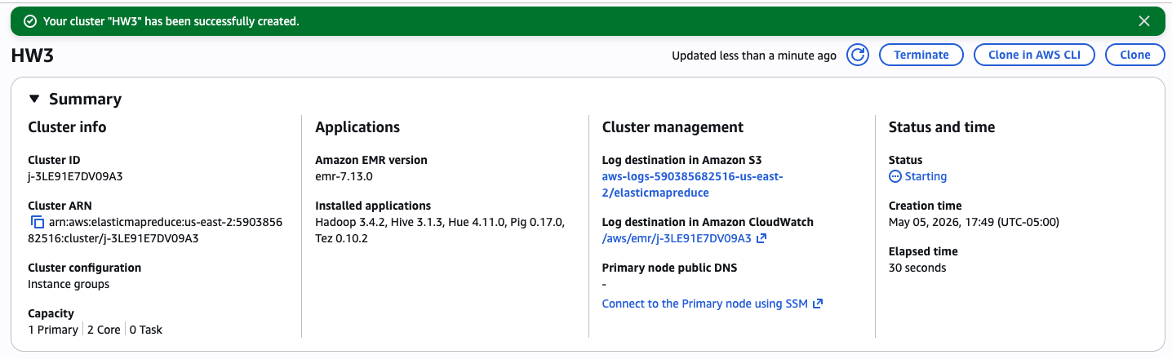
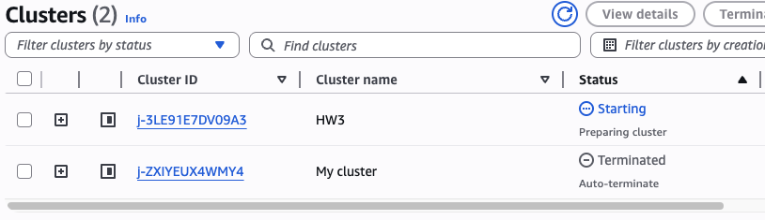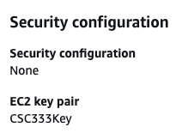

- (4 pts) SSH into the primary node of the new EMR cluster and provide a screenshot of the output of the following command: hadoop fs -ls (note that you have to SSH using the hadoop user for this command to work, as we experienced during class)
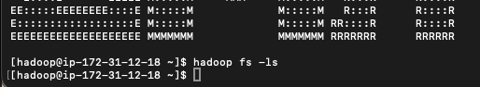

- (6 pts) Copy over the u.data file that you uploaded to S3 into the local file system of the primary node using the following command:
aws s3 cp s3://csc555-hw2-<youriamusername>/input/u.data u.data Provide a screenshot of the output of this command.
- (4 pts) Verify that the file has been successfully copied over by running the following commands: pwd ls -al
Provide a screenshot of the output of these commands.
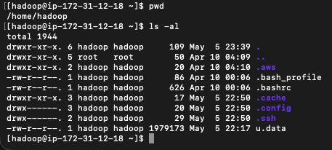
- (6 pts) The u.data file contains the MovieLens data set consisting of 100K movie ratings (1-5) from 943 users on 1682 movies. The data is a tab separated list of user id | item id | rating | timestamp, where the time stamps are Unix seconds since 1/1/1970 UTC.
Start a Hive shell using the hive command, and create a table called u_data using the u.data file that we brought into the primary node, as we did in class using the code in the slide below.

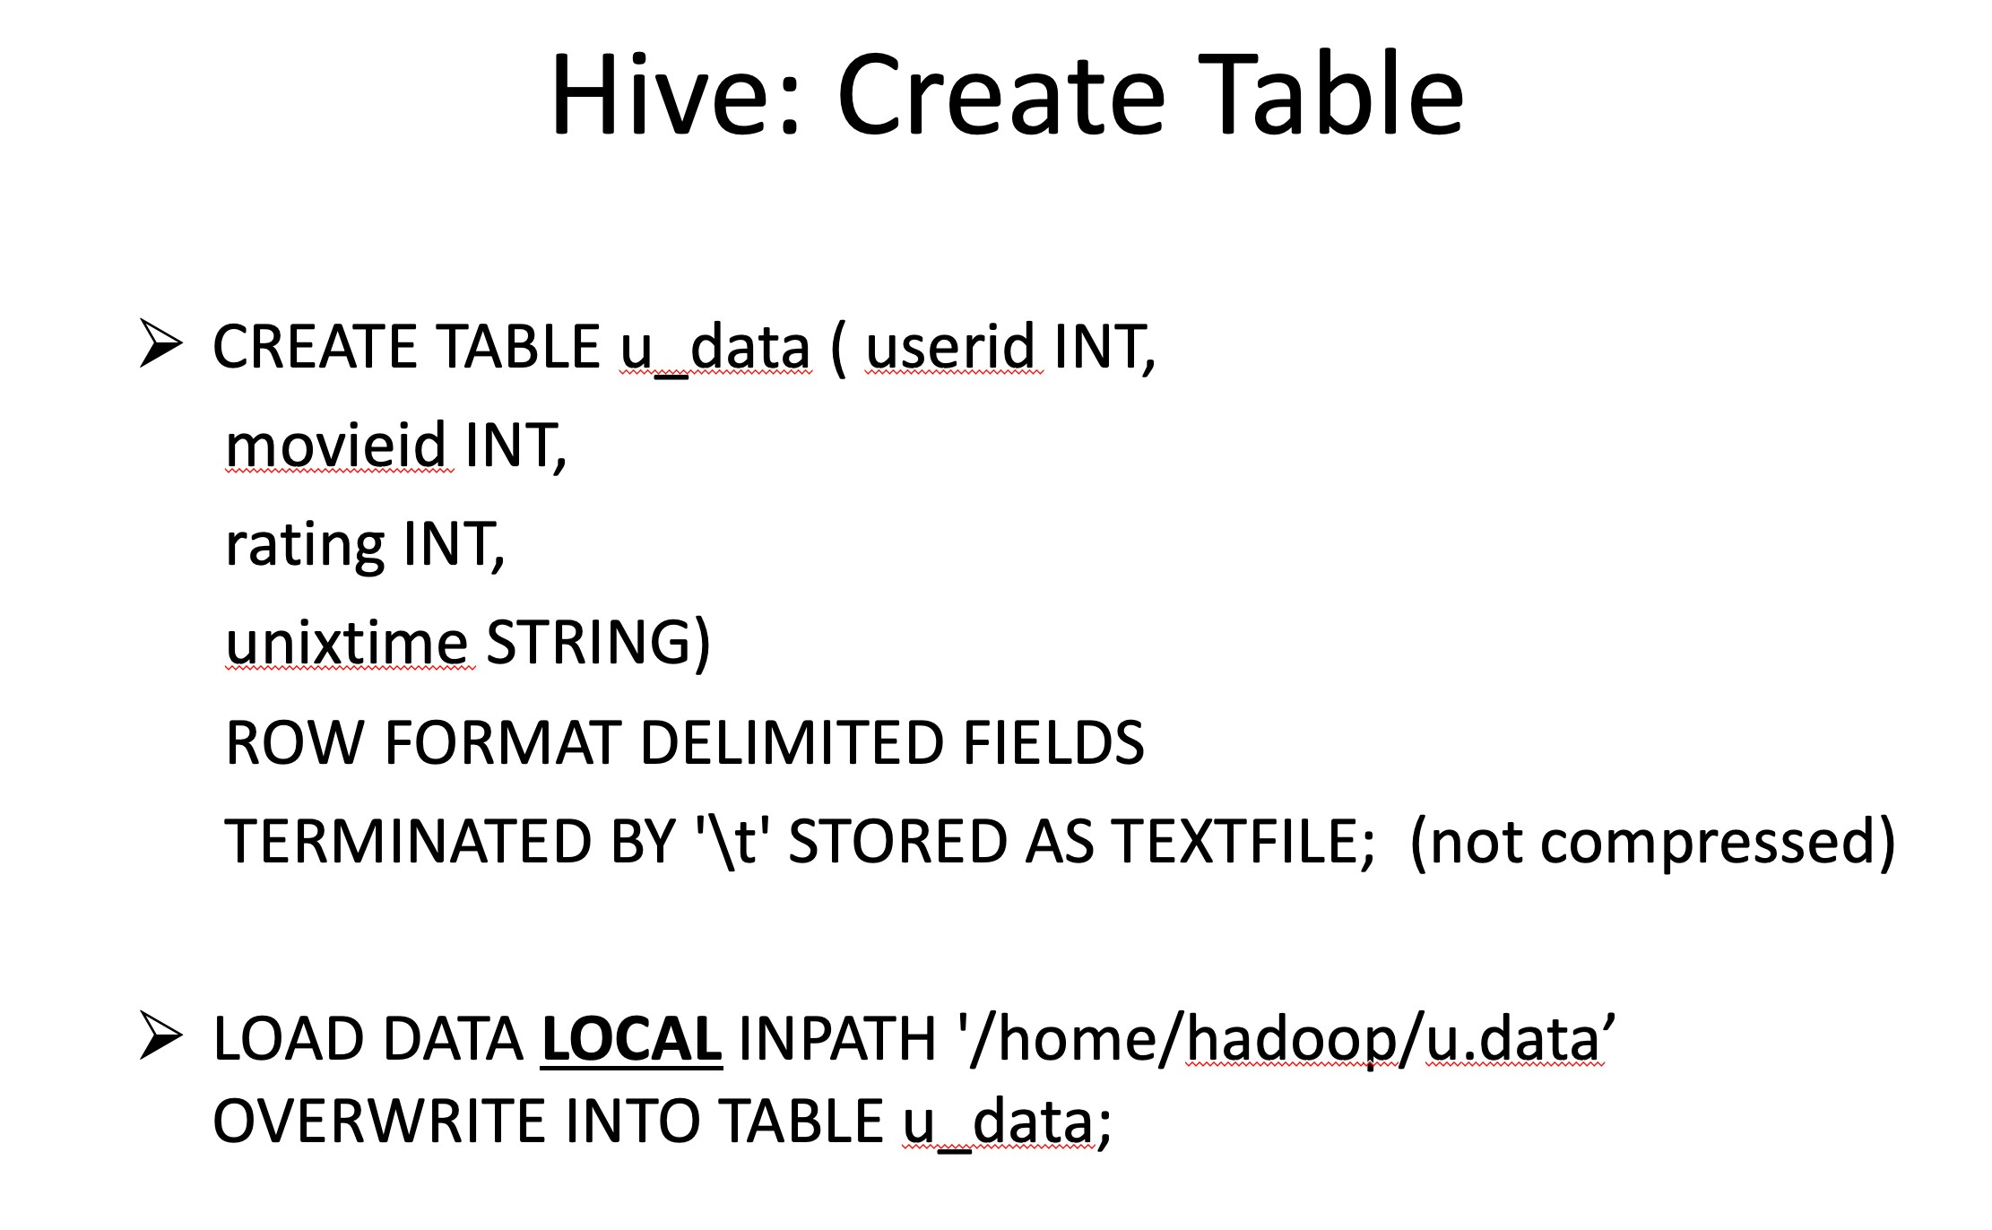
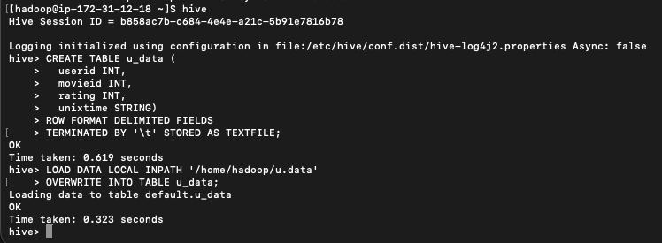
- (6 pts) Run the following queries using Hive on the u_data table and provide a screenshot of the
results for each one:

SELECT * FROM u_data WHERE userid = 550;
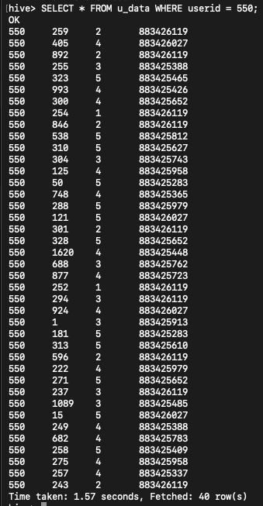
SELECT userid, AVG(rating) as AR from u_data GROUP BY userid ORDER BY AR;
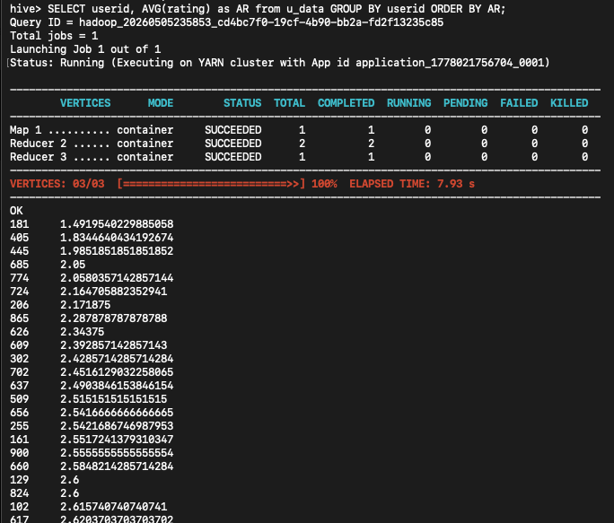

5. (22 pts) Transforming the Data Using Python
The Unix timestamps are difficult to work with. We will transform them into weekdays using Python.
- (6 pts) Exit the hive shell using the exit; command. The weekday_mapper.py file in D2L contains simple Python code that transforms a Unix timestamp into weekdays. Download the weekly_mapper.py file from D2L and bring it all the way to the primary node, following the same steps you did for the u.data (laptop -> S3 -> primary node). Provide a screenshot of the output of your aws s3 cp command.
- (4 pts) Verify that the file has been successfully copied over by running the following commands: pwd ls -al
Provide a screenshot of the output of these commands.
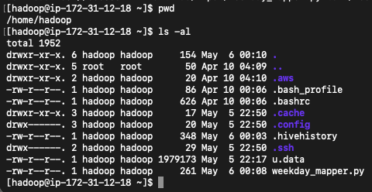
- (6 pts) Start a hive shell again and type the following commands to create a new table called u_data_new with a transformed date column that includes just the weekday:
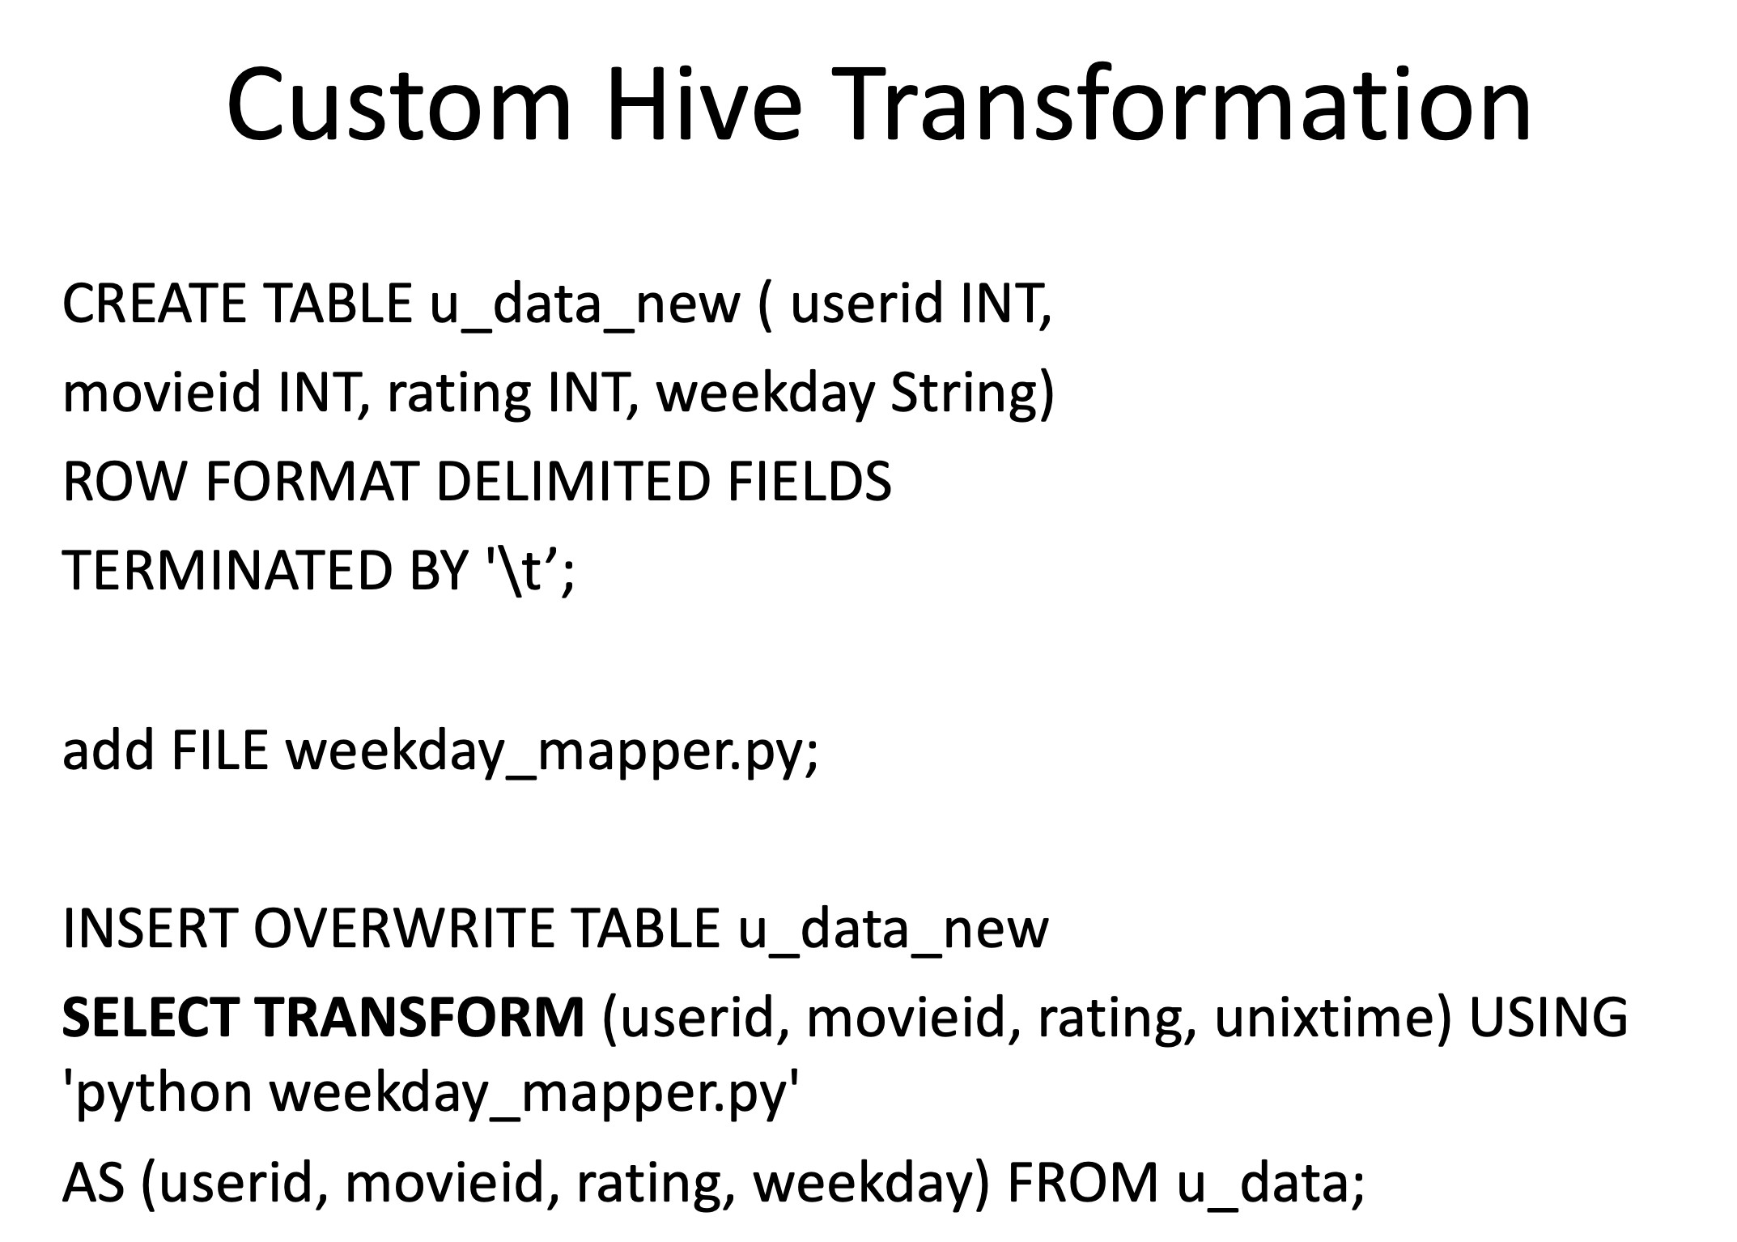
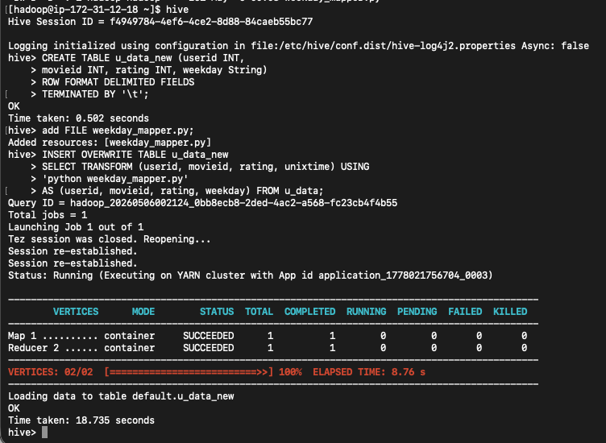
- (6 pts) Run the following queries using Hive on the u_data_new table and provide a screenshot of
the results for each one:

SELECT weekday, COUNT(*) FROM u_data_new GROUP BY weekday;
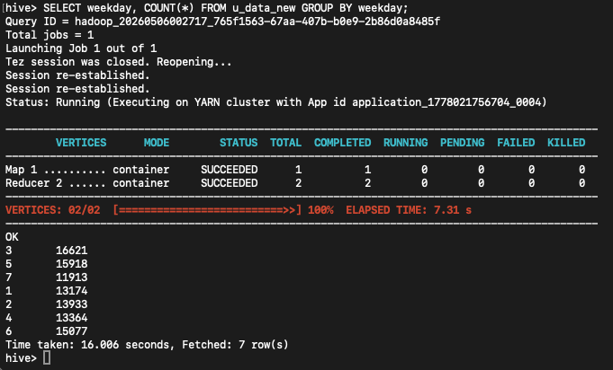
SELECT weekday, COUNT(*) as Total
FROM u_data_new GROUP BY weekday
ORDER BY Total;
