Sources vs. Information vs. Evidence vs. Proof

Source vs. Information
Sources are artifacts, books, documents, film, people, photographs, recordings, websites, databases, etc. Our evaluation of a source begins with its physical form: that is, whether it is an original or a derivative. Within this context, we consider such physical qualities as the condition of the record, the legibility of the image or the penmanship, or the skill with which the derivative was made.

Information refers to the content of a source—its factual statements or its raw data. The strength of any information depends upon the knowledge of the informant. Firsthand knowledge represents primary information. Hearsay or secondhand knowledge produces secondary information.

As careful researchers, we note these differences when we extract material from a source.

Information vs. Evidence
The information statements we find in sources are not “facts.” They are only assertions. Many assertions in historical records are false. Many statements are ambiguous or open to interpretation. Many words used in the past carried meanings different from those we apply today.

Evidence is our interpretation of a piece of information that is relevant to our research problem. If the evidence explicitly addresses our problem, it is direct evidence—which may or may not be true; we still need to support it with other evidence, independently created. If our evidence is in some way relevant to our problem but it does not explicitly state a solution, then we have indirect evidence. In that case, we might combine it with other evidence to build a case.

Source vs. Proof
No single source can prove a point of history. Sources err. They quibble, exaggerate, and misremember. Sources are biased. They have egos and ideologies.

Sources inform us, but the proof we ultimately offer will be the body of evidence we assemble to support our conclusion. Sound conclusions reflect four things:
- thorough research and documentation;
- accurate interpretations of the information;
- careful correlation of all the evidence;
- a well-reasoned, well-explained analysis or proof argument.
None of this, of course, is to say that an original source is always better than a derivative, that primary information is always better than secondary, or that direct evidence is always better than indirect. Life is never so simple.
Reaching sound conclusions about the past requires us to think past all labels. We cannot assign points on the basis of categories and seize upon whatever chalks up the most points. When we have conflicts between sources, we cannot count how many sources agree and how many disagree, then go with the “consensus.”

On the other hand, when we have conflicts and stalemates in our research, we often find the roots of our problem by thoughtfully considering three things—source by source, line by line:
- the quality of each source we used,
- the quality of the information taken from those sources, and
- the nature of the evidence we drew from the information we found.
This type of thoughtful analysis will reveal holes in our research. It will spotlight flaws in our logic. And it will point the way to additional records of value to our research.

Original Records, Image Copies, and Derivatives
Originals. True originals. Duplicate originals. Counterparts. Facsimiles. Photocopies. Scans. Digital copies. Image copies. Official copies. Record copies. Clerk’s copies. Certified copies. Certificates. Transcriptions. Translations. Extracts. Abstracts. Nutshells. Indexes. Databases. Reprints. Are we confused yet?
Historical research might be easy if we lived in a pristine world in which something is either true or it isn’t. If a kind of record is either reliable or it isn’t. Or if we could say: This record is an original, so I can trust it; but this is a derivative that may come back to bite me.
Considering all the sorts of records that exist, does it really matter which means or media we use to access them? Must we really quibble, in our research notes and citations, over the weight of a counterpart vis à vis a facsimile?
Yes—with caveats.

Why It Matters
Fake originals and faithful copies have always been a part of historical research. Technology changes things. Deceivers adapt. For researchers, the one constant across the morphing landscape of the documentary world is our need to be wary and analytical.
QuickLesson 2 introduced a basic concept: Sources give us information from which we select evidence. If research is thorough and findings are soundly analyzed, we might reach a conclusion. The body of evidence on which we base that conclusion is our “proof.”
In short: no information, no evidence, and no conclusion can be any better than the quality of each source from which we get each piece of data. That’s why we quibble.That’s why we even quibble about the quibbling!

Caveat No. 1
QuickLesson 2 also presents a basic framework for appraising our findings.
- Sources come in two basic classes: original and derivative.1
- Information comes in two basic classes: primary (firsthand) and secondary (secondhand).
- Evidence comes in two basic classes: direct and indirect.
So now, our first quibble: Derivatives can sometimes be more reliable than originals. Secondary information might be more reliable than primary. Quite often, well-assembled indirect evidence will get closer to the truth than a piece of direct evidence that supplies an outright answer to our burning question.
In short, we can’t just apply a convenient label to what we find and then file it away under “Gospel Truth” or “Treacherous Waters.”

Caveat 2
Most so-called records are not “true originals” at all. Technically, most are “derived” in some fashion. To weigh their worth, our credibility meter needs a sliding scale.
History has created enough paper records—original documents-—to plaster over every hill, vale, and sunken continent of Planet Earth. Our problem is access. We’re here. The records are there. Even if we go there, the originals may have been retired from public use in order to preserve them.
All this makes us grateful for derivatives that kind souls and capitalistic enterprises make available. It also begs for thoughtful quibbling.

The Big Divide
Theoretically, all those record types in our lead paragraph might be divided into two broad categories:
- formats that preserve the original content (and sometimes the form); and
- formats that process both the form and the content.
Before we can assign all those record types to one category or another, we need to understand what each represents. Evidence Explained, in its glossary and numerous text discussions, provides these definitions:
Original source: (Historical sense) One that is still in its first recorded or uttered form. (Modern U.S. law) A document that fits the historic definition of the term or the historic concept of “duplicate original,” below.2
True original: A redundant way of saying “original source.” The redundancy has a purpose, given that duplicates of various sorts are also called “originals” in legal and bureaucratic contexts.
Duplicate original: (Historical sense) a copy officially made at the same time as the official “original.” Examples: The grantor’s and grantee’s copies of a deed, simultaneously made; or the multiple copies of a census schedule that enumerators were required to make in certain years (Modern U.S. law) a “duplicate” means “a counterpart produced by a mechanical, photographic, chemical, electronic, or other equivalent process or technique that accurately reproduces the original.”3
Counterpart: (Historical sense) A synonym for “duplicate original." (Modern U.S. law) A synonym for either “original” or “duplicate original.”
Facsimile: An image copy, typically. This term, the basis for the now-ubiquitous “fax,” is also used for books that are reprinted exactly as the original appeared, without alteration.
Photocopy: A less-stuffy synonym for “facsimile.”
Scan: A facsimile made by an electronic device that “scans” a source to create digital data that can be printed or displayed electronically.
Digital copy: An image copy, displayed electronically.
Image copy: A photographic or electronic copy that can be printed or displayed electronically.
Record copy: A legal copy of a document, made by an official charged with creating and maintaining records.
Clerk’s copy: A copy made by an official and entered into a clerk’s record book; sometimes a copy made by an official for another legal purpose; typically a synonym for “record copy.”
Official copy: A copy made by an official for another purpose; the term is often used as a synonym for “record copy.”
Certified copy: An official copy with an added “certification,” attesting that the document was officially prepared. The fact that a copy is “certified” does not necessarily mean that all details from the original are provided.
Certificate: An official copy created on a preprinted form whose blanks are populated with data from the original or the record copy. The preprinted format typically means that the source data is now rearranged to fit the form and that data from the source will be omitted if the certificate form has no blank for it.
Transcript or transcription: An exact copy of a record, word-for-word, preserving original arrangement, capitalization, punctuation and spelling, as well as content.
Translation: A copy of a source in which the content has been expressed in a different language, making whatever amendments necessary to render the result grammatically and syntactically correct.
Extract: A portion of text quoted verbatim out of a record and enclosed in quotation marks. Unlike a transcript, it does not represent the complete record, but it is more precise than an abstract.
Abstract: (Notetaking context) a condensed version of a record, preserving all important details in original sequence. An abstract may contain verbatim extracts from the record, in which case those exactly copied words are placed in quotation marks.
Nutshell: A very abbreviated abstract that provides the gist of what the record is about but does not include all relevant details.
Indexes: A finding aid that selectively chooses names or words from a series of records or a narrative and points to its location within the indexed material.
Database: A digital finding aid that provides searchable access to pieces of data extracted from other sources or material items assembled from elsewhere.
Reprints: A replication of a previously published work. It may represent a new typesetting, it may contain added material, or it may be a “facsimile” reproduction.

Thoughtful Quibbling
Amid all these options, we can see the sliding scale at work. Some markers on that scale are obvious. A deed transcribed into a record book might be less reliable than the original or the counterpart preserved in personal papers; copying errors could affect the legal land description or the date of the transaction. A will transcribed into a record book might not be as reliable as the original or duplicate original filed in a probate packet; that official “record copy” might omit or wrongly name an heir.
Photography introduced new concerns. A photocopy of an affidavit from a legal case might be less readable than the original, depending upon the quality of the machine, the ink, or the paper. Microform images of a document collection might omit pages or create shadows or blurs that render some text illegible; and microfilm produced in the 1940s and 1950s is demonstrably inferior to later filmings. So, again, we quibble in our research notes, making a point to identify which filming we consulted and to describe any flaws in the image.
Digitization creates another layer of issues, positive as well as negative. A military record or a diplomatic dispatch, accessed through an online provider, might be more usable, or less so, depending upon which provider we are using. When multiple suppliers digitize the same set of microfilm, we might make radically different readings from the images they offer—especially if one provider used image-enhancement techniques such as those Ancestry.com applied to the 1851 census of Manchester, England.4 Thus, our research notes need to identify our provider as well as the source our provider cites.
(Shudder the thought that any of us, when we use digital images, would be so naive or foolish as to merely cite the original, on the assumption that all image editions are equal! If you still feel that way after reading this paragraph, stop now and click on the link in Note 4.)
Our willingness to quibble will usually determine whether our research hits brick walls or shatters them. Quibbles over differences between certificates and certified copies, extracts or abstracts, databases or images—all can affect the reliability of the information we take from our sources and the credibility of the conclusions we draw from that information. All this is why, when we access a source, we take the time to do two things:
- analyze exactly what we have; and
- identify our source as precisely—and as descriptively—as possible.

Practical Quibbling
Once we have thoroughly described our source, we are ready to get practical about our handling of all those record types. This is when we apply that “big divide” described above:

Formats that PRESERVE the original content (and sometimes the form):
- Originals
- True originals
- Duplicate originals or counterparts
- Clerk’s copies or record copies
- Certified copies
- Facsimiles or photocopies
- Scans
- Digital copies
- Image copies (digital, film, or paper)

Formats that PROCESS both the content and the form:
- Certificates
- Transcripts
- Translations
- Extracts
- Abstracts
- Nutshells
- Indexes
- Databases
- Reformatted reprints
Records that fall into the first category usually can be treated as originals or equivalents, so long as we are duly critical. Those in the second category are derivatives that reflect someone’s interpretation of what the original creator meant to say. This latter group might, indeed, be ticking bombs waiting to explode our theories. They are conveniences. We appreciate them. Still, they are best viewed as pointers to more-reliable versions.

Caveat 3
Not even “original” records or their equivalents let us off the analytical hook. The annals of history are rife with spurious collections such as the Horn Papers that vividly chronicled early Western Pennsylvania5 or the Lincoln Papers of the Atlantic Monthly Hoax.6 Researchers far better than any of us have been foiled by über-enthusiasm for a rich new source.
The greatest boon to the research world is the wealth of original records now accessible as images online or in microform. As a rule, archives that hold the originals expect us to use those image copies. As history researchers committed to records preservation—not to mention, perpetually short of time and funds—we are happy to comply.
Using image copies, however, adds to our burden of critical analysis. Altered images abound, created by individuals with endless reasons to “prove” what just isn’t so. Local archives with lax security have had forged documents and files illicitly inserted into their collections, as well as false statements added to recorded instruments. Once they are microfilmed or digitized in black and white, it can be totally impossible to tell that the ink or the paper is all wrong for the era.
As users of image copies, we protect ourselves by textually analyzing every image. For example:
- We critically examine each image for differences in penmanship, oddly placed details, misaligned words, subtly different backgrounds in the midst of text, and other flags that suggest the original may have been “doctored.”
- We dissect the language of the record, searching for anachronisms. Are there odd expressions or spellings not characteristic of the person who is said to have penned the document. Are there words or phrases inappropriate to the time and place?
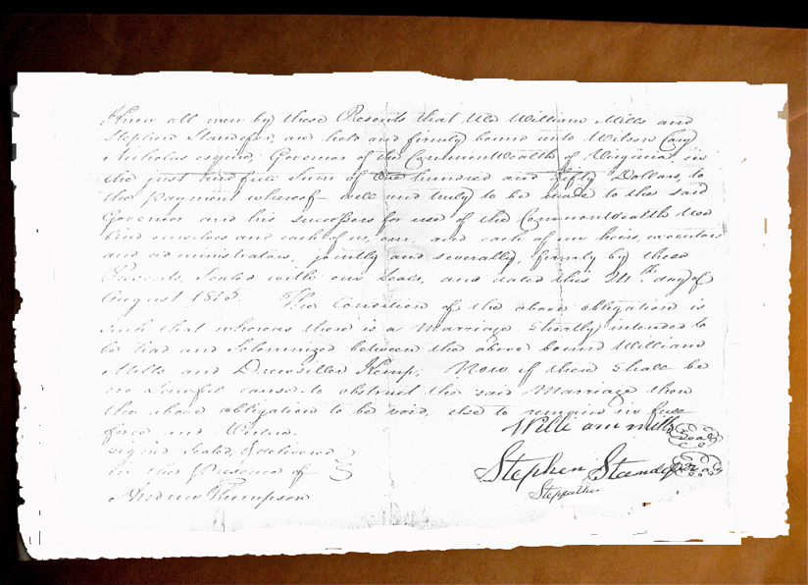

In the document used to illustrate this QuickLesson, for example, have you spotted yet the tampering?7 When you read the document, did you think, Wow! This is fantastic! Wouldn’t it be great if every bondsman stated his kinship on the bond! ... Or did you think, Whoa! This is weird. I’ve never seen a surety add a relationship to his signature. Why would this man vary from the norm? ... Did you then analyze that deviance and end up thinking, Hmmh. Did the “helpful soul” who put this image into circulation do a not so helpful cut-and-paste to promote a pet theory?
- If possible, we compare the image to others in the register or the collection to which it belongs. We look for other documents supposedly created by the same author or the same scribe and compare penmanship and writing style.
- We correlate the content of the image against all other related information we have gathered from other sources. Significant differences may suggest a fabricated record or an attempt by the original informant to fudge the facts. At the least, those differences will alert us to the need to consult the original.
When issues arise that cannot be otherwise resolved, it is appropriate to contact the archive that holds the original, explain the problem, and ask for access. Some repositories will prefer to make the reexaminations themselves. In other cases, we may need to engage a skilled local analyst to be our eyes and mind in a distant facility. Occasionally, travel to the repository may be our only option.

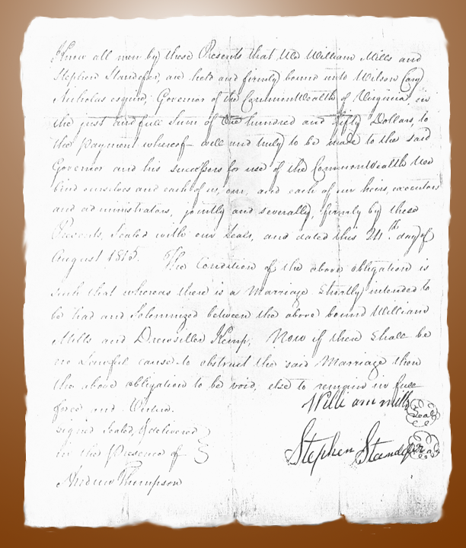

Many times, a reexamination will confirm our suspicions or clarify issues we did not know existed. As in the case of this QuickLesson’s bond, consulting the original may eliminate a red herring that has led researchers astray for more than thirty years.

The Bottom Line
With every record we use, the bottom line is the same. We need to define—in our minds and in our research notes—the extent to which the record has been processed, both in form and content. As with the food we digest, changes to the inherent physical characteristics of a record will degrade the quality. Intellectual processing of the content can even more radically alter the reliability or the completeness of a record. We all use image copies but only the foolhardy would accept them uncritically.

